# Installing ESP32 Add-on in Arduino IDE

To install the ESP32 board in your Arduino IDE, follow these next instructions:

In your Arduino IDE, go to File> Preferences

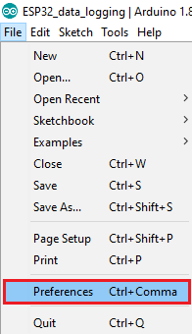

Enter https://dl.espressif.com/dl/package_esp32_index.json into the “Additional Board Manager URLs” field as shown in the figure below. Then, click the “OK” button:

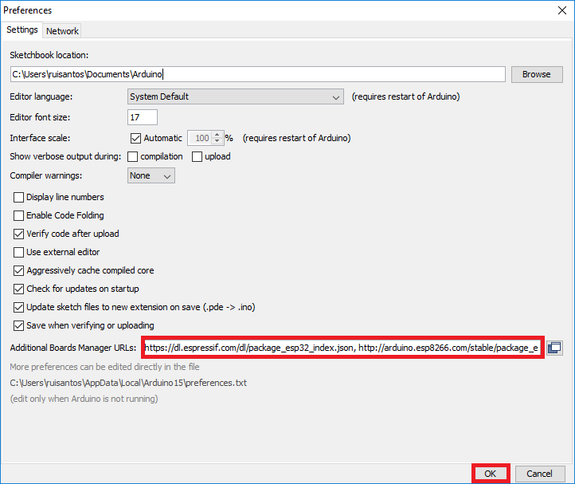

Note: if you already have the ESP8266 boards URL, you can separate the URLs with a comma as follows:

https://dl.espressif.com/dl/package_esp32_index.json, http://arduino.esp8266.com/stable/package_esp8266com_index.json

Open the Boards Manager. Go to Tools > Board > Boards Manager…

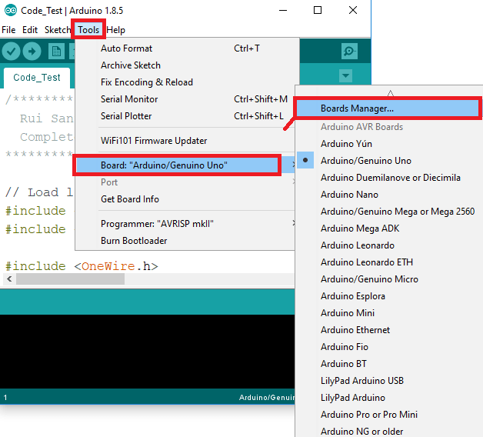

Search for ESP32 and press install button for the “ESP32 by Espressif Systems“:

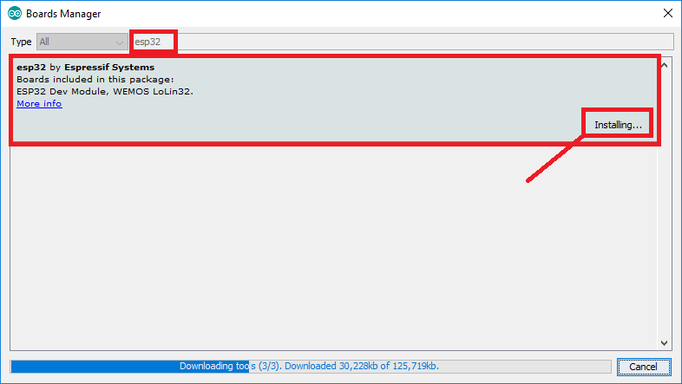

That’s it. It should be installed after a few seconds.

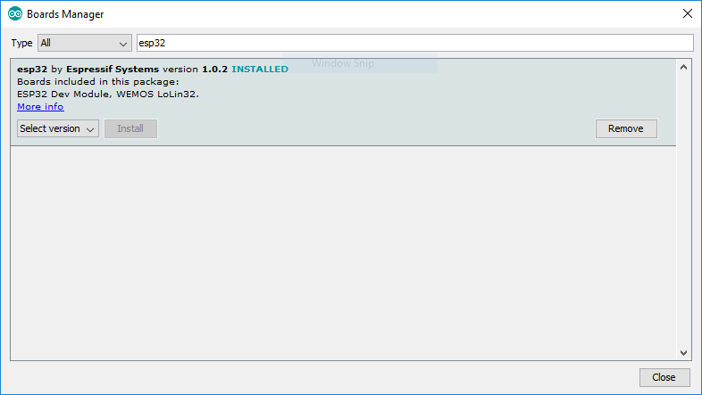

# Testing the Installation (optional)

Plug the ESP32 board to your computer. With your Arduino IDE open, follow these steps:

1. Select your Board in Tools > Board menu (in my case it’s the DOIT ESP32 DEVKIT V1)

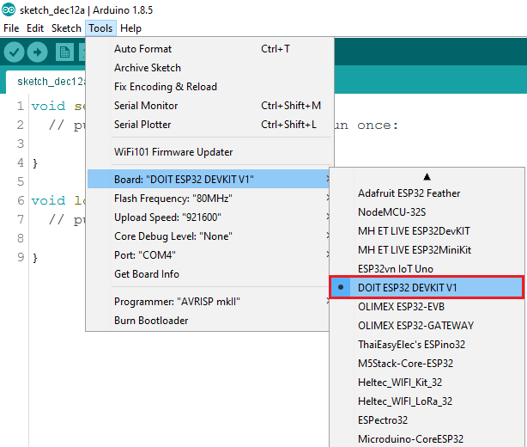

2. Select the Port (if you don’t see the COM Port in your Arduino IDE, you need to install the [CP210x USB to UART Bridge VCP Drivers](https://www.silabs.com/products/development-tools/software/usb-to-uart-bridge-vcp-drivers)):

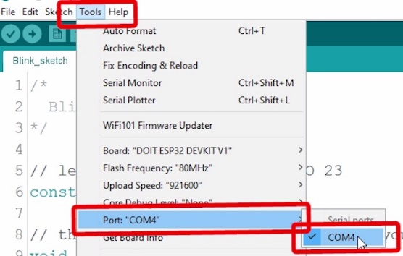

3. Open the following example under File > Examples > WiFi (ESP32) > WiFiScan

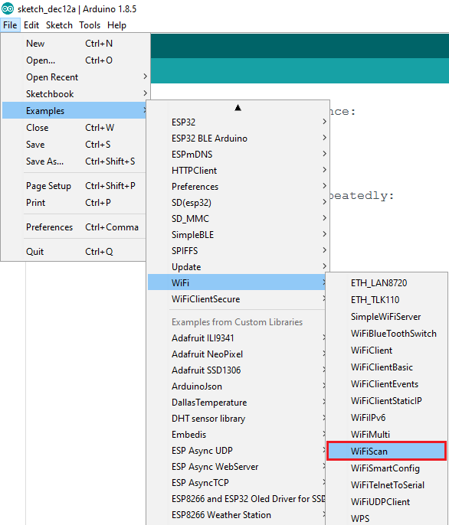

4. A new sketch opens in your Arduino IDE:

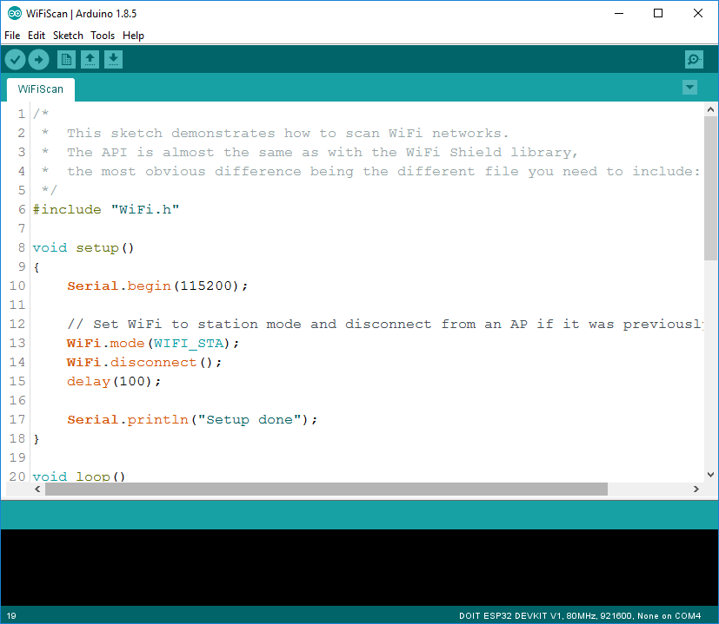

5. Press the Upload button in the Arduino IDE. Wait a few seconds while the code compiles and uploads to your board.

Arduino IDE upload WiFiScan sketch to ESP32

6. If everything went as expected, you should see a “Done uploading.” message.

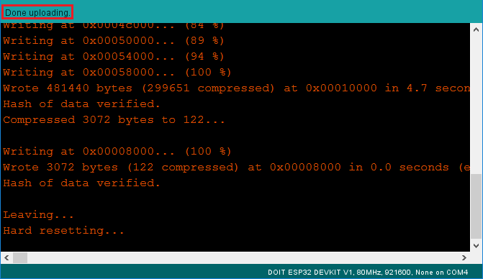

7. Open the Arduino IDE Serial Monitor at a baud rate of 115200:

Open Arduino IDE Serial Monitor at baud rate 115200

8. Press the ESP32 on-board Enable button and you should see the networks available near your ESP32:

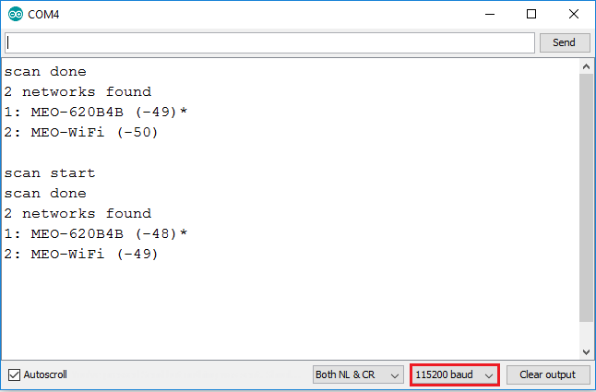

# Installing libraries

