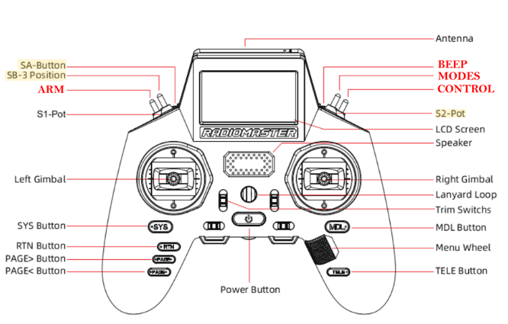**Cheat sheet**

|  |  |  |
| --- | --- | --- |
| THROTTLE (T) | Channel 1 |  |
| PITCH | Channel 2 |  |
| ROLL | Channel 3 |  |
| YAW | Channel 4 |  |
| ARM | Channel 5 | Arm the drone |
| MODES | Channel 6 | Change the modes |
| CTRL | Channel 7 | Leave/take control (do not used by iNAV) |
| BEEP | Channel 8 | Beeping |

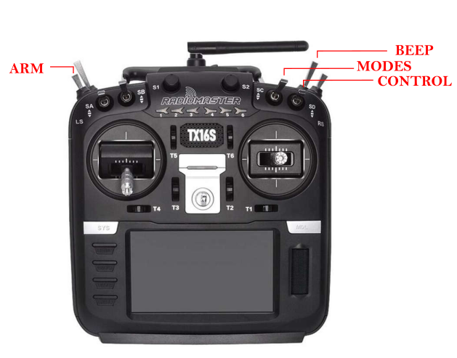**Values for channels**

|  |  |
| --- | --- |
| MIN_SBUS_VALUE | 172 |
| MAX_SBUS_VALUE | 1811 |
| MID_SBUS_VALUE | 992 |