**VISUAL ODOMETRY:**

* Determine its position and orientation throughout the flight.
* IN UAV Drones handled by the use of a
* Global Positioning System (GPS) receiver,
* Inertial Measurement Unit (IMU)
* The above methods are not applicable to indoor environment,
* Also prone to outdoor failure due to GPS jamming and multipath attenuation.
* One way to overcome this is **visual odometry.**

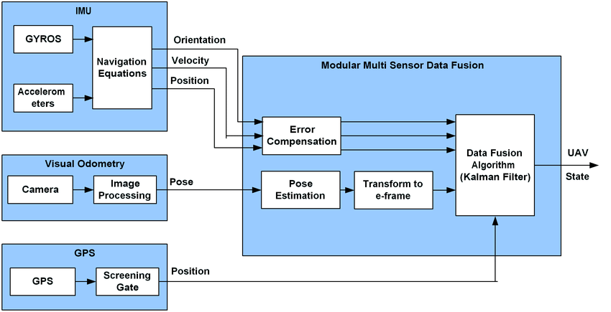

**ADVANTAGES OF VISUAL ODOMETRY:**

* low cost,
* increasingly miniaturized,
* Captured images have dual-use – visualization and motion estimation.

**KEY IDEA:**

* detecting image features
* Modelling perspective dynamics over successive frames.

**TECHNIQUES:**

* There are two basic approaches to VO:
* geometric
* learning.

**GEOMETRY:**

* Epipolar constraints and projective geometry are applied to match 3D scene points projected onto the 2D image planes.
* The reliability depends
* on accurate camera calibration,
* correctness of image feature correspondence.
* The key differentiating factor is
* in using a small set of sparse keypoint image features versus working directly on the images.

**LEARNING:**

* **has no such need for tedious camera calibration,**
* tries to **infer the motion model from many examples of features labelled with ground truth motion**.
* **Shift the burden of formulating an accurate camera motion model to collecting good feature data for training**.

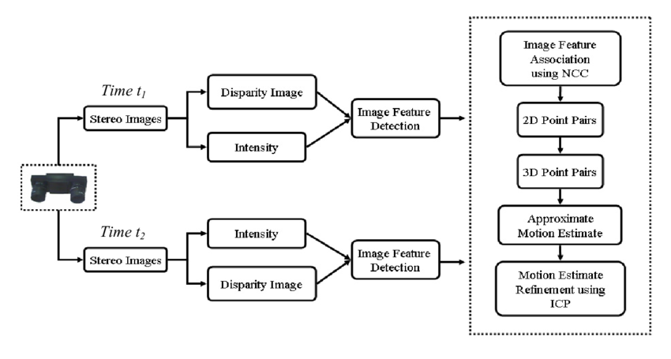



STEPS:

* **divide an image frame into blocks:**
* within which the average optical flow is used to train nearest neighbour regressors to vote for the final camera motion.
* **feature parameterization:**
* varying the grid size and quantizing into modulus and phase using different thresholds.
* **convolutional neural network (CNN)**
* A dense optical flow image as an input to a convolutional neural network (CNN), not only to regress odometry, but also to learn features useful for the ego-motion estimation task.