NAVIGATION IN UAV:

Navigation in UAV involves three steps:

1. Establish the track that needs to be followed (i.e. Flight Plan)
2. Establish current position relative to the FP
3. Execute all necessary guidance actions to correct any deviation in position

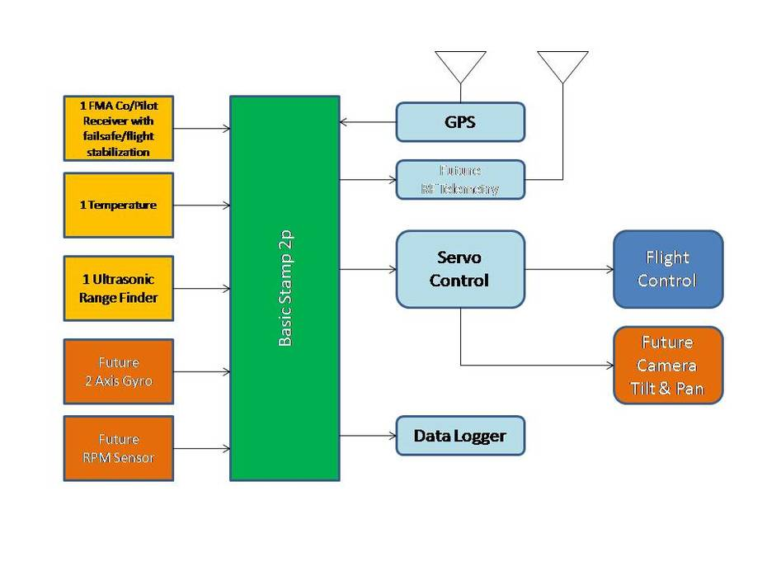

Some of the types of navigation are:

* **Pilotage.** Using visual ground references
* **Astro navigation.**
* Using angular measurements taken between a celestial body (the sun, the moon, a star…) and the visible horizon
* **Dead reckoning.**
* Involves the use of visual checkpoints (starting point) along with time, speed and heading measures to estimate the distance travelled
* **Inertial navigation**.
* An on-board computer processes speed and attitude, together with information provided by motion sensors (accelerometers, gyroscopes and magnetometers) in order to give the current location from a known start point.
* **Radio navigation.**
* The application of radio frequencies to determine current position.
* Aids used include: GNSS, VOR, DME and ADF.

**Pilotage:**

* **Pilotage**  is navigating,
* **using fixed points of reference** on the sea or on land,
* with **reference to a nautical chart** or aeronautical chart
* to **obtain a fix of the position** of the vessel or aircraft with respect to a desired course or location.
* **Horizontal fixes** of position from known reference points may be obtained by **sight or by radar.**
* **Vertical position** may be obtained by **depth sounder** to determine depth of the water body below a vessel or by altimeter to determine an aircraft's altitude, from which its distance above the ground can be deduced.

**Astro Navigation:**

* Celestial navigation, also known as astronavigation, is
* Ancient and modern practice of position fixing.
* Enables a navigator to transition through a space without having estimated calculations,
* Celestial navigation uses "**sights**", or angular measurements taken between a celestial body (e.g. the Sun, the Moon, a planet, or a star) and the visible horizon.
* The Sun is most commonly used, but navigators can also use the Moon, a planet, Polaris, or one of 57 other navigational stars whose coordinates are tabulated in the nautical almanac and air almanacs.

