**SIMULTANEOUS LOCALIZATION AND MAPPING(SLAM) TECHINIQUE:**

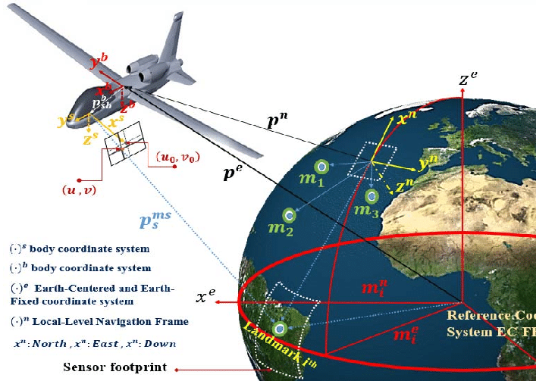

* Simultaneous localization and mapping, or SLAM for short, is the process of creating a map using a robot or unmanned vehicle that navigates that environment while using the map it generates.
* SLAM is technique behind robot mapping or robotic cartography.
* The robot or vehicle plots a course in an area, but at the same time, it also has to figure out where its own self is located in the place. The process of SLAM uses a complex array of computations, algorithms and sensory inputs to navigate around a previously unknown environment or to revise a map of a previously known environment.
* One requirement of SLAM is a range measurement device, the method for observing the environment around the robot. The most common form of measurement is a laser scanner such as LiDAR.
* Laser scanners are easy to use and very precise. However, they are also extremely expensive. There are other options, though. Sonar can be used, and this device is especially useful for mapping underwater environments.
* Imaging devices can also be used for SLAM. These optical readers can came in 2D or even 3D formats. The measurement device used depends on several variables, including preferences, costs, and availability.
* Another key component in the SLAM process is acquiring data about the environmental surroundings of the robot. Just like a human, the robot uses landmarks to determine its location using its sensors, the laser, sonar, or whichever measuring device is used.
* Once a robot has sensed a landmark, it can then determine its own location by extracting the sensory input and identifying the different landmarks. A method needs to be in place in order for the robot to do this.
* This landmark extraction can be done in a variety of ways from algorithms like Spike extraction to scan-matching. The important factor to remember is that the robot needs a way to identify a landmark.
* Robots can also use data from previously scanned landmarks and match them up with each other in order to determine its location.
* Popular approximate solution methods include the particle filter, extended Kalman filter, Covariance intersection, and GraphSLAM.
* SLAM algorithms are tailored to the available resources, hence not aimed at perfection, but at operational compliance. Published approaches are employed in self-driving cars, unmanned aerial vehicles, autonomous underwater vehicles, planetary rovers, newer domestic robots and even inside the human body