**NAVIGATION IN UAV:**

1. Dead Reckoning:

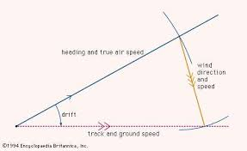

* In navigation, dead reckoning is the process of calculating one's current position by using a previously determined position, or fix, and advancing that position based upon known or estimated speeds over elapsed time and course.
* The corresponding term in biology, used to describe the processes by which animals update their estimates of position or heading, is path integration.
* Advances in navigational aids that give accurate information on position, in particular satellite navigation using the Global Positioning System, have made simple dead reckoning by humans obsolete for most purposes

.

* However, inertial navigation systems, which provide very accurate directional information, use dead reckoning and are very widely applied
* While dead reckoning can give the best available information on the present position with little math or analysis, it is subject to significant errors of approximation.
* For precise positional information, both speed and direction must be accurately known at all times during travel.

INERTIAL NAVIGATION:

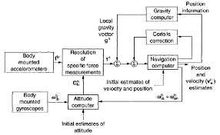

* An inertial navigation system (INS) is a navigation device that uses a computer, motion sensors (accelerometers) and rotation sensors (gyroscopes) to continuously calculate by dead reckoning the position, the orientation, and the velocity (direction and speed of movement) of a moving object without the need for external references
* An inertial navigation system comprises two-distinct parts; the first is the IMU (inertial measurement unit)—sometimes called the IRU (inertial reference unit). This is the collective name for the accelerometers and gyros that provide acceleration and angular velocity measurements.
* The second part is the navigation computer. The navigation computer takes measurements from the IMU and uses them to calculate the relative position, orientation and velocity of the INS.
* There are essentially two kinds of navigation computers in use; stabilised platforms and strap-down navigators.
* So, as the inertial navigation system rotates, the stabilised platform inside it does not. In this way, the system learns about its orientation and can make use of the measurements from the accelerometers.

3.Radio Navigation

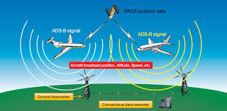

* Radio navigation or radio navigation is the application of radio frequencies to determine a position of an object on the Earth. Like radiolocation it is a type of radio direction. The basic principles are measurements from/to electric beacons especially
* Angular direction e.g. by bearing, radio phases or interferometry
* Distance eg ranging by measurement of time of flight between one transmitter and multiple receivers or vice versa
* Distance differences by measurement of times of arrivals of signals from one transmitter to multiple receivers or vice versa
* Partly also velocity e.g. by means of radio Doppler effect