eXtended Reality – Engineering Design Review

**Stage: Initial Planning**

Design Ideas

QR Code -

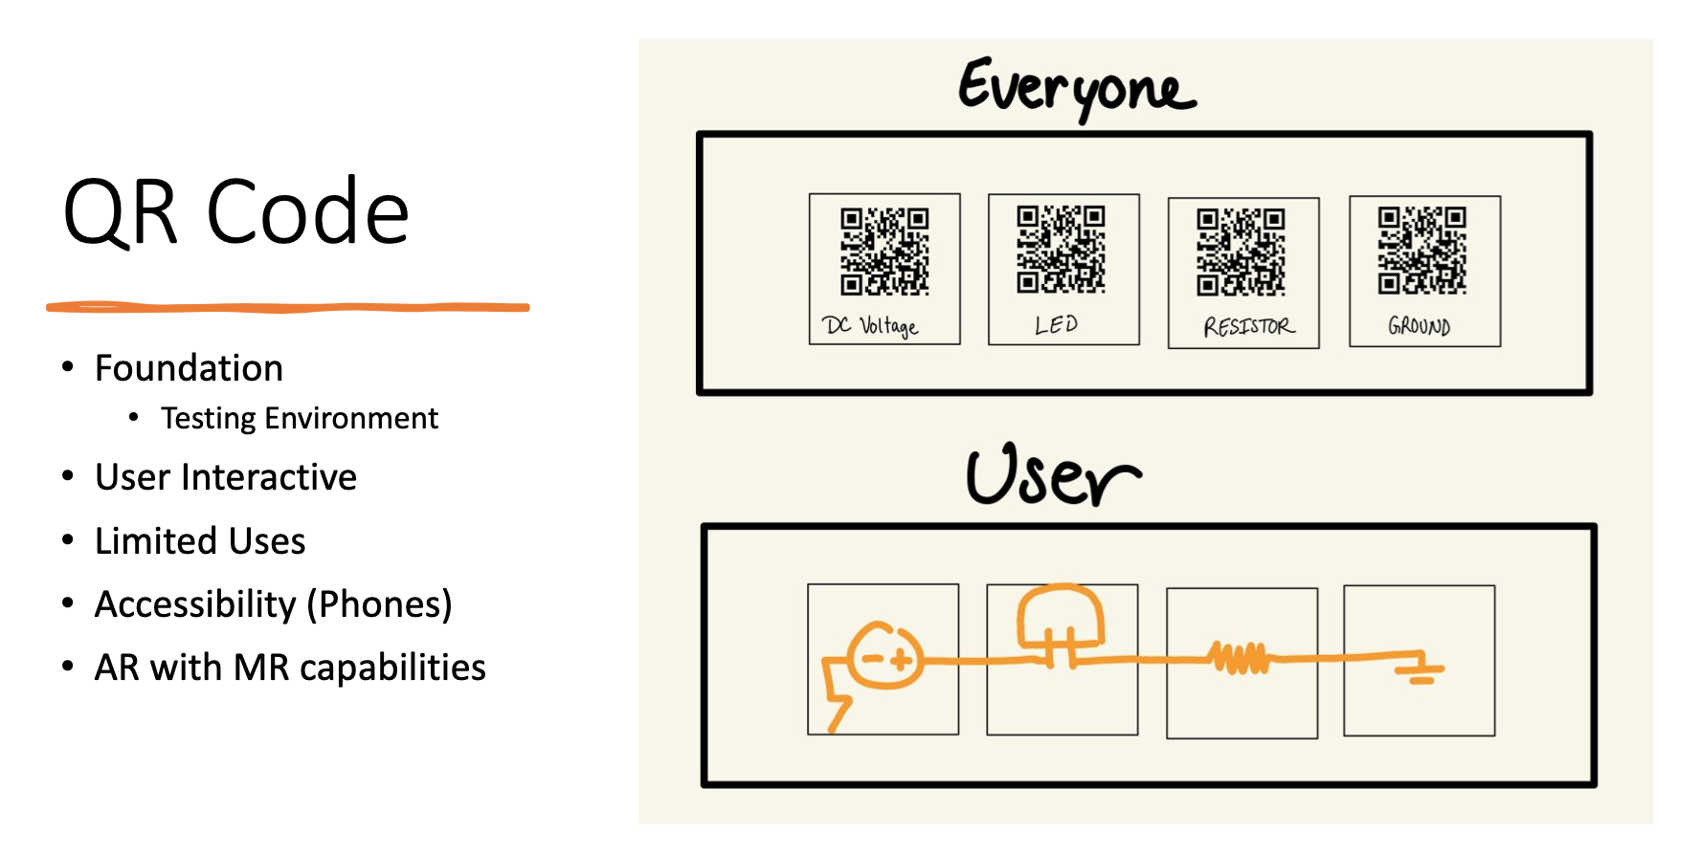

Virtual Interactive Learning -

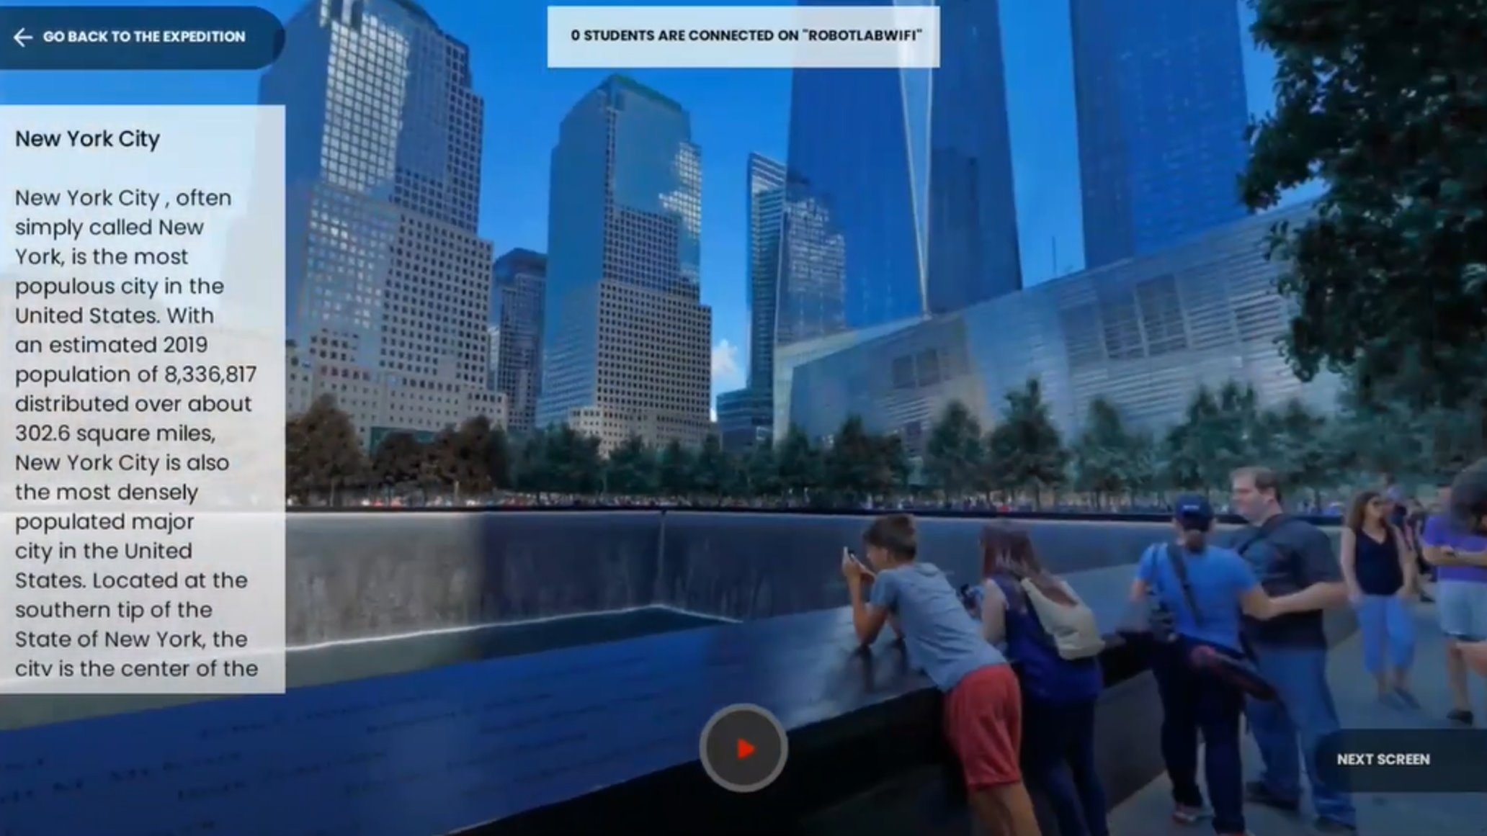

Digital-Physical Integration -

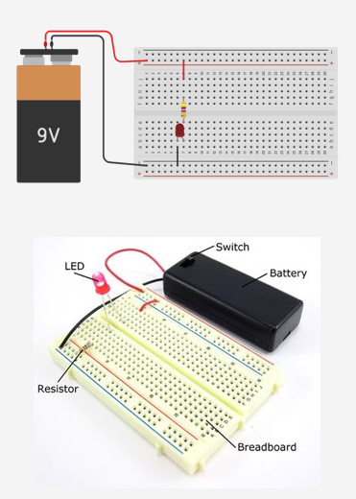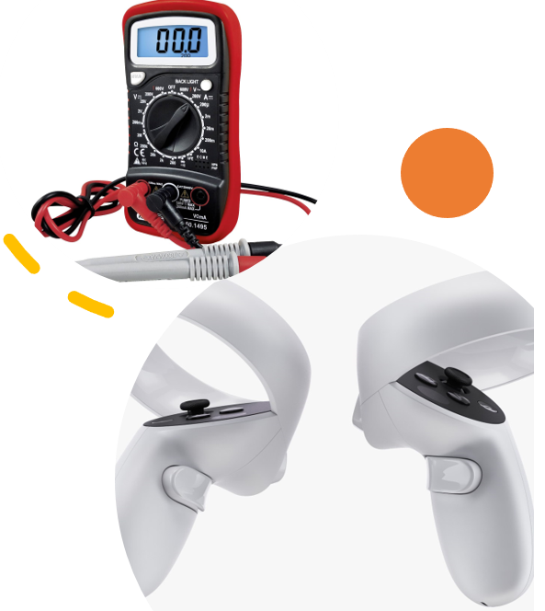

Diego Tapia - Point of Contact

* Reached out to stakeholder for initial meeting
* Suggested the idea of an interactive Lab-Like design
* Looked into potential design environments for project
* Researched into accessible hardware to be implemented

Joren Cruz – Archivist, Scheduler

* Scheduled weekly meetings with the team and Stakeholder
* Suggested the QR Code/AR idea
* Wrote notes and uploaded them on GitHub
* Made Teams to easily get a hold of our stakeholder when needed. (Easier than having tons of emails)

Daniel Wang – Editor, Treasurer

* Assembled (Informal) Documentation Dump
* Standardized Format Across All Documents
* PPT Slides
* Sketched Early Design Ideas