Lightning Presentation
Time Limit Constraint: 5 minutes (exactly with slides automatically advancing on timers!)
Each team will have exactly five minutes to provide a fast overview of their project. You need to prioritize, so use your time very wisely. It’s essential that the team repeatedly practices this presentation. The slides will be set to automatically advance.
Slide Size Constraint: All team’s slides will be integrated into a single slide deck. To avoid formatting issues, please make sure to select the Widescreen (16:9) slide size under the Design tab.
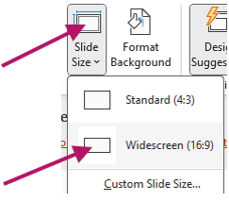
Embedded Videos: Teams, at their discretion, can embed short videos into their presentations to better demonstrate their systems. If you decide to do this, it’s critical to keep these short and to make sure to test that they play correctly and automatically on another machine.
Problem Framing & Engineering Design Approach (High-Level)
Your lightning presentation should clearly communicate what problem is being solved and how your engineering design addresses it, at a system level.
- Briefly describe the core problem or need, including why it matters to the stakeholder or end user.
- Summarize the high-level engineering design approach or system architecture used to address the problem.
- Highlight one or two key design decisions or trade-offs that shaped the solution.
- Explain why this approach was appropriate given the problem context, constraints, or stakeholder needs.
This content should remain high-level and accessible to a general audience. Focus on problem clarity, design intent, and engineering judgment. Avoiding getting lost in detailed technical minutiae. Given the five-minute constraint, you must prioritize the most essential aspects of your work.
Make sure your presentation is exactly 5 minutes long with auto-advancing slides (see below)

How to set PowerPoint to automatically advance:
  - Click on the Transitions tab
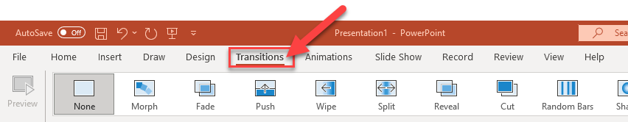
  - Under the Advance Slide area, check the box called After and set the desired time until the slide will advance to the next slide.
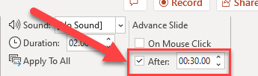

Submission Requirements:
  - Submit a .pptx file on GitHub under team_deliverables
  - The file must be set to auto-advance and the total time to advance through all the slides must be exactly 5 minutes. Make sure to test it with your phone’s stopwatch!

