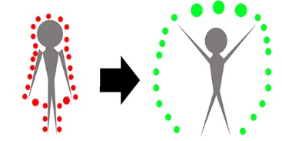

*catharsis.*

interactive projection mapping generative to twitter APIs and centered around mood.

**catharsis** - *a* **:** purification or purgation of the emotions (as pity and fear) primarily through art

*b* **:** a purification or purgation that brings about spiritual renewal or release from tension

**catharsis** creates a window to the streamlined emotions that social networking is most well-known for by engaging the participant to physically immerse themselves in the moods expressed by users on the internet. **catharsis** connects the participant by creating “emotive bubbles” that, depending on the key-term, will reflect a mood (negative to positive). **catharsis**insists the participant to “renew” what negativity these tweets convey by instructing the participant to use their hands and legs.

***(scope)***

1. ***Creating “bubbles/ellipses”.***
2. ***Collision/attractor detection for positioning of ellipses reactive to participant.***
3. ***Color of ellipses reactive to spring/collision.***
4. ***Tracking participant using OpenCV.***
5. ***Binding of ellipses proportional to participant in frame.***
6. ***Beginning point/end point for spring/collision in proportion to participant in frame.***
7. ***Aggregating Twitter APIs using certain keywords descriptive of mood (hate, love, angry, excited, upset, boyfriend, girlfriend, break-up, etc.)***
8. ***Creating individual classes for APIs to run inside “emotive bubbles”***
9. ***Instances for when API classes need to change.***
10. ***Possible background to projection?***