|  |
| --- |
| Golden Axe Beats |
| Work In Progress of Final Report |
| Group Project |

|  |
| --- |
| 3/10/2017 |

Contents

Executive Summary 2

Background 3

Results 4

Project Management 6

Conclusion 7

References 8

Appendix A (PID) 9

Appendix B 10

Appendix C 11

Appendix D 12

# Executive Summary

In the course of 4 months, a group was created with individuals that potentially brought a unique touch towards the production of creativity. We decided as a team, to produce a short music video consisting of music from Golden Axe Beats, a producer following the background from modern day electronic dance music. Our goal was to have a completed music video that can be viewed on multiple platforms online such as YouTube or Vimeo, and to create a trend following using networking and promoting tools. We established what we felt was a vital skill among the group that would help successfully complete the project – and that was demonstrating communication with everyone involved in the project. Throughout the project, we came across ideas and influences that helped create the preparation mould for the music video, including a shot list, a script and a storyboard. Identifying both the technological and the artistic side involved within the project allowed every member to identify both their strengths and weaknesses towards creating the music video, and how they can use their resources to overcome potential results.

Looking at some of the previous work involved with Golden Axe Beats, we were sure that this will be quite a challenge, however. We learned to keep track of our diaries using techniques that we felt suited towards the project, and making use of note taking on days of the meetings and visual/audio recordings.

I have been involved with the music production towards Golden Axe Beats, including the creative and directing work in producing documentations and the overall brains of the project. So far, the music has been recorded and mixed, and will later go through a mastering process, to compete against other major music labels and their music. A Sound cloud link is available to access the final mix of the music.

<https://soundcloud.com/goldenaxebeats/power-hour-final-mixunmastered/s-8DLAH>

# Background

**NOTE* *

|  |
| --- |
| This section summarise much of the information in the PID including aims, scope, limitations and context. |

# Results

**note** - here are statements from some group members which will be compacted down and written as one in a professional manner after the video has been completed and edited, valid points made by each individual:

John Irvine

The project so far has been successful in its production. Several scenes, including establishing shots in Motherwell and Edinburgh have been shot and the music is currently in its final mastering process. As a Digital Media student, working for the music video project has enhanced my filming experience, as well as animating motion graphics for a client-based project.

The team has to use the same camera (my Canon 1200D) to film as it was the only camera available for the project. However, my knowledge of working with the same camera progressed as I started working with manual focus as well as auto focus. I am also keen on creating time lapse videos after connecting a device to the camera that takes sequential photographs with ease.

Several short motion graphics were created in After Effects for the logo animation, one of which is to be chosen and placed at the end of the video. This experience has developed my skills in 2D animation. I was even offered some freelance work for a summer project with the same company.

Due to a car breakdown, filming has been halted until further notice since the car is an essential prop for the video.

Adam Malvern

My role thus far has primarily been as a cameraman on the music video project. Thus far I have participated in two full day shoots, taking place in both Motherwell and Edinburgh, as well as providing the necessary Recce and Risk Assessment documentation for each shooting location. To this point I feel the music has been a real test of my ability when operating a camera, challenging me to work with a DSLR camera for the first time, and shoot an array of experimental shots that I haven’t had the freedom to do on any other project I have previously worked on. Prior to this project, I had only ever used industry standard video cameras, which are significantly larger and operate very differently from DSLR’s. Before the first of day of shooting I rented out a DSLR camera from the university’s store to familiarise myself with the cameras. I now, having worked with the cameras on both the Motherwell and Edinburgh shoots, feel comfortable when operating the DSLR, a very useful skill that I have this project to thank for. At the present I personally feel the group is very functional and I’ve found everyone to be extremely coherent when suggesting new ideas or voicing opinions. As a cameraman I’m happy with the footage that we’ve gathered to this point, as well as the quantity of footage we presently have.

John-michael Charczuk

My role in the production stage of the creation of the music video has been of a videographer, as I have not only had experience working with much larger cameras, but also Canon DSLR’s. I have brought my knowledge of creating time-lapse sequences into the project, and have since implemented time-lapses into the music video itself. This was done by connecting my Interval meter to the Canon 1200D, and setting the remote to take stills at a fast rate. In my time as a media student, this was the first time working with a group to create a product, as all my other ventures have been solo. So, this project has helped me hone my team communication skills, as well as working to suit everyone’s individual schedule.

In the post-production stage I will be taking up the role as an editor, and footage logger. And after 2 full days shooting in Motherwell and Edinburgh, we had to delay the filming of the video, as the car that featured heavily in the video was taken into a mechanic. So, until the car is out and running again, filming has been delayed until further notice. Once the car is operational that should be the last day of filming, and post-production can start.

# Project Management

**note**

Here you should summarise the conduct of the project itself including those techniques that worked well and those that did not. Be sure to identify project successes as well as shortcomings. From your analysis, you should draw a set of lessons learned. These are useful pieces of information for use in future projects.

This section should also include a comparison of the original schedule compared to the actual. This would best be done as a table of milestones with their original and final dates taken from your Gantt charts.

Our means of communication were agree’d upon straight away. All of the group members are users of Facebook therefor we created a group chat on there, in which we can communicate in real time and also quickly share small files.

On a larger scare, I created a project on [GITHUB](https://github.com/UAshraf123/GOLDENAXEBEATS) in which we could share and edit large files which every member had access to. However a problem we came across was certain document types could not be edited on the github platform itself, meaning files had to be downloaded, edited, then re-uploaded which I found was not very efficient. We fixed this problem by………………… *

The next task for us was to make a weekly meeting session in which we could meet face to face and discuss the project and our progression. We decided to meet between 1 and 2pm every Tuesday in the library, in which we always booked a study room. This was very effective as it was a quiet room big enough for all of us, with various plugs for our laptops. At first we attempted meeting at the Kilby computer centre, however it was too noisy for us in there.

# Conclusion

**NOTE**

Overall summary of the project result - for example:

* How well does the project meet its original aims?
* Is the system fully usable?
* If not, what additional actions are still required to make it so?
* Have any unforeseen technical limitations come to light during the project itself?
* etc.

# References

**NOTE**

“In a real professional report, an explicit reference section is not always required. However, this report forms part of an academic assessment and correct referencing is very important. Please use the APA referencing style which you can select in the Microsoft Word referencing tool, or in an external tool such as Mendeley. With these tools available, there is no excuse for incorrect referencing. “

# Appendix A (PID)

**NOTE**

COPY AND PASTE PID DOCUMENT IN THIS SECTION

# Appendix B

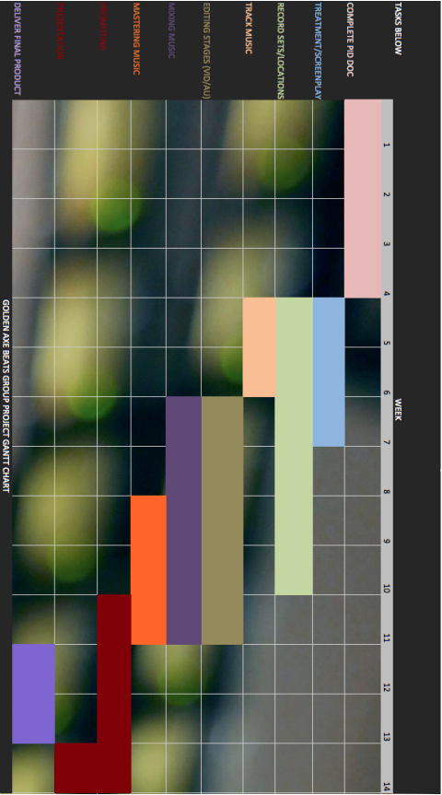

# Appendix C

**note** GET TOGETHER DETAILED TESTING RECORDS AND INSERT HERE

# Appendix D

**NOTE** TECHINICAL DOCUMENTATION FROM THE PROJECT, STORYBOARDS ETC