Exploratory Analysis - Diamonds Tibble

UB Orengo

5/6/2021

# LIBRARIES USED

library(tidyverse)

## Warning: package 'tidyverse' was built under R version 4.0.4

## -- Attaching packages --------------------------------------- tidyverse 1.3.0 --

## v ggplot2 3.3.3 v purrr 0.3.4  
## v tibble 3.0.4 v dplyr 1.0.2  
## v tidyr 1.1.2 v stringr 1.4.0  
## v readr 1.4.0 v forcats 0.5.0

## -- Conflicts ------------------------------------------ tidyverse_conflicts() --  
## x dplyr::filter() masks stats::filter()  
## x dplyr::lag() masks stats::lag()

library(dplyr)  
library(magrittr)

##   
## Attaching package: 'magrittr'

## The following object is masked from 'package:purrr':  
##   
## set_names

## The following object is masked from 'package:tidyr':  
##   
## extract

library(ggplot2)  
library(stats)  
library(scales)

##   
## Attaching package: 'scales'

## The following object is masked from 'package:purrr':  
##   
## discard

## The following object is masked from 'package:readr':  
##   
## col_factor

# DATASET EXPLORED

head(diamonds)

## # A tibble: 6 x 10  
## carat cut color clarity depth table price x y z  
## <dbl> <ord> <ord> <ord> <dbl> <dbl> <int> <dbl> <dbl> <dbl>  
## 1 0.23 Ideal E SI2 61.5 55 326 3.95 3.98 2.43  
## 2 0.21 Premium E SI1 59.8 61 326 3.89 3.84 2.31  
## 3 0.23 Good E VS1 56.9 65 327 4.05 4.07 2.31  
## 4 0.290 Premium I VS2 62.4 58 334 4.2 4.23 2.63  
## 5 0.31 Good J SI2 63.3 58 335 4.34 4.35 2.75  
## 6 0.24 Very Good J VVS2 62.8 57 336 3.94 3.96 2.48

# EXPLORING X Y Z VALUES

## INTIAL HISTOGRAMS

diamonds_hist <- ggplot(diamonds) +   
 geom_histogram(mapping = aes(x = x), binwidth = 1)

### This histogram for the x value has a bit of a left skew

diamonds_hist2 <- ggplot(diamonds) +   
 geom_histogram(mapping = aes(x = y), binwidth = 1)  
  
diamonds_hist3 <- ggplot(diamonds) +   
 geom_histogram(mapping = aes(x = z), binwidth = 1)  
print(diamonds_hist)

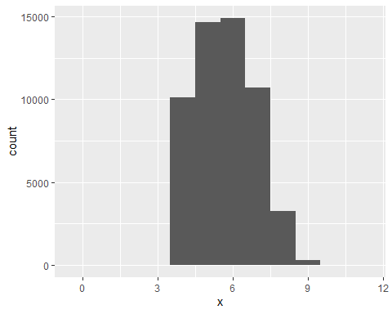

print(diamonds_hist2)

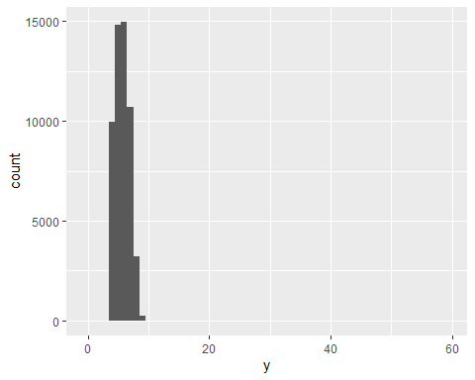

print(diamonds_hist3)

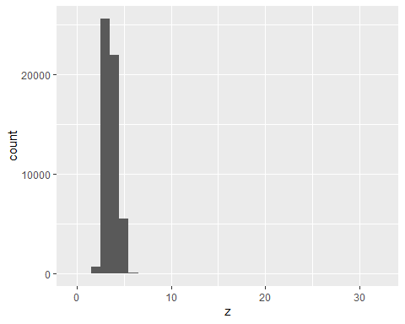

### We are unable to see the distribution properly of the y and z values because of outlier values

print(min(diamonds$y))

## [1] 0

print(max(diamonds$y))

## [1] 58.9

print(min(diamonds$z))

## [1] 0

print(max(diamonds$z))

## [1] 31.8

### After looking at the max/min values and observing the histograms, we create a subset of the current table without the outliers

out_diamond_y <- diamonds[which(diamonds[,9]>10),]  
  
out_diamond_z <- diamonds[which(diamonds[,10]>9),]  
  
diamonds_subset_y <- subset(diamonds, diamonds$y <= 11)  
  
diamonds_subset_z <- subset(diamonds, diamonds$z <= 8)

## SUBSET GRAPHS – REMOVED OUTLIERS

### We print new histograms, which are both semi-normally distributed, with new bins

diamonds_hist4 <- ggplot(diamonds_subset_y) +   
 geom_histogram(mapping = aes(x = y), binwidth = 1)  
  
diamonds_hist5 <- ggplot(diamonds_subset_z) +   
 geom_histogram(mapping = aes(x = z), binwidth = .5)  
  
print(diamonds_hist4)

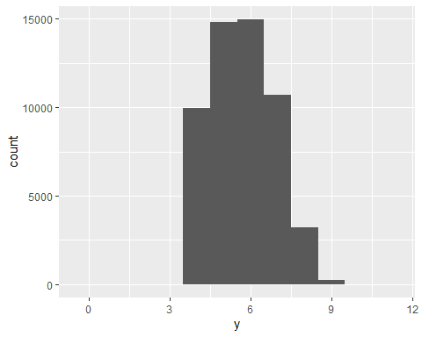

print(diamonds_hist5)

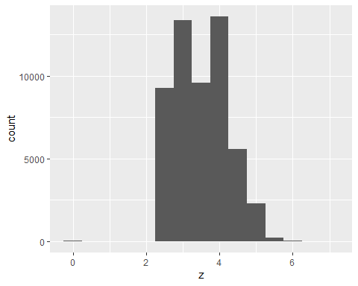

# EXPLORING PRICE OF DIAMONDS

## Histogram of Distribution of Price of Diamonds

diamonds_price <- ggplot(diamonds) +  
 geom_histogram(mapping = aes(x = price), binwidth = 100, color="white")  
  
print(min(diamonds$price))

## [1] 326

print(max(diamonds$price))

## [1] 18823

print(diamonds_price)

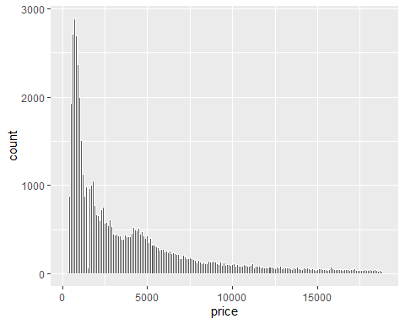 ### It seems that a large portion of the diamonds in the dataset are between the first 10 bins, which would be 0-1000$

# COMPARISION OF .99 CARAT DIAMONDS TO 1 CARAT DIAMONDS

carat_count <- diamonds[which(diamonds[,1] == 0.99),]  
view(carat_count)

### 23 rows in diamonds$carat = 0.99, there are 23 diamonds in the dataset that equal .99 carats

carat_count2 <- diamonds[which(diamonds[,1] == 1),]  
view(carat_count2)

### 1,558 rows in diamonds$carat = 1. there are 1,558 diamonds in the dataset that equal 1 carat.

### The difference may be attributed to values being rounded up to be able to price the diamonds at 1 carat, as opposed to .99 carats.

## Summary Table – Average Price by Carat

avg_price_by_carat <- diamonds %>%  
 group_by(carat) %>%  
 summarize(avg_price = mean(price))

## `summarise()` ungrouping output (override with `.groups` argument)

price_99_carat <- avg_price_by_carat[which(avg_price_by_carat[,1] == .99),]  
price_1_carat <- avg_price_by_carat[which(avg_price_by_carat[,1] == 1),]  
  
print(avg_price_by_carat)

## # A tibble: 273 x 2  
## carat avg_price  
## <dbl> <dbl>  
## 1 0.2 365.  
## 2 0.21 380.  
## 3 0.22 391.  
## 4 0.23 486.  
## 5 0.24 505.  
## 6 0.25 551.  
## 7 0.26 551.  
## 8 0.27 575.  
## 9 0.28 580.  
## 10 0.290 601.  
## # ... with 263 more rows

print(price_99_carat)

## # A tibble: 1 x 2  
## carat avg_price  
## <dbl> <dbl>  
## 1 0.99 4406.

print(price_1_carat)

## # A tibble: 1 x 2  
## carat avg_price  
## <dbl> <dbl>  
## 1 1 5242.

## 

## Line Plot of Average Price by Number of Carats

carat_plot <- ggplot(data = avg_price_by_carat, mapping = aes(x = carat, y = avg_price)) +  
 geom_line() +  
 geom_point() +  
 geom_smooth() +  
 ggtitle("Average Price By Carat") +  
 xlab("Number of Carats") + ylab("Average Price")  
  
print(carat_plot) + ggtitle("Average Price By Carat") + xlab("Number of Carats") + ylab("Average Price")

## `geom_smooth()` using method = 'loess' and formula 'y ~ x'

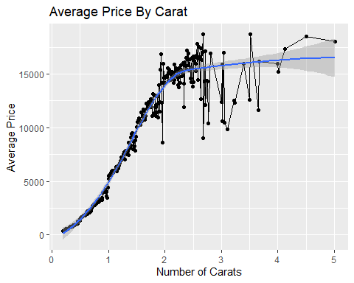

### You can see a distinct slope between .99 carat and 1 carat

print(price_99_carat)

## # A tibble: 1 x 2  
## carat avg_price  
## <dbl> <dbl>  
## 1 0.99 4406.

print(price_1_carat)

## # A tibble: 1 x 2  
## carat avg_price  
## <dbl> <dbl>  
## 1 1 5242.

price_diff <- price_1_carat[,2]-price_99_carat[,2]   
print(price_diff)

## avg_price  
## 1 835.4159

### There is an over 800$ difference between the average price of a .99 carat diamond and a 1 carat diamond