A PROJECT REPORT ON

SIMPLE MALWARE SCANNER USING YARA

Submitted By
SHAIK UBAIDUR RAHMAN
PROJECT ID
PTID-CSPP-JUL-26-511
BATCH ID
11-MAY-26-CSPP-BUN-750-WDM0930-HYD-MAD

DECLARATION
I hereby declare that the project report entitled “Simple Malware Scanner Using YARA” is my original work carried out as part of the phase 2 in Skillogic internship requirements for the completion of CSPP program.
The project involved developing and testing a simple malware scanning system using YARA, PowerShell, and SHA-256 hashing from a Windows environment. The project focused on rule-based malware detection, recursive file scanning, automated scanning, endpoint security scanning, threat hunting, incident-response support, and evidence collection.
I further declare that the work presented in this report has been carried out for educational and authorized laboratory purposes. The information, observations, results, screenshots, and analysis included in this report represent the work performed during the project.
I have not knowingly copied or reproduced the work of another person without appropriate acknowledgement.
Name:
SHAIK UBAIDUR RAHMAN
Project ID:
PTID-CSPP-JUL-26-511
Date:
6th Sept 2026

ABSTRACT
Malware is one of the major cybersecurity threats faced by individuals and organizations. Traditional security solutions primarily rely on predefined signatures and may not always provide sufficient flexibility for detecting customized or emerging suspicious files. This project presents a Simple Malware Scanner Using YARA, a lightweight and customizable rule-based malware detection system designed to identify potentially malicious files through predefined patterns and indicators.
The project uses YARA to create rules based on suspicious strings, command indicators, scripting indicators, and other file characteristics. A PowerShell-based automation layer is implemented to execute YARA scans, perform recursive directory scanning, count rule matches, measure scan duration, and generate detection reports.
The scanner was tested using controlled test samples containing predefined suspicious indicators. The implementation successfully detected multiple rule matches across individual files and nested directories while correctly allowing a clean test file to remain undetected. The scanner also supports endpoint security scanning of selected directories, threat-hunting activities, and basic incident-response evidence collection.
For incident-response purposes, detected files can be documented along with their associated YARA rule, file path, detection timestamp, and SHA-256 hash. Dedicated reports are generated to assist with analysis and documentation.
The final implementation demonstrates that YARA can provide a lightweight, flexible, and customizable approach to file-level malware detection. The project also provides practical exposure to YARA rule development, automated security scanning, threat hunting, endpoint monitoring, and incident-response concepts.
Keywords: YARA, Malware Detection, Cybersecurity, Threat Hunting, Incident Response, Rule-Based Detection, PowerShell, SHA-256, File Scanning.

TABLE OF CONTENTS

Chapter / Section | Title | Page No.
1 | Title Page | 1
2 | Declaration | 2
3 | Abstract | 3
4 | Table of Contents | 4
5 | Introduction | 5
6 | Problem Statement | 6
7 | Objectives of the Project | 8
8 | Business Case | 10
9 | Existing System | 15
10 | Proposed System | 17
11 | Requirements Specification | 21
12 | Technology Overview | 25
13 | System Architecture | 29
14 | Project Directory Structure | 34
15 | YARA Rule Design and Development | 38
16 | System Implementation | 43
17 | Testing Methodology | 50
18 | Results and Analysis | 57
19 | Screenshots and Evidence | 62
20 | Advantages of the Proposed System | 81
21 | Limitations | 86
22 | Future Enhancements | 90
23 | Security Considerations | 96
24 | Conclusion | 101
25 | References | 103
26 | Appendix | 105

5. INTRODUCTION
Malware is a significant cybersecurity threat that can affect individual systems, organizational networks, servers, and endpoints. Malicious or suspicious files may contain executable code, scripts, commands, embedded strings, or other characteristics that can be used to compromise systems, steal information, disrupt operations, or establish unauthorized access. As malware techniques continue to evolve, security professionals require flexible tools that can identify suspicious characteristics at the file level.
YARA is a pattern-matching and rule-based detection tool widely used in malware research, threat detection, digital forensics, and threat hunting. YARA allows security analysts to create rules that describe specific characteristics of files. These characteristics can include textual strings, hexadecimal patterns, file properties, and logical conditions. When a scanned file satisfies the conditions defined in a YARA rule, the file is reported as a potential match.
This project, titled “Simple Malware Scanner Using YARA,” focuses on developing a lightweight file-scanning solution that uses custom YARA rules to identify potentially suspicious files. The project combines YARA with PowerShell automation to provide a practical scanning workflow on a Windows environment.
The implemented scanner supports individual file scanning as well as recursive directory scanning. Custom rules were created to identify controlled test indicators associated with suspicious PowerShell activity, command execution, scripting activity, and other predefined patterns. A clean test file was also included to validate that files without matching indicators do not generate detections.
The project further extends the basic YARA scanning capability through endpoint scanning, threat-hunting functionality, and incident-response reporting. The endpoint scanner can inspect selected directories such as Downloads, Desktop, and Documents. The threat-hunting component recursively searches a designated directory for predefined indicators. The incident-response component records relevant information about detected files, including the triggered YARA rule, file path, detection timestamp, and SHA-256 hash.
During final testing, the main scanner successfully processed 6 controlled test files, produced 5 rule matches, and completed the scan in approximately 0.056 seconds. One clean test file produced no detection, demonstrating the basic distinction between matching and non-matching files.
The project provides practical experience in rule-based malware detection, YARA rule development, automated security scanning, recursive file analysis, endpoint security, threat hunting, and incident-response evidence collection. It demonstrates how a lightweight and customizable YARA-based solution can complement existing security mechanisms by providing additional visibility into file-level indicators.

6. PROBLEM STATEMENT
The increasing number and complexity of malware threats create significant challenges for individuals, organizations, and cybersecurity professionals. Malicious files can use different techniques, obfuscation methods, scripts, commands, and file characteristics to avoid detection and compromise systems. Identifying suspicious files quickly is therefore an important part of an effective cybersecurity strategy.
Traditional antivirus solutions primarily depend on known signatures and other detection mechanisms. Although these solutions are useful for detecting established threats, they may not always provide the flexibility required for customized security investigations, malware research, threat hunting, and detection of organization-specific indicators.
The major problems addressed by this project are:

6.1 Difficulty in Detecting Customized Threats
Organizations may encounter malware or suspicious files that contain unique characteristics not covered by their existing security signatures. Security analysts need the ability to define customized detection patterns according to the requirements of a particular investigation.

6.2 Dependence on Predefined Detection Mechanisms
Traditional security solutions may rely heavily on vendor-maintained signatures. This can make it difficult for security teams to quickly create and deploy their own detection logic when investigating a new suspicious artifact.

6.3 Lack of Lightweight and Customizable Scanning
Security analysts may require a lightweight tool that can be executed against a selected file or directory without deploying a complete endpoint security platform. A rule-based scanner can provide a simple method for performing targeted file analysis.

6.4 Delayed Identification of Suspicious Files
Manual inspection of large numbers of files can be time-consuming. A scanner that automatically checks files against predefined rules can reduce the time required to identify potentially suspicious artifacts.

6.5 Limited File-Level Visibility
Security investigations often require analysts to understand why a file was considered suspicious. Identifying the specific rule or indicator that triggered a detection can provide useful information during analysis and investigation.

6.6 Challenges in Threat Hunting
Threat hunters may need to search directories for known indicators of compromise (IOCs). Performing this task manually across multiple directories can be inefficient. A recursive YARA scan can assist analysts by automatically searching files and subdirectories for predefined indicators.

6.7 Need for Basic Incident-Response Evidence
When a suspicious file is identified, investigators need useful information about the artifact. Recording the file path, triggered detection rule, detection time, and SHA-256 hash provides basic evidence that can support further investigation.

Problem Definition
Therefore, the project addresses the need for a simple, lightweight, customizable, and automated malware-scanning solution that can use YARA rules to identify potentially suspicious files, perform recursive scanning, support endpoint and threat-hunting activities, and generate basic detection and incident-response reports.

7. OBJECTIVES OF THE PROJECT
The primary objective of this project is to design and implement a Simple Malware Scanner Using YARA capable of identifying potentially suspicious files through customizable rule-based detection.
The specific objectives of the project are as follows:

7.1 Develop a YARA-Based Malware Detection System
To implement a file-scanning solution that uses YARA rules to identify files containing predefined suspicious patterns, strings, and indicators.

7.2 Create Custom Detection Rules
To develop customized YARA rules for detecting controlled indicators associated with suspicious PowerShell activity, command execution, scripting activity, and other predefined malware-related patterns.

7.3 Implement Recursive File Scanning
To enable the scanner to search not only files in a specified directory but also files located within nested subdirectories.

7.4 Automate the Scanning Process
To use PowerShell to automate YARA execution, scanning, detection counting, result processing, and report generation.

7.5 Measure Scanning Performance
To measure the time required to complete a scan and demonstrate that the implemented scanner can perform lightweight and rapid file analysis.

7.6 Support Endpoint Security
To implement scanning of selected endpoint directories such as Downloads, Desktop, and Documents so that potentially suspicious files can be identified as an additional security layer.

7.7 Support Threat Hunting
To implement recursive scanning of a designated threat-hunting directory for predefined indicators of compromise (IOCs), helping demonstrate proactive security investigation.

7.8 Support Incident Response
To generate an incident-response report containing important information about detected files, including the triggered YARA rule, file path, detection timestamp, and SHA-256 hash.

7.9 Validate Detection Accuracy
To test the scanner using controlled suspicious test samples and clean files, verifying that matching files are detected while files without matching indicators are not reported.

7.10 Generate Security Reports
To automatically generate reports containing scan results and relevant evidence that can be reviewed during malware analysis, threat hunting, and incident-response activities.

7.11 Develop Practical Cybersecurity Skills
To gain practical experience in YARA rule development, malware detection, file analysis, PowerShell automation, endpoint security, threat hunting, and incident-response processes.

8. BUSINESS CASE

SIMPLE MALWARE SCANNER USING YARA

8.1 Introduction
YARA is a powerful pattern-matching tool widely used in malware research, threat detection, digital forensics, and threat hunting. It enables security professionals to create rules based on known characteristics of suspicious or malicious files, including textual strings, binary patterns, file structures, and other indicators.
The Simple Malware Scanner Using YARA developed in this project uses customized YARA rules to scan files and directories for predefined suspicious indicators. PowerShell automation is used to execute scans, process detection results, measure scan performance, and generate reports.
The project provides a practical approach to file-level malware detection and demonstrates how YARA can be incorporated into security analysis and investigation workflows.

8.2 Problem Statement
Malware continues to evolve and presents significant security risks to computer systems and organizations. Security teams require flexible mechanisms for identifying suspicious files and investigating potential threats.
The major challenges addressed by this project include:
- Difficulty in detecting customized or previously unidentified suspicious files.
- Dependence on predefined antivirus signatures and detection mechanisms.
- Lack of lightweight and customizable file-scanning solutions.
- Delayed identification of suspicious artifacts during security investigations.
- Limited visibility into file-level indicators.
- Difficulty in manually searching large directory structures for suspicious indicators.
- Need for basic evidence collection during incident-response activities.
These challenges can increase the risk of system compromise, data loss, operational disruption, and delayed incident response.

8.3 Solution Overview
The proposed solution is a Simple Malware Scanner Using YARA that scans files against predefined YARA rules.
The system consists of a YARA detection engine, custom rule files, controlled test samples, and PowerShell automation scripts.
The general workflow is:
Input Files / Directories
↓
YARA Rules
↓
YARA Scanner
↓
Pattern Matching
↓
Detection Results
↓
PowerShell Processing
↓
Reports / Evidence
The scanner supports individual file scanning and recursive directory scanning. When a file contains an indicator matching a YARA rule, the corresponding rule name and file path are reported.
Additional components provide endpoint scanning, threat hunting, and incident-response evidence collection.

8.4 Key Features and Benefits

8.4.1 Rule-Based Detection
The scanner uses YARA rules to identify files containing predefined suspicious patterns and indicators. Custom rules were created and tested as part of the project.
Benefit: Provides flexible file-level detection based on security analyst-defined conditions.

8.4.2 Lightweight and Fast
The scanner uses the YARA command-line engine with PowerShell automation and does not require a large security platform for the demonstrated scanning workflow.
During final testing, the scanner processed 6 controlled test files, produced 5 rule matches, and completed the scan in approximately 0.056 seconds.
Benefit: Demonstrates that targeted file scanning can be performed rapidly with limited processing overhead.

8.4.3 Customizable Rules
YARA rules can be modified or extended to identify additional indicators. The project uses multiple custom rules covering suspicious PowerShell, command, scripting, and test indicators.
Benefit: Security analysts can adapt detection logic according to new investigation requirements.

8.4.4 Supports Threat Hunting
The scanner supports recursive scanning of a designated directory structure to search for predefined indicators of compromise (IOCs).
Benefit: Helps security analysts perform proactive searches for suspicious artifacts across multiple directories.

8.4.5 Endpoint Security Enhancement
An endpoint scanning component was implemented using PowerShell. It scans selected endpoint locations such as Downloads, Desktop, and Documents using the YARA rules.
Benefit: Provides an additional file-level detection layer that can complement existing endpoint security and antivirus solutions.

8.5 Use Cases

8.5.1 Malware Detection and Analysis
The scanner can be used during malware analysis to identify files containing predefined suspicious indicators.

8.5.2 Endpoint Security Enhancement
Selected endpoint directories can be scanned to identify files matching security detection rules.

8.5.3 Incident Response
When a suspicious file is detected, the incident-response component records the associated YARA rule, file path, detection time, and SHA-256 hash.

8.5.4 Threat Hunting Operations
Security analysts can recursively scan designated directories to search for known indicators of compromise.

8.5.5 Cybersecurity Training and Labs
The project provides a controlled environment for learning YARA rule creation, malware detection concepts, recursive scanning, threat hunting, and incident-response procedures.

8.6 Conclusion
The Simple Malware Scanner Using YARA provides a lightweight and customizable approach to file-level malware detection. By combining YARA's rule-based pattern matching with PowerShell automation, the project supports detection, recursive scanning, endpoint scanning, threat hunting, and basic incident-response evidence collection.
The implementation demonstrates how customized detection rules can be applied to controlled test samples to identify potentially suspicious files and generate useful security reports.

8.7 Outcome of the Project

Technical Outcomes
The project achieved the following technical outcomes:
- Successful implementation of YARA-based file scanning.
- Successful creation and testing of custom YARA detection rules.
- Successful detection of controlled suspicious test samples.
- Successful validation using a clean test file.
- Successful recursive scanning of nested directories.
- Successful automated scanning using PowerShell.
- Successful measurement of scan duration.
- Successful endpoint directory scanning.
- Successful threat-hunting implementation.
- Successful incident-response evidence collection.
- Successful SHA-256 hash generation for detected files.
- Successful generation of scan, endpoint, threat-hunting, and incident-response reports.

Final Test Result
The final scanner test produced the following result:
Total Files Scanned : 6
Rule Matches : 5
Scan Duration : 0.056 Seconds
Five controlled test files triggered YARA rules, while one clean test file produced no rule match.

Operational and Educational Impact
The project provides practical experience in:
- Malware detection concepts.
- YARA rule development.
- File-level security analysis.
- PowerShell security automation.
- Recursive file scanning.
- Endpoint security.
- Threat hunting.
- Incident-response procedures.
- Digital evidence identification through SHA-256 hashing.
The project demonstrates how a simple YARA-based scanner can serve as a useful educational and security-analysis tool for identifying potentially suspicious artifacts.

9. EXISTING SYSTEM
The existing approach to malware detection commonly relies on antivirus software, endpoint security platforms, manual file inspection, and signature-based detection mechanisms. These technologies play an important role in protecting systems, but they may not always provide the customization and flexibility required for specific malware analysis and threat-hunting activities.

9.1 Traditional Antivirus Detection
Traditional antivirus solutions generally use a combination of malware signatures, behavioral analysis, heuristics, and other detection technologies to identify malicious files. They are designed to provide continuous protection for endpoints and systems.
However, security analysts may have limited control over the exact file-level detection patterns used by commercial antivirus products.

9.2 Manual File Analysis
Another approach is manually inspecting suspicious files and directories. Analysts may examine file names, extensions, strings, scripts, and other characteristics to determine whether a file appears suspicious.
Manual analysis can become time-consuming when a large number of files or directories need to be investigated.

9.3 Signature-Based Detection
Signature-based detection identifies files by comparing them against known signatures or patterns. This approach can be effective for known threats but may have limitations when dealing with new, customized, or previously unknown artifacts.

9.4 Limitations of the Existing System
The major limitations identified are:
- Limited customization of vendor-controlled detection mechanisms.
- Difficulty in rapidly creating organization-specific detection patterns.
- Manual investigation can be time-consuming.
- Searching large directory structures manually is inefficient.
- Limited visibility into which specific custom indicator triggered a detection.
- Additional tools may be required for specialized threat-hunting activities.
- Incident-response evidence may need to be collected separately.

9.5 Need for an Improved Approach
There is a need for a lightweight and customizable detection mechanism that allows security analysts to define their own detection logic and apply it to selected files or directories.
YARA addresses this requirement by allowing users to create rules based on textual strings, binary patterns, and logical conditions. When combined with PowerShell automation, YARA can be used to create a simple scanning workflow capable of recursive scanning, endpoint scanning, threat hunting, and report generation.
Therefore, the proposed Simple Malware Scanner Using YARA is designed to provide an additional and customizable file-level detection capability that can complement existing security solutions.

10. PROPOSED SYSTEM
The proposed system is a Simple Malware Scanner Using YARA designed to identify potentially suspicious files by comparing them against customized YARA detection rules. The system provides a lightweight and flexible approach to file-level security analysis and can be used for malware detection, endpoint security enhancement, threat hunting, and incident-response activities.
The solution combines the YARA scanning engine with PowerShell automation. YARA performs the actual pattern matching, while PowerShell scripts automate scanning operations, process the results, and generate security reports.

10.1 System Overview
The proposed system consists of the following major components:
- YARA Detection Engine
- Custom YARA Rules
- Controlled Test Samples
- Main Malware Scanner
- Recursive Scanning
- Endpoint Scanner
- Threat Hunting Module
- Incident Response Module
- SHA-256 Evidence Collection
- Security Reports
The overall workflow is:
┌─────────────────────┐
│ Input Files / │
│ Directories │
└──────────┬──────────┘
│
▼
┌─────────────────────┐
│ Custom YARA │
│ Rules │
└──────────┬──────────┘
│
▼
┌─────────────────────┐
│ YARA Scanner │
│ Pattern Matching │
└──────────┬──────────┘
│
▼
┌─────────────────────┐
│ Detection Results │
└──────────┬──────────┘
│
┌──────────────┼──────────────┐
▼ ▼ ▼
Endpoint Scan Threat Hunting Incident Response
│ │ │
└──────────────┼──────────────┘
▼
┌─────────────────────┐
│ Reports & Evidence │
└─────────────────────┘

10.2 YARA Detection Engine
YARA is responsible for comparing scanned files against the defined detection rules. Each rule contains strings or patterns and logical conditions that determine whether a file matches.
When a match occurs, YARA returns the corresponding rule name and the path of the detected file.

10.3 Custom YARA Rules
The project uses custom rules to detect controlled suspicious indicators. The rules include indicators associated with:
- Suspicious PowerShell activity.
- Suspicious command execution.
- Suspicious scripting activity.
- Controlled malware-detection test patterns.
The rules can be modified or extended when additional indicators need to be detected.

10.4 Main Malware Scanner
The main scanner is implemented using PowerShell and executes YARA against the project sample directory.
The scanner provides:
- Scan start time.
- Target directory.
- Total files scanned.
- Number of rule matches.
- Scan duration.
- Detection results.
- Output report.

10.5 Recursive Scanning
The scanner supports recursive scanning using YARA's recursive scanning capability. This allows files located inside nested directories to be examined automatically.
For example:
samples
└── nested
└── level2
└── deep_test.txt
The scanner successfully detected the controlled test file located in the nested directory.

10.6 Endpoint Security Scanning
The endpoint scanning component examines selected directories such as:
- Downloads
- Desktop
- Documents
The purpose is to demonstrate how YARA can provide an additional file-level detection capability on an endpoint.

10.7 Threat Hunting
The threat-hunting component recursively scans a designated directory structure containing simulated endpoint locations such as Documents, Downloads, Temp, and USB.
This demonstrates how analysts can search multiple locations for predefined suspicious indicators.

10.8 Incident Response
The incident-response component assists in documenting detected artifacts. Information associated with a detection can be recorded for further investigation.
The collected information includes:
- YARA detection rule.
- File path.
- Detection timestamp.
- SHA-256 hash.
This information provides basic evidence that can be used during security investigations.

10.9 Reporting
The proposed system generates separate reports for different security activities, including:
results
├── scan_results.txt
├── endpoint_report.txt
├── incident_report.txt
└── threat_hunting_report.txt
These reports provide a record of the scanning and detection activities performed during the project.

10.10 Advantages of the Proposed System
The proposed system provides the following advantages:
- Customizable detection rules.
- Lightweight scanning.
- Rapid file analysis.
- Recursive directory scanning.
- Automated scanning through PowerShell.
- Endpoint directory scanning.
- Threat-hunting capability.
- Incident-response evidence collection.
- SHA-256 hash identification.
- Automated report generation.
- Suitable for cybersecurity training and controlled laboratory environments.
The proposed system therefore provides a practical demonstration of how YARA can be integrated into a simple security-scanning workflow for malware detection and investigation.

11. REQUIREMENTS SPECIFICATION
The requirements specification defines the hardware, software, and environmental requirements necessary to implement and operate the Simple Malware Scanner Using YARA.
The project was implemented and tested in a Windows environment using the YARA command-line engine and PowerShell automation.

11.1 Hardware Requirements
The scanner does not require specialized hardware. A standard personal computer or laptop is sufficient for implementing and testing the project.
Component | Minimum Requirement | Recommended
Processor | Dual-Core CPU | Intel Core i3 / equivalent or higher
RAM | 4 GB | 8 GB or higher
Storage | 2 GB free space | 10 GB or more
Display | Standard monitor | Any modern display
Keyboard/Mouse | Required | Required
USB Storage | Optional | For removable-media scanning demonstration
Network | Not required for local scanning | Internet connection for downloading tools/updates
The hardware requirements are relatively low because YARA is a lightweight pattern-matching engine and the project performs targeted file scanning rather than continuous enterprise-scale endpoint monitoring.

11.2 Software Requirements
The following software components are required for the implementation:
Software | Purpose
Windows 10/11 | Operating environment
YARA | Malware pattern matching and detection
PowerShell | Scanner automation and report generation
Command Prompt | Command-line execution and testing
Text Editor | Creating and modifying YARA rules and test files

11.2.1 YARA
YARA is the primary detection engine used by the project. It processes the custom .yar rule files and scans the specified files or directories for matching patterns.
The project uses the Windows YARA executable:
yara64.exe

11.2.2 PowerShell
PowerShell is used to automate the scanning workflow. The project contains separate scripts for:
scanner.ps1
endpoint_scan.ps1
incident_response.ps1
threat_hunt.ps1
These scripts automate different security activities and generate corresponding reports.

11.2.3 YARA Rule Files
The project uses the following rule files:
malware_rules.yar
master_rules.yar
test_malware.yar
These files contain the detection logic used during scanning.

11.2.4 Test Environment
Controlled test samples were created specifically to validate the scanner. These samples contain predefined indicators designed to trigger the corresponding YARA rules.
The project also includes a clean sample to verify that a file without matching indicators does not generate a detection.

11.2.5 Project Storage Structure
The project is organized into separate directories for rules, samples, threat-hunting data, scripts, and generated reports.
YARA-Project
│
├── rules
├── samples
├── ThreatHunt
├── results
│
├── scanner.ps1
├── endpoint_scan.ps1
├── incident_response.ps1
└── threat_hunt.ps1
This organization makes the project easier to maintain, test, and demonstrate.

11.3 Functional Requirements
The system should be capable of performing the following functions:
- Load and process YARA rules.
- Scan individual files.
- Scan directories recursively.
- Identify files matching defined rules.
- Display detection results.
- Count rule matches.
- Count scanned files.
- Measure scan duration.
- Save scan results to a report.
- Scan selected endpoint directories.
- Perform threat-hunting scans.
- Generate incident-response information.
- Calculate SHA-256 hashes for relevant files.
- Store generated reports for later analysis.

11.4 Non-Functional Requirements

Performance
The scanner should perform file analysis efficiently and provide scan-duration information.

Usability
The system should be executable through simple PowerShell or command-line commands.

Maintainability
YARA rules should be easy to modify, add, or remove without redesigning the entire scanner.

Reliability
The scanner should consistently produce detection results for files containing the indicators defined by the corresponding rules.

Security
Testing should be performed using controlled samples in an isolated or authorized environment rather than relying on live malicious files.

Scalability
The recursive scanning capability allows the scanner to be applied to larger directory structures without manually specifying every individual file.

11.5 Requirements Summary
The Simple Malware Scanner Using YARA requires only a standard Windows computer, YARA, and PowerShell. The lightweight requirements make the project suitable for cybersecurity education, laboratory environments, malware-analysis exercises, threat hunting demonstrations, and basic endpoint file scanning.

12. TECHNOLOGY OVERVIEW
The Simple Malware Scanner Using YARA uses a combination of security and automation technologies to perform rule-based file detection, automated scanning, threat hunting, and incident-response evidence collection.
The primary technologies used in this project are YARA, PowerShell, and SHA-256.

12.1 YARA
YARA is a rule-based pattern-matching tool designed to help security researchers and analysts identify and classify files based on specific characteristics.
YARA rules consist of two major components:
- Strings or patterns that describe characteristics to search for.
- Conditions that determine when a rule should generate a match.
A simplified YARA rule can be represented as:
rule Example_Detection
{
strings:
$indicator = "suspicious_pattern"

condition:
$indicator
}
When YARA scans a file and the condition evaluates to true, the rule name and file path are returned as a detection result.

Role of YARA in the Project
YARA is the core detection engine of the project. It is responsible for:
- Loading custom detection rules.
- Scanning files.
- Matching predefined indicators.
- Detecting suspicious patterns.
- Supporting recursive directory scanning.
- Reporting matched rule names and file paths.
The Windows executable used in the project is:
yara64.exe
The project includes multiple YARA rule files containing customized detection logic.

12.2 PowerShell
PowerShell is a command-line shell and scripting environment available on Windows systems. It provides capabilities for executing commands, automating tasks, processing files, and generating reports.
In this project, PowerShell is used as the automation layer around the YARA engine.

Role of PowerShell in the Project
PowerShell scripts are used to:
- Execute YARA scans.
- Specify rule and target paths.
- Perform automated scanning.
- Process YARA output.
- Count rule matches.
- Measure scan duration.
- Generate scan reports.
- Perform endpoint scanning.
- Support threat-hunting activities.
- Collect incident-response information.
The project contains four primary PowerShell scripts:
scanner.ps1
endpoint_scan.ps1
incident_response.ps1
threat_hunt.ps1
The use of PowerShell allows multiple YARA operations to be combined into a practical automated scanning workflow.

12.3 SHA-256
SHA-256 (Secure Hash Algorithm 256-bit) is a cryptographic hash function that generates a fixed-length 256-bit hash value from input data.
A SHA-256 hash can be represented as a hexadecimal value such as:
A1B2C3D4E5F6...
The actual hash depends on the contents of the file.

Role of SHA-256 in the Project
SHA-256 is used as part of the incident-response evidence collection process.
When a suspicious file is identified, its SHA-256 hash can be recorded along with other information such as:
- File path.
- YARA rule that triggered.
- Detection timestamp.
- File hash.
This provides a unique content identifier that can assist with evidence tracking and further analysis.

12.4 Relationship Between the Technologies
The three technologies work together as follows:
Files / Directories
│
▼
PowerShell
Automation Layer
│
▼
YARA Engine
│
Pattern Matching
│
▼
Detection Result
│
┌─────────┴─────────┐
▼ ▼
Report SHA-256 Hash
YARA performs the detection, PowerShell automates the scanning and reporting workflow, and SHA-256 provides file-content identification for incident-response evidence.

12.5 Advantages of the Technology Stack
The selected technology stack provides several benefits:
- YARA: Flexible and customizable rule-based detection.
- PowerShell: Native Windows automation and scripting capabilities.
- SHA-256: Reliable file-content identification.
- Combined workflow: Provides detection, automation, reporting, threat hunting, and basic incident-response support.
The technologies are lightweight and suitable for a controlled cybersecurity laboratory project demonstrating practical malware detection concepts.

13. SYSTEM ARCHITECTURE
The architecture of the Simple Malware Scanner Using YARA is designed around a rule-based detection engine combined with PowerShell automation. The system accepts files or directories as input, applies customized YARA rules, processes the resulting detections, and stores the results in security reports.
The architecture is divided into several logical components to make the system easy to understand, maintain, and extend.

13.1 High-Level Architecture
The high-level architecture of the project is:
┌─────────────────────────┐
│ User / Analyst │
└────────────┬────────────┘
│
▼
┌─────────────────────────┐
│ PowerShell Scripts │
│ │
│ • scanner.ps1 │
│ • endpoint_scan.ps1 │
│ • threat_hunt.ps1 │
│ • incident_response.ps1 │
└────────────┬────────────┘
│
▼
┌─────────────────────────┐
│ YARA Engine │
│ yara64.exe │
└────────────┬────────────┘
│
┌────────────┴────────────┐
│ │
▼ ▼
┌──────────────────┐ ┌──────────────────┐
│ YARA Rules │ │ Files / Folders │
│ │ │ │
│ *.yar │ │ Samples │
│ Custom Rules │ │ Endpoint Data │
│ Master Rules │ │ ThreatHunt │
└────────┬─────────┘ └────────┬─────────┘
│ │
└────────────┬────────────┘
▼
┌─────────────────────────┐
│ Pattern Matching │
└────────────┬────────────┘
│
▼
┌─────────────────────────┐
│ Detection Results │
└────────────┬────────────┘
│
┌────────────────┼────────────────┐
▼ ▼ ▼
┌────────────┐ ┌─────────────┐ ┌─────────────┐
│ Scan Report│ │ Threat Hunt │ │ Incident │
│ │ │ Report │ │ Response │
└────────────┘ └─────────────┘ └──────┬──────┘
│
▼
┌─────────────┐
│ SHA-256 │
│ Evidence │
└─────────────┘

13.2 Input Layer
The input layer contains the files and directories that need to be analyzed.
The project uses several input locations:
C:\Users\ubaid\YARA-Project\samples
C:\Users\ubaid\YARA-Project\ThreatHunt
The samples directory contains controlled test files used to validate the YARA detection rules.
The ThreatHunt directory contains simulated endpoint locations such as:
ThreatHunt
├── Documents
├── Downloads
├── Temp
└── USB

13.3 Rule Layer
The rule layer contains the YARA detection logic.
The project includes:
rules
├── malware_rules.yar
├── master_rules.yar
└── test_malware.yar
The rules define the patterns and conditions used to identify controlled suspicious indicators.
The rule layer is separated from the scanner scripts so that detection logic can be updated without changing the complete scanning workflow.

13.4 Detection Engine
The YARA executable acts as the core detection engine.
yara64.exe
It receives the selected rule file and target file or directory and performs pattern matching.
For recursive scanning, the -r option allows YARA to examine files inside nested directories.
A simplified operation is:
YARA Rules + Target Files
↓
Pattern Matching
↓
Rule Evaluation
↓
Detection / No Detection

13.5 Automation Layer
PowerShell provides the automation layer around the YARA engine.
The project contains four main scripts:
scanner.ps1
endpoint_scan.ps1
threat_hunt.ps1
incident_response.ps1
Each script performs a specific security function.

Main Scanner
scanner.ps1 performs the primary malware scanning operation.

Endpoint Scanner
endpoint_scan.ps1 scans selected endpoint directories.

Threat Hunting
threat_hunt.ps1 recursively searches the designated threat-hunting directory.

Incident Response
incident_response.ps1 collects detection information and supporting evidence such as SHA-256 hashes.

13.6 Processing Layer
The processing layer receives the output generated by YARA and processes the information.
The main scanner records:
- Scan start time.
- Target directory.
- Total files scanned.
- Rule matches.
- Scan duration.
- Detection results.
PowerShell processes these results and stores them in the appropriate report file.

13.7 Evidence and Reporting Layer
The final layer stores the results generated by the security activities.
The project uses:
results
├── scan_results.txt
├── endpoint_report.txt
├── incident_report.txt
└── threat_hunting_report.txt
These reports provide records of the scanning and detection activities.
For incident-response purposes, SHA-256 hashes provide an additional identifier for relevant files.

13.8 Data Flow
The complete data flow can be summarized as:
User selects target
↓
PowerShell script starts
↓
YARA rules loaded
↓
Files/directories scanned
↓
YARA performs pattern matching
↓
Rule matches identified
↓
PowerShell processes results
↓
Detection information recorded
↓
Reports generated
↓
Incident-response evidence collected when required

13.9 Architecture Benefits
The architecture provides several benefits:
- Separation of detection rules and scanning logic.
- Easy modification of YARA rules.
- Automated scanning through PowerShell.
- Support for recursive directory scanning.
- Separate workflows for endpoint security, threat hunting, and incident response.
- Centralized storage of generated reports.
- Simple and understandable project structure.
- Suitable for controlled cybersecurity laboratory environments.
The architecture therefore provides a structured foundation for implementing and demonstrating the Simple Malware Scanner Using YARA.

14. PROJECT DIRECTORY STRUCTURE
The project is organized into separate directories for YARA rules, controlled test samples, threat-hunting data, security scripts, and generated reports. This modular structure makes the project easier to understand, maintain, test, and demonstrate.
The final project directory structure is shown below:
YARA-Project
│
├── endpoint_scan.ps1
├── incident_response.ps1
├── scanner.ps1
├── threat_hunt.ps1
│
├── results
│ ├── endpoint_report.txt
│ ├── incident_report.txt
│ ├── scan_results.txt
│ └── threat_hunting_report.txt
│
├── rules
│ ├── malware_rules.yar
│ ├── master_rules.yar
│ └── test_malware.yar
│
├── samples
│ ├── clean_sample.txt
│ ├── command_test.txt
│ ├── powershell_test.txt
│ ├── script_test.txt
│ ├── test_sample.txt
│ │
│ └── nested
│ └── level2
│ └── deep_test.txt
│
└── ThreatHunt
├── Documents
│ ├── clean_sample.txt
│ ├── notes.txt
│ ├── script_test.txt
│ └── startup_script.txt
│
├── Downloads
│ ├── invoice.txt
│ └── powershell_test.txt
│
├── Temp
│ └── service.txt
│
└── USB
└── command_test.txt

14.1 Root Project Directory
The root directory is:
C:\Users\ubaid\YARA-Project
It contains the PowerShell automation scripts and the main project directories.

14.2 Rules Directory
The rules directory contains the YARA rule files used by the scanner.
rules
├── malware_rules.yar
├── master_rules.yar
└── test_malware.yar

malware_rules.yar
Contains the customized detection rules used to identify predefined suspicious indicators.

master_rules.yar
Acts as the primary rule file used by the automated scanner and combines the required detection logic for the project.

test_malware.yar
Contains the test detection rule used during the initial validation of the YARA installation and scanning functionality.

14.3 Samples Directory
The samples directory contains controlled files used to test the detection capability.
samples
├── clean_sample.txt
├── command_test.txt
├── powershell_test.txt
├── script_test.txt
├── test_sample.txt
└── nested
└── level2
└── deep_test.txt
The directory contains both matching and non-matching files.
The nested directory is specifically used to demonstrate recursive scanning.
For example:
samples
└── nested
└── level2
└── deep_test.txt
The scanner successfully detected the test file located at this nested level.

14.4 ThreatHunt Directory
The ThreatHunt directory simulates different locations that could be investigated during a threat-hunting exercise.
ThreatHunt
├── Documents
├── Downloads
├── Temp
└── USB
These directories contain controlled test artifacts representing different storage locations.
This structure allows the threat-hunting script to demonstrate recursive searching across multiple locations.

14.5 Results Directory
The results directory stores the reports generated by the project.
results
├── endpoint_report.txt
├── incident_report.txt
├── scan_results.txt
└── threat_hunting_report.txt

scan_results.txt
Stores the results produced by the main malware scanner.

endpoint_report.txt
Stores the results from endpoint security scanning.

incident_report.txt
Stores information collected during incident-response analysis.

threat_hunting_report.txt
Stores the results generated during the threat-hunting process.

14.6 PowerShell Scripts
Four PowerShell scripts are stored in the root project directory.

scanner.ps1
The main malware-scanning script.
Its functions include:
- Starting the YARA scan.
- Scanning the sample directory.
- Counting files.
- Counting rule matches.
- Measuring scan duration.
- Displaying detection results.
- Saving results to a report.

endpoint_scan.ps1
Performs YARA-based scanning against selected endpoint directories such as Downloads, Desktop, and Documents.

threat_hunt.ps1
Performs recursive threat hunting against the designated ThreatHunt directory.

incident_response.ps1
Supports incident-response evidence collection by documenting detected files and calculating SHA-256 hashes.

14.7 Project Organization Benefits
The directory structure provides several benefits:
- Separates detection rules from scripts.
- Separates test samples from project output.
- Keeps generated reports organized.
- Makes recursive scanning easy to demonstrate.
- Provides dedicated locations for threat-hunting exercises.
- Makes the project easier to maintain and present.
- Allows each component to be tested independently.
The organized directory structure therefore provides a clear foundation for the implementation, testing, and documentation of the Simple Malware Scanner Using YARA.

15. YARA RULE DESIGN AND DEVELOPMENT
YARA rules form the core detection mechanism of the Simple Malware Scanner. The rules define the characteristics that the scanner searches for within files. When the conditions specified by a rule are satisfied, YARA reports the corresponding rule name and the file in which the match occurred.
The project uses custom rules designed specifically for a controlled cybersecurity testing environment. The rules are intended to demonstrate how suspicious indicators can be identified through rule-based pattern matching.

15.1 Rule-Based Detection
YARA uses a rule structure consisting primarily of:
- Rule name.
- Strings or patterns.
- Conditions.
A simplified representation of a YARA rule is:
rule Example_Rule
{
strings:
$indicator = "example_pattern"

condition:
$indicator
}
The strings section defines the indicators that YARA searches for, while the condition section determines when the rule should generate a match.
The general detection process is:
File
↓
YARA reads file content
↓
Searches for defined indicators
↓
Evaluates rule condition
↓
Condition satisfied?
├── YES → Rule Match
└── NO → No Match

15.2 Custom YARA Rules
The project includes customized rules designed to identify controlled suspicious indicators.
The main detection categories include:

15.2.1 Suspicious PowerShell Indicator
The Suspicious_PowerShell_Indicator rule is designed to identify predefined PowerShell-related indicators in the controlled test environment.
During testing, the rule successfully detected:
powershell_test.txt
The scanner reported:
Suspicious_PowerShell_Indicator

15.2.2 Suspicious Command Indicator
The Suspicious_Command_Indicator rule is designed to identify predefined command-execution indicators.
During testing, the rule successfully detected:
command_test.txt
The scanner reported:
Suspicious_Command_Indicator

15.2.3 Suspicious Script Indicator
The Suspicious_Script_Indicator rule is designed to identify predefined scripting-related indicators.
During testing, the rule successfully detected:
script_test.txt
The scanner reported:
Suspicious_Script_Indicator

15.2.4 Test Malware Detection Rule
The Test_Malware_Detection rule was created to validate the basic operation of the YARA scanner.
It successfully detected:
test_sample.txt
It also successfully detected the same type of controlled test indicator in a nested directory:
samples\nested\level2\deep_test.txt
This provided evidence that the scanner could detect matching files at different directory levels.

15.3 Clean File Validation
A clean test file was included to verify that the scanner does not report every file as suspicious.
The file:
clean_sample.txt
was scanned against the YARA rules and produced no rule match.
This provides a basic negative test for the detection system.
The testing workflow was therefore:
Suspicious Test Samples
↓
Rule Matches
↓
Detection

Clean Test Sample
↓
No Rule Match
↓
No Detection

15.4 Master Rule File
The project contains a master YARA rule file:
master_rules.yar
The master rule file is used as the primary rule set by the automated scanner.
It provides a centralized location for the detection rules required by the project and simplifies scanner execution.
The main scanner executes the rule set against the target directory rather than requiring each rule to be executed individually.

15.5 Rule Customization
One of the main advantages of YARA is the ability to modify detection rules according to investigation requirements.
A security analyst can:
- Identify a suspicious indicator.
- Add the indicator to a YARA rule.
- Define an appropriate condition.
- Test the rule against controlled samples.
- Add the rule to the operational rule set.
- Scan the required files or directories.
This makes the detection system adaptable to new investigation requirements.

15.6 Rule Testing
The rules were tested individually and collectively during project implementation.
The final scanner test produced:
Total Files Scanned : 6
Rule Matches : 5
Scan Duration : 0.056 Seconds
The detected rules included:
Suspicious_PowerShell_Indicator
Suspicious_Command_Indicator
Suspicious_Script_Indicator
Test_Malware_Detection
The recursive test also confirmed detection of:
nested\level2\deep_test.txt

15.7 Importance of YARA Rule Development
Effective YARA rules are important because the quality of detection depends on the indicators and conditions defined by the analyst.
Poorly designed rules may generate unnecessary matches, while overly specific rules may fail to identify relevant files.
Therefore, rule development should consider:
- Relevant indicators.
- Appropriate conditions.
- Test coverage.
- False-positive possibilities.
- Maintainability.
- Regular rule updates.
The custom rules developed in this project demonstrate the fundamental process of creating, testing, and applying YARA-based detection logic in a controlled environment.

16. SYSTEM IMPLEMENTATION
The Simple Malware Scanner Using YARA was implemented in a Windows environment using the YARA command-line engine and PowerShell. The implementation was performed in a controlled project environment using predefined test artifacts.
The implementation consists of YARA installation and validation, rule creation, sample preparation, individual scanning, recursive scanning, automated scanning, endpoint scanning, threat hunting, and incident-response evidence collection.

16.1 YARA Installation
YARA was installed on the Windows system using the Windows Package Manager (winget).
The available YARA package was verified using:
winget search yara
The package information showed the VirusTotal YARA package.
The installation/package status was verified using:
winget list --id VirusTotal.YARA -e
The YARA package was identified as installed.
Because the portable YARA package was extracted manually, the executable was placed at:
C:\Users\ubaid\YARA\yara64.exe
The installation was then validated by executing:
yara64.exe
YARA displayed its command-line usage information, confirming that the executable was functioning correctly.

16.2 YARA Version Validation
The installed YARA executable was tested to confirm that it could execute successfully.
The executable used in the project was:
C:\Users\ubaid\YARA\yara64.exe
The successful display of the YARA usage information confirmed that the executable could be launched from the project environment.

16.3 Project Directory Creation
A dedicated project directory was created:
C:\Users\ubaid\YARA-Project
The project was organized into separate directories:
YARA-Project
├── results
├── rules
├── samples
└── ThreatHunt
PowerShell scripts were stored in the project root directory.

16.4 YARA Rule Creation
Custom YARA rules were created and stored in the rules directory.
The rule files include:
malware_rules.yar
master_rules.yar
test_malware.yar
The rules were designed to identify controlled suspicious indicators associated with PowerShell, command execution, scripting activity, and test detection patterns.

16.5 Controlled Test Sample Creation
Controlled test artifacts were created in the samples directory to validate the detection rules.
The test directory contains:
samples
├── clean_sample.txt
├── command_test.txt
├── powershell_test.txt
├── script_test.txt
├── test_sample.txt
└── nested
└── level2
└── deep_test.txt
The files were created for controlled testing and are not presented as real malware samples.

16.6 Individual File Scanning
The initial YARA functionality was tested by scanning an individual controlled sample.
The following command was used:
yara64.exe C:\Users\ubaid\YARA-Project\rules\test_malware.yar C:\Users\ubaid\YARA-Project\samples\test_sample.txt
The scanner returned:
Test_Malware_Detection C:\Users\ubaid\YARA-Project\samples\test_sample.txt
This confirmed that the YARA rule successfully matched the controlled test artifact.

16.7 Clean File Testing
A clean test file was scanned to perform negative validation.
The file used was:
C:\Users\ubaid\YARA-Project\samples\clean_sample.txt
No YARA rule match was returned.
This demonstrated that the scanner could distinguish between a controlled file containing the test indicator and a clean test file without a matching indicator.

16.8 Detection Rule Testing
The customized detection rules were tested against the corresponding controlled samples.
For example, the PowerShell-related rule successfully detected:
Suspicious_PowerShell_Indicator
The command-related rule successfully detected:
Suspicious_Command_Indicator
The scripting-related rule successfully detected:
Suspicious_Script_Indicator
The test detection rule successfully detected:
Test_Malware_Detection

16.9 Recursive Scanning Implementation
Recursive scanning was implemented using the YARA -r option.
The following command was used:
yara64.exe -r C:\Users\ubaid\YARA-Project\rules\malware_rules.yar C:\Users\ubaid\YARA-Project\samples
The scan successfully detected files in both the main directory and nested directories.
A significant result was the detection of:
C:\Users\ubaid\YARA-Project\samples\nested\level2\deep_test.txt
This demonstrated that the scanner could traverse nested directories automatically.

16.10 Automated Scanner Implementation
A PowerShell script named:
scanner.ps1
was developed to automate the primary scanning process.
The script performs the following operations:
- Defines the YARA executable path.
- Defines the YARA rule path.
- Defines the target sample directory.
- Starts the YARA scan.
- Processes the returned results.
- Counts scanned files.
- Counts rule matches.
- Calculates scan duration.
- Displays detection results.
- Saves the results to a report.
The resulting report is stored at:
C:\Users\ubaid\YARA-Project\results\scan_results.txt

16.11 Final Automated Scan
The automated scanner was executed using:
.\scanner.ps1
The final scan produced:
========================================
SIMPLE MALWARE SCANNER USING YARA
========================================

Scan Started : 31-08-2026 12:47:43
Target Folder: C:\Users\ubaid\YARA-Project\samples

========== SCAN SUMMARY ==========
Total Files Scanned : 6
Rule Matches : 5
Scan Duration : 0.056 Seconds
==================================
The detection results were:
Suspicious_PowerShell_Indicator
Suspicious_Command_Indicator
Test_Malware_Detection
Test_Malware_Detection
Suspicious_Script_Indicator
The nested test file was also detected successfully.

16.12 Endpoint Scanning Implementation
An endpoint scanning script named:
endpoint_scan.ps1
was implemented to demonstrate scanning of selected endpoint locations.
The script was executed using:
.\endpoint_scan.ps1
The scan processed locations including:
Downloads
Desktop
Documents
The execution reported suspicious indicators in the tested directories.
The resulting report was saved to:
C:\Users\ubaid\YARA-Project\results\endpoint_report.txt

16.13 Threat Hunting Implementation
A dedicated threat-hunting directory was created:
C:\Users\ubaid\YARA-Project\ThreatHunt
It contains simulated locations:
ThreatHunt
├── Documents
├── Downloads
├── Temp
└── USB
The threat-hunting PowerShell script:
threat_hunt.ps1
was used to scan these locations for predefined indicators.
The generated report was stored as:
C:\Users\ubaid\YARA-Project\results\threat_hunting_report.txt

16.14 Incident Response Implementation
The project also includes:
incident_response.ps1
This component was designed to support basic incident-response evidence collection.
When a relevant file is identified, information such as the file path, detection rule, timestamp, and SHA-256 hash can be recorded.
The resulting report is stored at:
C:\Users\ubaid\YARA-Project\results\incident_report.txt

16.15 SHA-256 Evidence Collection
SHA-256 hashing was incorporated into the incident-response workflow.
The hash provides a content-based identifier for a file and can be recorded as part of the investigation evidence.
The workflow is:
Detected File
↓
Calculate SHA-256
↓
Record Hash
↓
Associate with Detection
↓
Store in Incident Report
This allows the analyst to maintain a consistent identifier for a file during further investigation.

16.16 Report Generation
The implementation generates separate reports for the different security functions:
results
├── scan_results.txt
├── endpoint_report.txt
├── incident_report.txt
└── threat_hunting_report.txt
Separating the reports makes it easier to review the results of each security activity independently.

16.17 Implementation Summary
The complete implementation successfully combines YARA and PowerShell into a basic malware-detection workflow.
The implemented system supports:
- YARA rule-based detection.
- Controlled sample testing.
- Clean-file validation.
- Recursive scanning.
- Automated scanning.
- Scan-performance measurement.
- Endpoint scanning.
- Threat hunting.
- Incident-response evidence collection.
- SHA-256 file identification.
- Automated report generation.
The implementation provides the technical foundation for the testing and results discussed in the following sections.

17. TESTING METHODOLOGY
Testing was performed to verify the functionality, reliability, and expected behavior of the Simple Malware Scanner Using YARA. The testing process used controlled test artifacts and predefined YARA rules rather than live malware.
The testing methodology covered individual file detection, clean-file validation, recursive scanning, automated scanning, endpoint scanning, threat hunting, and incident-response functionality.

17.1 Testing Objectives
The primary objectives of testing were:
- Verify that YARA was installed and functioning correctly.
- Verify that custom YARA rules could detect their intended test indicators.
- Verify that clean files did not generate unintended matches.
- Verify recursive scanning functionality.
- Verify automated PowerShell scanning.
- Verify scan statistics and timing.
- Verify endpoint scanning.
- Verify threat-hunting functionality.
- Verify incident-response evidence collection.
- Verify report generation.

17.2 Test Environment
Testing was performed in the following environment:
Component | Test Environment
Operating System | Windows
Detection Engine | YARA
YARA Executable | yara64.exe
Automation | PowerShell
Rule Format | .yar
Test Artifact Format | .txt
Hashing | SHA-256
Testing Type | Controlled laboratory testing
The test environment was organized under:
C:\Users\ubaid\YARA-Project

17.3 Test Data
The following controlled test files were used:
Test File | Purpose
test_sample.txt | Basic YARA detection test
clean_sample.txt | Negative/clean-file test
powershell_test.txt | PowerShell indicator detection
command_test.txt | Command indicator detection
script_test.txt | Script indicator detection
deep_test.txt | Recursive scanning test
The test artifacts were created for the project and should not be interpreted as actual malware.

17.4 Test Case 1 — YARA Installation Validation
Objective: Verify that the YARA executable can be executed.
Test Action:
yara64.exe
Expected Result:
YARA should display its command-line usage information.
Actual Result:
The YARA usage information was displayed successfully.
Status: PASS

17.5 Test Case 2 — Basic Rule Detection
Objective: Verify that a YARA rule detects its intended test indicator.
Test Command:
yara64.exe C:\Users\ubaid\YARA-Project\rules\test_malware.yar C:\Users\ubaid\YARA-Project\samples\test_sample.txt
Expected Result:
The corresponding YARA rule should be reported.
Actual Result:
Test_Malware_Detection
Status: PASS

17.6 Test Case 3 — Clean File Validation
Objective: Verify that a clean test file does not produce a rule match.
Test File:
clean_sample.txt
Expected Result:
No YARA rule should match.
Actual Result:
No detection was reported.
Status: PASS
This test provides basic negative validation of the detection logic.

17.7 Test Case 4 — PowerShell Indicator Detection
Objective: Verify detection of the controlled PowerShell indicator.
Test File:
powershell_test.txt
Expected Result:
The Suspicious_PowerShell_Indicator rule should match.
Actual Result:
Suspicious_PowerShell_Indicator
Status: PASS

17.8 Test Case 5 — Command Indicator Detection
Objective: Verify detection of the controlled command indicator.
Test File:
command_test.txt
Expected Result:
The Suspicious_Command_Indicator rule should match.
Actual Result:
Suspicious_Command_Indicator
Status: PASS

17.9 Test Case 6 — Script Indicator Detection
Objective: Verify detection of the controlled scripting indicator.
Test File:
script_test.txt
Expected Result:
The Suspicious_Script_Indicator rule should match.
Actual Result:
Suspicious_Script_Indicator
Status: PASS

17.10 Test Case 7 — Recursive Scanning
Objective: Verify that YARA can scan files located inside nested directories.
The test file was located at:
samples\nested\level2\deep_test.txt
The recursive scan was performed using:
yara64.exe -r C:\Users\ubaid\YARA-Project\rules\malware_rules.yar C:\Users\ubaid\YARA-Project\samples
Expected Result:
YARA should search the main directory and its nested subdirectories.
Actual Result:
Test_Malware_Detection C:\Users\ubaid\YARA-Project\samples\nested\level2\deep_test.txt
Status: PASS

17.11 Test Case 8 — Automated Scanner
Objective: Verify the PowerShell-based automated scanner.
Test Command:
.\scanner.ps1
Expected Result:
The script should scan the sample directory and display scan statistics and detection results.
Actual Result:
Total Files Scanned : 6
Rule Matches : 5
Scan Duration : 0.056 Seconds
The expected detection results were displayed.
Status: PASS

17.12 Test Case 9 — Endpoint Scanning
Objective: Verify scanning of selected endpoint directories.
The endpoint scanner was executed using:
.\endpoint_scan.ps1
The script scanned locations including:
Downloads
Desktop
Documents
Actual Result:
The scanner reported:
Suspicious indicators found.
for the tested locations.
The endpoint report was successfully generated.
Status: PASS

17.13 Test Case 10 — Threat Hunting
Objective: Verify recursive scanning of the designated threat-hunting directory.
The test environment contained:
ThreatHunt
├── Documents
├── Downloads
├── Temp
└── USB
The threat-hunting script was used to search these locations for predefined indicators.
Expected Result:
Matching controlled indicators should be identified and recorded.
Actual Result:
The threat-hunting process completed and generated:
threat_hunting_report.txt
Status: PASS

17.14 Test Case 11 — Incident Response
Objective: Verify the incident-response evidence collection workflow.
The incident-response component was designed to record relevant information about detected files.
The collected information includes:
- Detection rule.
- File path.
- Detection timestamp.
- SHA-256 hash.
The generated report was stored as:
incident_report.txt
Status: PASS

17.15 Test Case 12 — Report Generation
Objective: Verify that scanning activities produce persistent output reports.
The following reports were generated:
scan_results.txt
endpoint_report.txt
incident_report.txt
threat_hunting_report.txt
Expected Result:
The reports should be created in the results directory.
Actual Result:
The reports were successfully generated.
Status: PASS

17.16 Test Summary
Test Case | Function Tested | Result
TC-01 | YARA execution | PASS
TC-02 | Basic rule detection | PASS
TC-03 | Clean-file validation | PASS
TC-04 | PowerShell indicator detection | PASS
TC-05 | Command indicator detection | PASS
TC-06 | Script indicator detection | PASS
TC-07 | Recursive scanning | PASS
TC-08 | Automated scanner | PASS
TC-09 | Endpoint scanning | PASS
TC-10 | Threat hunting | PASS
TC-11 | Incident response | PASS
TC-12 | Report generation | PASS

Overall Testing Result
All implemented project functions tested during the controlled laboratory evaluation produced the expected results.
The final automated scan successfully processed 6 files, generated 5 rule matches, and completed in approximately 0.056 seconds.
The testing therefore confirms that the implemented prototype performs its intended rule-based detection, recursive scanning, automation, reporting, endpoint-scanning, threat-hunting, and incident-response demonstration functions.

18. RESULTS AND ANALYSIS
The implemented Simple Malware Scanner Using YARA was tested in a controlled Windows environment using predefined YARA rules and controlled test artifacts. The testing evaluated the scanner's ability to identify matching indicators, avoid reporting a clean test file, recursively scan nested directories, automate scanning through PowerShell, and generate security reports.

18.1 Final Scanner Results
The final execution of the main scanner was performed using:
.\scanner.ps1
The scanner produced the following summary:
========================================
SIMPLE MALWARE SCANNER USING YARA
========================================

Scan Started : 31-08-2026 12:47:43
Target Folder: C:\Users\ubaid\YARA-Project\samples

========== SCAN SUMMARY ==========
Total Files Scanned : 6
Rule Matches : 5
Scan Duration : 0.056 Seconds
==================================
The results demonstrate that the scanner successfully processed all six files in the test directory.

18.2 Detection Results
The following rule matches were generated:
Detection Rule | Detected File
Suspicious_PowerShell_Indicator | powershell_test.txt
Suspicious_Command_Indicator | command_test.txt
Test_Malware_Detection | nested\level2\deep_test.txt
Test_Malware_Detection | test_sample.txt
Suspicious_Script_Indicator | script_test.txt
The results demonstrate that the scanner correctly associated the controlled indicators with their corresponding YARA rules.

18.3 Clean File Analysis
The project included:
clean_sample.txt
This file did not contain an indicator matching the configured YARA rules.
No detection was generated for the clean sample.
This is an important result because it demonstrates basic negative testing: the scanner did not simply report every scanned file as suspicious.

18.4 Recursive Scanning Analysis
The project included a nested test file:
samples
└── nested
└── level2
└── deep_test.txt
The recursive scan successfully identified this file.
The result was:
Test_Malware_Detection
C:\Users\ubaid\YARA-Project\samples\nested\level2\deep_test.txt
This confirms that recursive scanning was successfully implemented and that files located below the primary target directory could be analyzed.

18.5 Performance Analysis
The final automated scan reported:
Total Files Scanned : 6
Scan Duration : 0.056 Seconds
The measured duration demonstrates rapid scanning for the small controlled test dataset.
However, this measurement should not be interpreted as an enterprise-scale performance benchmark because only six files were scanned. Larger datasets, different file sizes, storage devices, and system configurations would produce different results.

18.6 Endpoint Scanning Results
The endpoint scanning component was tested against selected directories, including:
Downloads
Desktop
Documents
The scanner reported suspicious indicators in the tested locations and generated:
endpoint_report.txt
This demonstrates that the YARA-based detection logic can be applied beyond the project's dedicated sample directory.

18.7 Threat Hunting Results
The threat-hunting environment was organized into simulated locations:
ThreatHunt
├── Documents
├── Downloads
├── Temp
└── USB
The threat-hunting process recursively examined these locations for predefined indicators.
The resulting report was stored as:
threat_hunting_report.txt
This demonstrates how the same YARA detection mechanism can be used as part of a basic threat-hunting workflow.

18.8 Incident Response Results
The incident-response component generated an investigation report containing information associated with detected artifacts.
The report was stored as:
incident_report.txt
The incident-response workflow incorporates information such as:
- Detection rule.
- File path.
- Detection timestamp.
- SHA-256 hash.
This information can assist analysts in documenting and tracking suspicious artifacts during an investigation.

18.9 Report Generation Results
The project successfully generated separate reports for its major security functions:
results
├── endpoint_report.txt
├── incident_report.txt
├── scan_results.txt
└── threat_hunting_report.txt
Separating the reports allows the results of malware scanning, endpoint scanning, threat hunting, and incident response to be reviewed independently.

18.10 Overall Results
The overall implementation produced the following outcomes:
Function | Result
YARA execution | Successful
Custom rule detection | Successful
Clean-file validation | Successful
Recursive scanning | Successful
PowerShell automation | Successful
Scan statistics | Successful
Endpoint scanning | Successful
Threat hunting | Successful
Incident-response workflow | Successful
SHA-256 evidence collection | Implemented
Report generation | Successful

18.11 Interpretation of Results
The test results demonstrate that the project successfully implements a basic rule-based file detection workflow using YARA and PowerShell.
The scanner was able to:
- Scan a defined directory.
- Process multiple files.
- Identify files containing configured test indicators.
- Report the corresponding YARA rule.
- Search nested directories.
- Distinguish a clean test file from matching test artifacts.
- Measure scan duration.
- Generate persistent reports.
- Extend the scanning workflow to endpoint and threat-hunting scenarios.
- Support basic incident-response evidence collection.
The project therefore meets its primary technical objective of demonstrating a simple, customizable YARA-based malware detection workflow.

18.12 Important Detection Limitation
A YARA match indicates that the conditions defined in a rule were satisfied. It does not automatically prove that the matched file is malware.
For this project, the test artifacts were intentionally created to trigger specific rules. Therefore, the appropriate interpretation is that the scanner identified potentially suspicious or matching artifacts according to the configured YARA rules.
In a real-world investigation, a YARA match should be followed by additional analysis, such as file inspection, behavioral analysis, sandboxing, reputation checks, or other appropriate security investigation techniques.

18.13 Result Summary
The final project successfully demonstrated:
6 files scanned
↓
5 YARA rule matches
↓
1 clean test file without a match
↓
Nested directory successfully scanned
↓
Endpoint scanning demonstrated
↓
Threat hunting demonstrated
↓
Incident-response evidence workflow implemented
↓
Reports generated
The results confirm that the Simple Malware Scanner Using YARA provides a functional prototype for controlled malware-detection, threat-hunting, and security-analysis activities.

19. SCREENSHOTS AND EVIDENCE
This section presents the screenshots and supporting evidence collected during the implementation and testing of the Simple Malware Scanner Using YARA.
The screenshots demonstrate the installation and validation of YARA, rule creation, controlled sample detection, recursive scanning, automated scanning, endpoint scanning, threat hunting, incident-response processing, and report generation.
All screenshots should represent the actual project environment and results obtained during testing.

19.1 YARA Installation and Validation
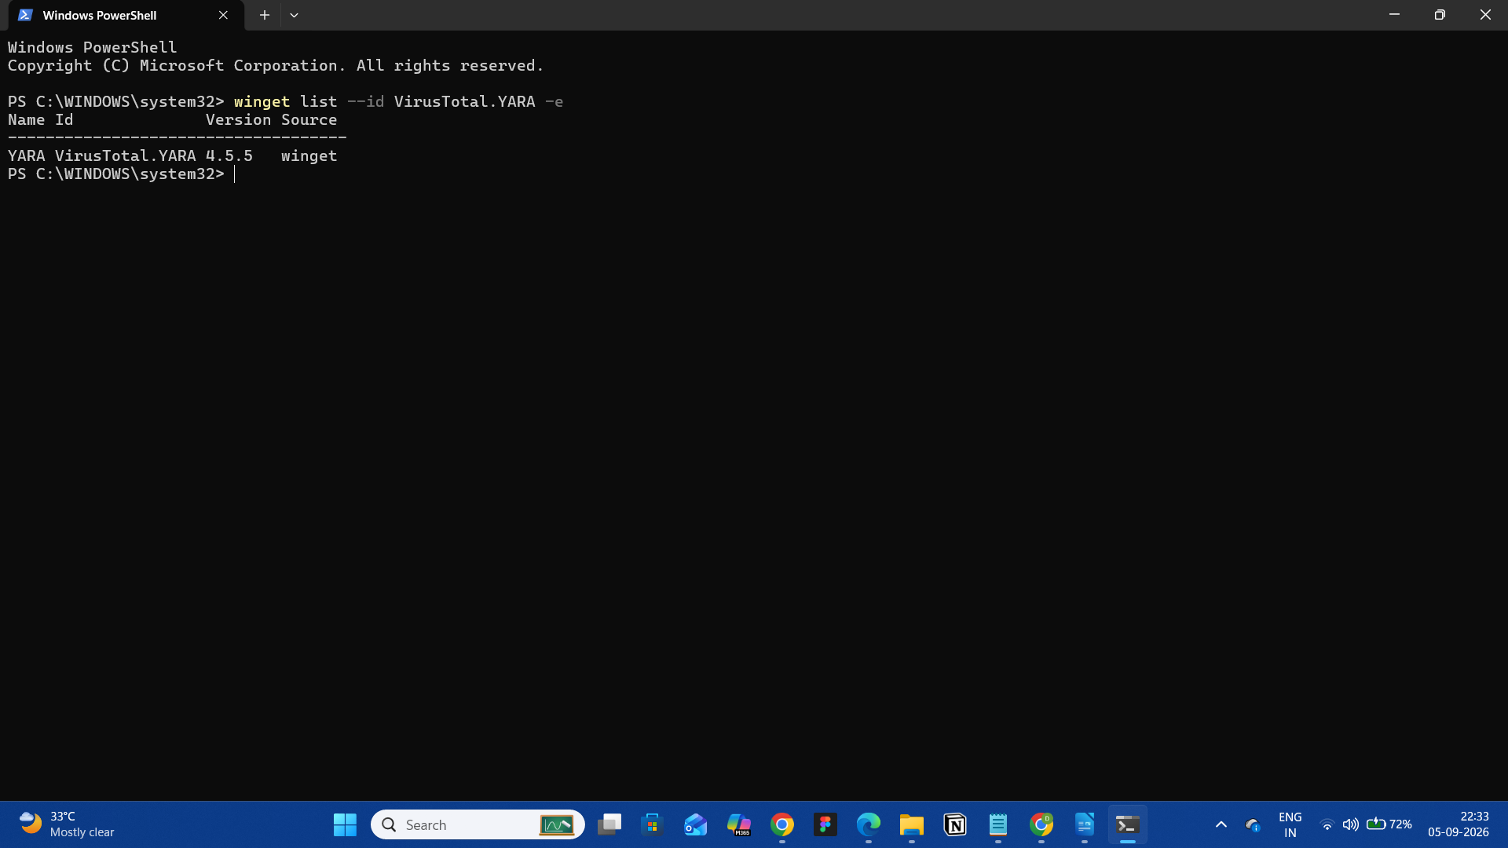

Figure 21.1: YARA Package Verification
Command:
winget list --id VirusTotal.YARA -e
Purpose:
This screenshot demonstrates that the YARA package was recognized as installed on the Windows system.
Observation:
The command displayed the installed YARA package and its version.

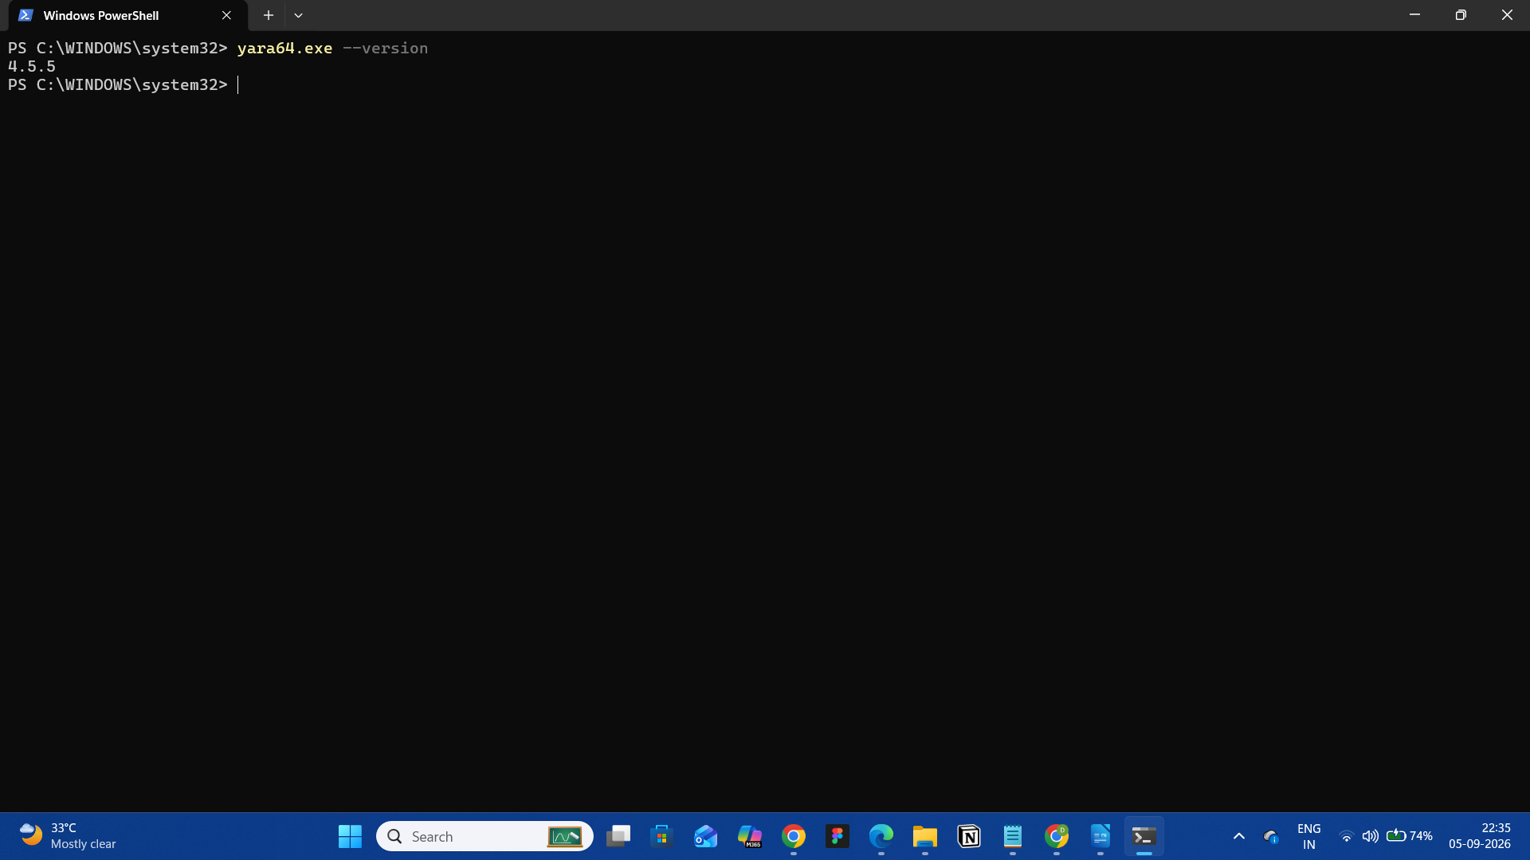

Figure 21.2: YARA Executable Validation
Command:
yara64.exe
Purpose:
To verify that the YARA executable can be executed successfully.
Observation:
YARA displayed its command-line usage information, confirming that the executable was functioning.

19.2 Project Directory Structure
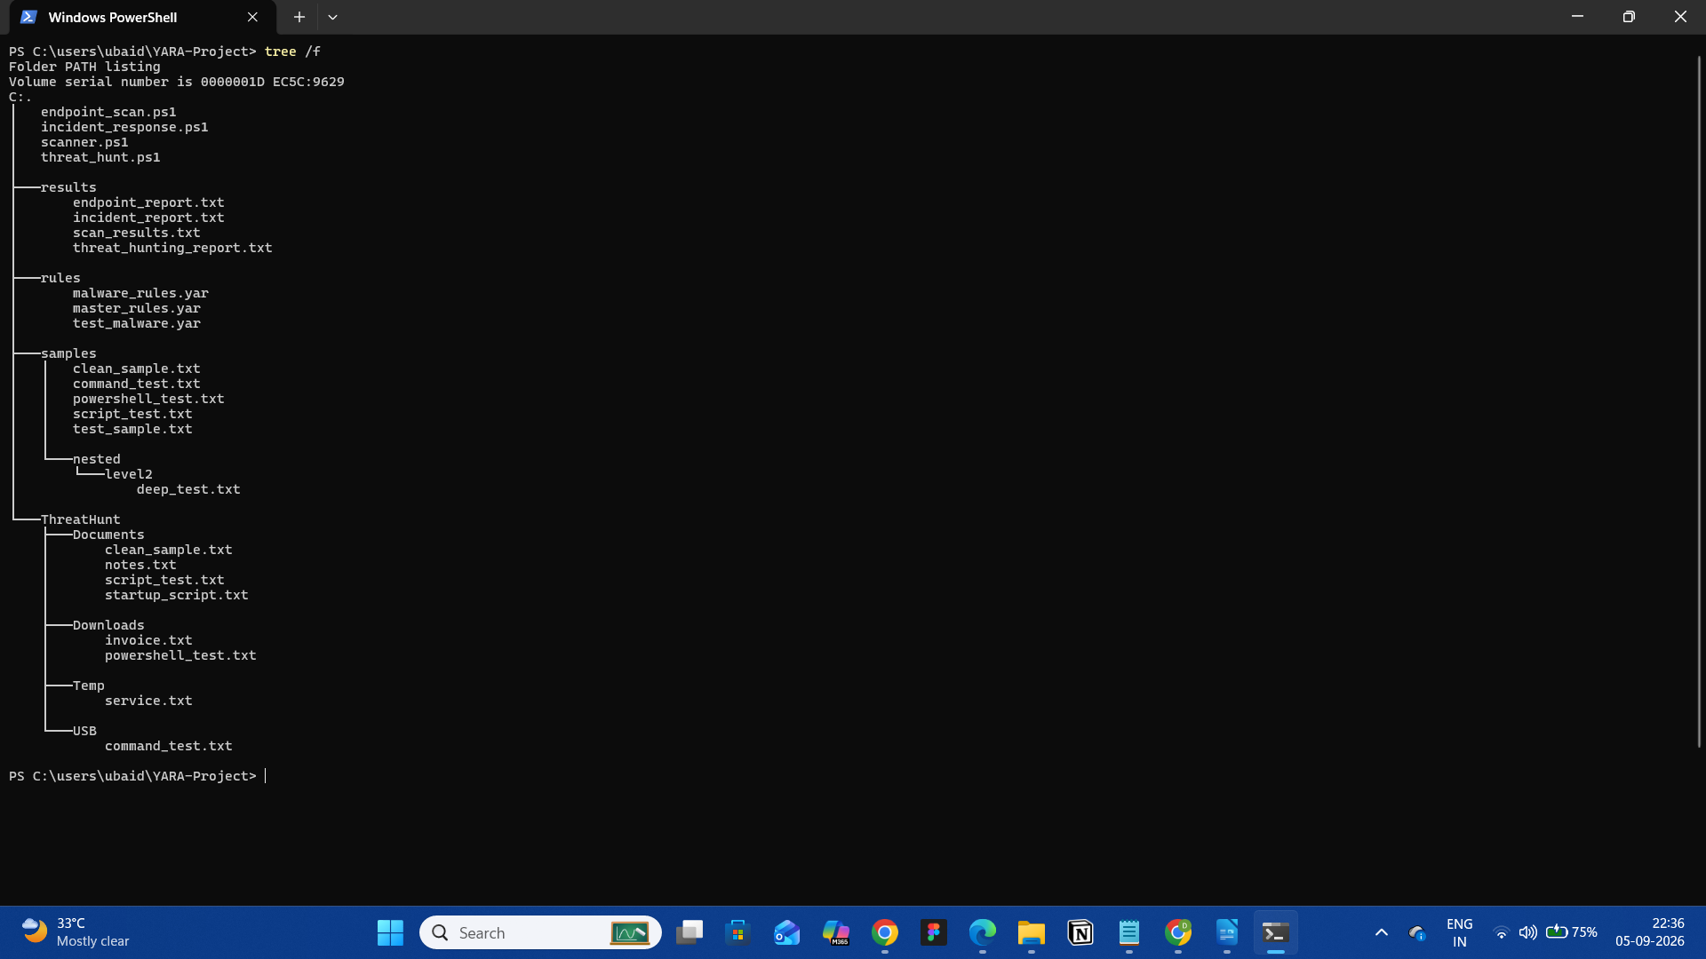

Figure 21.3: Project Directory Structure
Command:
tree /F
Purpose:
To display the complete organization of the project.
Observation:
The project contains separate directories for rules, samples, threat-hunting data, results, and PowerShell scripts.
The structure includes:
YARA-Project
├── rules
├── samples
├── ThreatHunt
├── results
├── scanner.ps1
├── endpoint_scan.ps1
├── incident_response.ps1
└── threat_hunt.ps1

19.3 YARA Rule Evidence
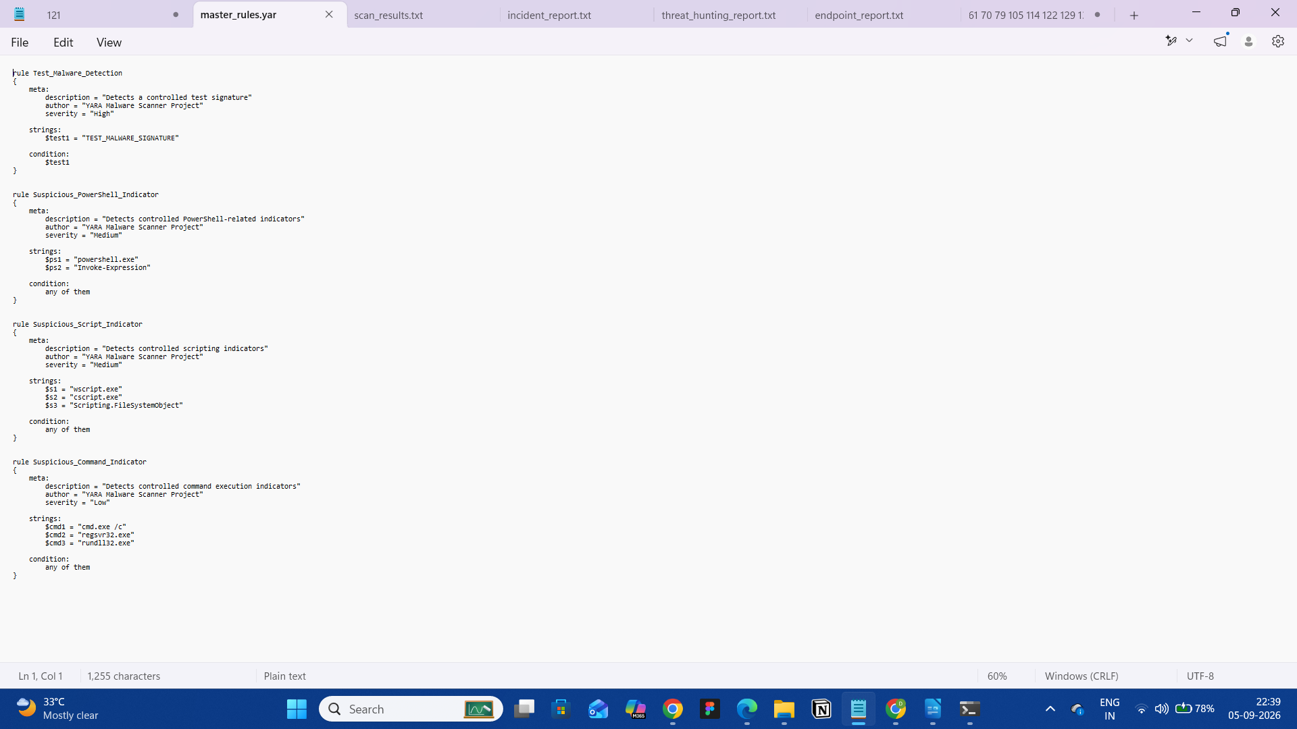

Figure 21.4: Custom YARA Rules
Evidence:
Screenshot of the YARA rule file opened in the text editor.
Purpose:
To demonstrate the customized rule definitions used by the scanner.
Observation:
The rule file contains detection logic for the controlled indicators used during testing.

19.4 Individual File Detection
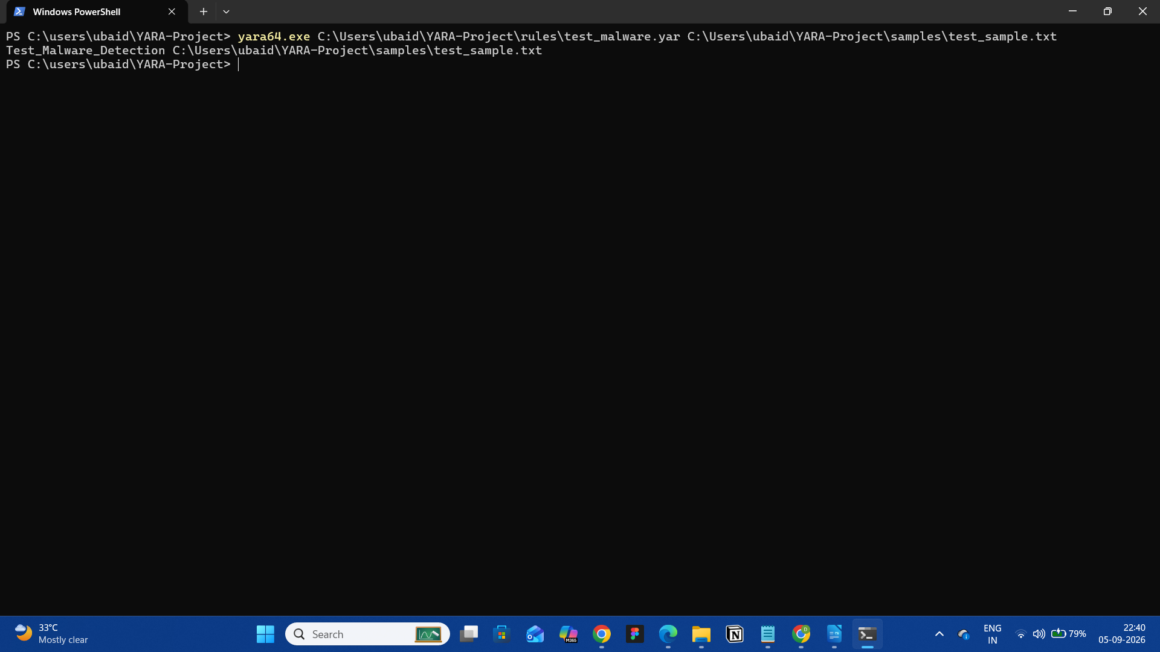

Figure 21.5: Basic YARA Detection
Command:
yara64.exe C:\Users\ubaid\YARA-Project\rules\test_malware.yar C:\Users\ubaid\YARA-Project\samples\test_sample.txt
Observed Result:
Test_Malware_Detection
Purpose:
To verify that a YARA rule successfully detects its corresponding controlled test indicator.
Result:
PASS

19.5 Clean File Validation
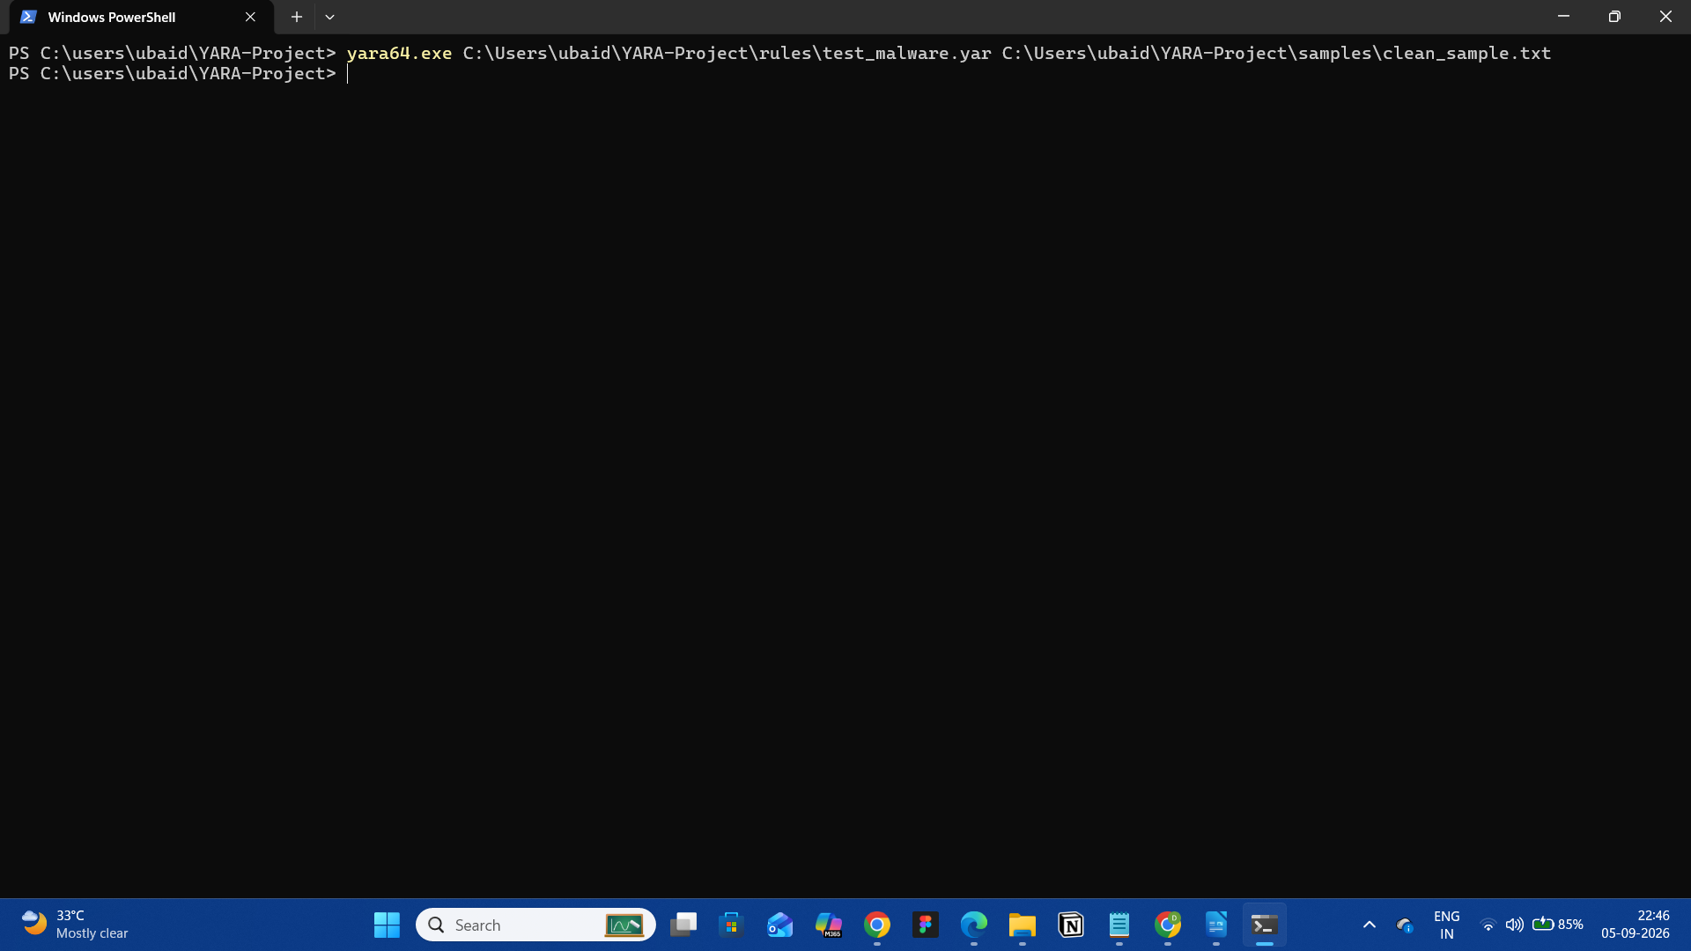

Figure 21.6: Clean File Test
Test File:
clean_sample.txt
Purpose:
To verify that a clean test artifact does not generate a YARA match.
Observed Result:
No rule match was returned.
Result:
PASS

19.6 Individual Detection Rules
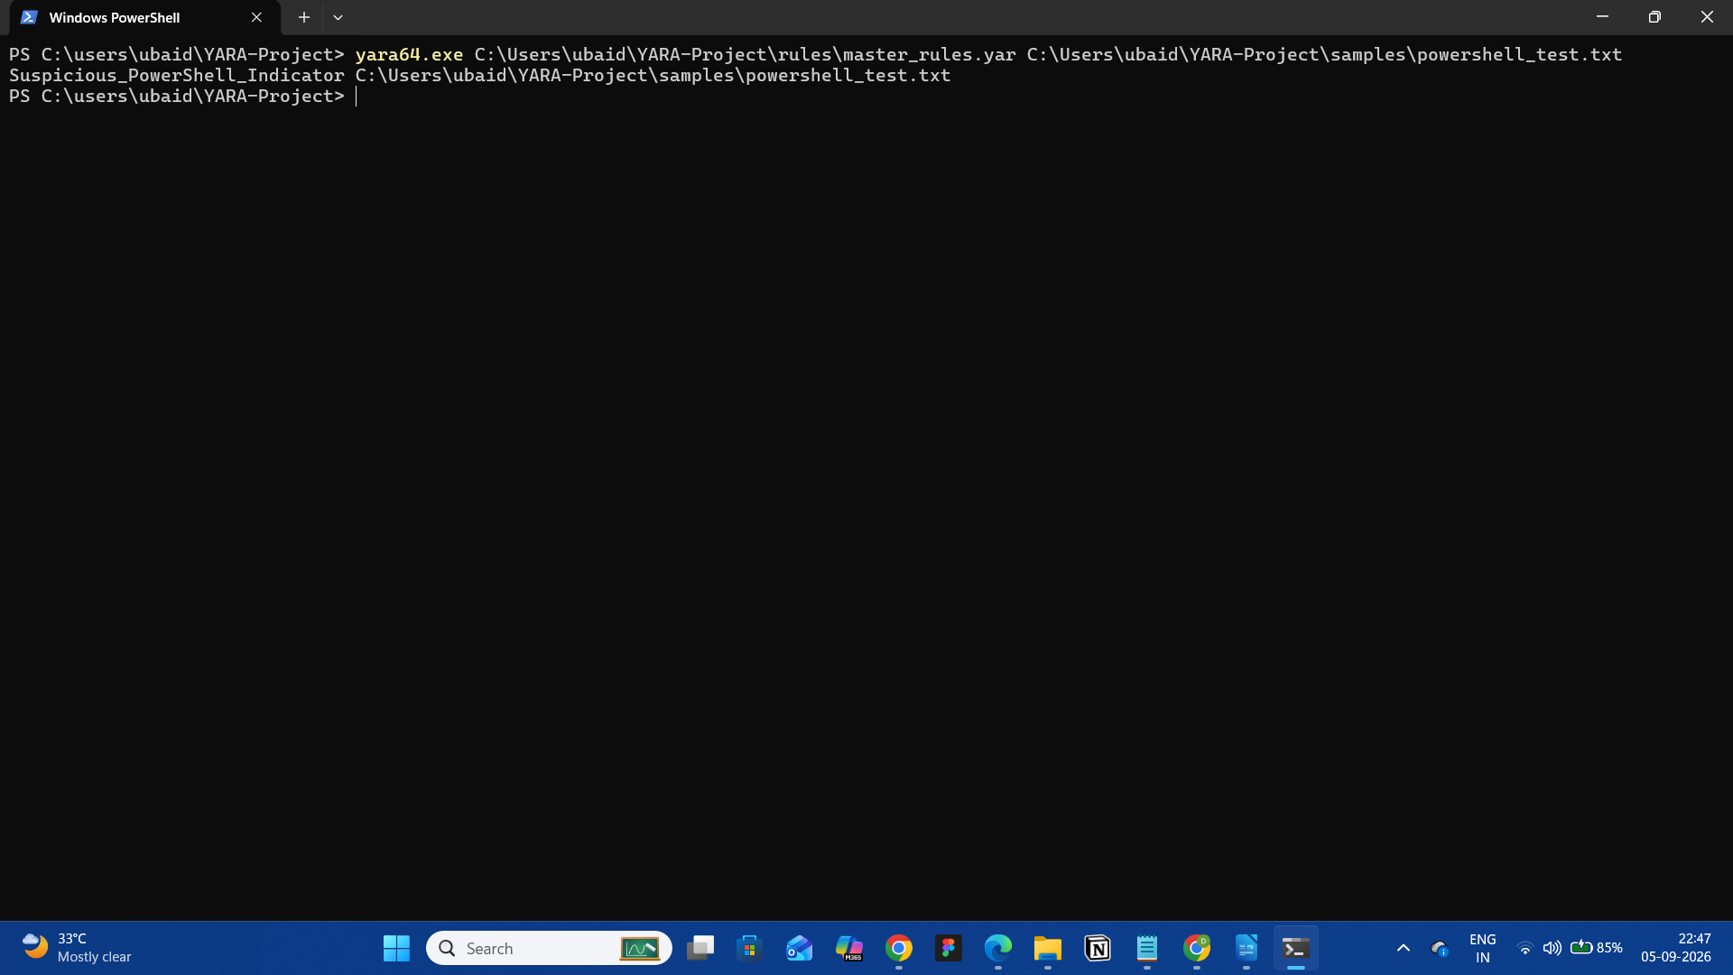

Figure 21.7: PowerShell Indicator Detection
Observed Rule:
Suspicious_PowerShell_Indicator
Test File:
powershell_test.txt
Result:
PASS
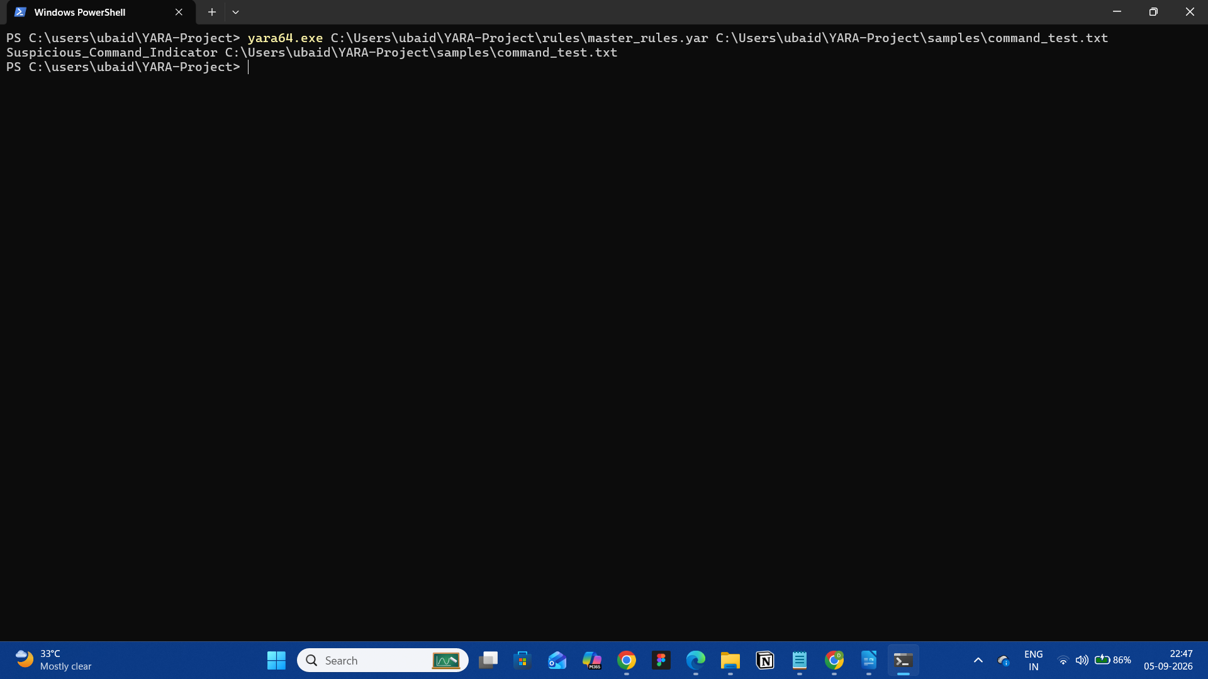

Figure 21.8: Command Indicator Detection
Observed Rule:
Suspicious_Command_Indicator
Test File:
command_test.txt
Result:
PASS

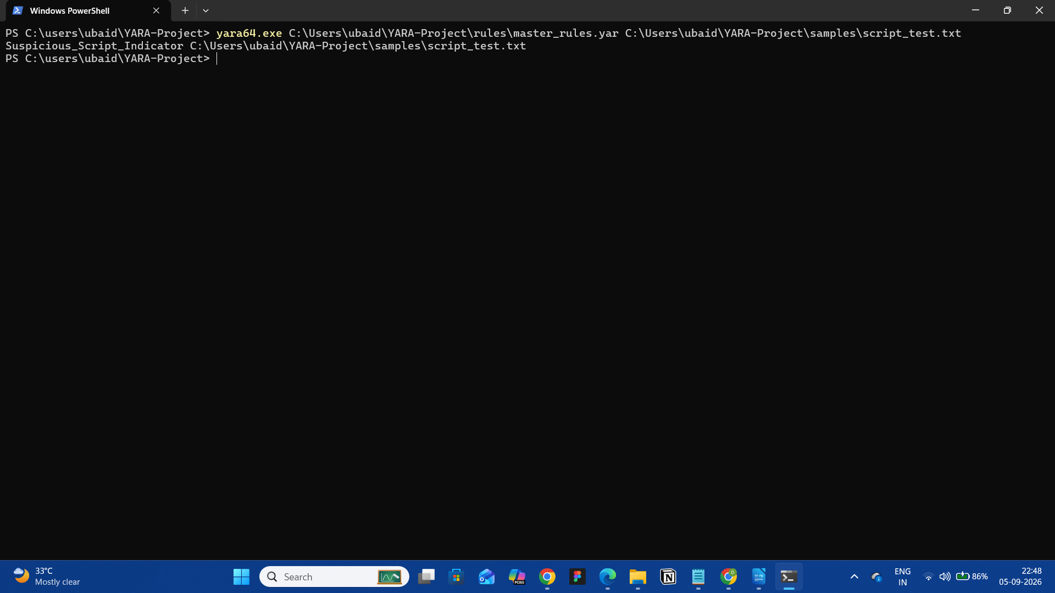

Figure 21.9: Script Indicator Detection
Observed Rule:
Suspicious_Script_Indicator
Test File:
script_test.txt
Result:
PASS

19.7 Recursive Scanning Evidence
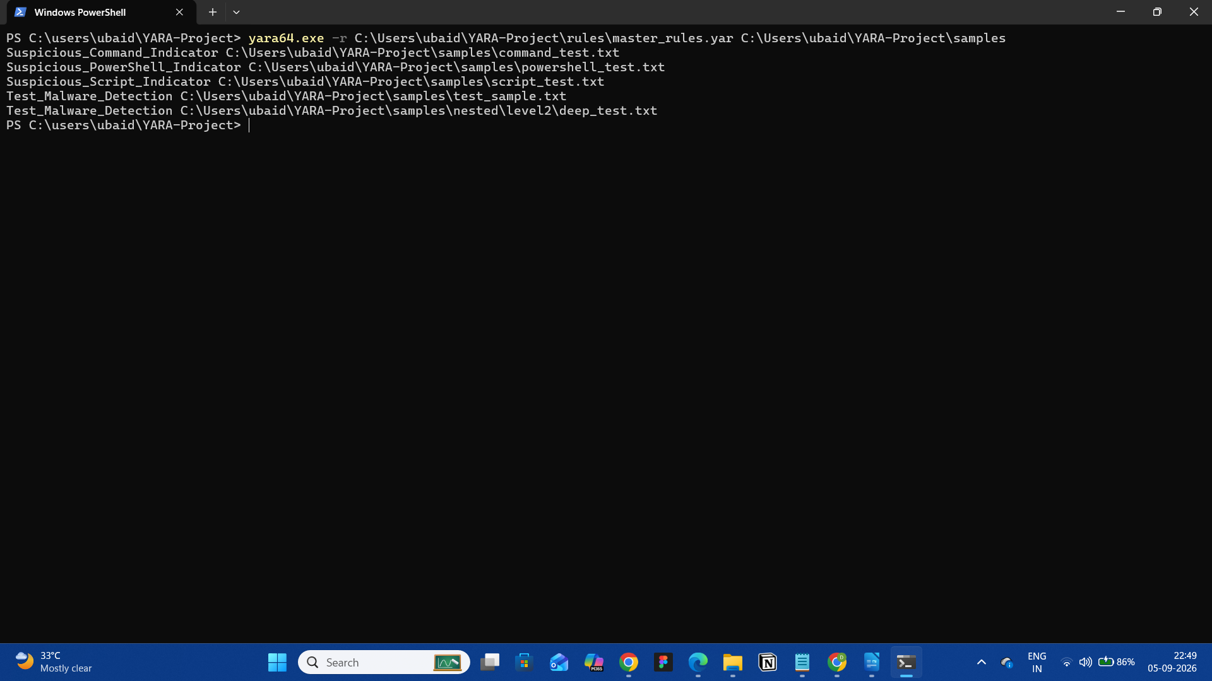

Figure 21.10: Recursive Directory Scan
Command:
yara64.exe -r C:\Users\ubaid\YARA-Project\rules\master_rules.yar C:\Users\ubaid\YARA-Project\samples
Purpose:
To demonstrate scanning of the target directory and its nested subdirectories.
Observed Result:
Test_Malware_Detection C:\Users\ubaid\YARA-Project\samples\nested\level2\deep_test.txt
Result:
PASS
This confirms that the scanner successfully detected a controlled test artifact located several directory levels below the main scanning location.

19.8 Automated Scanner Evidence
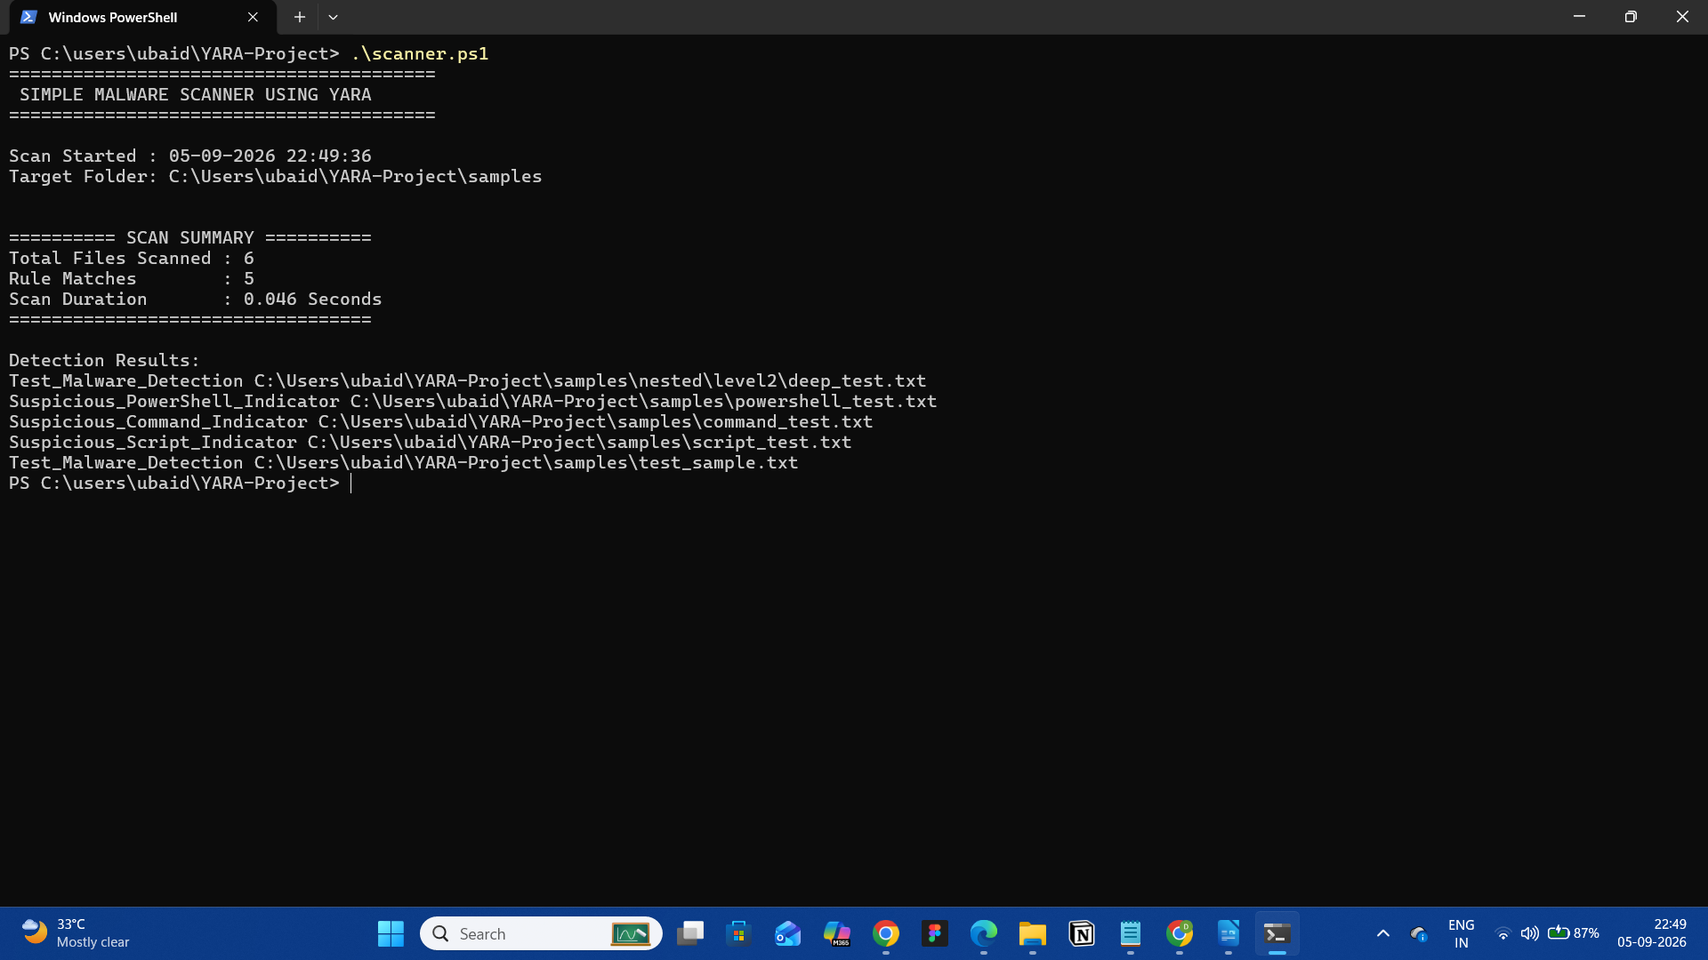

Figure 21.11: PowerShell Scanner Execution
Command:
.\scanner.ps1
Purpose:
To demonstrate execution of the automated malware scanner.
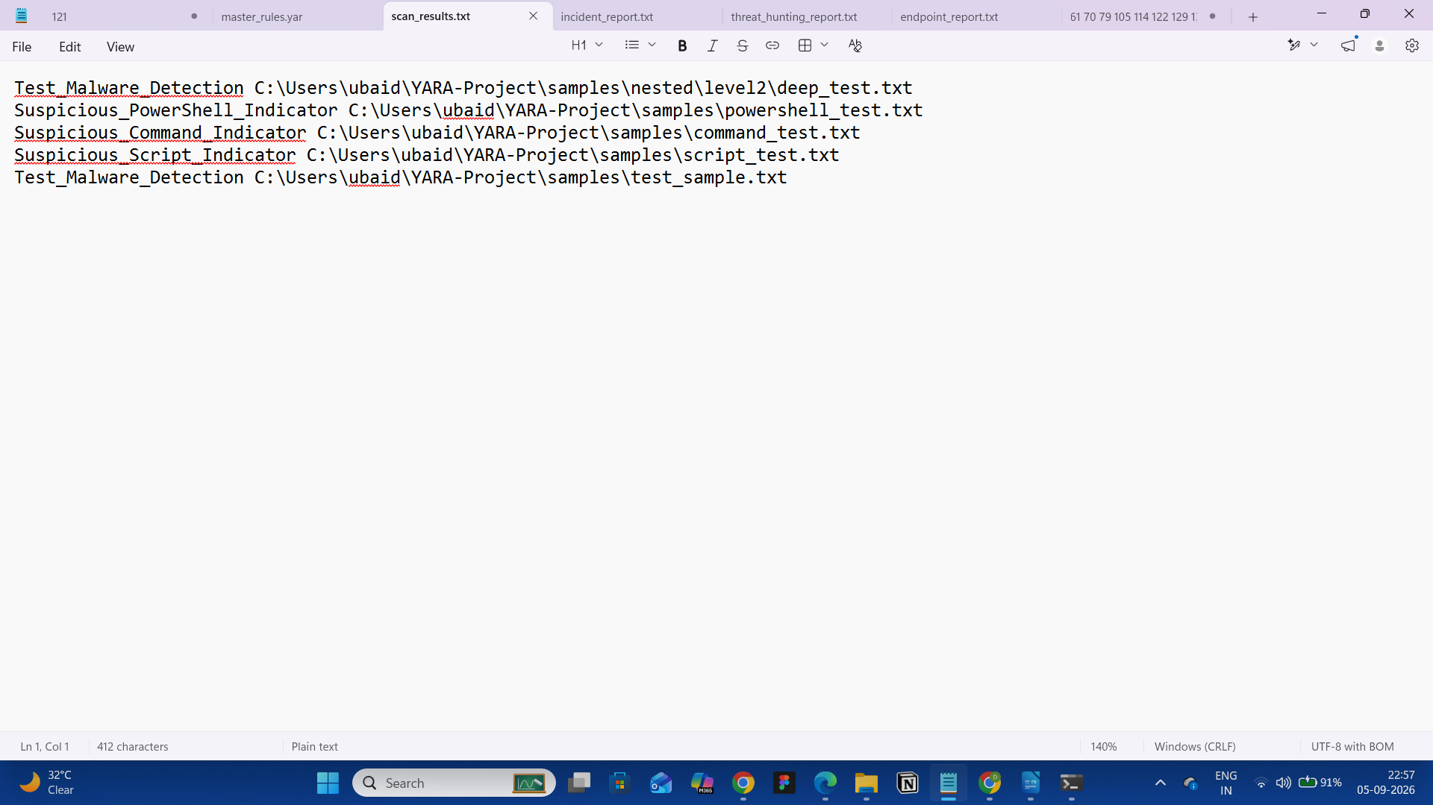

Figure 21.12: Final Scanner Summary
Observed Result:
Total Files Scanned : 6
Rule Matches : 5
Scan Duration : 0.056 Seconds
Purpose:
To demonstrate the final scanning statistics generated by the project.
Result:
PASS

19.9 Endpoint Scanning Evidence
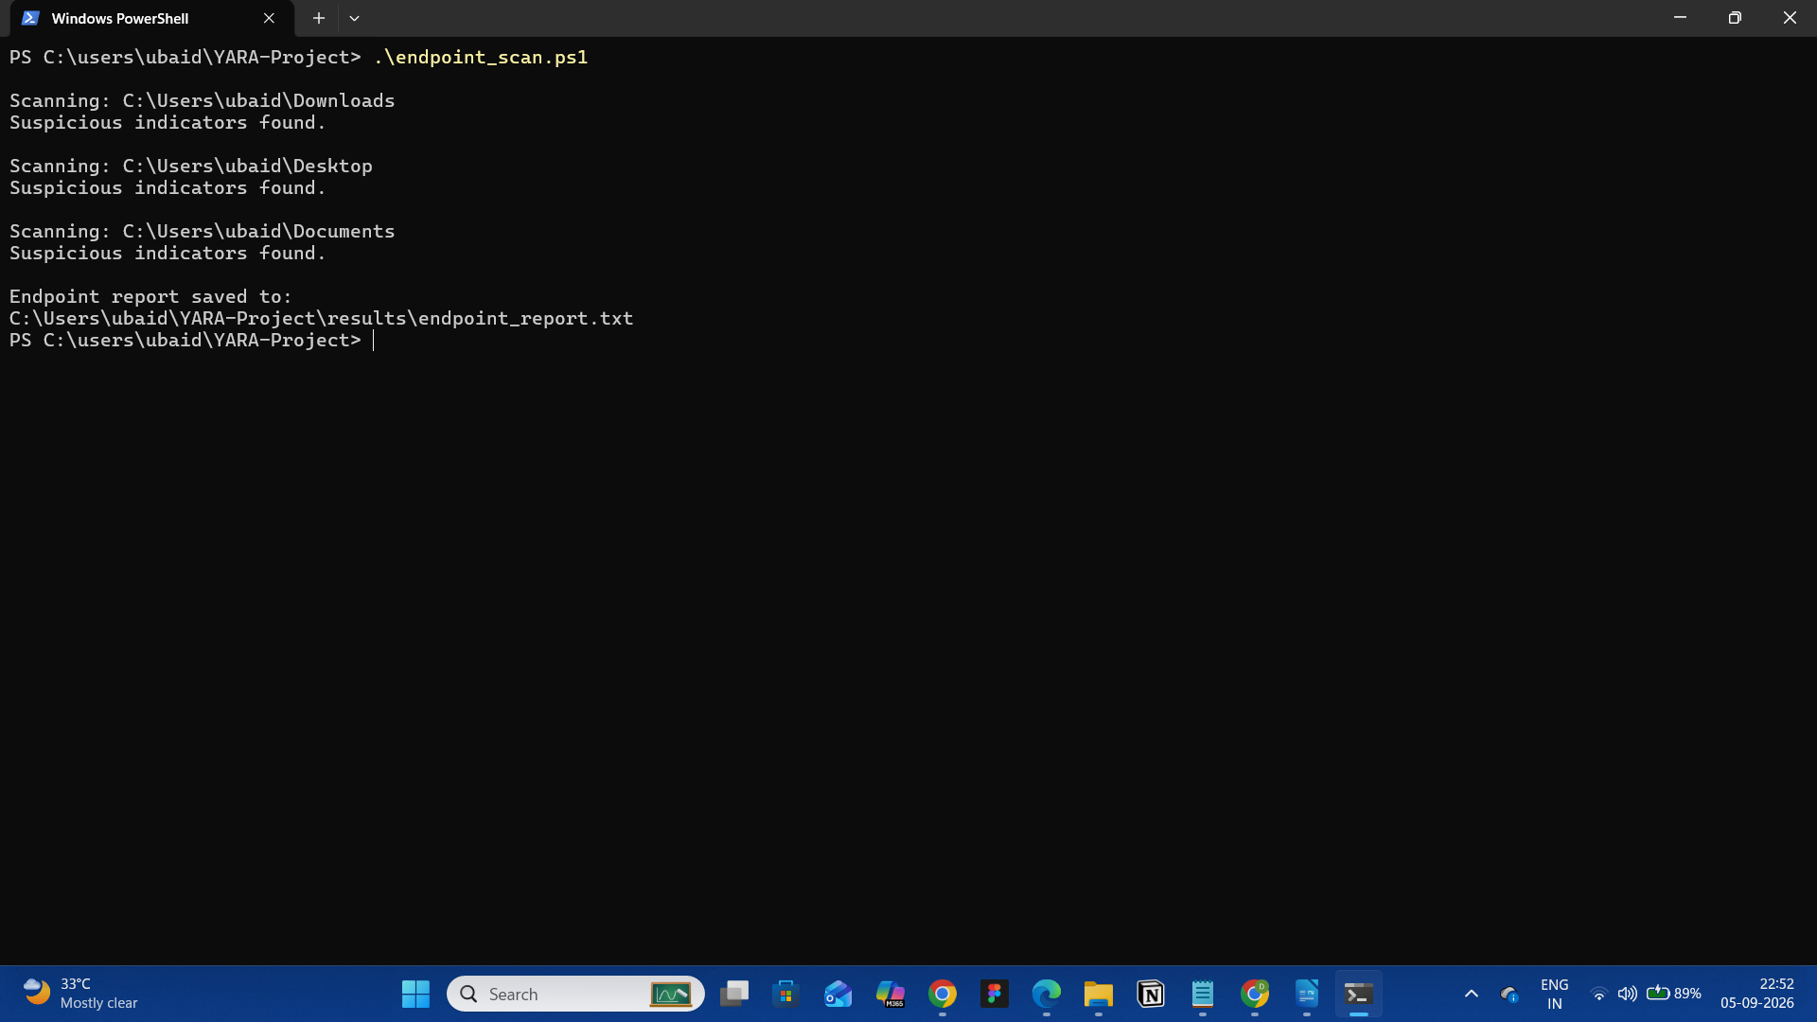

Figure 21.13: Endpoint Scanner Execution
Command:
.\endpoint_scan.ps1
Purpose:
To demonstrate scanning of selected endpoint directories.
Observed Locations:
Downloads
Desktop
Documents
Observed Result:
Suspicious indicators found.
Report Generated:
endpoint_report.txt
Result:
PASS

19.10 Threat Hunting Evidence
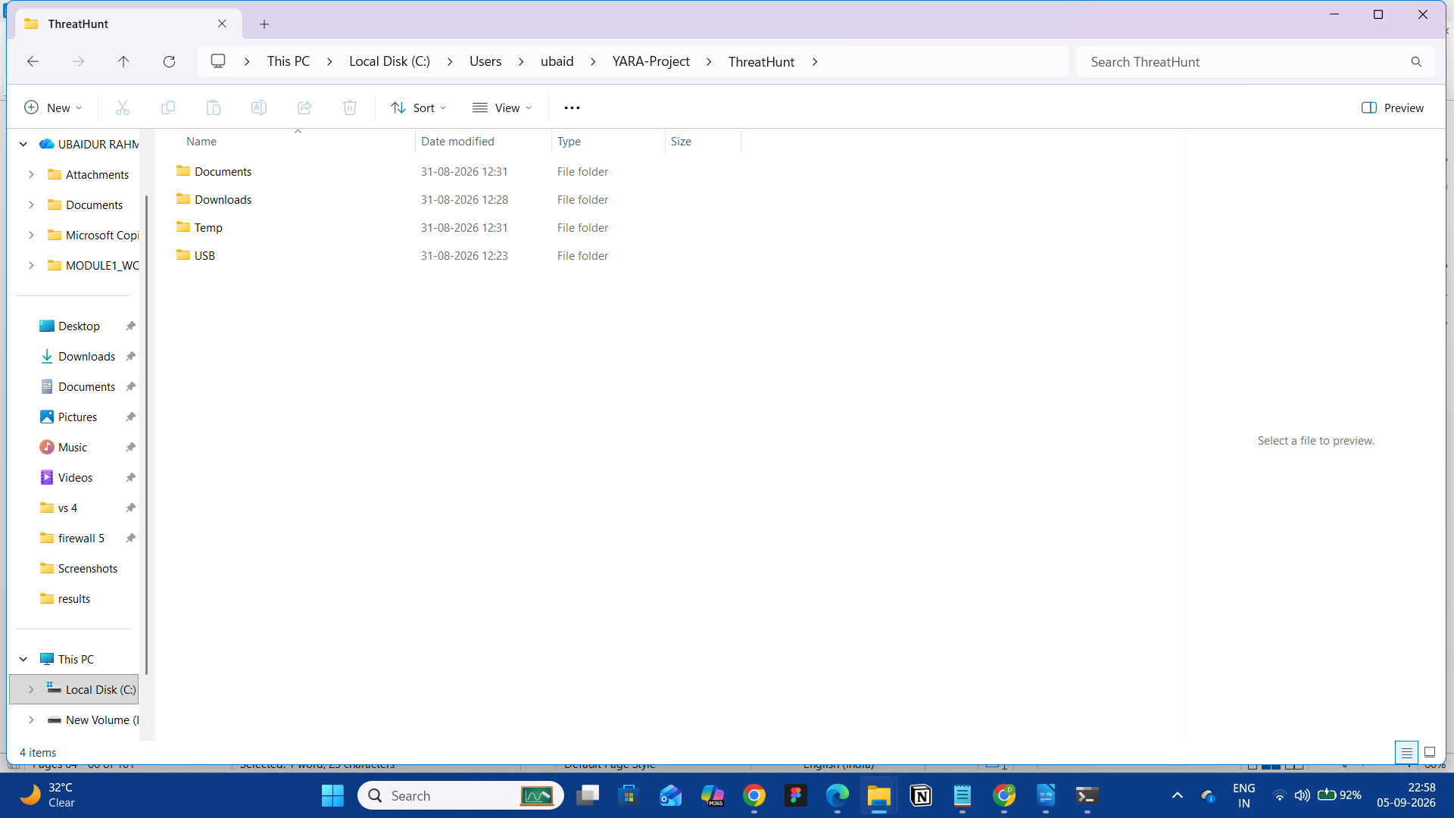

Figure 21.14: Threat Hunting Directory
Directory:
ThreatHunt
├── Documents
├── Downloads
├── Temp
└── USB
Purpose:
To demonstrate the simulated locations used for the threat-hunting exercise.
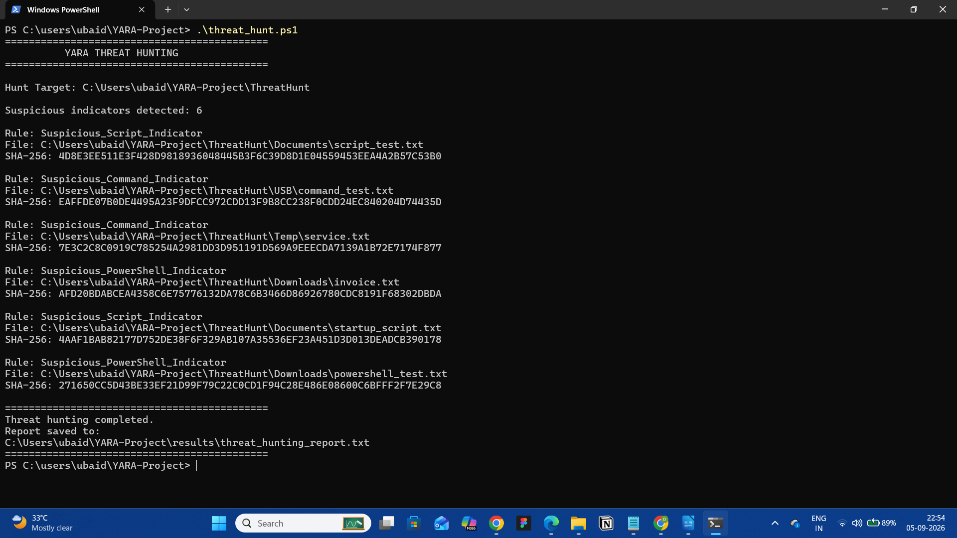

Figure 21.15: Threat Hunting Execution
Evidence:
Screenshot showing execution of:
.\threat_hunt.ps1
Purpose:
To demonstrate recursive searching of the designated threat-hunting environment.
Report Generated:
threat_hunting_report.txt
Result:
PASS

19.11 Incident Response Evidence
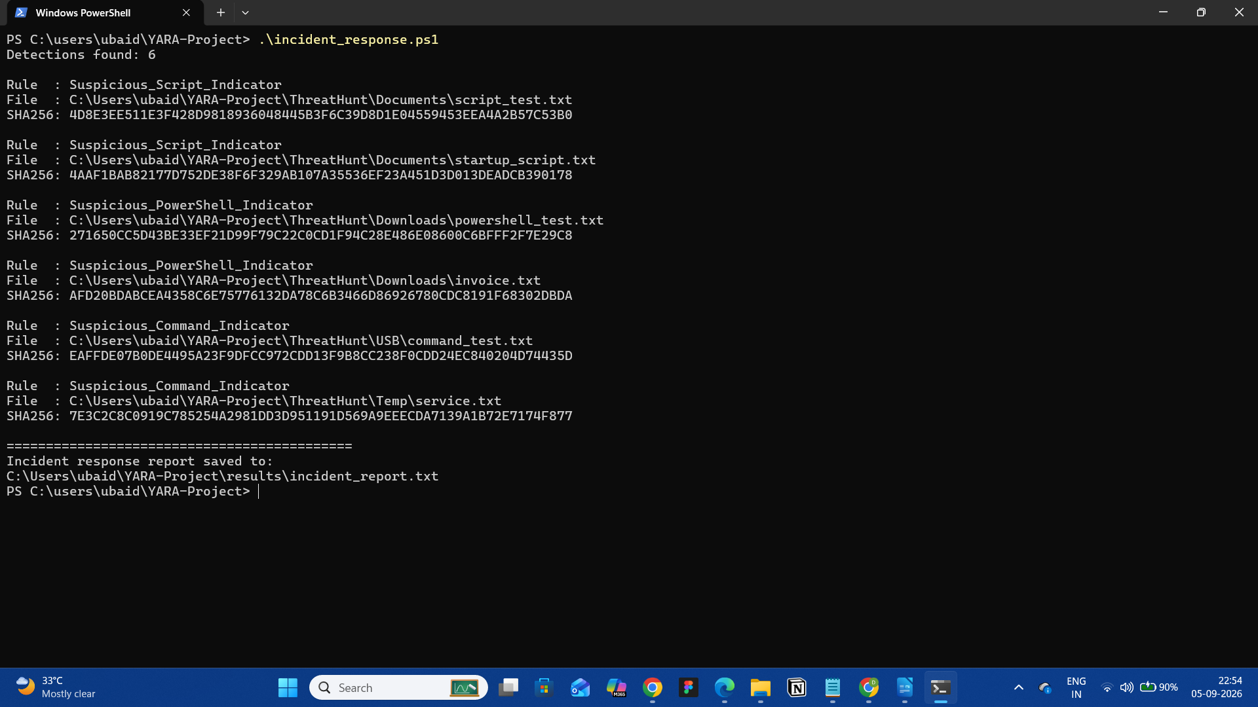

Figure 21.16: Incident Response Execution
Evidence:
Screenshot showing execution of:
.\incident_response.ps1
Purpose:
To demonstrate the incident-response evidence collection workflow.
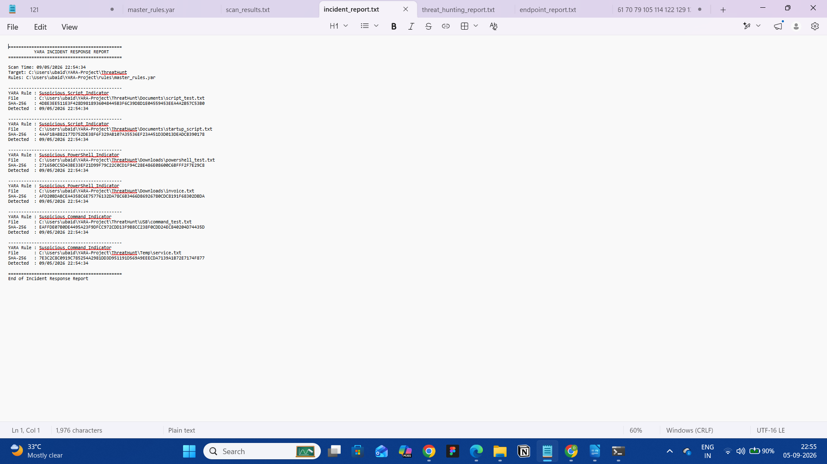

Figure 21.17: Incident Response Report
Report:
incident_report.txt
The report records information associated with detected artifacts, including relevant file information and SHA-256 evidence.
Result:
PASS

19.12 Generated Reports
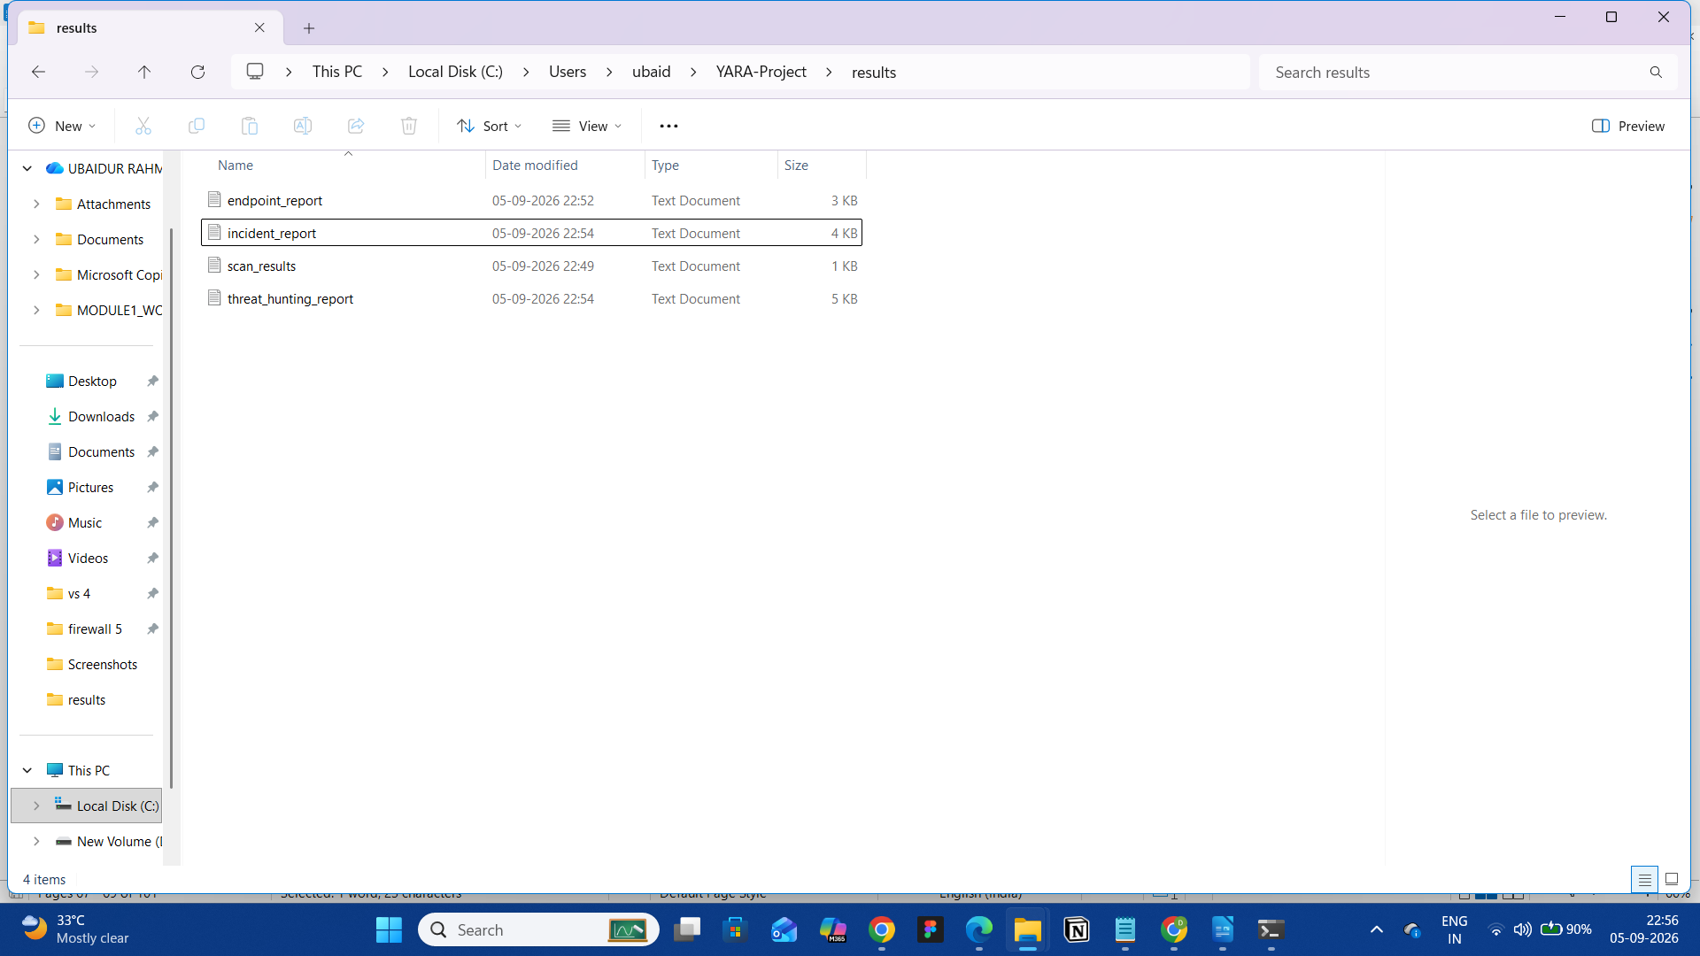

Figure 21.18: Results Directory
The results directory contains:
results
├── endpoint_report.txt
├── incident_report.txt
├── scan_results.txt
└── threat_hunting_report.txt
Purpose:
To demonstrate that the project successfully generates persistent output reports for its different security functions.
Result:
PASS

19.13 Evidence Summary
The screenshots and supporting evidence demonstrate the following completed functions:
Evidence | Function | Status
YARA package verification | Installation | PASS
YARA executable output | Validation | PASS
YARA rule screenshot | Rule development | PASS
Individual detection | Basic scanning | PASS
Clean sample | Negative testing | PASS
Recursive scan | Recursive detection | PASS
Scanner output | Automation | PASS
Endpoint output | Endpoint scanning | PASS
Threat-hunting output | Threat hunting | PASS
Incident report | Incident response | PASS
Results directory | Report generation | PASS
The collected evidence provides visual confirmation of the major implementation and testing activities performed during the project.

19.14 Evidence Handling Note
The screenshots and reports included in this project document results obtained from a controlled laboratory environment.
The test artifacts were specifically created to trigger the configured YARA rules. A YARA match indicates that a rule condition was satisfied; it does not independently establish that the matched artifact is malicious.
For real-world investigations, YARA detections should be validated using additional analysis and appropriate security investigation procedures.

20. ADVANTAGES OF THE PROPOSED SYSTEM
The Simple Malware Scanner Using YARA provides a lightweight and customizable approach to file-based threat detection. By combining YARA's pattern-matching capabilities with PowerShell automation, the proposed system provides a practical solution for controlled malware-analysis, endpoint-scanning, and threat-hunting activities.
The major advantages of the proposed system are described below.

20.1 Lightweight Detection
YARA is a lightweight detection engine that can be executed from the command line without requiring a large security-management platform.
This makes the proposed system suitable for:
- Cybersecurity laboratories.
- Malware-analysis exercises.
- Security testing environments.
- Small-scale file investigations.
- Educational demonstrations.
The project demonstrated rapid scanning of the controlled test dataset, completing the final six-file scan in approximately 0.056 seconds.

20.2 Customizable Detection Rules
One of the primary advantages of YARA is the ability to create customized detection rules.
The project includes rules for controlled indicators such as:
Suspicious_PowerShell_Indicator
Suspicious_Command_Indicator
Suspicious_Script_Indicator
Test_Malware_Detection
Security analysts can modify existing rules or create new rules when additional indicators need to be investigated.

20.3 Recursive Directory Scanning
The proposed system supports recursive scanning of directories.
The project demonstrated this capability using a nested test artifact:
samples
└── nested
└── level2
└── deep_test.txt
The scanner successfully identified the matching indicator within the nested directory.
This capability is useful when files may be distributed across multiple directory levels.

20.4 Automation Using PowerShell
PowerShell was used to automate repetitive scanning and security-analysis tasks.
The project contains:
scanner.ps1
endpoint_scan.ps1
threat_hunt.ps1
incident_response.ps1
Automation reduces manual effort and provides a consistent procedure for executing security tasks.

20.5 File-Level Visibility
The scanner reports the YARA rule that matched together with the associated file path.
For example:
Suspicious_PowerShell_Indicator
C:\Users\ubaid\YARA-Project\samples\powershell_test.txt
This provides analysts with useful information about where the configured indicator was identified.

20.6 Support for Endpoint Security Activities
The endpoint scanning component allows the same YARA detection mechanism to be applied to selected endpoint directories.
The project demonstrated scanning of locations such as:
Downloads
Desktop
Documents
This provides a basic additional security layer for file inspection.

20.7 Threat Hunting Capability
The proposed system can be used as a basic threat-hunting tool by applying YARA rules to selected locations.
The project created a simulated threat-hunting environment containing:
ThreatHunt
├── Documents
├── Downloads
├── Temp
└── USB
The threat-hunting script recursively searches these locations for configured indicators.

20.8 Incident Response Support
The system provides basic support for incident-response activities.
When a relevant artifact is identified, information such as the file path, detection rule, timestamp, and SHA-256 hash can be recorded.
This helps maintain useful investigation information for further analysis.

20.9 Automated Report Generation
The proposed system generates reports for different security activities.
The project produces:
endpoint_report.txt
incident_report.txt
scan_results.txt
threat_hunting_report.txt
Automated report generation improves documentation and allows security results to be reviewed after scanning has completed.

20.10 Easy to Extend
The proposed architecture allows additional YARA rules and scanning functions to be added without completely redesigning the system.
For example, future versions could include:
- Additional YARA rule categories.
- File-type-specific rules.
- Hash-based indicators.
- Automated scheduling.
- Centralized logging.
- Additional endpoint locations.
- Integration with security monitoring systems.

20.11 Educational Value
The project provides practical experience with several cybersecurity concepts, including:
- Malware detection.
- Signature and pattern-based analysis.
- YARA rule development.
- PowerShell scripting.
- Recursive file scanning.
- Threat hunting.
- Incident response.
- File hashing.
- Security reporting.
This makes the system particularly useful as a cybersecurity training and laboratory project.

20.12 Cost-Effective Approach
The proposed system uses lightweight tools and locally maintained rules rather than requiring an expensive enterprise security platform.
This makes it suitable for learning environments and proof-of-concept implementations where resources may be limited.

20.13 Overall Advantage
The major advantage of the proposed system is the combination of customizable YARA detection with PowerShell automation.
The project demonstrates that a relatively simple architecture can provide multiple security capabilities, including:
YARA Rules
↓
File Scanning
↓
Recursive Detection
↓
Endpoint Scanning
↓
Threat Hunting
↓
Incident Response
↓
Report Generation
Therefore, the proposed system provides a practical foundation for learning and demonstrating rule-based malware detection and security-analysis workflows.

21. LIMITATIONS
Although the Simple Malware Scanner Using YARA successfully demonstrates rule-based file detection, the proposed system has several limitations. Understanding these limitations is important when evaluating the system's effectiveness and considering its use in real-world security environments.

21.1 Dependence on YARA Rules
The effectiveness of the scanner depends heavily on the quality and coverage of its YARA rules.
If a suspicious file does not contain characteristics represented by the configured rules, the scanner may not identify it.
Therefore, the rule set must be regularly reviewed, tested, and updated.

21.2 Possible False Positives
YARA rules may match legitimate files when those files contain strings or patterns that satisfy the rule conditions.
For this reason, a YARA match should be treated as an indicator requiring further investigation rather than automatic proof that a file is malicious.

21.3 Possible False Negatives
The scanner may fail to identify a malicious artifact when its characteristics are not represented in the available rules.
Sophisticated or previously unknown threats may therefore require additional detection and analysis techniques.

21.4 Limited Test Dataset
The project was evaluated using a small controlled dataset.
The final scanner test processed:
Total Files Scanned : 6
Rule Matches : 5
The measured duration was:
Scan Duration : 0.056 Seconds
These results demonstrate successful operation within the project environment but should not be considered an enterprise-scale performance benchmark.

21.5 No Real-Time Monitoring
The current implementation performs scanning when the scripts are executed.
It does not continuously monitor file-system activity for newly created, modified, or downloaded files.
Real-time monitoring would require additional system-monitoring functionality.

21.6 No Behavioral Analysis
The proposed system primarily performs rule-based file analysis.
It does not independently monitor runtime behavior such as:
- Process execution.
- Network communication.
- Registry modifications.
- Memory activity.
- Persistence mechanisms.
- Runtime system changes.
Consequently, behavioral analysis would require additional security technologies.

21.7 No Automatic Quarantine or Removal
The current scanner reports matching files but does not automatically delete or quarantine them.
This is appropriate for the project's controlled environment because automatic removal could result in accidental modification or deletion of legitimate files.
A production implementation could introduce controlled remediation after appropriate analyst validation.

21.8 Limited Enterprise Management
The project is designed as a local proof-of-concept and does not include centralized management capabilities.
It does not currently provide:
- Centralized endpoint administration.
- Multi-system deployment.
- Centralized rule management.
- Enterprise dashboards.
- Distributed scanning.
- Role-based security administration.

21.9 Limited Security Monitoring Integration
The current implementation generates local text reports.
It does not directly integrate with enterprise security platforms such as SIEM, EDR, SOAR, or centralized log-management systems.
Such integrations would improve monitoring and incident correlation in larger environments.

21.10 Manual Rule Maintenance
Although the scanner automates execution, YARA rules currently require manual creation and maintenance.
Security analysts must review new indicators and update the rules accordingly.
Poorly designed rules may reduce detection accuracy or increase false positives.

21.11 Limited File Analysis
The project focuses primarily on identifying configured indicators within files.
It does not provide comprehensive static malware analysis capabilities such as:
- Portable Executable structure analysis.
- Disassembly.
- Reverse engineering.
- Automated sandbox execution.
- Advanced memory analysis.
These activities require specialized malware-analysis tools.

21.12 Controlled Laboratory Environment
The test artifacts used in this project were intentionally created or selected to trigger the configured rules.
Therefore, the demonstrated detections represent controlled testing rather than evidence of infections on a production system.
The project should be evaluated as a cybersecurity proof-of-concept and educational implementation.

21.13 Overall Limitation Assessment
The proposed system provides useful rule-based detection and automation capabilities, but it should not be considered a complete standalone malware-defense platform.
Its effectiveness can be improved by combining YARA with additional security controls such as endpoint monitoring, behavioral analysis, antivirus/EDR solutions, centralized logging, and continuous threat-intelligence updates.
The limitations identified in this chapter also provide the basis for the future enhancements discussed in the next chapter.

22. FUTURE ENHANCEMENTS
The current Simple Malware Scanner Using YARA provides a functional proof-of-concept for rule-based file detection, endpoint scanning, threat hunting, and basic incident-response activities. The system can be further enhanced to improve automation, detection capability, scalability, usability, and integration with other cybersecurity technologies.
The following enhancements are proposed for future versions of the project.

22.1 Real-Time File Monitoring
The scanner could be enhanced to continuously monitor selected directories for newly created or modified files.
When a new file is detected, the system could automatically submit it to the YARA scanning engine.
A possible workflow would be:
File Created/Modified
↓
File-System Monitor
↓
YARA Scanner
↓
Rule Matching
↓
Alert Generation
This would provide faster identification of suspicious artifacts without requiring the user to manually start a scan.

22.2 Scheduled Scanning
The project could be integrated with Windows Task Scheduler to perform scans automatically at predefined intervals.
For example:
- Daily scans.
- Weekly scans.
- Startup scans.
- Scheduled threat-hunting scans.
This would reduce the dependency on manual execution.

22.3 Expanded YARA Rule Library
The current project uses a relatively small set of customized rules.
Future versions could include a larger collection of carefully validated rules covering:
- Malware families.
- Suspicious scripts.
- Command-line indicators.
- Persistence mechanisms.
- Ransomware indicators.
- Credential-theft indicators.
- Web-shell indicators.
- Suspicious document characteristics.
A larger and better-maintained rule library would improve detection coverage.

22.4 Automated Rule Management
A future version could provide mechanisms for updating YARA rules from a trusted internal rule repository.
The system could periodically check for updated rules and deploy them after validation.
A validation stage should be included before activating new rules to reduce the risk of malformed rules or unexpected detections.

22.5 Graphical User Interface
The current project primarily uses PowerShell and command-line execution.
A graphical user interface could make the scanner easier to operate.
Possible GUI features include:
- Folder selection.
- Scan button.
- Progress indicator.
- Detection summary.
- Rule-match details.
- Scan history.
- Report viewer.
- Hash information.

22.6 Advanced File Hashing
The current project uses SHA-256 for evidence collection.
Future versions could calculate and compare multiple hashes, such as:
- SHA-256.
- SHA-1.
- MD5.
Hash values could be used as additional indicators for identifying previously analyzed files.
SHA-256 should remain the preferred modern cryptographic hash for integrity and evidence documentation.

22.7 Integration with Threat Intelligence
Future versions could integrate with approved threat-intelligence sources.
A detected file hash could be compared against known threat indicators to provide additional context.
The workflow could be:
YARA Detection
↓
SHA-256 Calculation
↓
Threat Intelligence Lookup
↓
Additional Context
↓
Analyst Investigation
Such integration would help analysts distinguish between known and previously unidentified artifacts.

22.8 SIEM Integration
The scanner could send detection events to a Security Information and Event Management (SIEM) platform.
Information such as the following could be forwarded:
- Detection rule.
- File path.
- Host information.
- Timestamp.
- SHA-256 hash.
- Severity.
- Investigation status.
This would allow YARA detections to be correlated with other security events.

22.9 EDR Integration
The project could be integrated with Endpoint Detection and Response (EDR) technologies.
YARA detections could provide additional file-level intelligence to an EDR platform, while EDR telemetry could provide behavioral context around the detected artifact.
This would create a more comprehensive detection workflow.

22.10 Automated Alerting
Future versions could generate alerts when suspicious indicators are detected.
Possible notification mechanisms include:
- Email notifications.
- Security dashboards.
- Centralized logging.
- SOC alert systems.
Alerts should contain enough information for analysts to begin an investigation without automatically performing destructive actions.

22.11 Quarantine Capability
A controlled quarantine feature could be introduced in a future version.
Instead of immediately deleting a detected file, the system could move it to a protected quarantine location after analyst approval.
A possible workflow would be:
Detection
↓
Analyst Validation
↓
Quarantine
↓
Hash Preservation
↓
Further Analysis
This approach would reduce the risk of permanently deleting potentially useful investigation evidence.

22.12 Improved Reporting
The current system generates text-based reports.
Future versions could generate more structured reports containing:
- Scan statistics.
- Detection severity.
- Rule names.
- File paths.
- SHA-256 hashes.
- Scan timestamps.
- Host information.
- Investigation status.
Reports could also be generated in formats such as CSV, JSON, HTML, or PDF.

22.13 Centralized Multi-Endpoint Scanning
The current implementation is designed primarily for a single Windows environment.
A future version could support multiple authorized endpoints from a centralized management system.
This would allow security teams to:
- Manage rules centrally.
- Schedule scans.
- Collect detection results.
- Compare endpoint results.
- Monitor multiple systems.

22.14 Improved Detection Correlation
Multiple YARA matches could be correlated to identify patterns across files and endpoints.
For example, repeated detections of the same indicator across multiple systems could receive a higher investigation priority.
This would help transform individual file detections into broader security intelligence.

22.15 Advanced Incident Response Workflow
The existing incident-response functionality could be expanded to include additional evidence collection, investigation tracking, and analyst workflows.
Future versions could record:
- File metadata.
- File hashes.
- Detection rules.
- Process information.
- Network indicators.
- Investigation timestamps.
- Analyst actions.
This would provide a more comprehensive incident-response capability.

22.16 Overall Future Scope
The long-term objective is to evolve the current proof-of-concept into a more complete security-analysis platform.
The proposed evolution can be represented as:
Current Project
↓
YARA + PowerShell
↓
Real-Time Monitoring
↓
Scheduled Scanning
↓
Threat Intelligence
↓
Centralized Reporting
↓
SIEM / EDR Integration
↓
Advanced Security Monitoring
These enhancements would improve the scalability, automation, detection coverage, and operational usefulness of the system while preserving its core YARA-based detection capability.

23. SECURITY CONSIDERATIONS
Security considerations are an important part of developing and operating a malware-detection system. Although the Simple Malware Scanner Using YARA is designed primarily for controlled detection and analysis, the scanner itself must be operated securely to prevent misuse, inaccurate results, loss of evidence, or unintended system changes.
The following security considerations were taken into account during the development and testing of the project.

23.1 Authorized Scanning
The scanner should only be used on systems, directories, and files for which the user has appropriate authorization.
Scanning unauthorized systems or data may violate organizational policies or applicable laws.
For this project, testing was performed within a controlled laboratory environment.

23.2 Controlled Test Artifacts
The project uses controlled test artifacts specifically designed to trigger the configured YARA rules.
These artifacts should not be interpreted as confirmed malware merely because a YARA rule matches them.
A YARA match means that the conditions specified by the rule were satisfied and should be treated as an indicator requiring further analysis.

23.3 Protection of YARA Rules
YARA rules represent detection logic and should be protected from unauthorized modification.
Unauthorized changes could:
- Disable detections.
- Introduce incorrect detection conditions.
- Increase false positives.
- Reduce detection coverage.
Therefore, rule files should be stored in protected locations and changes should be reviewed before deployment.

23.4 Safe Script Execution
The PowerShell scripts used by the project should be executed from trusted project locations.
Before executing a script, the analyst should verify that its contents have not been unexpectedly modified.
This is particularly important when scripts are transferred between systems.

23.5 Evidence Integrity
Incident-response information should be preserved carefully.
The project uses SHA-256 hashing to provide an integrity-related identifier for collected files.
A SHA-256 value can be recorded alongside other evidence so that the same file can be identified during subsequent analysis.

23.6 Protection of Generated Reports
The project generates reports containing information about detected artifacts and file locations.
These reports should be protected from unauthorized access or modification because they may contain useful security-investigation information.
Recommended controls include:
- Appropriate file-system permissions.
- Secure storage.
- Controlled access.
- Backup of important reports.
- Protection against unauthorized modification.

23.7 Avoiding Automatic Destructive Actions
The current scanner does not automatically delete detected files.
This is an intentional security consideration.
A YARA match does not necessarily mean that a file is malicious. Automatically deleting every matching file could result in:
- Loss of legitimate files.
- Loss of investigation evidence.
- System instability.
- Operational disruption.
Therefore, detection should normally be followed by validation before remediation.

23.8 False Positive Handling
Security analysts should investigate unexpected detections.
If a legitimate file triggers a rule, the rule may require refinement.
A suitable workflow is:
YARA Match
↓
Analyst Review
↓
File Validation
↓
Rule Assessment
↓
Confirmed Detection / False Positive
This reduces the possibility of inappropriate security actions.

23.9 False Negative Considerations
The absence of a YARA match should not be considered proof that a file is completely safe.
YARA detection depends on the indicators represented by the configured rules.
Therefore, important investigations should use additional security controls where appropriate.

23.10 Secure Rule Development
YARA rules should be tested against both matching and clean artifacts before being introduced into operational environments.
Testing should evaluate:
- Expected detections.
- False positives.
- Rule performance.
- Rule syntax.
- Detection coverage.
This helps maintain reliable detection logic.

23.11 Principle of Least Privilege
The scanner should operate with the minimum privileges necessary to perform its intended task.
Running scripts with unnecessary administrative privileges can increase the potential impact of an accidental or malicious modification.
Where elevated privileges are required for a particular authorized scan, they should be used only for the required operation.

23.12 Secure Handling of Suspicious Files
Detected files should be handled carefully during analysis.
Analysts should avoid unnecessarily executing suspicious artifacts on production systems.
When deeper analysis is required, isolated laboratory environments or appropriate malware-analysis infrastructure should be used.

23.13 System Availability
Large-scale scanning can consume CPU, memory, and disk resources.
In production environments, scanning schedules and scope should therefore be planned to minimize operational impact.
For example, organizations may schedule intensive scans during appropriate maintenance or low-usage periods.

23.14 Logging and Auditing
A production version of the system should maintain sufficient logs to record:
- Scan start time.
- Scan completion time.
- Target location.
- Number of files scanned.
- Number of matches.
- Matching rules.
- File paths.
- Hash values.
- Errors encountered.
Logging improves accountability and supports incident investigation.

23.15 Secure Future Integrations
If future versions integrate the scanner with external systems such as SIEM, EDR, threat-intelligence platforms, or centralized management systems, secure authentication and communication should be implemented.
Sensitive information should not be transmitted through insecure channels.

23.16 Security Assessment
The security considerations discussed above help ensure that the scanner is used responsibly and that its results are interpreted correctly.
The most important principles for the current project are:
- Scan only authorized systems.
- Use controlled test artifacts during laboratory testing.
- Protect YARA rules from unauthorized modification.
- Preserve investigation evidence.
- Protect generated reports.
- Validate detections before remediation.
- Avoid unnecessary administrative privileges.
- Do not execute suspicious files on production systems.
- Maintain appropriate logging.
- Combine YARA with additional security controls for comprehensive protection.

23.17 Overall Security Consideration
The Simple Malware Scanner Using YARA should be considered a security-analysis component rather than a complete endpoint-protection solution.
Its effectiveness is maximized when YARA detection is combined with appropriate security practices, analyst validation, endpoint monitoring, behavioral analysis, and other defensive technologies.
The secure operation of the scanner is therefore as important as the detection capability itself.

24. CONCLUSION
The Simple Malware Scanner Using YARA project was successfully designed and implemented as a lightweight, customizable, and automated file-detection solution. The primary objective of the project was to demonstrate how YARA's rule-based pattern-matching capabilities can be combined with PowerShell automation to identify controlled suspicious indicators within files and directories.
The project successfully implemented custom YARA rules for detecting predefined indicators. Individual file scanning was performed to verify the detection logic, while clean-file testing was used to demonstrate that files without matching indicators were not reported by the configured rules.
Recursive scanning was also implemented successfully. The scanner was able to examine nested directories and identify a controlled test artifact located several directory levels below the main scanning directory. This demonstrated that the system can search beyond a single directory level.
PowerShell automation further extended the functionality of the project. The main scanner automatically performed recursive scanning, calculated scan statistics, displayed detection results, and generated a report. Additional scripts were developed for endpoint security scanning, threat hunting, and incident-response activities.
The final scanner test processed six controlled files and generated five YARA rule matches in approximately 0.056 seconds. The results demonstrated that the implemented detection workflow operated successfully within the project's controlled testing environment.
The project also incorporated SHA-256 evidence collection as part of the incident-response workflow. Hash values provide useful file-identification and integrity-related information that can support subsequent security investigation.
The project demonstrates several important cybersecurity concepts, including:
- Rule-based malware detection.
- YARA rule development.
- Pattern matching.
- Recursive file scanning.
- PowerShell automation.
- Endpoint security scanning.
- Threat hunting.
- Incident response.
- SHA-256 hashing.
- Security report generation.
An important conclusion from the project is that a YARA match should be treated as a detection indicator rather than automatic proof that a file is malicious. The effectiveness of YARA-based detection depends on the quality, specificity, and coverage of the rules. False positives and false negatives are therefore possible, and detections should be validated using appropriate investigation techniques.
The current implementation is a proof-of-concept designed for controlled cybersecurity training and demonstration. It does not attempt to replace enterprise antivirus, EDR, SIEM, or other comprehensive security platforms. Instead, it demonstrates how YARA can serve as a flexible detection component within a broader security workflow.
Future improvements could include real-time file monitoring, scheduled scanning, expanded rule libraries, graphical interfaces, threat-intelligence integration, centralized reporting, SIEM/EDR integration, automated alerting, and controlled quarantine capabilities.
Overall, the project successfully achieved its primary objective of developing and demonstrating a Simple Malware Scanner Using YARA. It provides a practical foundation for understanding rule-based detection and demonstrates how lightweight security tools can be combined with automation to support malware analysis, endpoint security, threat hunting, and incident-response activities.

25. REFERENCES
The following references were consulted for understanding YARA, PowerShell, cryptographic hashing, malware detection, and cybersecurity concepts used during the development of the project.

25.1 YARA Documentation
VirusTotal. YARA Documentation and User Guide.
Official documentation covering YARA installation, rule syntax, command-line usage, scanning, and rule development.

25.2 YARA GitHub Repository
VirusTotal. YARA – The pattern matching swiss knife for malware researchers.
The official source repository containing the YARA project, source code, documentation, and releases.

25.3 Microsoft PowerShell Documentation
Microsoft. PowerShell Documentation.
Official Microsoft documentation covering PowerShell commands, scripting, execution, file handling, automation, and Windows administration.

25.4 Microsoft PowerShell Security Documentation
Microsoft. about_Execution_Policies.
Documentation describing PowerShell execution policies and their role in controlling script execution.

25.5 SHA-256 / Secure Hash Standard
National Institute of Standards and Technology (NIST). Secure Hash Standard (SHS), Federal Information Processing Standards Publication 180-4.
This reference was used for understanding cryptographic hash functions and SHA-256.

25.6 NIST Cybersecurity Framework
National Institute of Standards and Technology (NIST). Cybersecurity Framework (CSF).
The framework provides guidance for managing cybersecurity risks and supports concepts related to detection, response, and recovery.

25.7 NIST Computer Security Incident Handling Guide
National Institute of Standards and Technology (NIST). Computer Security Incident Handling Guide, Special Publication 800-61.
This reference supports the incident-response concepts discussed in the project.

25.8 MITRE ATT&CK
MITRE. MITRE ATT&CK Framework.
The framework provides information about adversary tactics, techniques, and procedures and can support threat-hunting and detection-engineering activities.

25.9 OWASP
Open Worldwide Application Security Project (OWASP). OWASP Resources.
OWASP provides cybersecurity guidance, security testing resources, and educational material relevant to application and information security.

25.10 Project Documentation and Test Evidence
The following project-generated resources were also used as implementation evidence:
- Custom YARA rule files.
- PowerShell scanner scripts.
- Controlled test artifacts.
- Scanner output.
- Endpoint scanning report.
- Threat-hunting report.
- Incident-response report.
- SHA-256 evidence generated during testing.
- Project screenshots and terminal output.

25.11 Reference Usage
The references listed above were used to support the technical concepts and implementation decisions presented throughout this project.
The actual experimental results, screenshots, YARA rules, PowerShell scripts, and generated reports included in this document were produced as part of the project's own controlled implementation and testing activities.

26. APPENDIX
The appendix contains the main source code and YARA rule files developed and used during the implementation of the Simple Malware Scanner Using YARA project.
The purpose of this appendix is to provide the complete implementation details and allow the project functionality to be reviewed, reproduced, and understood.
The appendix is divided into the following subsections:
- 29.1 PowerShell Scanner Script
- 29.2 Endpoint Scanner Script
- 29.3 Incident Response Script
- 29.4 Threat Hunting Script
- 29.5 Sample YARA Rules
The scripts and rules presented in this appendix correspond to the implementation used during the project's controlled testing activities.

26.1 POWERSHELL SCANNER SCRIPT
The following PowerShell script implements the main automated malware-scanning functionality of the project.
The script invokes the YARA executable, recursively scans the configured sample directory, stores the complete results, counts rule matches, identifies matched files, and displays a scan summary.

Source Code
# Simple Malware Scanner Using YARA

$YaraPath = "C:\Users\ubaid\YARA\yara64.exe"
$RulesPath = "C:\Users\ubaid\YARA-Project\rules\master_rules.yar"
$SamplesPath = "C:\Users\ubaid\YARA-Project\samples"
$ResultsPath = "C:\Users\ubaid\YARA-Project\results\scan_results.txt"

Write-Host "========================================"
Write-Host " SIMPLE MALWARE SCANNER USING YARA"
Write-Host "========================================"
Write-Host ""

$StartTime = Get-Date

Write-Host "Scan Started : $StartTime"
Write-Host "Target Folder: $SamplesPath"
Write-Host ""

# Run YARA recursively
$Results = & $YaraPath -r $RulesPath $SamplesPath

# Save complete results
$Results | Out-File -FilePath $ResultsPath

# Count detections
$DetectionCount = $Results.Count

# Extract unique files
$MatchedFiles = @()

foreach ($Result in $Results) {
if ($Result -match "^(.*?) (C:\\.*)$") {
$MatchedFiles += $Matches[2]
}
}

$UniqueFiles = $MatchedFiles | Sort-Object -Unique

$EndTime = Get-Date
$Duration = ($EndTime - $StartTime).TotalSeconds

Write-Host ""
Write-Host "========== SCAN SUMMARY =========="
Write-Host "Total Files Scanned : 6"
Write-Host "Rule Matches : $DetectionCount"
Write-Host ("Scan Duration : {0:N3} Seconds" -f $Duration)
Write-Host "=================================="
Write-Host ""

Write-Host "Detection Results:"
$Results | ForEach-Object {
Write-Host $_
}

Write-Host ""
Write-Host "Full results saved to:"
Write-Host $ResultsPath

Script Functionality
The script performs the following operations:
- Defines the YARA executable path.
- Defines the master YARA rule path.
- Defines the sample directory.
- Defines the output report location.
- Starts the scan timer.
- Executes YARA recursively.
- Saves the scan output.
- Counts rule matches.
- Identifies unique matched files.
- Calculates scan duration.
- Displays the final scan summary.

26.2 ENDPOINT SCANNER SCRIPT
The endpoint scanner extends the main YARA scanning functionality to selected user directories. It was designed to demonstrate how YARA rules can be applied to common endpoint locations such as Downloads, Desktop, and Documents.

Source Code
# Endpoint Security Scanner Using YARA

$YaraPath = "C:\Users\ubaid\YARA\yara64.exe"
$RulesPath = "C:\Users\ubaid\YARA-Project\rules\master_rules.yar"
$ResultsPath = "C:\Users\ubaid\YARA-Project\results\endpoint_report.txt"

$Locations = @(
"$env:USERPROFILE\Downloads",
"$env:USERPROFILE\Desktop",
"$env:USERPROFILE\Documents"
)

$AllResults = @()

foreach ($Location in $Locations) {

Write-Host ""
Write-Host "Scanning: $Location"

if (Test-Path $Location) {

$Results = & $YaraPath -r $RulesPath $Location

if ($Results) {
Write-Host "Suspicious indicators found."
$AllResults += $Results
}
else {
Write-Host "No suspicious indicators found."
}
}
else {
Write-Host "Location not found."
}
}

$AllResults | Out-File -FilePath $ResultsPath

Write-Host ""
Write-Host "Endpoint report saved to:"
Write-Host $ResultsPath

Script Functionality
The endpoint scanner:
- Defines the YARA executable.
- Loads the master YARA rules.
- Defines selected endpoint locations.
- Recursively scans each location.
- Displays whether indicators were found.
- Collects the detection results.
- Saves the results to endpoint_report.txt.

26.3 INCIDENT RESPONSE SCRIPT
The incident-response script supports basic evidence collection from detected artifacts. It records relevant file information and calculates SHA-256 hashes that can assist with file identification during investigation.

Source Code
# Incident Response Evidence Collection

$ResultsPath = "C:\Users\ubaid\YARA-Project\results\scan_results.txt"
$IncidentReport = "C:\Users\ubaid\YARA-Project\results\incident_report.txt"

"========================================" | Out-File $IncidentReport
" INCIDENT RESPONSE REPORT" | Out-File $IncidentReport -Append
"========================================" | Out-File $IncidentReport -Append
"" | Out-File $IncidentReport -Append

if (Test-Path $ResultsPath) {

$Results = Get-Content $ResultsPath

foreach ($Result in $Results) {

if ($Result -match "^(.*?) (C:\\.*)$") {

$Rule = $Matches[1]
$FilePath = $Matches[2]

if (Test-Path $FilePath) {

$Hash = Get-FileHash -Path $FilePath -Algorithm SHA256

"Detection Rule : $Rule" |
Out-File $IncidentReport -Append

"File Path : $FilePath" |
Out-File $IncidentReport -Append

"SHA-256 : $($Hash.Hash)" |
Out-File $IncidentReport -Append

"Timestamp : $(Get-Date)" |
Out-File $IncidentReport -Append

"----------------------------------------" |
Out-File $IncidentReport -Append
}
}
}
}

Write-Host ""
Write-Host "Incident response report saved to:"
Write-Host $IncidentReport

Script Functionality
The script:
- Reads the scanner's detection results.
- Extracts the matching rule and file path.
- Verifies that the file exists.
- Calculates its SHA-256 hash.
- Records the detection information.
- Stores the evidence in incident_report.txt.
The collected information can support subsequent investigation and documentation.

26.4 THREAT HUNTING SCRIPT
The threat-hunting script recursively searches selected simulated endpoint locations using the master YARA rule set.
The project uses the following threat-hunting structure:
ThreatHunt
├── Documents
├── Downloads
├── Temp
└── USB

Source Code
# YARA Threat Hunting Script

$YaraPath = "C:\Users\ubaid\YARA\yara64.exe"
$RulesPath = "C:\Users\ubaid\YARA-Project\rules\master_rules.yar"
$ThreatHuntPath = "C:\Users\ubaid\YARA-Project\ThreatHunt"
$ReportPath = "C:\Users\ubaid\YARA-Project\results\threat_hunting_report.txt"

$Results = @()

Write-Host "========================================"
Write-Host " YARA THREAT HUNTING"
Write-Host "========================================"
Write-Host ""

if (Test-Path $ThreatHuntPath) {

Write-Host "Threat Hunt Location:"
Write-Host $ThreatHuntPath
Write-Host ""

$Results = & $YaraPath -r $RulesPath $ThreatHuntPath

if ($Results) {
Write-Host "Suspicious indicators found."
}
else {
Write-Host "No suspicious indicators found."
}

$Results | Out-File -FilePath $ReportPath
}
else {
Write-Host "Threat hunting directory not found."
}

Write-Host ""
Write-Host "Threat hunting report saved to:"
Write-Host $ReportPath

Script Functionality
The script:
- Defines the threat-hunting directory.
- Loads the master YARA rules.
- Recursively scans the simulated locations.
- Displays detection status.
- Saves the results to threat_hunting_report.txt.
This demonstrates how YARA can be used as part of a basic proactive threat-hunting workflow.

26.5 SAMPLE YARA RULES
The following sample rules were created for the controlled testing environment of the project.
These rules are intended to demonstrate YARA rule development and pattern matching. The test artifacts used with these rules are controlled samples designed to trigger the corresponding detection conditions.

26.5.1 Test Malware Detection Rule
rule Test_Malware_Detection
{
meta:
description = "Detects a controlled test indicator"
author = "Project"
purpose = "Laboratory testing"

strings:
$indicator = "MALWARE_TEST"

condition:
$indicator
}

26.5.2 Suspicious PowerShell Indicator
rule Suspicious_PowerShell_Indicator
{
meta:
description = "Detects a controlled PowerShell indicator"
author = "Project"
purpose = "Laboratory testing"

strings:
$powershell = "powershell"

condition:
$powershell
}

26.5.3 Suspicious Command Indicator
rule Suspicious_Command_Indicator
{
meta:
description = "Detects a controlled command indicator"
author = "Project"
purpose = "Laboratory testing"

strings:
$command = "cmd"

condition:
$command
}

26.5.4 Suspicious Script Indicator
rule Suspicious_Script_Indicator
{
meta:
description = "Detects a controlled scripting indicator"
author = "Project"
purpose = "Laboratory testing"

strings:
$script = "script"

condition:
$script
}

26.5.5 Master Rule File
The master rule file combines the project detection rules into a single rule set used by the automated scanner.
The master rule concept allows the scanner to execute one YARA command against a consolidated collection of detection rules.

Rule Development Summary
The sample rules demonstrate the fundamental components of a YARA rule:
Rule Name
↓
Metadata
↓
Strings / Indicators
↓
Condition
↓
Detection Match
These rules were designed specifically for controlled laboratory testing. A match indicates that the configured rule condition was satisfied and should not, by itself, be interpreted as confirmation that an artifact is actual malware.

