Forest Landscape Generator: algorithm and model described

The following document describes the assumptions and methods behind the model forest generator (henceforth referred to as “the model”). A model algorithm flow chart can be found in Appendix 1.

Model description
The objective of this model is to generate a GIS layer that represents a forested area. The output is a rectangular matrix of sqare cells. The user defines the size of the cells, as well as the number of “rows” and “columns” to generate. Cells are then grouped into patches, and each patch is assigned a type and an age class. The statistical distributions of the patch size, patch type and ages class attributes are all allocated according to user-defined distributions.

Patch type allocation
Patch types are randomly allocated according to a user-defined discrete distribution, stored in tabular form. See Figure 1 below for a sample patch type distribution table. The document FLG_inputs.doc contains a more detailed description of the tables that store the patch type and age class distribution data.
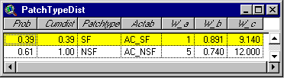
Figure 1. Sample patch type distribution table

Age Class Allocation
Age classes are randomly allocated in much the same manner as the patch types. The only distinction is that each patch type has its own age class distribution. Each patch type therefore has a corresponding age class distribution table. The FLG associates age class distributions with patch types by storing the name of the age class distribution table corresponding each patch type. This information is stored in the Actab field of the patch type distribution table. See Figure 2 below for a sample age class distribution table. When a new patch is generated, the model first randomely selects a patch type, and then uses the appropriate age class table (i.e. the table whose name is stored in the Actab field for that patch type) to randomely generate an age class.

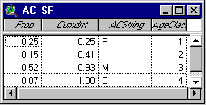
Figure 2. Sample age class distribution table

Patch allocation
Patches are generated one at a time, till all the cells have been allocated. They are “grown” around a mother cell, which has been randomly selected from among the cells that have not been allocated yet. The target size for a patch is randomly generated from a continuous Weibull distribution function. See Figure 1 below for a sample graph of an actual patch size distribution histogram from patches generated using the FLG. The histogram is overlaid with a best-fit Weibull function.
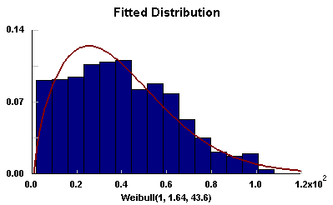Figure 3. Sample patch size distribution generated using FLG

Patch growth around the mother cell continues until either the target patch size has been reached, or the patch filled all the unallocated cells adjacent to the mother cell. Growth is simulated by iteratively selecting unallocated cells that touch the current patch. This allows patches to “squeeze” through narrow unallocated corridors, but not to “jump over” allocated cells. The final patch size distribution will never exactly correspond to the target distribution, because patch growth is truncated when the model runs out of allocated adjacent cells. This effect is accentuated towards the end of the patch generation process, as vacant spaces become smaller. This effect has been partially offset by sorting the patch attribute list such that the largest patches are generated first.

Weibull distribution
The Weibull distribution has been widely used to model the distributions of stand descriptors such as basal area and stem diameter (Little 1983; Rennolls, Geary and Rollinson 1985; Laroque, Parton and Archibald 1996). The 3-parameter Weibull distribution was used to model patch size in the FLG. This function is very flexible – manipulation of the three parameters can produce a wide variety of unimodal continuous patch size distributions, including approximations of symmetrical and skewed normal distributions, as well as exponential distributions (Law and Kelton 1991). Studies in both Ontario and New Brunswick have shown that forest patch sizes demonstrate an exponential, or “inverse-J,” distribution (Pearce 1993, Whittaker 1994), which is easily modeled by the Weibull distribution. Moreover, since the distribution function for a Weibull distributed random variable x with location parameter a, scale parameter b and shape parameter c is 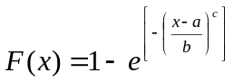, it is easily invertable for inverse transform random sampling (Law and Kelton 1991).

Generating a forest

Collecting input data
Follow these steps to create your own forest. See FLG_inputs.doc for additional information about the format tables that store the patch type and age class distribution data.
- Decide how many different patch types you want, and derive a discrete patch type cumulative distribution. The probabilities used must reflect the patch count distribution, as opposed to the distribution of total area in each patch type. For example, suppose you have 10 patches that you divide into 2 patch types, with 6 patches in one type and 4 patches in the other type. The probabilies of generating a patch of type A is 0.6, and the probability of generating a patch of type B is 0.4. As you can see this has nothing to do with either the size of the individual patches, or the total area taken up by each patch type.
- For each patch type, create a discrete age class cumulative distribution. Store each distribution in a separate ArcView table document. The table names can be anything you like as long as (a) each age class table has a different name, and (b) you link the age class distributions to the patch types by entering the appropriate age class table name in the Actab field of the patch type distribution table (named PatchTypeDist). Note that you must enter the table name as it appears in your ArcView project (as opposed to the name of the file from which you created the table, for example). See FLG_inputs.doc for an example.

Launching the FLG
To run the FLG, simply open the FLG ArcView project file, and click the Launch FLG button with a View document active.

FLG Output
When the FLG has finished generating your forest, two new themes will be added to the the active View document. The first theme will be a shapefile representing the dissolved patches, and the second theme will display the GRID file that the shapefile was created from.

The patch attributes are stored in the GRID theme’s Value Attribute Table (VAT).

Appendix 1 – Model algorithm flow chart
START
Set constant values
Display user input dialog
GENERATE patch list
SORT patch attribute list
Create new VTAB
(to store patch attributes)
Pick MOTHER cell
Get next item from LIST
Grow patch
Store patch extent
Store patch attributes
in VTAB
CLONE sorted attribute list
All cells allocated?
End of patch list?
Switch to cloned
patch attribute list
Output PATCH ID’s
to ASCII format raster file
Import ASCII raster file
to ESRI GRID format
Export GRID
to Polygon FTAB
JOIN polygon FTAB
to patch attribute VTAB
ASCII
raster file
ESRI
GRID file
STOP
Select new LAYER
of adjacent
unallocated cells
Generate RANDOM
proportion of new
layer to discard
(0 - 50 %)
Randomly select
cells to discard
Add remaining cells
to patch
Run out of room?
Patch too big?

