IP Settings on computer:
- Connect the IPA-Controller (X3) with an Ethernet cable to the computer. If only one port is available disconnect the Internet.

- Set the IP address of the computer manually:

  - Open “Network and Internet Settings” -> Ethernet
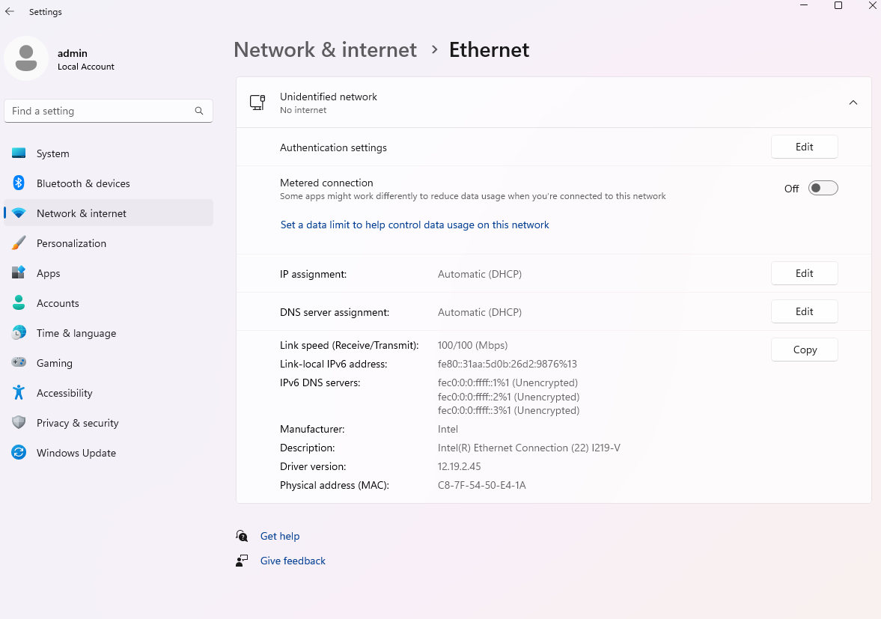
  - Click on Edit next to IP assignment
  - Select “Manual” from the drop-down menu
  - Activate IPv4
  - Enter the Ethernet address: 192.168.100.222
  - Enter Subnet Mask : 255.255.255.0
  - Click on save
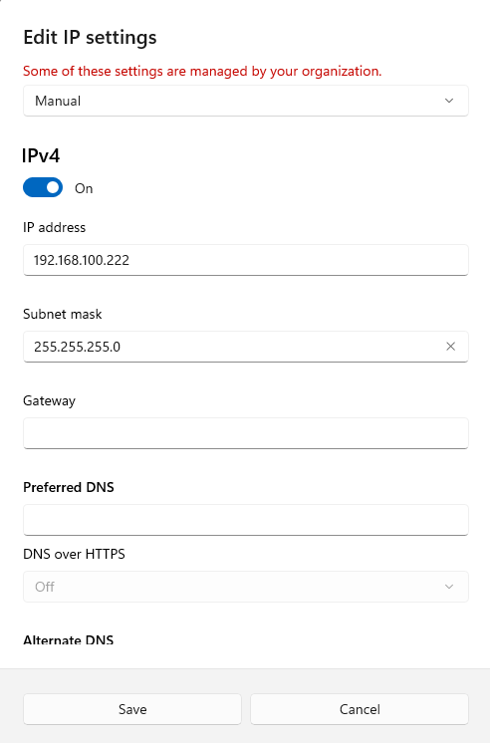
- Open ACR-View Software
- If you used the only ethernet port of your computer remember to change the IP address settings back to Automatic!!

