Final Report

Cuthbert Chow, Rong Li, Andy Yang

2021-12-10

Table of Contents

## Aim and Summary

One of the most important things in the job search is about the salaries, specifically, does this job’s salary meet our expectations? However, it is not that easy to set proper expectations. Setting an expectation too high or too low will both be harmful to our job search.

Here, this project is to help you to answer this question: What we can expect a person’s salary to be in the US?

To answer this question, we use two different regression models to do the prediction task. The first model we choose is a linear regression model. According to Martín et al. (2018), a linear regression model is a good model for predicting salaries. The second one we choose is the random forest regression model, because of its good nature (i.e., robust to outliers, low bias, etc.)(Kho 2019). We score the model using r2 and root mean squared error (RMSE), and it turns out that after hyperparameter optimization, the ridge (which is a linear regressor with regularization) is performing a little bit better than the random forest regressor. On the unseen test data set, our best linear regression model has an r2 score of 0.38 and RMSE of 48398.05.

To further understand which factors provide the most predictive power when trying to predict a person’s salary, we present some important features with the highest/lowest coefficients of the linear regression model and some important features with the highest feature importance of the random forest model. We noticed that although the most important features are not very similar for the two models, they are both understandable and somewhat expected.

## Data & Method

The dataset we are analysing comes from a salary survey from the “Ask a Manager” blog by Alison Green. This dataset contains survey data gathered from “Ask a Manager” readers working in a variety of industries (Green 2021).

As references, we utilized the guide for methodological practices regarding linear, ridge and lasso regression(Jain 2017), as well as the article from Martín et al. (2018) which recommended linear regression for problems similar to the one we are analysing.  
We also select the random forest regression model according to Kho (2019).

The Python (Van Rossum and Drake 2009) and R (R Core Team 2021) programming languages and the following Python and R packages were used to perform the data analysis and present results: Pandas (Reback et al. 2020), Scikit-learn (Pedregosa et al. 2011), Altair (VanderPlas et al. 2018), docopt (Keleshev 2014), knitr (Xie 2021).

## Analysis

### Data Exploration

To get a better idea of our data and how to process it, we conducted an exploratory data analysis. First, we looked at the distribution of our target “Annual Salary.” As shown in the graph below, it seems to be a largely right-skewed distribution with a median salary of around $80,000. This indicates to us that there are likely outliers with abnormally high income values which can cause overfitting in machine learning models if not addressed at the pre-processing stage.

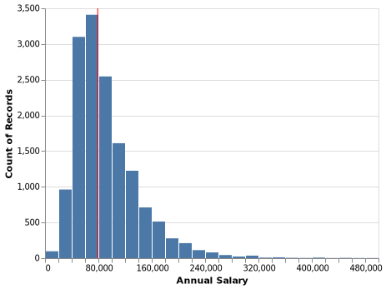

Figure 1 - Distribution of Annual Salaries

Next, we gathered some general information about our dataset:

To look at whether the features in our dataset are useful to predict annual salary, we first looked at a summary table about our features:

Table 1 - Summary Information About Key Features

| Features | Not.Null.Count | Null.Count | Number.of.Unique.Values | Types |
| --- | --- | --- | --- | --- |
| how_old_are_you | 15037 | 0 | 7 | object |
| industry | 15008 | 29 | 675 | object |
| job_title | 15037 | 0 | 7970 | object |
| other_monetary_comp | 11282 | 3755 | 583 | float64 |
| state | 14914 | 123 | 108 | object |
| city | 15006 | 31 | 2482 | object |
| overall_years_of_professional_experience | 15037 | 0 | 8 | object |
| years_of_experience_in_field | 15037 | 0 | 8 | object |
| highest_level_of_education_completed | 14935 | 102 | 6 | object |

We noticed that there are lots of null values in the additional information features (additional_context_on_job_title, additional_context_on_income, etc), and some of the variables have a lot of unique values. Therefore, later we dropped the two additional information features and used the bag-of-words model to extract features from text columns such as industry and job title.

Since variables with 100s or 1000s of distinct values would be harder to visualize in a meaningful way, here we are exploring those variables that have < 10 unique values and check their distributions and relationships with the annual salary:

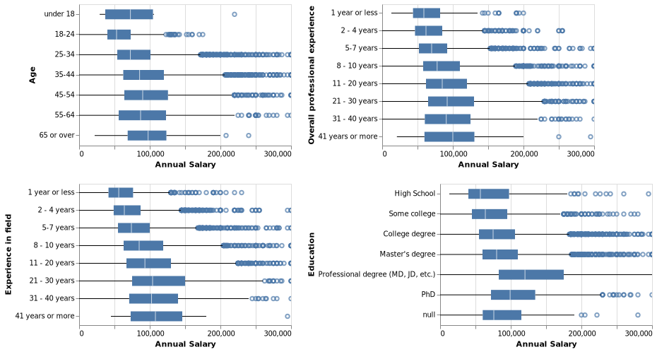

Figure 2 - Salary For Various Categorial Features

As shown above, the higher salaries are roughly associated with the older age groups, the longer experience and the higher education, which indicates those are likely to be good predictors of our target.

### Data cleaning

We chose two different types of models to predict annual salary based on the given features in the dataset. A linear model, Ridge, and an ensemble model, RandomForestRegressor. To ensure that the models were not overfitting to training data, we conducted some additional data cleaning. Firstly, *annual_salary* values within the training dataset of less than 10,000 USD or over 1,000,000 USD were removed. This is to prevent significant overfitting of our models since thesee values make up a small percentage of our overall data. Additionally, text values that occurred less than 5 times in the *state* or *city* features were imputed with an empty string. This ensures that highly specific values will be removed which also helps reduce overfitting.

### Find the best model

To score the models, we relied on the r2 and root mean squared error scores since they are simple to interpret. Since the annual salary target of the test set can be 0, MAPE would not be a suitable metric in this scenario. We did not filter the test dataset to allow for MAPE scoring since this would bias the test set against evaluation data.

To optimize model performance, hyperparameter optimization was performed on the Ridge and Random Forest models. For Ridge, the alpha parameter was optimized with a search space spanning ${10}^{\left(−5\right)}−{10}^{\left(5\right)}$ with 20 total iterations. The ideal alpha value which provided the highest r2 score was determined to be approximately 6.16 as seen by the results table.

Table 2.1 - Scores For Various Alpha Values

| r2 | Negative.RMSE | alpha |
| --- | --- | --- |
| 0.4952179 | -37852.02 | 6.158482e+00 |
| 0.4910140 | -38009.13 | 2.069138e+01 |
| 0.4892775 | -38074.54 | 1.832981e+00 |
| 0.4768487 | -38535.54 | 5.455595e-01 |
| 0.4740495 | -38637.41 | 6.951928e+01 |
| 0.4647394 | -38979.44 | 1.623777e-01 |
| 0.4572101 | -39252.72 | 4.832930e-02 |
| 0.4538497 | -39373.37 | 1.438450e-02 |
| 0.4523925 | -39426.25 | 3.793000e-04 |
| 0.4520337 | -39439.02 | 4.281300e-03 |
| 0.4513788 | -39461.73 | 1.129000e-04 |
| 0.4512609 | -39465.70 | 1.000000e-05 |
| 0.4512501 | -39466.43 | 3.360000e-05 |
| 0.4512336 | -39467.41 | 1.274300e-03 |
| 0.4439331 | -39728.32 | 2.335721e+02 |
| 0.4026841 | -41175.61 | 7.847600e+02 |
| 0.3457046 | -43095.39 | 2.636651e+03 |
| 0.2605887 | -45814.10 | 8.858668e+03 |
| 0.1527303 | -49041.58 | 2.976351e+04 |
| 0.0661657 | -51484.57 | 1.000000e+05 |

For Random Forest Regressor, we optimized the n_estimators for speed. We searched for performance increases within the hyperparameters of 10, 20, 50, and 100 trees. We picked the 50 tree regressor for time savings, since the 100 tree regressor provided very little performance boost compared to processing time required.

Table 2.2 - Scores For Various n_estimators

| test.r2 | train.r2 | Negative.RMSE | n_estimators |
| --- | --- | --- | --- |
| 0.4605616 | 0.9260365 | -39139.02 | 100 |
| 0.4530413 | 0.9163876 | -39409.02 | 20 |
| 0.4520001 | 0.9248364 | -39449.32 | 50 |
| 0.4325112 | 0.9032956 | -40135.90 | 10 |

By comparing the two models’ cross-validation scores above, We ultimately selected the Ridge model with the alpha value around 6.16, as it provided better results on both r2 and root mean squared error, although the performance of each model was overall similar. As a result, we will evaluate this model’s performance against the test set and utilise it to make salary predictions.

### Important Features

One of our goals with this study was to gauge which factors are important in making salary predictions to give us insight into which roles/qualities are valued in an individual in terms of salary. We can gain insight into how our model makes predictions by analyzing the coefficient values associated with the regression. The tables below show the difference in salary that the model predicts given the change in the associated feature for the Ridge model. The first table displays the top 10 positive coefficients.

Table 3.1 - Ten most positive coefficients

| Feature | Coefficient |
| --- | --- |
| physician | 74378.06 |
| svp | 63693.00 |
| md | 62148.93 |
| partner | 58460.39 |
| psychiatrist | 53449.05 |
| city_Bay Area | 46940.70 |
| equity | 45417.85 |
| chief | 43903.58 |
| machine | 41832.51 |
| onlyfans | 41546.77 |

The top 10 most positively correlated features with higher income are somewhat expected, as they mostly consist of text features that represent high-paying jobs, or titles such as MD. An interesting feature we didn’t expect was onlyfans, which is a more recent phenomenon. This shows the effects of modern technology on methods to earn income.

Table 3.2 - Ten most negative coefficients

| Feature | Coefficient |
| --- | --- |
| paralegal | -38459.81 |
| resident | -28017.91 |
| adjunct | -24873.13 |
| office | -23446.57 |
| clerk | -21622.61 |
| bookkeeper | -20096.76 |
| assistant | -18435.04 |
| city_Tallahassee | -18421.47 |
| legal | -18358.64 |
| secretary | -18255.88 |

The most negative coefficient features are also somewhat expected, as they mostly consist of traditionally lower-paying jobs in the US.

The top 10 positive features from Ridge and the top 10 most important features from the random forest model are presented below. We can see the differences between the two models are huge - the most important features are not overlapping between the two models. However, when we tried to interpret the result we found both are understandable. For example, “senior” and “director” are getting high feature importance in the random forest model.

Table 4 - Feature importance comparison

| Significance.Rank | Ridge.Feature | Ridge.Coefficient | Random.Forest.Feature | RandomForest.Coefficient |
| --- | --- | --- | --- | --- |
| 1 | physician | 74378.06 | other_monetary_comp | 0.2637 |
| 2 | svp | 63693.00 | years_of_experience_in_field | 0.0614 |
| 3 | md | 62148.93 | highest_level_of_education_completed | 0.0512 |
| 4 | partner | 58460.39 | computing | 0.0447 |
| 5 | psychiatrist | 53449.05 | overall_years_of_professional_experience | 0.0170 |
| 6 | city_Bay Area | 46940.70 | how_old_are_you | 0.0159 |
| 7 | equity | 45417.85 | senior | 0.0140 |
| 8 | chief | 43903.58 | state_California | 0.0129 |
| 9 | machine | 41832.51 | director | 0.0110 |
| 10 | onlyfans | 41546.77 | engineer | 0.0104 |

Note that the feature importance value is incomparable between the two models since the random forest model is not linear, and cannot be interpreted in the same way as the coefficients for the ridge. Nonetheless, viewing the coefficients can still inform us about the specific features which each model deems to be the most important.

Overall, job title seems to influence a lot when we tried to predict salaries in the US. City name seems also to play a role there.

### Results & Discussion

Here, we evaluated the best model we found (the Ridge model with the alpha value around 6.16) on the test data. The results can be seen in the table below.

Table 5 - Scores of Ridge Model on Test Data

| Metric | Ridge.Scores |
| --- | --- |
| R2 | 0.38 |
| RMSE | 48398.03 |

As we can see, the R2 score is 0.38, suggesting that 38% of the variance can be explained by our model. The test score is a bit different from the validation score, so there might be a lot of variance within the data set.

To visualize the effectiveness of our models, we can plot the predicted salary values against the actual salary values and compare the correlation to a 45 degree line.

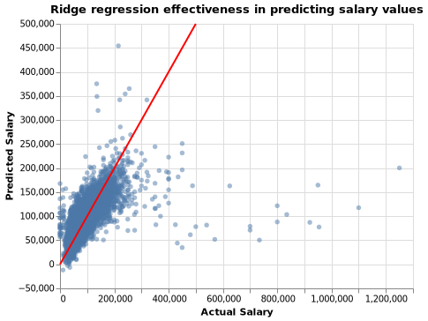

Figure 3 - Actual vs Predicted Salary Values

Overall, the model provides an acceptable estimate within the range of 0 to 200,000. However, it performs poorly when trying to predict higher values (>500,000). There seems to be a trend of underestimating higher values.

## Conclusion & Reccomendations

Ultimately, our model achieved an R2 score of 0.38, which is somewhat unsatisfactory. This suggests that our model has difficulty explaining sources of variance, and has a particularly difficult time predicting larger salary values. This is likely a result of our training data processing and our efforts to prevent overfitting. The difference between our test and validation scores is still somewhat significant, suggesting an element of overfitting is still present.

Several things could be done to further improve this model in future. First of all, doing some feature engineering might help us get a better model, such as including some polynomial terms. Also, we might be able to solve the problem of extreme values using different regularization/loss functions. Additionally, we can consider using some other tree-based ensemble models.

## References

Green, Alison. 2021. “How Much Money Do You Make?” *Ask A Manager*. <https://www.askamanager.org/2021/04/how-much-money-do-you-make-4.html>.

Jain, Shubham. 2017. “A Comprehensive Beginners Guide for Linear, Ridge and Lasso Regression in Python and r.” *Analytics Vidhya*. <https://www.analyticsvidhya.com/blog/2017/06/a-comprehensive-guide-for-linear-ridge-and-lasso-regression/>.

Keleshev, Vladimir. 2014. *Docopt: Command-Line Interface Description Language*. <https://github.com/docopt/docopt>.

Kho, Julia. 2019. “Why Random Forest Is My Favorite Machine Learning Model.” *Medium*. Towards Data Science. <https://towardsdatascience.com/why-random-forest-is-my-favorite-machine-learning-model-b97651fa3706>.

Martín, Ignacio, Andrea Mariello, Roberto Battiti, and José Alberto Hernández. 2018. “Salary Prediction in the IT Job Market with Few High-Dimensional Samples: A Spanish Case Study.” *International Journal of Computational Intelligence Systems* 11: 1192–1209. https://doi.org/<https://doi.org/10.2991/ijcis.11.1.90>.

Pedregosa, Fabian, Gaël Varoquaux, Alexandre Gramfort, Vincent Michel, Bertrand Thirion, Olivier Grisel, Mathieu Blondel, et al. 2011. “Scikit-Learn: Machine Learning in Python.” *Journal of Machine Learning Research* 12 (Oct): 2825–30.

R Core Team. 2021. *R: A Language and Environment for Statistical Computing*. Vienna, Austria: R Foundation for Statistical Computing. <https://www.R-project.org/>.

Reback, Jeff, jbrockmendel, Wes McKinney, Joris Van den Bossche, Tom Augspurger, Phillip Cloud, Simon Hawkins, et al. 2020. *Pandas-Dev/Pandas: Pandas* (version latest). Zenodo. <https://doi.org/10.5281/zenodo.3509134>.

Van Rossum, Guido, and Fred L. Drake. 2009. *Python 3 Reference Manual*. Scotts Valley, CA: CreateSpace.

VanderPlas, Jacob, Brian Granger, Jeffrey Heer, Dominik Moritz, Kanit Wongsuphasawat, Arvind Satyanarayan, Eitan Lees, Ilia Timofeev, Ben Welsh, and Scott Sievert. 2018. “Altair: Interactive Statistical Visualizations for Python.” *Journal of Open Source Software* 3 (32): 1057.

Xie, Yihui. 2021. *Knitr: A General-Purpose Package for Dynamic Report Generation in r*. <https://yihui.org/knitr/>.