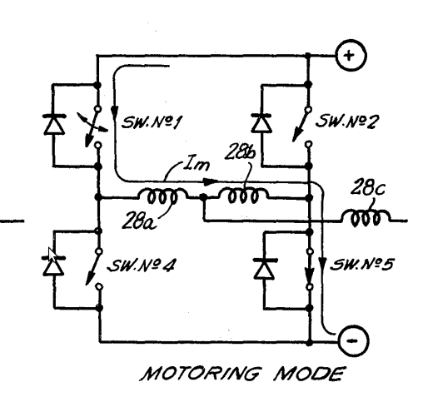
Notation: mosfets are referred to as F1 to F4, with F1 being the top left one and counted from counterclockwise. Diodes will be referred to as Diode1 to Diode4, matching F1 to F4.
Dutycycles applied are D1 to D4. PWM Period is T.

PROBLEM: The diagram to the right shows a simplified diagram of motor control. Given that F1 is applied a PWM of 50% and F3 is ON, a back emf (Vemf) is generated that is very close to Vapplied = D1*Vbatt. When a Vapplied that is lower than Vemf is desired, the equivalent voltage applied to the motor is NOT Vapplied. Rather,

Vactual = (Vbatt-Vemf) for D1*T and Vemf for (1-D1)*T

What we want is Vactual = Vapplied = Vbatt*D1. This only holds during acceleration, and decceleration within the range of +Vapplied (not switching drive direction by PWM controlling F4 and Turning F2 on) is not possible at this point. Thus, our robots cannot slowly deccelerate, it only sharply deccelerates by reversing drive direction and applying voltage that way.

SOLUTION:

Constantly update an estimate of the Vemf. PSEUDOCODE:

Update Vemf;

if (Vapplied >= Vemf){
D1 = Vapplied/Vback;
D3 = 1; // Constantly on

//All other fets are off, so D2 and D3 are zero
}else{
D2 = 1-(Vapplied/Vemf);
// All other fets are off (D1 = 0;D3 = 0; D4 = 0;)
}

Explanation: When Vapplied needs to be below the Vemf, a duty cycle of D = 1-(Vapplied/Vemf) is given to the low side nmos at the higher potential side of Vemf (So in the case of the above diagram, it is for F2). Under the assumption that when no current is flowing (when F2 is off), it is equivalent to applying Vapplied that equals to Vemf. And when F2 is on, current is flowing to discharge the motor back emf, and that is equivalent to Vapplied = 0. Thus, controlling the dutycycle applied to F2 (changing D2) can provide a ratio of applying 0 to Vemf, and a linear Vactual can be created.

Vactual = Vemf*(1-D2)
Note: The above equation has (1-D2) as D because when F2 is on, it is equivalent to providing a Vactual of zero (since F2 shorts the motor to ground, it is equivalent to stopping).

Limitations:
- During this mode of generation (we call it generation because we are discharging the motor Vemf), the current must flow through Diode3 Unless F3 is also switched on, thus a diode voltage drop would occur. This I leave for you to decide Jon, as to whether we want to turn F3 on during this generation mode or not.

Options:
It is possible to PWM F4 instead of F2 during the generation mode in question, and instead of turning F3 on solid, turn F1 on solid. However, shoot through could still occur under the same likelihood when switching from this generation mode to driving mode in the same direction (Shootthrough from F4 to F3). My opinion is to switch F2 and keep F3 on, because n mosfets are faster than p mosfets.

