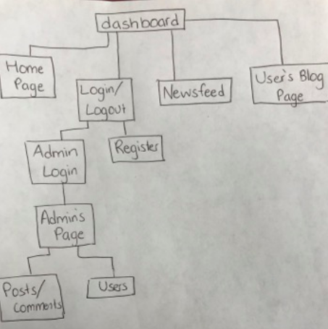PetBlog

This is a site map of the website. The dashboard is linked to all of the pages.

The first page one will see when going onto the website is the Home Page. From here, you are able to go to different pages from the navigation bar(dashboard).

The navigation bar will look different to everyone depending on if they are not logged in, logged in, or logged in as an Admin

Users Not Logged in:

The navigation bar will have the options of Home, Log In and Newsfeed.

Everyone can look through the newsfeed, see all the posts and comments. They are not able to post anything or post comments.

The log in page has an option to Register(button), that will go to the Registration page. Once you are done registering, you will be directed to the log in page to log in.

The log in page also has the option for Admins to log in at the bottom

Users Logged in:

The navigation bar will have the options of Home, LogOut, Newsfeed and your Blog.

Logout will log you out and take you to the home page

The newfeed when logged in has the option of commenting on posts.

Your blog page has all your blogs in chronological order and an option to post blogs. The blogs you post will post onto the worldwide newsfeed as well as your own blog

Admin Log In:

Once the admin is logged in, the navigation car will look similar to if a user is logged in

The admin has 2 buttons to go to the users or posts.

The users button goes to a list of all the users and the option to delete a user.

The posts button goes to a list of all the posts with options to delete a post

or a comment.

Client side security:

The password that is made by the user is not secure. This problem will be fixed by hashing and using HTTPS.

The password is now obfuscated for security purposes.

The following images are the layout plan for the website. It is a image of what every page on the website will look like.

The highlighted part on the navigation bar reference what page is being displayed.

