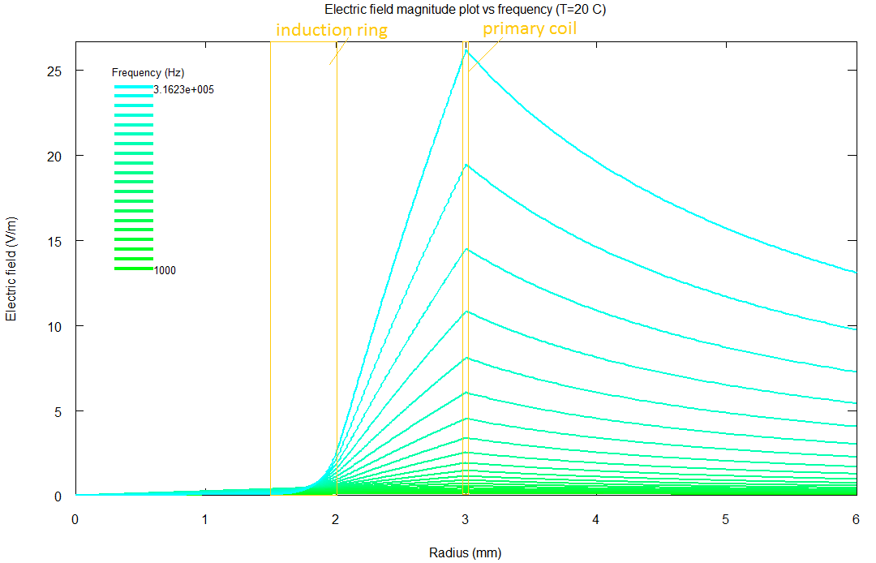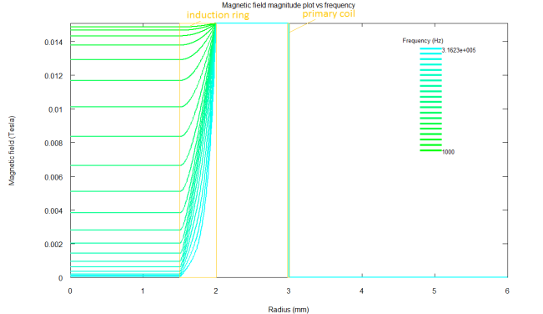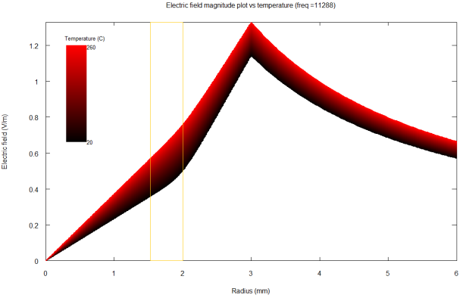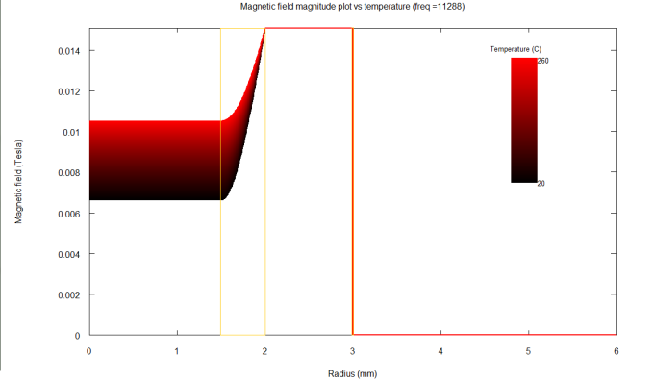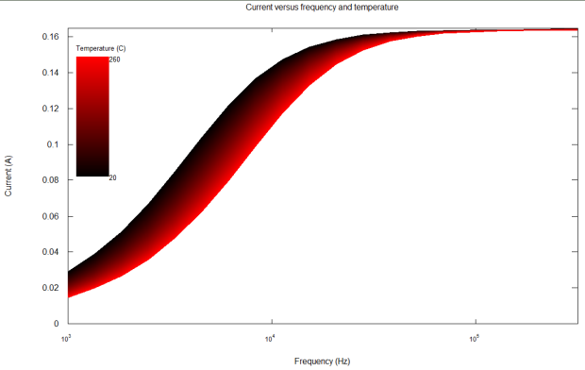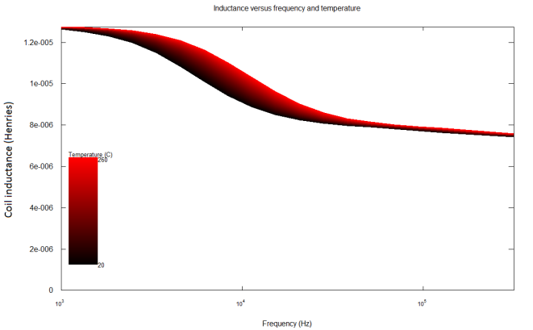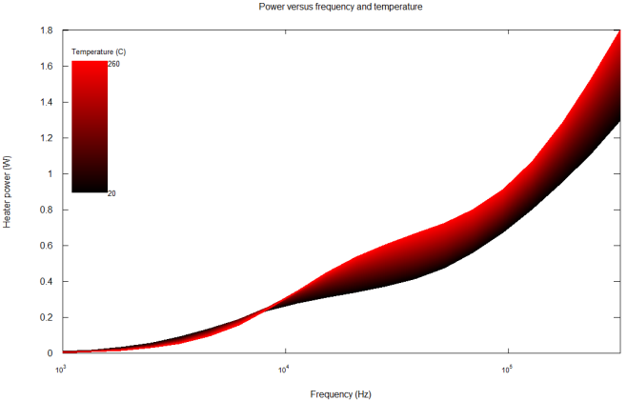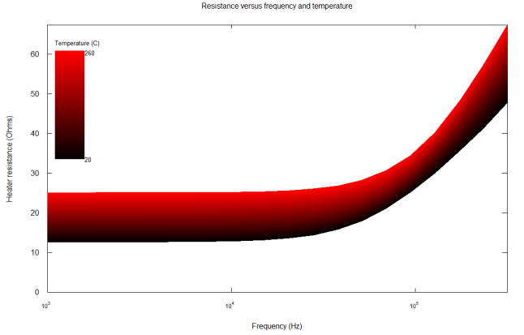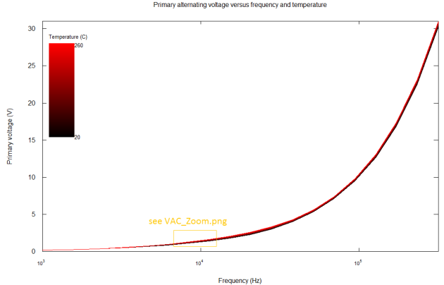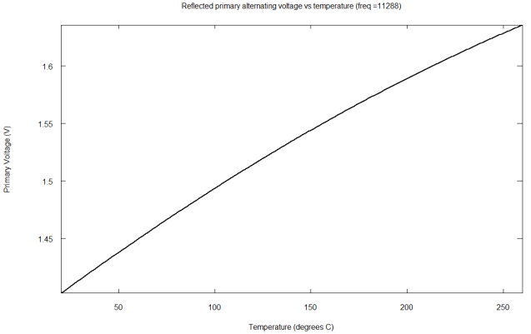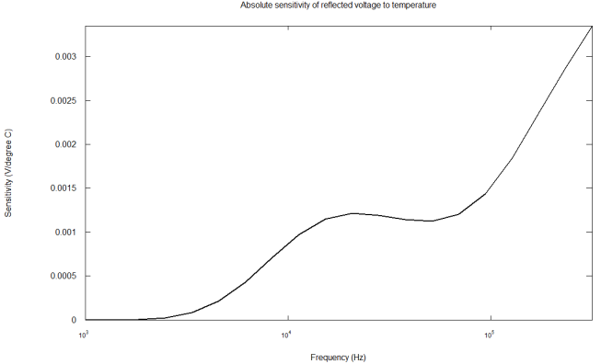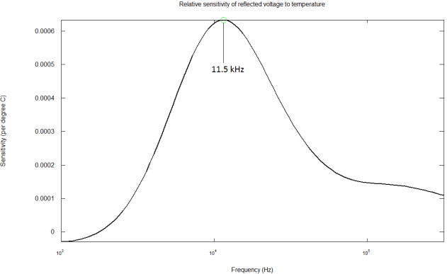

Owen Bridge

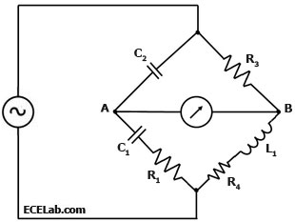

$$Z_{C}=\frac{1}{jωC}$$

$$Z_{L}=jωL$$

$$Z_{A}=\frac{1}{jωC_{1}}+\frac{1}{jωC_{2}}+R_{1}$$

$$Z_{B}=R_{3}+R_{4}+ jωL_{4}$$

$$R_{4}=R_{0}\left(T_{0}\right)+∆R\left(∆T\right)$$

$$R_{4}=R_{p}\left(T\right)+R_{s}\left(T\right)$$

$$R_{4}=R_{p0}\left(T_{0}\right)+∆R_{p}\left(∆T\right)+R_{s0}\left(T_{0}\right)+∆R_{s}(∆T)$$

$$L_{4}=L_{0}\left(T_{0}\right)+∆L(T)$$

$$I_{A}Z_{A}=I_{B}Z_{B}$$

$$I_{A}\left(\frac{1}{jωC_{1}}+\frac{1}{jωC_{2}}+R_{1}\right)=I_{B}\left(R_{3}+R_{4}+ jωL_{4}\right)$$

$$V_{A}=I_{A}\frac{1}{jωC_{2}}$$

$$V_{B}=I_{B}R_{3}$$

If VA = VB:

Let’s set this to be the case at temperature T0.

Now let’s investigate how the voltage changes as the temperature varies.

$$V_{AB}=V_{A}-V_{B}=V_{AB}(T)$$

$$V_{AB}=I_{A}\frac{1}{jωC_{2}}-I_{B}R_{3}$$

$$I_{A}=I_{B}\frac{\left(R_{3}+R_{4}+ jωL_{4}\right)}{\left(\frac{1}{jωC_{1}}+\frac{1}{jωC_{2}}+R_{1}\right)}$$

$$V_{AB}=I_{B}\frac{\left(R_{3}+R_{4}+ jωL_{4}\right)}{\left(\frac{C_{1}+C_{2}}{jωC_{1}C_{2}}+R_{1}\right)}\frac{1}{jωC_{2}}-I_{B}R_{3}$$

$$V_{AB}=I_{B}\left(\frac{\left(R_{3}+R_{4}+ jωL_{4}\right)}{\left(1+\frac{C_{2}}{C_{1}}+jωC_{2}R_{1}\right)}-R_{3}\right)$$

$$I_{B}=\frac{V_{S}}{Z_{B}}=\frac{V_{S}}{R_{3}+R_{4}+ jωL_{4}}$$

$$V_{AB}=\frac{V_{S}}{R_{3}+R_{4}+ jωL_{4}}\left(\frac{\left(R_{3}+R_{4}+ jωL_{4}\right)}{\left(1+\frac{C_{2}}{C_{1}}+jωC_{2}R_{1}\right)}-R_{3}\right)$$

$$V_{AB}=V_{S}\left(\frac{1}{1+\frac{C_{2}}{C_{1}}+jωC_{2}R_{1}}-\frac{R_{3}}{R_{3}+R_{4}+ jωL_{4}}\right)$$

Now invoke the temperature dependence:

$$L_{4}=L_{0}\left(T_{0}\right)+∆L(T)$$

$$R_{4}=R_{0}\left(T_{0}\right)+∆R\left(∆T\right)$$

$$V_{AB}=V_{S}\left(\frac{1}{1+\frac{C_{2}}{C_{1}}+jωC_{2}R_{1}}-\frac{R_{3}}{R_{3}+R_{0}\left(T_{0}\right)+∆R\left(∆T\right)+ jω\left(L_{0}\left(T_{0}\right)+∆L(T)\right)}\right)$$

$$V_{AB}=V_{S}\left(\frac{1}{1+\frac{C_{2}}{C_{1}}+jωC_{2}R_{1}}-\frac{R_{3}}{R_{3}+R_{0}\left(T_{0}\right)+∆R\left(∆T\right)+ jω\left(L_{0}\left(T_{0}\right)+∆L(T)\right)}\right)$$

But we know from the condition we set up:

$$\frac{C_{2}}{C_{1}}R_{3}=R_{0}\left(T_{0}\right)$$

$$R_{1}R_{3}C_{2}=L_{0}\left(T_{0}\right)$$

$$V_{AB}=V_{S}\left(\frac{1}{1+\frac{C_{2}}{C_{1}}+jωC_{2}R_{1}}-\frac{R_{3}}{R_{3}+\frac{C_{2}}{C_{1}}R_{3}+∆R\left(∆T\right)+ jω\left(R_{1}R_{3}C_{2}+∆L(T)\right)}\right)$$

$$V_{AB}=V_{S}\left(\frac{1}{1+\frac{C_{2}}{C_{1}}+jωC_{2}R_{1}}-\frac{R_{3}}{R_{3}+\frac{C_{2}}{C_{1}}R_{3}+∆R\left(∆T\right)+ jωR_{1}R_{3}C_{2}+ jωR_{1}∆L(T)}\right)$$

$$V_{AB}=V_{S}\left(\frac{R_{3}+\frac{C_{2}}{C_{1}}R_{3}+∆R\left(∆T\right)+ jωC_{2}R_{1}R_{3}+ jωR_{1}∆L\left(T\right)-R_{3}-\frac{C_{2}}{C_{1}}R_{3}-jωC_{2}R_{1}R_{3}}{\left(1+\frac{C_{2}}{C_{1}}+jωC_{2}R_{1}\right)\left(R_{3}+\frac{C_{2}}{C_{1}}R_{3}+∆R\left(∆T\right)+ jωR_{1}R_{3}C_{2}+ jωR_{1}∆L(T)\right)}\right)$$

$$V_{AB}=V_{S}\left(\frac{∆R\left(∆T\right)+ jωR_{1}∆L\left(T\right)}{\left(1+\frac{C_{2}}{C_{1}}+jωC_{2}R_{1}\right)\left(R_{3}+\frac{C_{2}}{C_{1}}R_{3}+∆R\left(∆T\right)+ jωR_{1}R_{3}C_{2}+ jωR_{1}∆L(T)\right)}\right)$$

Denominator:

$$R_{3}+2\frac{C_{2}}{C_{1}}R_{3}+jωC_{2}R_{1}R_{3}+{\left(\frac{C_{2}}{C_{1}}\right)}^{2}R_{3}+jωC_{2}R_{1}R_{3}\frac{C_{2}}{C_{1}}+∆R\left(∆T\right)+\frac{C_{2}}{C_{1}}∆R\left(∆T\right)+jωC_{2}R_{1}∆R\left(∆T\right)+ jωR_{1}R_{3}C_{2}+\frac{C_{2}}{C_{1}} jωR_{1}R_{3}C_{2}-ωC_{2}R_{1} ωR_{1}R_{3}C_{2}+ jωR_{1}∆L\left(T\right)+\frac{C_{2}}{C_{1}} jωR_{1}∆L\left(T\right)-ωC_{2}R_{1} ωR_{1}∆L(T)$$

$$\left(R_{3}+2\frac{C_{2}}{C_{1}}R_{3}+{\left(\frac{C_{2}}{C_{1}}\right)}^{2}R_{3}+\frac{C_{2}}{C_{1}}∆R\left(∆T\right)+∆R\left(∆T\right)-ωC_{2}R_{1} ωR_{1}R_{3}C_{2}-ωC_{2}R_{1} ωR_{1}∆L(T)\right)+jω\left(C_{2}R_{1}R_{3}+C_{2}R_{1}R_{3}\frac{C_{2}}{C_{1}}+C_{2}R_{1}∆R\left(∆T\right)+R_{1}R_{3}C_{2}+\frac{C_{2}}{C_{1}} R_{1}R_{3}C_{2}+ R_{1}∆L\left(T\right)+\frac{C_{2}}{C_{1}} R_{1}∆L\left(T\right)\right)$$

$$\left[R_{3}{\left(1+\frac{C_{2}}{C_{1}}\right)}^{2}+∆R\left(∆T\right)\left(1+\frac{C_{2}}{C_{1}}\right)-ω^{2}C_{2}{R_{1}}^{2}\left(R_{3}C_{2}+∆L(T)\right)\right]+jω\left[C_{2}R_{1}R_{3}\left(1+\frac{C_{2}}{C_{1}}\right)+C_{2}R_{1}∆R\left(∆T\right)+R_{1}R_{3}C_{2}\left(1+\frac{C_{2}}{C_{1}}\right)+ R_{1}∆L\left(T\right)\left(1+\frac{C_{2}}{C_{1}} \right)\right]$$

$$V_{AB}=V_{S}\left(\frac{∆R\left(∆T\right)+ jωR_{1}∆L\left(T\right)}{\left[R_{3}{\left(1+\frac{C_{2}}{C_{1}}\right)}^{2}+∆R\left(∆T\right)\left(1+\frac{C_{2}}{C_{1}}\right)-ω^{2}C_{2}{R_{1}}^{2}\left(R_{3}C_{2}+∆L(T)\right)\right]+jω\left[2C_{2}R_{1}R_{3}\left(1+\frac{C_{2}}{C_{1}}\right)+C_{2}R_{1}∆R\left(∆T\right)+ R_{1}∆L\left(T\right)\left(1+\frac{C_{2}}{C_{1}} \right)\right]}\right)$$

$$V_{AB}=V_{S}\left(\frac{∆R\left(∆T\right)+ jωR_{1}∆L\left(T\right)}{\left[A\right]+jω\left[B\right]}\right)$$

$$V_{AB}=V_{S}\left(\frac{\left(∆R\left(∆T\right)+ jωR_{1}∆L\left(T\right)\right)\left(\left[A\right]-jω\left[B\right]\right)}{\left(\left[A\right]+jω\left[B\right]\right)\left(\left[A\right]-jω\left[B\right]\right)}\right)$$

$$V_{AB}=V_{S}\left(\frac{\left[\left[A\right]∆R\left(∆T\right)+ω^{2}\left[B\right]R_{1}∆L\left(T\right)\right]+ jω\left[\left[A\right]R_{1}∆L\left(T\right)-\left[B\right]∆R\left(∆T\right)\right]}{{\left[A\right]}^{2}+ω^{2}{\left[B\right]}^{2}}\right)$$

$$V_{AB}=V_{S}\left(\frac{\left[\left[A\right]∆R\left(∆T\right)+ω^{2}\left[B\right]R_{1}∆L\left(T\right)\right]}{{\left[A\right]}^{2}+ω^{2}{\left[B\right]}^{2}}\right)+V_{S} \left(\frac{jω\left[\left[A\right]R_{1}∆L\left(T\right)-\left[B\right]∆R\left(∆T\right)\right]}{{\left[A\right]}^{2}+ω^{2}{\left[B\right]}^{2}}\right)$$

$$V_{ABreal}=V_{S}\left(\frac{\left[\left[A\right]∆R\left(∆T\right)+ω^{2}\left[B\right]R_{1}∆L\left(T\right)\right]}{{\left[A\right]}^{2}+ω^{2}{\left[B\right]}^{2}}\right)$$

$$V_{ABreal}=V_{S}\left(\frac{\left[\left[R_{3}{\left(1+\frac{C_{2}}{C_{1}}\right)}^{2}+∆R\left(∆T\right)\left(1+\frac{C_{2}}{C_{1}}\right)-ω^{2}C_{2}{R_{1}}^{2}\left(R_{3}C_{2}+∆L(T)\right)\right]∆R\left(∆T\right)+ω^{2}\left[2C_{2}R_{1}R_{3}\left(1+\frac{C_{2}}{C_{1}}\right)+C_{2}R_{1}∆R\left(∆T\right)+ R_{1}∆L\left(T\right)\left(1+\frac{C_{2}}{C_{1}} \right)\right]R_{1}∆L\left(T\right)\right]}{{\left[R_{3}{\left(1+\frac{C_{2}}{C_{1}}\right)}^{2}+∆R\left(∆T\right)\left(1+\frac{C_{2}}{C_{1}}\right)-ω^{2}C_{2}{R_{1}}^{2}\left(R_{3}C_{2}+∆L(T)\right)\right]}^{2}+ω^{2}{\left[2C_{2}R_{1}R_{3}\left(1+\frac{C_{2}}{C_{1}}\right)+C_{2}R_{1}∆R\left(∆T\right)+ R_{1}∆L\left(T\right)\left(1+\frac{C_{2}}{C_{1}} \right)\right]}^{2}}\right)$$

$$V_{ABimag}=V_{S}jω\left(\frac{\left[A\right]R_{1}∆L\left(T\right)-\left[B\right]∆R\left(∆T\right)}{{\left[A\right]}^{2}+ω^{2}{\left[B\right]}^{2}}\right)$$

$$V_{ABimag}=V_{S}jω\left(\frac{\left[R_{3}{\left(1+\frac{C_{2}}{C_{1}}\right)}^{2}+∆R\left(∆T\right)\left(1+\frac{C_{2}}{C_{1}}\right)-ω^{2}C_{2}{R_{1}}^{2}\left(R_{3}C_{2}+∆L(T)\right)\right]R_{1}∆L\left(T\right)-\left[2C_{2}R_{1}R_{3}\left(1+\frac{C_{2}}{C_{1}}\right)+C_{2}R_{1}∆R\left(∆T\right)+ R_{1}∆L\left(T\right)\left(1+\frac{C_{2}}{C_{1}} \right)\right]∆R\left(∆T\right)}{{\left[R_{3}{\left(1+\frac{C_{2}}{C_{1}}\right)}^{2}+∆R\left(∆T\right)\left(1+\frac{C_{2}}{C_{1}}\right)-ω^{2}C_{2}{R_{1}}^{2}\left(R_{3}C_{2}+∆L(T)\right)\right]}^{2}+ω^{2}{\left[2C_{2}R_{1}R_{3}\left(1+\frac{C_{2}}{C_{1}}\right)+C_{2}R_{1}∆R\left(∆T\right)+ R_{1}∆L\left(T\right)\left(1+\frac{C_{2}}{C_{1}} \right)\right]}^{2}}\right)$$

Assuming $∆R\left(∆T\right)$ is small and $∆L(T)$ is small:

$$∆R\left(∆T\right)=β_{R}∆T$$

$$∆L\left(∆T\right)=β_{L}∆T$$

$$V_{ABreal}=V_{S}\left(\frac{\left[\left[R_{3}{\left(1+\frac{C_{2}}{C_{1}}\right)}^{2}+β_{R}∆T\left(1+\frac{C_{2}}{C_{1}}\right)-ω^{2}C_{2}{R_{1}}^{2}\left(R_{3}C_{2}+β_{L}∆T\right)\right]β_{R}∆T+ω^{2}\left[2C_{2}R_{1}R_{3}\left(1+\frac{C_{2}}{C_{1}}\right)+C_{2}R_{1}β_{R}∆T+ R_{1}β_{L}∆T\left(1+\frac{C_{2}}{C_{1}} \right)\right]R_{1}β_{L}∆T\right]}{{\left[R_{3}{\left(1+\frac{C_{2}}{C_{1}}\right)}^{2}+β_{R}∆T\left(1+\frac{C_{2}}{C_{1}}\right)-ω^{2}C_{2}{R_{1}}^{2}\left(R_{3}C_{2}+β_{L}∆T\right)\right]}^{2}+ω^{2}{\left[2C_{2}R_{1}R_{3}\left(1+\frac{C_{2}}{C_{1}}\right)+C_{2}R_{1}β_{R}∆T+ R_{1}β_{L}∆T\left(1+\frac{C_{2}}{C_{1}} \right)\right]}^{2}}\right)$$

$$V_{ABimag}=V_{S}jω\left(\frac{\left[R_{3}{\left(1+\frac{C_{2}}{C_{1}}\right)}^{2}+β_{R}∆T\left(1+\frac{C_{2}}{C_{1}}\right)-ω^{2}C_{2}{R_{1}}^{2}\left(R_{3}C_{2}+β_{L}∆T\right)\right]R_{1}β_{L}∆T-\left[2C_{2}R_{1}R_{3}\left(1+\frac{C_{2}}{C_{1}}\right)+C_{2}R_{1}β_{R}∆T+ R_{1}β_{L}∆T\left(1+\frac{C_{2}}{C_{1}} \right)\right]β_{R}∆T}{{\left[R_{3}{\left(1+\frac{C_{2}}{C_{1}}\right)}^{2}+β_{R}∆T\left(1+\frac{C_{2}}{C_{1}}\right)-ω^{2}C_{2}{R_{1}}^{2}\left(R_{3}C_{2}+β_{L}∆T\right)\right]}^{2}+ω^{2}{\left[2C_{2}R_{1}R_{3}\left(1+\frac{C_{2}}{C_{1}}\right)+C_{2}R_{1}β_{R}∆T+ R_{1}β_{L}∆T\left(1+\frac{C_{2}}{C_{1}} \right)\right]}^{2}}\right)$$

Now we can find these in terms of $∆T$, and find the sensitivity versus $∆T$…

$$V_{ABreal}=V_{S}∆T\left(\frac{\left[\left[R_{3}{\left(1+\frac{C_{2}}{C_{1}}\right)}^{2}+β_{R}∆T\left(1+\frac{C_{2}}{C_{1}}\right)-ω^{2}C_{2}{R_{1}}^{2}\left(R_{3}C_{2}+β_{L}∆T\right)\right]β_{R}+ω^{2}\left[2C_{2}R_{1}R_{3}\left(1+\frac{C_{2}}{C_{1}}\right)+C_{2}R_{1}β_{R}∆T+ R_{1}β_{L}∆T\left(1+\frac{C_{2}}{C_{1}} \right)\right]R_{1}β_{L}\right]}{{\left[R_{3}{\left(1+\frac{C_{2}}{C_{1}}\right)}^{2}+β_{R}∆T\left(1+\frac{C_{2}}{C_{1}}\right)-ω^{2}C_{2}{R_{1}}^{2}\left(R_{3}C_{2}+β_{L}∆T\right)\right]}^{2}+ω^{2}{\left[2C_{2}R_{1}R_{3}\left(1+\frac{C_{2}}{C_{1}}\right)+C_{2}R_{1}β_{R}∆T+ R_{1}β_{L}∆T\left(1+\frac{C_{2}}{C_{1}} \right)\right]}^{2}}\right)$$

$$\frac{β_{R}R_{3}{\left(1+\frac{C_{2}}{C_{1}}\right)}^{2}+{β_{R}}^{2}∆T\left(1+\frac{C_{2}}{C_{1}}\right)-β_{R}ω^{2}C_{2}{R_{1}}^{2}\left(R_{3}C_{2}+β_{L}∆T\right)+2ω^{2}β_{L}C_{2}{R_{1}}^{2}R_{3}\left(1+\frac{C_{2}}{C_{1}}\right)+ω^{2}β_{L}C_{2}{R_{1}}^{2}β_{R}∆T+ ω^{2}{R_{1}}^{2}{β_{L}}^{2}∆T\left(1+\frac{C_{2}}{C_{1}} \right)}{{\left[R_{3}{\left(1+\frac{C_{2}}{C_{1}}\right)}^{2}+β_{R}∆T\left(1+\frac{C_{2}}{C_{1}}\right)-ω^{2}C_{2}{R_{1}}^{2}\left(R_{3}C_{2}+β_{L}∆T\right)\right]}^{2}+ω^{2}{\left[2C_{2}R_{1}R_{3}\left(1+\frac{C_{2}}{C_{1}}\right)+C_{2}R_{1}β_{R}∆T+ R_{1}β_{L}∆T\left(1+\frac{C_{2}}{C_{1}} \right)\right]}^{2}}$$

$$\frac{β_{R}R_{3}{\left(1+\frac{C_{2}}{C_{1}}\right)}^{2}+{β_{R}}^{2}∆T\left(1+\frac{C_{2}}{C_{1}}\right)-β_{R}ω^{2}{R_{1}}^{2}{C_{2}}^{2}R_{3}-β_{R}ω^{2}C_{2}{R_{1}}^{2}β_{L}∆T+2ω^{2}β_{L}C_{2}{R_{1}}^{2}R_{3}\left(1+\frac{C_{2}}{C_{1}}\right)+ω^{2}β_{L}C_{2}{R_{1}}^{2}β_{R}∆T+ ω^{2}{R_{1}}^{2}{β_{L}}^{2}∆T\left(1+\frac{C_{2}}{C_{1}} \right)}{{\left[R_{3}{\left(1+\frac{C_{2}}{C_{1}}\right)}^{2}+β_{R}∆T\left(1+\frac{C_{2}}{C_{1}}\right)-ω^{2}C_{2}{R_{1}}^{2}\left(R_{3}C_{2}+β_{L}∆T\right)\right]}^{2}+ω^{2}{\left[2C_{2}R_{1}R_{3}\left(1+\frac{C_{2}}{C_{1}}\right)+C_{2}R_{1}β_{R}∆T+ R_{1}β_{L}∆T\left(1+\frac{C_{2}}{C_{1}} \right)\right]}^{2}}$$

$$\frac{∆T\left({β_{R}}^{2}\left(1+\frac{C_{2}}{C_{1}}\right)-β_{R}β_{L}ω^{2}C_{2}{R_{1}}^{2}+β_{R}β_{L}ω^{2}C_{2}{R_{1}}^{2}+ω^{2}{R_{1}}^{2}{β_{L}}^{2}\left(1+\frac{C_{2}}{C_{1}} \right)\right)+β_{R}R_{3}{\left(1+\frac{C_{2}}{C_{1}}\right)}^{2}-β_{R}ω^{2}{R_{1}}^{2}{C_{2}}^{2}R_{3}+2ω^{2}β_{L}C_{2}{R_{1}}^{2}R_{3}\left(1+\frac{C_{2}}{C_{1}}\right) }{{\left[R_{3}{\left(1+\frac{C_{2}}{C_{1}}\right)}^{2}+β_{R}∆T\left(1+\frac{C_{2}}{C_{1}}\right)-ω^{2}C_{2}{R_{1}}^{2}\left(R_{3}C_{2}+β_{L}∆T\right)\right]}^{2}+ω^{2}{\left[2C_{2}R_{1}R_{3}\left(1+\frac{C_{2}}{C_{1}}\right)+C_{2}R_{1}β_{R}∆T+ R_{1}β_{L}∆T\left(1+\frac{C_{2}}{C_{1}} \right)\right]}^{2}}$$

$$\frac{∆T\left({β_{R}}^{2}\left(1+\frac{C_{2}}{C_{1}}\right)+ω^{2}{R_{1}}^{2}{β_{L}}^{2}\left(1+\frac{C_{2}}{C_{1}} \right)\right)+β_{R}R_{3}{\left(1+\frac{C_{2}}{C_{1}}\right)}^{2}-β_{R}ω^{2}{R_{1}}^{2}{C_{2}}^{2}R_{3}+2ω^{2}β_{L}C_{2}{R_{1}}^{2}R_{3}\left(1+\frac{C_{2}}{C_{1}}\right) }{{\left[R_{3}{\left(1+\frac{C_{2}}{C_{1}}\right)}^{2}+β_{R}∆T\left(1+\frac{C_{2}}{C_{1}}\right)-ω^{2}C_{2}{R_{1}}^{2}\left(R_{3}C_{2}+β_{L}∆T\right)\right]}^{2}+ω^{2}{\left[2C_{2}R_{1}R_{3}\left(1+\frac{C_{2}}{C_{1}}\right)+C_{2}R_{1}β_{R}∆T+ R_{1}β_{L}∆T\left(1+\frac{C_{2}}{C_{1}} \right)\right]}^{2}}$$

First half of denominator:

$$R_{3}{\left(1+\frac{C_{2}}{C_{1}}\right)}^{2}\left[R_{3}{\left(1+\frac{C_{2}}{C_{1}}\right)}^{2}+β_{R}∆T\left(1+\frac{C_{2}}{C_{1}}\right)-ω^{2}C_{2}{R_{1}}^{2}\left(R_{3}C_{2}+β_{L}∆T\right)\right]+β_{R}∆T\left(1+\frac{C_{2}}{C_{1}}\right)\left[R_{3}{\left(1+\frac{C_{2}}{C_{1}}\right)}^{2}+β_{R}∆T\left(1+\frac{C_{2}}{C_{1}}\right)-ω^{2}C_{2}{R_{1}}^{2}\left(R_{3}C_{2}+β_{L}∆T\right)\right]-ω^{2}C_{2}{R_{1}}^{2}\left(R_{3}C_{2}+β_{L}∆T\right)\left[R_{3}{\left(1+\frac{C_{2}}{C_{1}}\right)}^{2}+β_{R}∆T\left(1+\frac{C_{2}}{C_{1}}\right)-ω^{2}C_{2}{R_{1}}^{2}\left(R_{3}C_{2}+β_{L}∆T\right)\right]$$

$$\left[{R_{3}}^{2}{\left(1+\frac{C_{2}}{C_{1}}\right)}^{4}+β_{R}∆T{R_{3}\left(1+\frac{C_{2}}{C_{1}}\right)}^{3}-ω^{2}{R_{1}}^{2}R_{3}C_{2}\left(R_{3}C_{2}+β_{L}∆T\right){\left(1+\frac{C_{2}}{C_{1}}\right)}^{2}\right]+\left[β_{R}∆TR_{3}{\left(1+\frac{C_{2}}{C_{1}}\right)}^{3}+{β_{R}}^{2}{∆T}^{2}{\left(1+\frac{C_{2}}{C_{1}}\right)}^{2}-ω^{2}C_{2}{R_{1}}^{2}\left(R_{3}C_{2}+β_{L}∆T\right)β_{R}∆T\left(1+\frac{C_{2}}{C_{1}}\right)\right]-\left[ω^{2}{R_{1}}^{2}R_{3}C_{2}\left(R_{3}C_{2}+β_{L}∆T\right){\left(1+\frac{C_{2}}{C_{1}}\right)}^{2}+ω^{2}C_{2}{R_{1}}^{2}\left(R_{3}C_{2}+β_{L}∆T\right)β_{R}∆T\left(1+\frac{C_{2}}{C_{1}}\right)-ω^{4}{C_{2}}^{2}{R_{1}}^{4}{\left(R_{3}C_{2}+β_{L}∆T\right)}^{2}\right]$$

$${R_{3}}^{2}{\left(1+\frac{C_{2}}{C_{1}}\right)}^{4}+2β_{R}∆T{R_{3}\left(1+\frac{C_{2}}{C_{1}}\right)}^{3}-2ω^{2}{R_{1}}^{2}R_{3}C_{2}\left(R_{3}C_{2}+β_{L}∆T\right){\left(1+\frac{C_{2}}{C_{1}}\right)}^{2}+{β_{R}}^{2}{∆T}^{2}{\left(1+\frac{C_{2}}{C_{1}}\right)}^{2}-2ω^{2}C_{2}{R_{1}}^{2}\left(R_{3}C_{2}+β_{L}∆T\right)β_{R}∆T\left(1+\frac{C_{2}}{C_{1}}\right)+ω^{4}{C_{2}}^{2}{R_{1}}^{4}{\left(R_{3}C_{2}+β_{L}∆T\right)}^{2}$$

$${R_{3}}^{2}{\left(1+\frac{C_{2}}{C_{1}}\right)}^{4}-2ω^{2}{R_{1}}^{2}{R_{3}}^{2}{C_{2}}^{2}{\left(1+\frac{C_{2}}{C_{1}}\right)}^{2}+∆T\left(2β_{R}{R_{3}\left(1+\frac{C_{2}}{C_{1}}\right)}^{3}-2ω^{2}{R_{1}}^{2}R_{3}C_{2}β_{L}{\left(1+\frac{C_{2}}{C_{1}}\right)}^{2}-2ω^{2}{C_{2}}^{2}{R_{1}}^{2}R_{3}β_{R}\left(1+\frac{C_{2}}{C_{1}}\right)\right)+{∆T}^{2}\left({β_{R}}^{2}{\left(1+\frac{C_{2}}{C_{1}}\right)}^{2}-2ω^{2}C_{2}{R_{1}}^{2}β_{L}β_{R}\left(1+\frac{C_{2}}{C_{1}}\right)\right)+ω^{4}{C_{2}}^{2}{R_{1}}^{4}\left({R_{3}}^{2}{C_{2}}^{2}+2R_{3}C_{2}β_{L}∆T+{β_{L}}^{2}{∆T}^{2}\right)$$

$${R_{3}}^{2}{\left(1+\frac{C_{2}}{C_{1}}\right)}^{4}-2ω^{2}{R_{1}}^{2}{R_{3}}^{2}{C_{2}}^{2}{\left(1+\frac{C_{2}}{C_{1}}\right)}^{2}+ω^{4}{R_{1}}^{4}{R_{3}}^{2}{C_{2}}^{4}+∆T\left(2β_{R}{R_{3}\left(1+\frac{C_{2}}{C_{1}}\right)}^{3}-2ω^{2}{R_{1}}^{2}R_{3}C_{2}β_{L}{\left(1+\frac{C_{2}}{C_{1}}\right)}^{2}-2ω^{2}{C_{2}}^{2}{R_{1}}^{2}R_{3}β_{R}\left(1+\frac{C_{2}}{C_{1}}\right)+2ω^{4}{C_{2}}^{3}{R_{1}}^{4}R_{3}β_{L}\right)+{∆T}^{2}\left({β_{R}}^{2}{\left(1+\frac{C_{2}}{C_{1}}\right)}^{2}-2ω^{2}C_{2}{R_{1}}^{2}β_{L}β_{R}\left(1+\frac{C_{2}}{C_{1}}\right)+ω^{4}{C_{2}}^{2}{R_{1}}^{4}{β_{L}}^{2}\right)$$

Other half of denominator:

$$ω^{2}\left[\left[4{C_{2}}^{2}{R_{1}}^{2}{R_{3}}^{2}{\left(1+\frac{C_{2}}{C_{1}}\right)}^{2}+2{C_{2}}^{2}{R_{1}}^{2}R_{3}\left(1+\frac{C_{2}}{C_{1}}\right)β_{R}∆T+ 2C_{2}{R_{1}}^{2}R_{3}{\left(1+\frac{C_{2}}{C_{1}} \right)}^{2}β_{L}∆T\right]+\left[2{C_{2}}^{2}{R_{1}}^{2}R_{3}\left(1+\frac{C_{2}}{C_{1}}\right)β_{R}∆T+{C_{2}}^{2}{R_{1}}^{2}{β_{R}}^{2}{∆T}^{2}+ C_{2}{R_{1}}^{2}\left(1+\frac{C_{2}}{C_{1}} \right)β_{R}β_{L}{∆T}^{2}\right]+ \left[2C_{2}{R_{1}}^{2}R_{3}{\left(1+\frac{C_{2}}{C_{1}}\right)}^{2}β_{L}∆T+C_{2}{R_{1}}^{2}\left(1+\frac{C_{2}}{C_{1}} \right)β_{L}β_{R}{∆T}^{2}+ {R_{1}}^{2}{\left(1+\frac{C_{2}}{C_{1}} \right)}^{2}{β_{L}}^{2}{∆T}^{2}\right]\right]$$

$$ω^{2}\left[4{C_{2}}^{2}{R_{1}}^{2}{R_{3}}^{2}{\left(1+\frac{C_{2}}{C_{1}}\right)}^{2}+∆T\left(2{C_{2}}^{2}{R_{1}}^{2}R_{3}\left(1+\frac{C_{2}}{C_{1}}\right)β_{R}+ 2C_{2}{R_{1}}^{2}R_{3}{\left(1+\frac{C_{2}}{C_{1}} \right)}^{2}β_{L}+2{C_{2}}^{2}{R_{1}}^{2}R_{3}\left(1+\frac{C_{2}}{C_{1}}\right)β_{R}+ 2C_{2}{R_{1}}^{2}R_{3}{\left(1+\frac{C_{2}}{C_{1}}\right)}^{2}β_{L}\right)+{∆T}^{2}\left({C_{2}}^{2}{R_{1}}^{2}{β_{R}}^{2}+ C_{2}{R_{1}}^{2}\left(1+\frac{C_{2}}{C_{1}} \right)β_{R}β_{L}+C_{2}{R_{1}}^{2}\left(1+\frac{C_{2}}{C_{1}} \right)β_{L}β_{R}+ {R_{1}}^{2}{\left(1+\frac{C_{2}}{C_{1}} \right)}^{2}{β_{L}}^{2}\right)\right]$$

$$ω^{2}\left[4{C_{2}}^{2}{R_{1}}^{2}{R_{3}}^{2}{\left(1+\frac{C_{2}}{C_{1}}\right)}^{2}+∆T\left(4C_{2}{R_{1}}^{2}R_{3}\left(1+\frac{C_{2}}{C_{1}}\right)\left(C_{2}β_{R}+\left(1+\frac{C_{2}}{C_{1}}\right)β_{L}\right)\right)+{∆T}^{2}\left({C_{2}}^{2}{R_{1}}^{2}{β_{R}}^{2}+ 2C_{2}{R_{1}}^{2}\left(1+\frac{C_{2}}{C_{1}} \right)β_{R}β_{L}+ {R_{1}}^{2}{\left(1+\frac{C_{2}}{C_{1}} \right)}^{2}{β_{L}}^{2}\right)\right]$$

$$4ω^{2}{C_{2}}^{2}{R_{1}}^{2}{R_{3}}^{2}{\left(1+\frac{C_{2}}{C_{1}}\right)}^{2}+∆T\left(4ω^{2}C_{2}{R_{1}}^{2}R_{3}\left(1+\frac{C_{2}}{C_{1}}\right)\left(C_{2}β_{R}+\left(1+\frac{C_{2}}{C_{1}}\right)β_{L}\right)\right)+{∆T}^{2}\left(ω^{2}{C_{2}}^{2}{R_{1}}^{2}{β_{R}}^{2}+ 2ω^{2}C_{2}{R_{1}}^{2}\left(1+\frac{C_{2}}{C_{1}} \right)β_{R}β_{L}+ ω^{2}{R_{1}}^{2}{\left(1+\frac{C_{2}}{C_{1}} \right)}^{2}{β_{L}}^{2}\right)$$

Combined denominator:

$${R_{3}}^{2}{\left(1+\frac{C_{2}}{C_{1}}\right)}^{4}-2ω^{2}{R_{1}}^{2}{R_{3}}^{2}{C_{2}}^{2}{\left(1+\frac{C_{2}}{C_{1}}\right)}^{2}+ω^{4}{R_{1}}^{4}{R_{3}}^{2}{C_{2}}^{4}+4ω^{2}{C_{2}}^{2}{R_{1}}^{2}{R_{3}}^{2}{\left(1+\frac{C_{2}}{C_{1}}\right)}^{2}+∆T\left(2β_{R}{R_{3}\left(1+\frac{C_{2}}{C_{1}}\right)}^{3}-2ω^{2}{R_{1}}^{2}R_{3}C_{2}β_{L}{\left(1+\frac{C_{2}}{C_{1}}\right)}^{2}-2ω^{2}{C_{2}}^{2}{R_{1}}^{2}R_{3}β_{R}\left(1+\frac{C_{2}}{C_{1}}\right)+2ω^{4}{C_{2}}^{3}{R_{1}}^{4}R_{3}β_{L}+\left(4ω^{2}C_{2}{R_{1}}^{2}R_{3}\left(1+\frac{C_{2}}{C_{1}}\right)\left(C_{2}β_{R}+\left(1+\frac{C_{2}}{C_{1}}\right)β_{L}\right)\right)\right)+{∆T}^{2}\left({\left(1+\frac{C_{2}}{C_{1}}\right)}^{2}\left({β_{R}}^{2}+ ω^{2}{R_{1}}^{2}{β_{L}}^{2}\right)-2ω^{2}C_{2}{R_{1}}^{2}β_{L}β_{R}\left(1+\frac{C_{2}}{C_{1}}\right)+ω^{4}{C_{2}}^{2}{R_{1}}^{4}{β_{L}}^{2}+ω^{2}{C_{2}}^{2}{R_{1}}^{2}{β_{R}}^{2}+ 2ω^{2}C_{2}{R_{1}}^{2}\left(1+\frac{C_{2}}{C_{1}} \right)β_{R}β_{L}\right)$$

$${R_{3}}^{2}{\left(1+\frac{C_{2}}{C_{1}}\right)}^{4}-2ω^{2}{R_{1}}^{2}{R_{3}}^{2}{C_{2}}^{2}{\left(1+\frac{C_{2}}{C_{1}}\right)}^{2}+ω^{4}{R_{1}}^{4}{R_{3}}^{2}{C_{2}}^{4}+4ω^{2}{C_{2}}^{2}{R_{1}}^{2}{R_{3}}^{2}{\left(1+\frac{C_{2}}{C_{1}}\right)}^{2}+∆T\left(2β_{R}{R_{3}\left(1+\frac{C_{2}}{C_{1}}\right)}^{3}-2ω^{2}{R_{1}}^{2}R_{3}C_{2}β_{L}{\left(1+\frac{C_{2}}{C_{1}}\right)}^{2}-2ω^{2}{C_{2}}^{2}{R_{1}}^{2}R_{3}β_{R}\left(1+\frac{C_{2}}{C_{1}}\right)+2ω^{4}{C_{2}}^{3}{R_{1}}^{4}R_{3}β_{L}+\left(4ω^{2}C_{2}{R_{1}}^{2}R_{3}\left(1+\frac{C_{2}}{C_{1}}\right)\left(C_{2}β_{R}+\left(1+\frac{C_{2}}{C_{1}}\right)β_{L}\right)\right)\right)+{∆T}^{2}\left(\left({β_{R}}^{2}+ ω^{2}{R_{1}}^{2}{β_{L}}^{2}\right)\left({\left(1+\frac{C_{2}}{C_{1}}\right)}^{2}+ω^{2}{C_{2}}^{2}{R_{1}}^{2}\right)\right)$$

$${R_{3}}^{2}{\left({\left(1+\frac{C_{2}}{C_{1}}\right)}^{2}+ω^{2}{C_{2}}^{2}{R_{1}}^{2}\right)}^{2}+∆T\left(2β_{R}{R_{3}\left(1+\frac{C_{2}}{C_{1}}\right)}^{3}+2ω^{2}{R_{1}}^{2}R_{3}C_{2}\left(β_{L}{\left(1+\frac{C_{2}}{C_{1}}\right)}^{2}+C_{2}\left(1+\frac{C_{2}}{C_{1}}\right)β_{R}-ω^{2}{C_{2}}^{2}{R_{1}}^{2}β_{L}\right)\right)+{∆T}^{2}\left(\left({β_{R}}^{2}+ ω^{2}{R_{1}}^{2}{β_{L}}^{2}\right)\left({\left(1+\frac{C_{2}}{C_{1}}\right)}^{2}+ω^{2}{C_{2}}^{2}{R_{1}}^{2}\right)\right)$$

Plug this back in as the denominator:

$$V_{ABreal}=V_{S}∆T\frac{∆T\left(1+\frac{C_{2}}{C_{1}}\right)\left({β_{R}}^{2}+ω^{2}{R_{1}}^{2}{β_{L}}^{2}\right)+β_{R}R_{3}\left({\left(1+\frac{C_{2}}{C_{1}}\right)}^{2}-ω^{2}{R_{1}}^{2}{C_{2}}^{2}\right)+2ω^{2}β_{L}C_{2}{R_{1}}^{2}R_{3}\left(1+\frac{C_{2}}{C_{1}}\right) }{{R_{3}}^{2}{\left({\left(1+\frac{C_{2}}{C_{1}}\right)}^{2}+ω^{2}{C_{2}}^{2}{R_{1}}^{2}\right)}^{2}+∆T\left(2β_{R}{R_{3}\left(1+\frac{C_{2}}{C_{1}}\right)}^{3}+2ω^{2}{R_{1}}^{2}R_{3}C_{2}\left(β_{L}{\left(1+\frac{C_{2}}{C_{1}}\right)}^{2}+C_{2}\left(1+\frac{C_{2}}{C_{1}}\right)β_{R}-ω^{2}{C_{2}}^{2}{R_{1}}^{2}β_{L}\right)\right)+{∆T}^{2}\left(\left({β_{R}}^{2}+ ω^{2}{R_{1}}^{2}{β_{L}}^{2}\right)\left({\left(1+\frac{C_{2}}{C_{1}}\right)}^{2}+ω^{2}{C_{2}}^{2}{R_{1}}^{2}\right)\right)}$$

Imaginary numerator:

$$β_{L}R_{3}R_{1}\left({\left(1+\frac{C_{2}}{C_{1}}\right)}^{2}-ω^{2}{R_{1}}^{2}{C_{2}}^{2}\right)-2C_{2}R_{1}R_{3}\left(1+\frac{C_{2}}{C_{1}}\right)β_{R}+∆T\left(C_{2}R_{1}{β_{R}}^{2}+2R_{1}β_{L}β_{R}\left(1+\frac{C_{2}}{C_{1}}\right)-ω^{2}C_{2}{R_{1}}^{3}{β_{L}}^{2}\right)$$

$$V_{ABimag}=V_{S}jω∆T\frac{∆T\left(C_{2}R_{1}{β_{R}}^{2}+2R_{1}β_{L}β_{R}\left(1+\frac{C_{2}}{C_{1}}\right)-ω^{2}C_{2}{R_{1}}^{3}{β_{L}}^{2}\right)+β_{L}R_{3}R_{1}\left({\left(1+\frac{C_{2}}{C_{1}}\right)}^{2}-ω^{2}{R_{1}}^{2}{C_{2}}^{2}\right)-2C_{2}R_{1}R_{3}\left(1+\frac{C_{2}}{C_{1}}\right)β_{R}}{{R_{3}}^{2}{\left({\left(1+\frac{C_{2}}{C_{1}}\right)}^{2}+ω^{2}{C_{2}}^{2}{R_{1}}^{2}\right)}^{2}+∆T\left(2β_{R}{R_{3}\left(1+\frac{C_{2}}{C_{1}}\right)}^{3}+2ω^{2}{R_{1}}^{2}R_{3}C_{2}\left(β_{L}{\left(1+\frac{C_{2}}{C_{1}}\right)}^{2}+C_{2}\left(1+\frac{C_{2}}{C_{1}}\right)β_{R}-ω^{2}{C_{2}}^{2}{R_{1}}^{2}β_{L}\right)\right)+{∆T}^{2}\left(\left({β_{R}}^{2}+ ω^{2}{R_{1}}^{2}{β_{L}}^{2}\right)\left({\left(1+\frac{C_{2}}{C_{1}}\right)}^{2}+ω^{2}{C_{2}}^{2}{R_{1}}^{2}\right)\right)}$$

Now, what if $\frac{C_{2}}{C_{1}}$ = 1?

$$V_{ABreal}=V_{S}∆T\frac{2∆T\left({β_{R}}^{2}+ω^{2}{R_{1}}^{2}{β_{L}}^{2}\right)+β_{R}R_{3}\left(4-ω^{2}{R_{1}}^{2}{C_{2}}^{2}\right)+4ω^{2}β_{L}C_{2}{R_{1}}^{2}R_{3}}{{R_{3}}^{2}{\left(4+ω^{2}{C_{2}}^{2}{R_{1}}^{2}\right)}^{2}+∆T\left(16β_{R}R_{3}+2ω^{2}{R_{1}}^{2}R_{3}C_{2}\left(4β_{L}+2C_{2}β_{R}-ω^{2}{C_{2}}^{2}{R_{1}}^{2}β_{L}\right)\right)+{∆T}^{2}\left(\left({β_{R}}^{2}+ ω^{2}{R_{1}}^{2}{β_{L}}^{2}\right)\left(4+ω^{2}{C_{2}}^{2}{R_{1}}^{2}\right)\right)}$$

$$V_{ABimag}=V_{S}jω∆T\frac{∆T\left(C_{2}R_{1}{β_{R}}^{2}+4R_{1}β_{L}β_{R}-ω^{2}C_{2}{R_{1}}^{3}{β_{L}}^{2}\right)+β_{L}R_{3}R_{1}\left(4-ω^{2}{R_{1}}^{2}{C_{2}}^{2}\right)-4C_{2}R_{1}R_{3}β_{R}}{{R_{3}}^{2}{\left(4+ω^{2}{C_{2}}^{2}{R_{1}}^{2}\right)}^{2}+∆T\left(16β_{R}R_{3}+2ω^{2}{R_{1}}^{2}R_{3}C_{2}\left(4β_{L}+2C_{2}β_{R}-ω^{2}{C_{2}}^{2}{R_{1}}^{2}β_{L}\right)\right)+{∆T}^{2}\left(\left({β_{R}}^{2}+ ω^{2}{R_{1}}^{2}{β_{L}}^{2}\right)\left(4+ω^{2}{C_{2}}^{2}{R_{1}}^{2}\right)\right)}$$

Now, what if $16β_{R}R_{3}+2ω^{2}{R_{1}}^{2}R_{3}C_{2}\left(4β_{L}+2C_{2}β_{R}-ω^{2}{C_{2}}^{2}{R_{1}}^{2}β_{L}\right)=0$?

Solve for C2…

$$16β_{R}R_{3}+8β_{L}ω^{2}{R_{1}}^{2}R_{3}C_{2}+4{C_{2}}^{2}β_{R}ω^{2}{R_{1}}^{2}R_{3}=ω^{2}{C_{2}}^{2}{R_{1}}^{2}β_{L}2ω^{2}{R_{1}}^{2}R_{3}C_{2}$$

$${C_{2}}^{3}\left(ω^{2}{R_{1}}^{2}β_{L}2ω^{2}{R_{1}}^{2}R_{3}\right)-C_{2}\left(8β_{L}ω^{2}{R_{1}}^{2}R_{3}\right)-{C_{2}}^{2}\left(4β_{R}ω^{2}{R_{1}}^{2}R_{3}\right)-16β_{R}R_{3}=0$$

$${C_{2}}^{3}-{C_{2}}^{2}\left(\frac{2β_{R}}{ω^{2}{R_{1}}^{2}β_{L}}\right)-C_{2}\left(\frac{4}{ω^{2}{R_{1}}^{2}}\right)-\frac{8β_{R}}{ω^{4}{R_{1}}^{4}β_{L}}=0$$

$$R_{1}=\frac{L_{0}\left(T_{0}\right)}{R_{3}C_{2}}$$

$${C_{2}}^{3}-{C_{2}}^{2}\left(\frac{2β_{R}}{ω^{2}{\left(\frac{L_{0}\left(T_{0}\right)}{R_{3}C_{2}}\right)}^{2}β_{L}}\right)-C_{2}\left(\frac{4}{ω^{2}{\left(\frac{L_{0}\left(T_{0}\right)}{R_{3}C_{2}}\right)}^{2}}\right)-\frac{8β_{R}}{ω^{4}{\left(\frac{L_{0}\left(T_{0}\right)}{R_{3}C_{2}}\right)}^{4}β_{L}}=0$$

$${C_{2}}^{7}-{C_{2}}^{4}\left(\frac{2β_{R}{R_{3}}^{2}}{ω^{2}{\left(L_{0}\left(T_{0}\right)\right)}^{2}β_{L}}\right)-{C_{2}}^{3}\left(\frac{4{R_{3}}^{2}}{ω^{2}{\left(L_{0}\left(T_{0}\right)\right)}^{2}}\right)-\frac{8β_{R}{R_{3}}^{4}}{ω^{4}{\left(L_{0}\left(T_{0}\right)\right)}^{4}β_{L}}=0$$

Now that we’ve found a solution, what does the function look like?

$$V_{ABreal}=V_{S}∆T\frac{2∆T\left({β_{R}}^{2}+ω^{2}{R_{1}}^{2}{β_{L}}^{2}\right)+β_{R}R_{3}\left(4-ω^{2}{R_{1}}^{2}{C_{2}}^{2}\right)+4ω^{2}β_{L}C_{2}{R_{1}}^{2}R_{3}}{{R_{3}}^{2}{\left(4+ω^{2}{C_{2}}^{2}{R_{1}}^{2}\right)}^{2}+{∆T}^{2}\left(\left({β_{R}}^{2}+ ω^{2}{R_{1}}^{2}{β_{L}}^{2}\right)\left(4+ω^{2}{C_{2}}^{2}{R_{1}}^{2}\right)\right)}$$

$$V_{ABimag}=V_{S}jω∆T\frac{∆T\left(C_{2}R_{1}{β_{R}}^{2}+4R_{1}β_{L}β_{R}-ω^{2}C_{2}{R_{1}}^{3}{β_{L}}^{2}\right)+β_{L}R_{3}R_{1}\left(4-ω^{2}{R_{1}}^{2}{C_{2}}^{2}\right)-4C_{2}R_{1}R_{3}β_{R}}{{R_{3}}^{2}{\left(4+ω^{2}{C_{2}}^{2}{R_{1}}^{2}\right)}^{2}+{∆T}^{2}\left(\left({β_{R}}^{2}+ ω^{2}{R_{1}}^{2}{β_{L}}^{2}\right)\left(4+ω^{2}{C_{2}}^{2}{R_{1}}^{2}\right)\right)}$$

Somehow, the bridge doesn’t seem to be balanced, VABimag is not zero at dT =0. And yet, here it sayu it should be. What is different about the condition?

Balanced arm impedances?

$$Z_{A}=Z_{B}$$

$$\frac{1}{jωC_{1}}+\frac{1}{jωC_{2}}+R_{1}=R_{3}+R_{4}+ jωL_{4}$$

$$\frac{1}{C_{1}}+\frac{1}{C_{2}}+jωR_{1}=jωR_{3}+jωR_{4}-ω^{2}L_{4}$$

$\frac{1}{C_{1}}+\frac{1}{C_{2}}=-ω^{2}L_{4}$ <-not possible! Negative capacitance.

$$R_{1}=R_{3}+R_{4}$$

Maxwell Bridge Time!

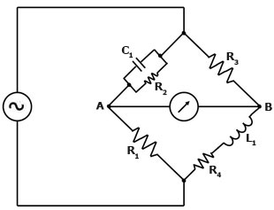

This is a bridge that I might be able to see working…

$$Z_{C}=\frac{1}{jωC}$$

$$Z_{L}=jωL$$

$$Z_{1}=R_{1}$$

$$Z_{2}=\frac{1}{jωC_{2}+\frac{1}{R_{2}}}$$

$$Z_{3}=R_{3}$$

$$Z_{4}=R_{4}+jωL_{4}$$

$$Z_{A}=Z_{1}+Z_{2}=R_{1}+\frac{1}{jωC_{2}+\frac{1}{R_{2}}}$$

$$Z_{B}=R_{3}+R_{4}+jωL_{4}$$

$$I_{A}=\frac{V_{S}}{Z_{A}}=\frac{V_{S}}{R_{1}+\frac{1}{jωC_{2}+\frac{1}{R_{2}}}}$$

$$I_{B}=\frac{V_{S}}{Z_{B}}=\frac{V_{S}}{R_{3}+R_{4}+jωL_{4}}$$

$$V_{A}=I_{A}Z_{1}=V_{S}\frac{R_{1}}{R_{1}+\frac{1}{jωC_{2}+\frac{1}{R_{2}}}}$$

$$V_{B}=I_{B}Z_{4}=V_{S}\frac{R_{4}+jωL_{4}}{R_{3}+R_{4}+jωL_{4}}$$

$$V_{AB}=V_{A}-V_{B}=V_{S}\left(\frac{R_{1}}{R_{1}+\frac{1}{jωC_{2}+\frac{1}{R_{2}}}}-\frac{R_{4}+jωL_{4}}{R_{3}+R_{4}+jωL_{4}}\right)$$

Balanced bridge:

$$V_{AB}=0=V_{S}\left(\frac{R_{1}}{R_{1}+\frac{1}{jωC_{2}+\frac{1}{R_{2}}}}-\frac{R_{0}+jωL_{0}}{R_{3}+R_{0}+jωL_{0}}\right)$$

$$R_{1}R_{3}\left(jωC_{2}+\frac{1}{R_{2}}\right)+R_{1}R_{0}\left(jωC_{2}+\frac{1}{R_{2}}\right)+jωL_{0}R_{1}\left(jωC_{2}+\frac{1}{R_{2}}\right)=jωC_{2}R_{1}\left(R_{0}+jωL_{0}\right)+\frac{R_{1}}{R_{2}}\left(R_{0}+jωL_{0}\right)+\left(R_{0}+jωL_{0}\right)$$

$$jωC_{2}R_{1}R_{3}+\frac{R_{1}}{R_{2}}R_{3}+jωC_{2}R_{1}R_{0}+\frac{R_{1}}{R_{2}}R_{0}-ω^{2}L_{0}R_{1}C_{2}+jωL_{0}R_{1}\frac{1}{R_{2}}=jωC_{2}R_{1}R_{0}-ω^{2}C_{2}R_{1}L_{0}+\frac{R_{1}}{R_{2}}R_{0}+jωL_{0}\frac{R_{1}}{R_{2}}+R_{0}+jωL_{0}$$

Match imaginary and real parts:

$$R_{1}R_{3}=R_{0}R_{2}$$

$$C_{2}=\frac{L_{0}}{R_{1}R_{3}}=\frac{L_{0}}{R_{0}R_{2}}$$

Let’s now target maximum sensitivity. First, use intuition to guess the condition that makes this possible:

$$Z_{A}=Z_{B}?$$

$$R_{1}+\frac{1}{jωC_{2}+\frac{1}{R_{2}}}=R_{3}+R_{0}+jωL_{0}$$

$$jωC_{2}R_{1}+\frac{R_{1}}{R_{2}}+1=jωC_{2}R_{3}+jωC_{2}R_{0}-ω^{2}C_{2}L_{0}+\frac{R_{3}}{R_{2}}+\frac{R_{0}}{R_{2}}+jωL_{0}\frac{1}{R_{2}}$$

$$jωC_{2}R_{1}R_{2}+R_{1}+R_{2}=jωC_{2}R_{3}R_{2}+jωC_{2}R_{0}R_{2}-ω^{2}C_{2}L_{0}R_{2}+R_{3}+R_{0}+jωL_{0}$$

Match imaginary and real parts:

$$R_{1}+R_{2}=-ω^{2}C_{2}L_{0}R_{2}+R_{3}+R_{0}$$

$$C_{2}R_{1}R_{2}=C_{2}R_{3}R_{2}+C_{2}R_{0}R_{2}+L_{0}$$

Using what we got from the condition for balance:

$$C_{2}R_{2}\left(R_{1}-R_{3}\right)=2L_{0}$$

$$R_{1}+R_{2}=R_{3}+R_{0}-ω^{2}C_{2}L_{0}R_{2}$$

We now have four equations and four unknowns. So we ought to be able to solve for every component.

$$1. R_{1}=\frac{R_{0}R_{2}}{R_{3}}$$

$$2. R_{2}=\frac{L_{0}}{C_{2}R_{0}}$$

$$R_{0}R_{2}+R_{2}R_{3}={R_{3}}^{2}+R_{0}R_{3}-ω^{2}C_{2}L_{0}R_{2}R_{3}$$

$$\frac{L_{0}}{C_{2}}\left(R_{0}+R_{3}\right)={R_{3}}^{2}+{R_{0}}^{2}R_{3}-ω^{2}{L_{0}}^{2}R_{3}$$

$$3. C_{2}=\frac{L_{0}\left(R_{0}+R_{3}\right)}{R_{3}\left({R_{0}}^{2}-ω^{2}{L_{0}}^{2}\right)}$$

$$4. {R_{3}}^{2}+R_{3}3R_{0}+{R_{0}}^{2}+ω^{2}{L_{0}}^{2}=0$$

This is a quadratic… two solutions:

$$R_{3}=\frac{-3R_{0}±\sqrt{9{R_{0}}^{2}-4{R_{0}}^{2}-4ω^{2}{L_{0}}^{2}}}{2}$$

This does seem unsolvable. Clearly we would need the positive branch… but this will probably still result in a negative resistance.

$$R_{3}=\frac{-3R_{0}+\sqrt{5{R_{0}}^{2}-4ω^{2}{L_{0}}^{2}}}{2}$$

Okay, let’s try an alternate route, by taking the actual sensitivity and setting its derivative to zero.

$$R_{1}=\frac{R_{0}R_{2}}{R_{3}}$$

$$C_{2}=\frac{L_{0}}{R_{1}R_{3}}=\frac{L_{0}}{R_{0}R_{2}}$$

$$V_{AB}=V_{S}\left(\frac{\frac{R_{0}R_{2}}{R_{3}}}{\frac{R_{0}R_{2}}{R_{3}}+\frac{1}{jω\frac{L_{0}}{R_{0}R_{2}}+\frac{1}{R_{2}}}}-\frac{R_{0}+∆R\left(∆T\right)+jωL_{0}+jω∆L(T)}{R_{3}+R_{0}+∆R\left(∆T\right)+jωL_{0}+jω∆L(T)}\right)$$

$$\frac{1}{1+\frac{R_{3}}{jωL_{0}+R_{0}}}-\frac{R_{0}+∆R\left(∆T\right)+jωL_{0}+jω∆L(T)}{R_{3}+R_{0}+∆R\left(∆T\right)+jωL_{0}+jω∆L(T)}$$

$$\frac{R_{3}+R_{0}+∆R\left(∆T\right)+jωL_{0}+jω∆L(T)-\left(R_{0}+∆R\left(∆T\right)+jωL_{0}+jω∆L(T)+\frac{R_{3}}{jωL_{0}+R_{0}}\left(R_{0}+∆R\left(∆T\right)+jωL_{0}+jω∆L(T)\right)\right)}{\left(1+\frac{R_{3}}{jωL_{0}+R_{0}}\right)\left(R_{3}+R_{0}+∆R\left(∆T\right)+jωL_{0}+jω∆L(T)\right)}$$

$$\frac{R_{3}-\frac{R_{3}}{jωL_{0}+R_{0}}\left(R_{0}+∆R\left(∆T\right)+jωL_{0}+jω∆L(T)\right)}{\left(1+\frac{R_{3}}{jωL_{0}+R_{0}}\right)\left(R_{3}+R_{0}+∆R\left(∆T\right)+jωL_{0}+jω∆L(T)\right)}$$

$$\frac{R_{3}-\frac{R_{3}\left(R_{0}-jωL_{0}\right)}{{R_{0}}^{2}+ω^{2}{L_{0}}^{2}}\left(R_{0}+∆R\left(∆T\right)+jωL_{0}+jω∆L(T)\right)}{\left(1+\frac{R_{3}}{jωL_{0}+R_{0}}\right)\left(R_{3}+R_{0}+∆R\left(∆T\right)+jωL_{0}+jω∆L(T)\right)}$$

$$\frac{R_{3}}{jωL_{0}+R_{0}}=\frac{R_{3}\left(R_{0}-jωL_{0}\right)}{{R_{0}}^{2}+ω^{2}{L_{0}}^{2}}$$

$$\frac{\left(R_{3}+R_{0}+∆R\left(∆T\right)+jωL_{0}+jω∆L(T)\right)\left(\frac{R_{3}\left(jωL_{0}-R_{0}\right)}{{R_{0}}^{2}+ω^{2}{L_{0}}^{2}}\right)}{\left(1+\frac{R_{3}\left(R_{0}-jωL_{0}\right)}{{R_{0}}^{2}+ω^{2}{L_{0}}^{2}}\right)\left(R_{3}+R_{0}+∆R\left(∆T\right)+jωL_{0}+jω∆L(T)\right)}$$

Denominator:

$$R_{3}+R_{0}+∆R\left(∆T\right)+\frac{R_{3}}{{R_{0}}^{2}+ω^{2}{L_{0}}^{2}}\left(R_{0}R_{3}+{R_{0}}^{2}+R_{0}∆R\left(∆T\right)+ω^{2}{L_{0}}^{2}+ω^{2}L_{0}∆L(T)\right)+jω\left[L_{0}+∆L\left(T\right)+\frac{R_{3}}{{R_{0}}^{2}+ω^{2}{L_{0}}^{2}}\left(-L_{0}R_{3}-L_{0}∆R\left(∆T\right)+R_{0}∆L\left(T\right)\right)\right]$$

Numerator:

$$R_{3}-\frac{R_{3}}{{R_{0}}^{2}+ω^{2}{L_{0}}^{2}}\left({R_{0}}^{2}+R_{0}∆R\left(∆T\right)+ω^{2}{L_{0}}^{2}+ω^{2}L_{0}∆L(T)+jωR_{0}∆L\left(T\right)-jωL_{0}∆R\left(∆T\right)\right)$$

$$R_{3}-\frac{R_{3}\left({R_{0}}^{2}+R_{0}∆R\left(∆T\right)+ω^{2}{L_{0}}^{2}+ω^{2}L_{0}∆L(T)\right)}{{R_{0}}^{2}+ω^{2}{L_{0}}^{2}}+jω\left[\frac{R_{3}\left(L_{0}∆R\left(∆T\right)-R_{0}∆L\left(T\right)\right)}{{R_{0}}^{2}+ω^{2}{L_{0}}^{2}}\right]$$

Full equation:

$$\frac{\left[R_{3}-\frac{R_{3}\left({R_{0}}^{2}+R_{0}∆R\left(∆T\right)+ω^{2}{L_{0}}^{2}+ω^{2}L_{0}∆L(T)\right)}{{R_{0}}^{2}+ω^{2}{L_{0}}^{2}}\right]+jω\left[\frac{R_{3}\left(L_{0}∆R\left(∆T\right)-R_{0}∆L\left(T\right)\right)}{{R_{0}}^{2}+ω^{2}{L_{0}}^{2}}\right]}{\left[R_{3}+R_{0}+∆R\left(∆T\right)+\frac{R_{3}}{{R_{0}}^{2}+ω^{2}{L_{0}}^{2}}\left(R_{0}R_{3}+{R_{0}}^{2}+R_{0}∆R\left(∆T\right)+ω^{2}{L_{0}}^{2}+ω^{2}L_{0}∆L(T)\right)\right]+jω\left[L_{0}+∆L\left(T\right)+\frac{R_{3}}{{R_{0}}^{2}+ω^{2}{L_{0}}^{2}}\left(-L_{0}R_{3}-L_{0}∆R\left(∆T\right)+R_{0}∆L\left(T\right)\right)\right]}$$

$$\frac{\left(\left[R_{3}-\frac{R_{3}\left({R_{0}}^{2}+R_{0}∆R\left(∆T\right)+ω^{2}{L_{0}}^{2}+ω^{2}L_{0}∆L(T)\right)}{{R_{0}}^{2}+ω^{2}{L_{0}}^{2}}\right]+jω\left[\frac{R_{3}\left(L_{0}∆R\left(∆T\right)-R_{0}∆L\left(T\right)\right)}{{R_{0}}^{2}+ω^{2}{L_{0}}^{2}}\right]\right)\left(\left[R_{3}+R_{0}+∆R\left(∆T\right)+\frac{R_{3}}{{R_{0}}^{2}+ω^{2}{L_{0}}^{2}}\left(R_{0}R_{3}+{R_{0}}^{2}+R_{0}∆R\left(∆T\right)+ω^{2}{L_{0}}^{2}+ω^{2}L_{0}∆L(T)\right)\right]-jω\left[L_{0}+∆L\left(T\right)+\frac{R_{3}}{{R_{0}}^{2}+ω^{2}{L_{0}}^{2}}\left(-L_{0}R_{3}-L_{0}∆R\left(∆T\right)+R_{0}∆L\left(T\right)\right)\right]\right)}{{\left[R_{3}+R_{0}+∆R\left(∆T\right)+\frac{R_{3}}{{R_{0}}^{2}+ω^{2}{L_{0}}^{2}}\left(R_{0}R_{3}+{R_{0}}^{2}+R_{0}∆R\left(∆T\right)+ω^{2}{L_{0}}^{2}+ω^{2}L_{0}∆L(T)\right)\right]}^{2}+ω^{2}{\left[L_{0}+∆L\left(T\right)+\frac{R_{3}}{{R_{0}}^{2}+ω^{2}{L_{0}}^{2}}\left(-L_{0}R_{3}-L_{0}∆R\left(∆T\right)+R_{0}∆L\left(T\right)\right)\right]}^{2}}$$

Numerator:

$$\left(\left[R_{3}-\frac{R_{3}\left({R_{0}}^{2}+R_{0}∆R\left(∆T\right)+ω^{2}{L_{0}}^{2}+ω^{2}L_{0}∆L(T)\right)}{{R_{0}}^{2}+ω^{2}{L_{0}}^{2}}\right]\left[R_{3}+R_{0}+∆R\left(∆T\right)+\frac{R_{3}}{{R_{0}}^{2}+ω^{2}{L_{0}}^{2}}\left(R_{0}R_{3}+{R_{0}}^{2}+R_{0}∆R\left(∆T\right)+ω^{2}{L_{0}}^{2}+ω^{2}L_{0}∆L(T)\right)\right]+jω\left[\frac{R_{3}\left(L_{0}∆R\left(∆T\right)-R_{0}∆L\left(T\right)\right)}{{R_{0}}^{2}+ω^{2}{L_{0}}^{2}}\right]\left[R_{3}+R_{0}+∆R\left(∆T\right)+\frac{R_{3}}{{R_{0}}^{2}+ω^{2}{L_{0}}^{2}}\left(R_{0}R_{3}+{R_{0}}^{2}+R_{0}∆R\left(∆T\right)+ω^{2}{L_{0}}^{2}+ω^{2}L_{0}∆L(T)\right)\right]\right)+\left(-jω\left[L_{0}+∆L\left(T\right)+\frac{R_{3}}{{R_{0}}^{2}+ω^{2}{L_{0}}^{2}}\left(-L_{0}R_{3}-L_{0}∆R\left(∆T\right)+R_{0}∆L\left(T\right)\right)\right]\left[R_{3}-\frac{R_{3}\left({R_{0}}^{2}+R_{0}∆R\left(∆T\right)+ω^{2}{L_{0}}^{2}+ω^{2}L_{0}∆L(T)\right)}{{R_{0}}^{2}+ω^{2}{L_{0}}^{2}}\right]-jω\left[L_{0}+∆L\left(T\right)+\frac{R_{3}}{{R_{0}}^{2}+ω^{2}{L_{0}}^{2}}\left(-L_{0}R_{3}-L_{0}∆R\left(∆T\right)+R_{0}∆L\left(T\right)\right)\right]jω\left[\frac{R_{3}\left(L_{0}∆R\left(∆T\right)-R_{0}∆L\left(T\right)\right)}{{R_{0}}^{2}+ω^{2}{L_{0}}^{2}}\right]\right)$$

$$\left[{R_{3}}^{2}-\frac{{R_{3}}^{2}\left({R_{0}}^{2}+R_{0}∆R\left(∆T\right)+ω^{2}{L_{0}}^{2}+ω^{2}L_{0}∆L(T)\right)}{{R_{0}}^{2}+ω^{2}{L_{0}}^{2}}+R_{0}R_{3}-\frac{R_{0}R_{3}\left({R_{0}}^{2}+R_{0}∆R\left(∆T\right)+ω^{2}{L_{0}}^{2}+ω^{2}L_{0}∆L(T)\right)}{{R_{0}}^{2}+ω^{2}{L_{0}}^{2}}+R_{3}∆R\left(∆T\right)-\frac{R_{3}∆R\left(∆T\right)\left({R_{0}}^{2}+R_{0}∆R\left(∆T\right)+ω^{2}{L_{0}}^{2}+ω^{2}L_{0}∆L(T)\right)}{{R_{0}}^{2}+ω^{2}{L_{0}}^{2}}+\frac{{R_{3}}^{2}R_{0}R_{3}+{R_{3}}^{2}\left({R_{0}}^{2}+R_{0}∆R\left(∆T\right)+ω^{2}{L_{0}}^{2}+ω^{2}L_{0}∆L(T)\right)}{{R_{0}}^{2}+ω^{2}{L_{0}}^{2}}-\frac{{R_{3}}^{2}\left({R_{0}}^{2}+R_{0}∆R\left(∆T\right)+ω^{2}{L_{0}}^{2}+ω^{2}L_{0}∆L(T)\right)\left(R_{0}R_{3}+{R_{0}}^{2}+R_{0}∆R\left(∆T\right)+ω^{2}{L_{0}}^{2}+ω^{2}L_{0}∆L(T)\right)}{{\left({R_{0}}^{2}+ω^{2}{L_{0}}^{2}\right)}^{2}}\right]+\left[ω^{2}L_{0}\left[\frac{R_{3}L_{0}∆R\left(∆T\right)-R_{3}R_{0}∆L\left(T\right)}{{R_{0}}^{2}+ω^{2}{L_{0}}^{2}}\right]+ω^{2}∆L\left(T\right)\left[\frac{R_{3}L_{0}∆R\left(∆T\right)-R_{3}R_{0}∆L\left(T\right)}{{R_{0}}^{2}+ω^{2}{L_{0}}^{2}}\right]+\frac{ω^{2}R_{3}}{{\left({R_{0}}^{2}+ω^{2}{L_{0}}^{2}\right)}^{2}}\left[R_{3}\left(L_{0}∆R\left(∆T\right)-R_{0}∆L\left(T\right)\right)\right]\left(-L_{0}R_{3}-L_{0}∆R\left(∆T\right)+R_{0}∆L\left(T\right)\right)\right]+jω\left[\left[\frac{R_{3}\left(L_{0}∆R\left(∆T\right)-R_{0}∆L\left(T\right)\right)}{{R_{0}}^{2}+ω^{2}{L_{0}}^{2}}\right]\left[R_{3}+R_{0}+∆R\left(∆T\right)+\frac{R_{3}}{{R_{0}}^{2}+ω^{2}{L_{0}}^{2}}\left(R_{0}R_{3}+{R_{0}}^{2}+R_{0}∆R\left(∆T\right)+ω^{2}{L_{0}}^{2}+ω^{2}L_{0}∆L(T)\right)\right]-\left[L_{0}+∆L\left(T\right)+\frac{R_{3}}{{R_{0}}^{2}+ω^{2}{L_{0}}^{2}}\left(-L_{0}R_{3}-L_{0}∆R\left(∆T\right)+R_{0}∆L\left(T\right)\right)\right]\left[R_{3}-\frac{R_{3}\left({R_{0}}^{2}+R_{0}∆R\left(∆T\right)+ω^{2}{L_{0}}^{2}+ω^{2}L_{0}∆L(T)\right)}{{R_{0}}^{2}+ω^{2}{L_{0}}^{2}}\right]\right]$$

$${R_{3}}^{2}+R_{0}R_{3}-\frac{R_{0}R_{3}\left({R_{0}}^{2}+R_{0}∆R\left(∆T\right)+ω^{2}{L_{0}}^{2}+ω^{2}L_{0}∆L(T)\right)}{{R_{0}}^{2}+ω^{2}{L_{0}}^{2}}+R_{3}∆R\left(∆T\right)-\frac{R_{3}∆R\left(∆T\right)\left({R_{0}}^{2}+R_{0}∆R\left(∆T\right)+ω^{2}{L_{0}}^{2}+ω^{2}L_{0}∆L(T)\right)}{{R_{0}}^{2}+ω^{2}{L_{0}}^{2}}+\frac{{R_{3}}^{2}R_{0}R_{3}}{{R_{0}}^{2}+ω^{2}{L_{0}}^{2}}-\frac{{R_{3}}^{2}\left({R_{0}}^{2}+R_{0}∆R\left(∆T\right)+ω^{2}{L_{0}}^{2}+ω^{2}L_{0}∆L(T)\right)\left(R_{0}R_{3}+{R_{0}}^{2}+R_{0}∆R\left(∆T\right)+ω^{2}{L_{0}}^{2}+ω^{2}L_{0}∆L(T)\right)}{{\left({R_{0}}^{2}+ω^{2}{L_{0}}^{2}\right)}^{2}}+\frac{ω^{2}{L_{0}}^{2}R_{3}∆R\left(∆T\right)-ω^{2}L_{0}R_{3}R_{0}∆L\left(T\right)}{{R_{0}}^{2}+ω^{2}{L_{0}}^{2}}+\frac{ω^{2}L_{0}R_{3}∆R\left(∆T\right)∆L\left(T\right)-ω^{2}R_{3}R_{0}{∆L\left(T\right)}^{2}}{{R_{0}}^{2}+ω^{2}{L_{0}}^{2}}+\frac{ω^{2}{R_{3}}^{2}}{{\left({R_{0}}^{2}+ω^{2}{L_{0}}^{2}\right)}^{2}}\left[-{L_{0}}^{2}R_{3}∆R\left(∆T\right)+L_{0}R_{3}R_{0}∆L\left(T\right)-{L_{0}}^{2}{∆R\left(∆T\right)}^{2}+2L_{0}R_{0}∆R\left(∆T\right)∆L\left(T\right)-{R_{0}}^{2}{∆L\left(T\right)}^{2}\right]+jω\left[\left[\frac{R_{3}\left(L_{0}∆R\left(∆T\right)-R_{0}∆L\left(T\right)\right)}{{R_{0}}^{2}+ω^{2}{L_{0}}^{2}}\right]\left[R_{3}+R_{0}+∆R\left(∆T\right)+\frac{R_{3}}{{R_{0}}^{2}+ω^{2}{L_{0}}^{2}}\left(R_{0}R_{3}+{R_{0}}^{2}+R_{0}∆R\left(∆T\right)+ω^{2}{L_{0}}^{2}+ω^{2}L_{0}∆L(T)\right)\right]-\left[L_{0}+∆L\left(T\right)+\frac{R_{3}}{{R_{0}}^{2}+ω^{2}{L_{0}}^{2}}\left(-L_{0}R_{3}-L_{0}∆R\left(∆T\right)+R_{0}∆L\left(T\right)\right)\right]\left[R_{3}-\frac{R_{3}\left({R_{0}}^{2}+R_{0}∆R\left(∆T\right)+ω^{2}{L_{0}}^{2}+ω^{2}L_{0}∆L(T)\right)}{{R_{0}}^{2}+ω^{2}{L_{0}}^{2}}\right]\right]$$

$${R_{3}}^{2}+R_{0}R_{3}+R_{3}∆R\left(∆T\right)+\frac{1}{{R_{0}}^{2}+ω^{2}{L_{0}}^{2}}\left(-R_{0}R_{3}\left({R_{0}}^{2}+R_{0}∆R\left(∆T\right)+ω^{2}{L_{0}}^{2}+ω^{2}L_{0}∆L(T)\right)-R_{3}∆R\left(∆T\right)\left({R_{0}}^{2}+R_{0}∆R\left(∆T\right)+ω^{2}{L_{0}}^{2}+ω^{2}L_{0}∆L(T)\right)+{R_{3}}^{2}R_{0}R_{3}+ω^{2}{L_{0}}^{2}R_{3}∆R\left(∆T\right)-ω^{2}L_{0}R_{3}R_{0}∆L\left(T\right)+ω^{2}L_{0}R_{3}∆R\left(∆T\right)∆L\left(T\right)-ω^{2}R_{3}R_{0}{∆L\left(T\right)}^{2}\right)-\frac{{R_{3}}^{2}\left({R_{0}}^{2}+R_{0}∆R\left(∆T\right)+ω^{2}{L_{0}}^{2}+ω^{2}L_{0}∆L(T)\right)\left(R_{0}R_{3}+{R_{0}}^{2}+R_{0}∆R\left(∆T\right)+ω^{2}{L_{0}}^{2}+ω^{2}L_{0}∆L(T)\right)}{{\left({R_{0}}^{2}+ω^{2}{L_{0}}^{2}\right)}^{2}}+\frac{ω^{2}{R_{3}}^{2}}{{\left({R_{0}}^{2}+ω^{2}{L_{0}}^{2}\right)}^{2}}\left[-{L_{0}}^{2}R_{3}∆R\left(∆T\right)+L_{0}R_{3}R_{0}∆L\left(T\right)-{L_{0}}^{2}{∆R\left(∆T\right)}^{2}+2L_{0}R_{0}∆R\left(∆T\right)∆L\left(T\right)-{R_{0}}^{2}{∆L\left(T\right)}^{2}\right]+jω\left[\left[\frac{R_{3}\left(L_{0}∆R\left(∆T\right)-R_{0}∆L\left(T\right)\right)}{{R_{0}}^{2}+ω^{2}{L_{0}}^{2}}\right]\left[R_{3}+R_{0}+∆R\left(∆T\right)+\frac{R_{3}}{{R_{0}}^{2}+ω^{2}{L_{0}}^{2}}\left(R_{0}R_{3}+{R_{0}}^{2}+R_{0}∆R\left(∆T\right)+ω^{2}{L_{0}}^{2}+ω^{2}L_{0}∆L(T)\right)\right]-\left[L_{0}+∆L\left(T\right)+\frac{R_{3}}{{R_{0}}^{2}+ω^{2}{L_{0}}^{2}}\left(-L_{0}R_{3}-L_{0}∆R\left(∆T\right)+R_{0}∆L\left(T\right)\right)\right]\left[R_{3}-\frac{R_{3}\left({R_{0}}^{2}+R_{0}∆R\left(∆T\right)+ω^{2}{L_{0}}^{2}+ω^{2}L_{0}∆L(T)\right)}{{R_{0}}^{2}+ω^{2}{L_{0}}^{2}}\right]\right]$$

$${R_{3}}^{2}+R_{0}R_{3}+R_{3}∆R\left(∆T\right)+\frac{1}{{R_{0}}^{2}+ω^{2}{L_{0}}^{2}}\left(-R_{3}{R_{0}}^{3}-R_{0}R_{3}ω^{2}{L_{0}}^{2}-R_{3}{R_{0}}^{2}∆R\left(∆T\right)-R_{0}R_{3}ω^{2}L_{0}∆L\left(T\right)-R_{3}{R_{0}}^{2}∆R\left(∆T\right)-R_{3}R_{0}{∆R\left(∆T\right)}^{2}-ω^{2}{L_{0}}^{2}R_{3}∆R\left(∆T\right)-ω^{2}L_{0}R_{3}∆R\left(∆T\right)∆L(T)+{R_{3}}^{2}R_{0}R_{3}+ω^{2}{L_{0}}^{2}R_{3}∆R\left(∆T\right)-ω^{2}R_{3}R_{0}{∆L\left(T\right)}^{2}\right)-\frac{{R_{3}}^{2}\left({R_{0}}^{2}+R_{0}∆R\left(∆T\right)+ω^{2}{L_{0}}^{2}+ω^{2}L_{0}∆L(T)\right)\left(R_{0}R_{3}+{R_{0}}^{2}+R_{0}∆R\left(∆T\right)+ω^{2}{L_{0}}^{2}+ω^{2}L_{0}∆L(T)\right)}{{\left({R_{0}}^{2}+ω^{2}{L_{0}}^{2}\right)}^{2}}+\frac{ω^{2}{R_{3}}^{2}}{{\left({R_{0}}^{2}+ω^{2}{L_{0}}^{2}\right)}^{2}}\left[-{L_{0}}^{2}R_{3}∆R\left(∆T\right)+L_{0}R_{3}R_{0}∆L\left(T\right)-{L_{0}}^{2}{∆R\left(∆T\right)}^{2}+2L_{0}R_{0}∆R\left(∆T\right)∆L\left(T\right)-{R_{0}}^{2}{∆L\left(T\right)}^{2}\right]+jω\left[\left[\frac{R_{3}\left(L_{0}∆R\left(∆T\right)-R_{0}∆L\left(T\right)\right)}{{R_{0}}^{2}+ω^{2}{L_{0}}^{2}}\right]\left[R_{3}+R_{0}+∆R\left(∆T\right)+\frac{R_{3}}{{R_{0}}^{2}+ω^{2}{L_{0}}^{2}}\left(R_{0}R_{3}+{R_{0}}^{2}+R_{0}∆R\left(∆T\right)+ω^{2}{L_{0}}^{2}+ω^{2}L_{0}∆L(T)\right)\right]-\left[L_{0}+∆L\left(T\right)+\frac{R_{3}}{{R_{0}}^{2}+ω^{2}{L_{0}}^{2}}\left(-L_{0}R_{3}-L_{0}∆R\left(∆T\right)+R_{0}∆L\left(T\right)\right)\right]\left[R_{3}-\frac{R_{3}\left({R_{0}}^{2}+R_{0}∆R\left(∆T\right)+ω^{2}{L_{0}}^{2}+ω^{2}L_{0}∆L(T)\right)}{{R_{0}}^{2}+ω^{2}{L_{0}}^{2}}\right]\right]$$

$${R_{3}}^{2}+R_{0}R_{3}+R_{3}∆R\left(∆T\right)+\frac{R_{3}}{{R_{0}}^{2}+ω^{2}{L_{0}}^{2}}\left({R_{3}}^{2}R_{0}-{R_{0}}^{3}-R_{0}ω^{2}{L_{0}}^{2}-{R_{0}}^{2}∆R\left(∆T\right)-R_{0}ω^{2}L_{0}∆L\left(T\right)-{R_{0}}^{2}∆R\left(∆T\right)-R_{0}{∆R\left(∆T\right)}^{2}-ω^{2}L_{0}∆R\left(∆T\right)∆L(T)-ω^{2}R_{0}{∆L\left(T\right)}^{2}\right)+\frac{{R_{3}}^{2}}{{\left({R_{0}}^{2}+ω^{2}{L_{0}}^{2}\right)}^{2}}\left[-ω^{2}{L_{0}}^{2}R_{3}∆R\left(∆T\right)+ω^{2}L_{0}R_{3}R_{0}∆L\left(T\right)-ω^{2}{L_{0}}^{2}{∆R\left(∆T\right)}^{2}+2ω^{2}L_{0}R_{0}∆R\left(∆T\right)∆L\left(T\right)-ω^{2}{R_{0}}^{2}{∆L\left(T\right)}^{2}-{R_{0}}^{3}R_{3}-{R_{0}}^{4}-{R_{0}}^{3}∆R\left(∆T\right)-{R_{0}}^{2}ω^{2}{L_{0}}^{2}-{R_{0}}^{2}ω^{2}L_{0}∆L(T)-{R_{0}}^{2}R_{3}∆R\left(∆T\right)-{R_{0}}^{3}∆R\left(∆T\right)-{R_{0}}^{2}{∆R\left(∆T\right)}^{2}-ω^{2}{L_{0}}^{2}R_{0}∆R\left(∆T\right)-ω^{2}L_{0}R_{0}∆R\left(∆T\right)∆L(T)-ω^{2}{L_{0}}^{2}R_{0}R_{3}-ω^{2}{L_{0}}^{2}{R_{0}}^{2}-ω^{2}{L_{0}}^{2}R_{0}∆R\left(∆T\right)-ω^{4}{L_{0}}^{4}-ω^{4}{L_{0}}^{3}∆L(T)-ω^{2}L_{0}R_{0}R_{3}∆L(T)-ω^{2}L_{0}{R_{0}}^{2}∆L(T)-ω^{2}L_{0}R_{0}∆R\left(∆T\right)∆L(T)-ω^{4}{L_{0}}^{3}∆L(T)-ω^{4}{L_{0}}^{2}{∆L(T)}^{2}\right]+jω\left[\left[\frac{R_{3}\left(L_{0}∆R\left(∆T\right)-R_{0}∆L\left(T\right)\right)}{{R_{0}}^{2}+ω^{2}{L_{0}}^{2}}\right]\left[R_{3}+R_{0}+∆R\left(∆T\right)+\frac{R_{3}}{{R_{0}}^{2}+ω^{2}{L_{0}}^{2}}\left(R_{0}R_{3}+{R_{0}}^{2}+R_{0}∆R\left(∆T\right)+ω^{2}{L_{0}}^{2}+ω^{2}L_{0}∆L(T)\right)\right]-\left[L_{0}+∆L\left(T\right)+\frac{R_{3}}{{R_{0}}^{2}+ω^{2}{L_{0}}^{2}}\left(-L_{0}R_{3}-L_{0}∆R\left(∆T\right)+R_{0}∆L\left(T\right)\right)\right]\left[R_{3}-\frac{R_{3}\left({R_{0}}^{2}+R_{0}∆R\left(∆T\right)+ω^{2}{L_{0}}^{2}+ω^{2}L_{0}∆L(T)\right)}{{R_{0}}^{2}+ω^{2}{L_{0}}^{2}}\right]\right]$$

$$-{R_{0}}^{3}R_{3}-{R_{0}}^{4}-ω^{2}{L_{0}}^{2}R_{0}R_{3}-2ω^{2}{L_{0}}^{2}{R_{0}}^{2}-ω^{4}{L_{0}}^{4}-ω^{2}{L_{0}}^{2}R_{3}∆R\left(∆T\right)-2ω^{2}{L_{0}}^{2}R_{0}∆R\left(∆T\right)-{R_{0}}^{2}R_{3}∆R\left(∆T\right)-2{R_{0}}^{3}∆R\left(∆T\right)+ω^{2}L_{0}R_{3}R_{0}∆L\left(T\right)-ω^{4}{L_{0}}^{3}∆L(T)-ω^{2}L_{0}R_{0}R_{3}∆L(T)-ω^{2}L_{0}{R_{0}}^{2}∆L(T)-ω^{4}{L_{0}}^{3}∆L(T)-{R_{0}}^{2}ω^{2}L_{0}∆L(T)+2ω^{2}L_{0}R_{0}∆R\left(∆T\right)∆L\left(T\right)-2ω^{2}L_{0}R_{0}∆R\left(∆T\right)∆L(T)-{R_{0}}^{2}{∆R\left(∆T\right)}^{2}-ω^{2}{L_{0}}^{2}{∆R\left(∆T\right)}^{2}-ω^{4}{L_{0}}^{2}{∆L(T)}^{2}-ω^{2}{R_{0}}^{2}{∆L\left(T\right)}^{2}$$

$$-{R_{0}}^{3}R_{3}-{R_{0}}^{4}-ω^{2}{L_{0}}^{2}R_{0}R_{3}-2ω^{2}{L_{0}}^{2}{R_{0}}^{2}-ω^{4}{L_{0}}^{4}-ω^{2}{L_{0}}^{2}R_{3}∆R\left(∆T\right)-2ω^{2}{L_{0}}^{2}R_{0}∆R\left(∆T\right)-{R_{0}}^{2}R_{3}∆R\left(∆T\right)-2{R_{0}}^{3}∆R\left(∆T\right)-2ω^{4}{L_{0}}^{3}∆L(T)-2{R_{0}}^{2}ω^{2}L_{0}∆L(T)-{R_{0}}^{2}{∆R\left(∆T\right)}^{2}-ω^{2}{L_{0}}^{2}{∆R\left(∆T\right)}^{2}-ω^{4}{L_{0}}^{2}{∆L(T)}^{2}-ω^{2}{R_{0}}^{2}{∆L\left(T\right)}^{2}$$

$$\left(-R_{0}R_{3}-{R_{0}}^{2}-ω^{2}{L_{0}}^{2}-R_{3}∆R\left(∆T\right)-2R_{0}∆R\left(∆T\right)-2ω^{2}L_{0}∆L\left(T\right)-{∆R\left(∆T\right)}^{2}-ω^{2}{∆L\left(T\right)}^{2}\right)\left({R_{0}}^{2}+ω^{2}{L_{0}}^{2}\right)$$

$${R_{3}}^{2}+R_{0}R_{3}+R_{3}∆R\left(∆T\right)+\frac{R_{3}}{{R_{0}}^{2}+ω^{2}{L_{0}}^{2}}\left({R_{3}}^{2}R_{0}-{R_{0}}^{3}-R_{0}ω^{2}{L_{0}}^{2}-{R_{0}}^{2}∆R\left(∆T\right)-R_{0}ω^{2}L_{0}∆L\left(T\right)-{R_{0}}^{2}∆R\left(∆T\right)-R_{0}{∆R\left(∆T\right)}^{2}-ω^{2}L_{0}∆R\left(∆T\right)∆L(T)-ω^{2}R_{0}{∆L\left(T\right)}^{2}\right)+\frac{{R_{3}}^{2}}{{R_{0}}^{2}+ω^{2}{L_{0}}^{2}}\left[\left(-R_{0}R_{3}-{R_{0}}^{2}-ω^{2}{L_{0}}^{2}-R_{3}∆R\left(∆T\right)-2R_{0}∆R\left(∆T\right)-2ω^{2}L_{0}∆L\left(T\right)-{∆R\left(∆T\right)}^{2}-ω^{2}{∆L\left(T\right)}^{2}\right)\right]+jω\left[\left[\frac{R_{3}\left(L_{0}∆R\left(∆T\right)-R_{0}∆L\left(T\right)\right)}{{R_{0}}^{2}+ω^{2}{L_{0}}^{2}}\right]\left[R_{3}+R_{0}+∆R\left(∆T\right)+\frac{R_{3}}{{R_{0}}^{2}+ω^{2}{L_{0}}^{2}}\left(R_{0}R_{3}+{R_{0}}^{2}+R_{0}∆R\left(∆T\right)+ω^{2}{L_{0}}^{2}+ω^{2}L_{0}∆L(T)\right)\right]-\left[L_{0}+∆L\left(T\right)+\frac{R_{3}}{{R_{0}}^{2}+ω^{2}{L_{0}}^{2}}\left(-L_{0}R_{3}-L_{0}∆R\left(∆T\right)+R_{0}∆L\left(T\right)\right)\right]\left[R_{3}-\frac{R_{3}\left({R_{0}}^{2}+R_{0}∆R\left(∆T\right)+ω^{2}{L_{0}}^{2}+ω^{2}L_{0}∆L(T)\right)}{{R_{0}}^{2}+ω^{2}{L_{0}}^{2}}\right]\right]$$

$${R_{3}}^{2}+R_{0}R_{3}+R_{3}∆R\left(∆T\right)+\frac{R_{3}}{{R_{0}}^{2}+ω^{2}{L_{0}}^{2}}\left(-{R_{0}}^{3}-R_{3}{R_{0}}^{2}-R_{3}ω^{2}{L_{0}}^{2}-R_{0}ω^{2}{L_{0}}^{2}-{R_{3}}^{2}∆R\left(∆T\right)-2R_{3}R_{0}∆R\left(∆T\right)-2{R_{0}}^{2}∆R\left(∆T\right)-R_{0}ω^{2}L_{0}∆L\left(T\right)-2R_{3}ω^{2}L_{0}∆L\left(T\right)-ω^{2}L_{0}∆R\left(∆T\right)∆L(T)-R_{0}{∆R\left(∆T\right)}^{2}-R_{3}{∆R\left(∆T\right)}^{2}-ω^{2}R_{0}{∆L\left(T\right)}^{2}-R_{3}ω^{2}{∆L\left(T\right)}^{2}\right)+jω\left[\left[\frac{R_{3}\left(L_{0}∆R\left(∆T\right)-R_{0}∆L\left(T\right)\right)}{{R_{0}}^{2}+ω^{2}{L_{0}}^{2}}\right]\left[R_{3}+R_{0}+∆R\left(∆T\right)+\frac{R_{3}}{{R_{0}}^{2}+ω^{2}{L_{0}}^{2}}\left(R_{0}R_{3}+{R_{0}}^{2}+R_{0}∆R\left(∆T\right)+ω^{2}{L_{0}}^{2}+ω^{2}L_{0}∆L(T)\right)\right]-\left[L_{0}+∆L\left(T\right)+\frac{R_{3}}{{R_{0}}^{2}+ω^{2}{L_{0}}^{2}}\left(-L_{0}R_{3}-L_{0}∆R\left(∆T\right)+R_{0}∆L\left(T\right)\right)\right]\left[R_{3}-\frac{R_{3}\left({R_{0}}^{2}+R_{0}∆R\left(∆T\right)+ω^{2}{L_{0}}^{2}+ω^{2}L_{0}∆L(T)\right)}{{R_{0}}^{2}+ω^{2}{L_{0}}^{2}}\right]\right]$$

Imaginary part:

$$+jω\left[\left[\frac{R_{3}}{{R_{0}}^{2}+ω^{2}{L_{0}}^{2}}\right]\left[R_{3}L_{0}∆R\left(∆T\right)+R_{0}L_{0}∆R\left(∆T\right)+L_{0}{∆R\left(∆T\right)}^{2}+\frac{R_{3}L_{0}∆R\left(∆T\right)}{{R_{0}}^{2}+ω^{2}{L_{0}}^{2}}\left(R_{0}R_{3}+{R_{0}}^{2}+R_{0}∆R\left(∆T\right)+ω^{2}{L_{0}}^{2}+ω^{2}L_{0}∆L(T)\right)-R_{0}R_{3}∆L\left(T\right)-{R_{0}}^{2}∆L\left(T\right)-R_{0}∆L\left(T\right)∆R\left(∆T\right)+\frac{-R_{0}R_{3}∆L\left(T\right)}{{R_{0}}^{2}+ω^{2}{L_{0}}^{2}}\left(R_{0}R_{3}+{R_{0}}^{2}+R_{0}∆R\left(∆T\right)+ω^{2}{L_{0}}^{2}+ω^{2}L_{0}∆L(T)\right)\right]+\left[-L_{0}-∆L\left(T\right)+\frac{R_{3}}{{R_{0}}^{2}+ω^{2}{L_{0}}^{2}}\left(L_{0}R_{3}+L_{0}∆R\left(∆T\right)-R_{0}∆L\left(T\right)\right)\right]\left[R_{3}-\frac{R_{3}\left({R_{0}}^{2}+R_{0}∆R\left(∆T\right)+ω^{2}{L_{0}}^{2}+ω^{2}L_{0}∆L(T)\right)}{{R_{0}}^{2}+ω^{2}{L_{0}}^{2}}\right]\right]$$

$$\left[-L_{0}R_{3}-R_{3}∆L\left(T\right)+\frac{R_{3}}{{R_{0}}^{2}+ω^{2}{L_{0}}^{2}}\left(L_{0}{R_{3}}^{2}+L_{0}R_{3}∆R\left(∆T\right)-R_{0}R_{3}∆L\left(T\right)\right)+L_{0}\frac{R_{3}\left({R_{0}}^{2}+R_{0}∆R\left(∆T\right)+ω^{2}{L_{0}}^{2}+ω^{2}L_{0}∆L(T)\right)}{{R_{0}}^{2}+ω^{2}{L_{0}}^{2}}+∆L\left(T\right)\frac{R_{3}\left({R_{0}}^{2}+R_{0}∆R\left(∆T\right)+ω^{2}{L_{0}}^{2}+ω^{2}L_{0}∆L(T)\right)}{{R_{0}}^{2}+ω^{2}{L_{0}}^{2}}+\left(-L_{0}R_{3}-L_{0}∆R\left(∆T\right)+R_{0}∆L\left(T\right)\right)\frac{{R_{3}}^{2}\left({R_{0}}^{2}+R_{0}∆R\left(∆T\right)+ω^{2}{L_{0}}^{2}+ω^{2}L_{0}∆L(T)\right)}{{\left({R_{0}}^{2}+ω^{2}{L_{0}}^{2}\right)}^{2}}\right]$$

Sensitivity:

$$B=\frac{∂V}{∂∆T}$$