UBC Rapid Meeting minutes from 24 Feb 2011: Induction heating circuitry updates

Thursday’s meeting saw a lot of ideas proposed to solve the remaining issues in the induction-heating extruder and temperature sensor. We started by identifying all of the open questions:

1. Current sources – how do we build them / where do we buy them? Can we get current sources that go up to 100 kHz @ a couple of amps for the main heater? Can they be electronically controlled by an arduino?
2. We also need one that will go up to 10 kHz @ hundreds of milliamps for the sensor.
3. DC current source – need a stable DC source to counteract changing resistance in the primary coil. The coil resistance will add an extra Rcoil*Isens to the sensed AC voltage, which can change with temperature, and is undesirable. Kevin pointed out that DC current injected into the coil will shift the AC sensing signal up or down by exactly Rcoil*IDC. He suggested that if we use a *half-wave* rectifier (4), this will be subtracted from the rectified voltage. Then if we use IDC=Isens, and measure the peak voltage, we should get back exactly the right voltage with no corruption from the coil’s own resistance!

Since we’re looking for IDC = Isens, it would make sense that our DC current source should probably be a (full-wave) rectified version of the sense current source, or otherwise somehow controlled to have the same amplitude.

1. Signal rectifier – we can’t measure the AC signal (V) directly with an analog-to-digital converter, so it has to be rectified first. As mentioned above, we will want a half-wave rectifier for this. The half-wave rectifier should also be set up to ‘hold’ the peak of the wave (I think this is covered in EECE 363), but it shouldn’t have too long a time constant or else we won’t be able measure changes in the sensor output.

We also need a filter before the rectifier to reduce noise. But we also have to make sure that the filter doesn’t filter out the DC offset that we deliberately added in to cancel the coil resistance.

Also we’ll need to use not-so-simple rectifier, since one made just with diodes will have an 0.7V drop, which will wipe out our signal completely.

1. Power factor compensation – the extruder is an inductive load so is there something we can do to get a nicer power factor?
2. Amplification of signal: We’ll need some kind of instrumentation amplifier for the rectified bridge voltage.
3. Feedback control – something that measures the voltage, converts it to temperature, compares it with a set point, and controls the heater current. Will probably need to make a look-up table for the temperature conversion step.
4. Filter out Iheat. We want all of the heater current going through the extruder only, and none of it going into the sensing bridge. So we will need to put some kind of filter into one of the bridge arms to block it, or use a bridge style that blocks frequencies above the sense frequency.

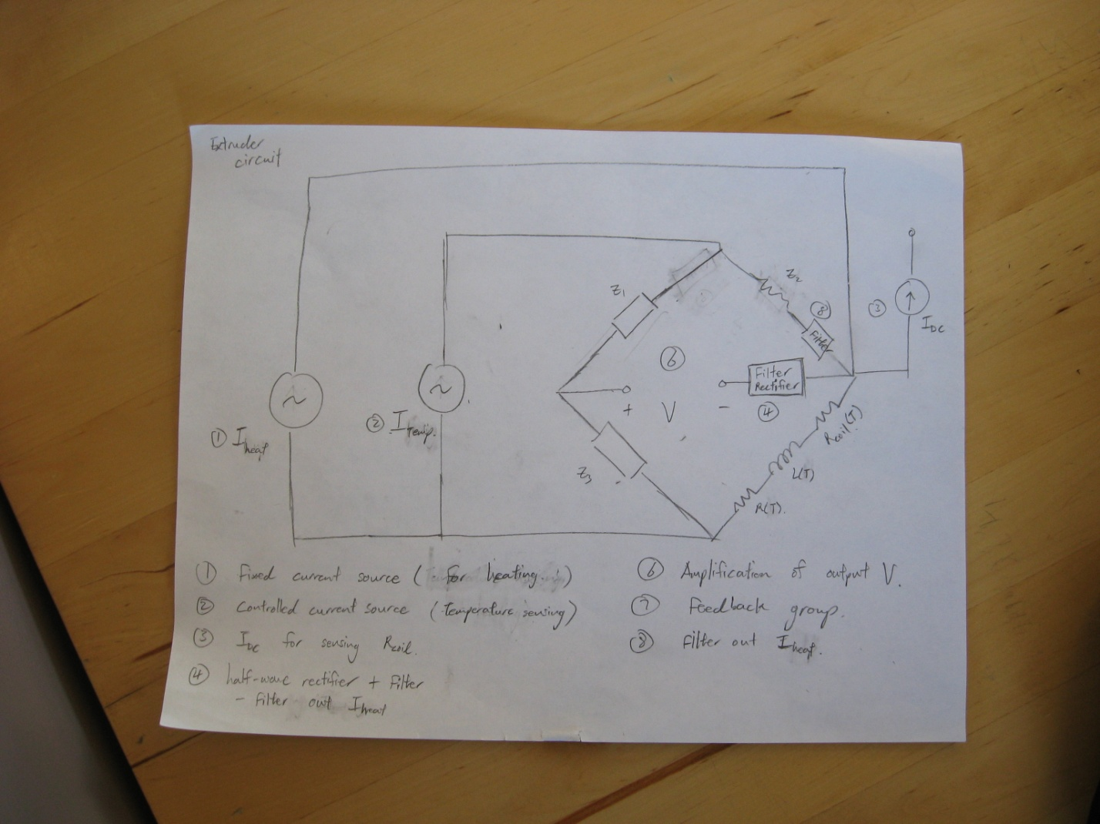

Summary of extruder circuit design, 24 Feb 2011.

Other meeting stuff:

* Kevin has volunteered to machine some copper rings for test purposes. Here are some parts drawings for Kevin. Stock copper rod probably be obtained from physics stores, I’ll try to find out what our speedchart is from Jon. Kevin when you’re ready to machine it, I’ll bring you a glass nozzle so that you can compare diameters and get the fit right. The fit should probably be very *slightly* undersize - the ring will probably expand about half a percent when it’s heated, but the glass won’t expand at all (it’s pyrex).
* Let’s also get a few people looking at each of the above problems. What would you like to do?

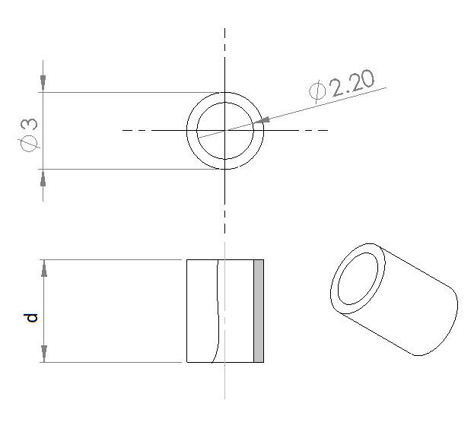

Copper ring drawing. We might want to try out a few different d’s. Maybe d=2 mm, 3mm, 4mm, 5mm, 6mm.

Inside hole diameter is not crucial if that exact drill can’t be found.

* For circuit designers: These are numbers that come from my Octave simulation

|  |  |  |  |  |  |
| --- | --- | --- | --- | --- | --- |
| **L** | **Sense freq** | **R (mOhm)** | **dR/dT** | **L (uH)** | **dL/dT** |
| 2 | 15.38 kHz | 6.5830 | 1.3614e-6 | 2.8294 | 9.12e-10 |
| 3 | 16.30 kHz | 10.403 | 3.7182e-6 | 2.8100 | 8.9947e-10 |
| 4 | 17.27 kHz | 14.566 | 7.3515e-6 | 2.791 | 8.8132e-10 |
| 5 | 18.31 KhZ | 19.062 | 1.2345e-5 | 2.7725 | 8.5803e-10 |
| 6 | 19.40 kHz | 23.876 | 1.8749e-5 | 2.7544 | 8.3016e-10 |