UBC Rapid 12 Feb 2011 **Extruder: Main Documentation v1.0**

Warning: This was written by Jacob, who is making most of this up and has no idea if it is correct. So if something seems odd, it probably is.

Induction Extruder: Project Documentation

1. Goals and motivation
   1. Current RepRap extruders
   2. Why the induction heater is better
2. Current status of design
   1. Modelling the induction heater
   2. Sensing the temperature
3. Remaining areas in need of work
4. Goals and motivation

*Why are we making such a complicated thing to do something so simple?*

1.1 Current RepRap extruders

RepRap already has a wide variety of workable extruder hot ends and nozzles. However, there is always room to improve performance. The induction heater is meant to resolve some shortcomings common to every current design.

There are two current approaches to RepRap extruders. The earlier approach was to take a brass tube, wrap fibreglass-insulated nichrome heating wire around it, secure it with high-temperature kapton tape, and then cover that with some kind of insulating layer. There’s variations on this technique – the very early ones used bare kapton coated in fire cement as a combination of thermal and electrical insulation. A temperature sensor (either a thermocouple or a thermistor) is wedged under the insulation and held in place with kapton tape.

The newer approach is to press-fit a power resistor and a temperature sensor into an aluminum heating block, and screw the extruder barrel into that block. There is usually no insulation used in this case. The main advantage of this type is that it’s much easier to put together and take apart, and much less prone to failure. The nichrome-wound ones are always at risk of shorting out, because the insulation can burn at high temperatures. And if anything does go wrong, it takes a long time to unwind all the insulation and fix things and put it back together.

Above the metal barrel is typically a block of high-temperature insulating material like PEEK or PTFE (Teflon). This protects the reprap’s plastic components from the high temperature of the extruder.

From a temperature control standpoint, both have a fairly large thermal mass (the heater block’s typically is higher). The large thermal mass results in a stable temperature, but long warm-up and cool-down times that can add significantly to the time it takes to print a model. A high thermal mass is worthwhile in many cases, especially because the temperature sensor is located outside the barrel, meaning there’s a delay between when a temperature change occurs and when it’s detected. So a very slowly-varying temperature is good, because then it won’t be significantly affected by the delay.

In both cases a metal barrel is heated from the outside. Metal is a good heat conductor, making it almost impossible to avoid a long melt zone. That is, because the metal conducts heat well, the entire barrel will be at a nearly uniform temperature. The sharp temperature gradient occurs in the insulating plastic block, so somewhere inside the plastic is usually where the melting point is located.

Sometimes a heat sink is placed on the metal barrel, to shorten the melting zone. From a fluid mechanics point of view, the shorter the column of liquid, the better. The plastic is highly viscous, especially right near the transition point, and so there’s a lot of drag from pushing liquid plastic through a long narrow tube. As a general rule, the longer it stays solid, the better.

* 1. Why the induction heater is better

The induction heater was originally devised as a way to make better use of glass nozzles. Although most nozzles are currently machined from metal, I (Jacob) thought that glass had some worthwhile advantages. First of all it’s transparent, which will let you observe the conditions in the melt chamber – something that nobody has been able to do before. So there’s good scientific value. Secondly, it should allow for very sharp transitions because glass is a pretty good insulator (thermal conductivity 1.0 W/mK, versus aluminum’s 235 W/mK). Thirdly, it can be drawn instead of drilled, which should make it easier to make fine nozzles.

The difficulty is that because glass is such a poor thermal conductor, it’s hard to get the heat into the nozzle in the first place. If you wrap nichrome or fit an aluminum heater block to the outside of the tube, the temperature of the heater will need to be quite high for a significant amount of heat to conduct through the wall of the glass. Measuring the temperature inside the nozzle would also be very difficult, because the temperature sensor would be outside the glass too. Some people have proposed embedding heaters and temperature sensors into the glass, but that would be really hard to do in practice.

So induction heating seems like a natural solution: If you can’t push the heat in from outside, and you can’t run wires through the glass, then wirelessly generate the heat right on the inside of the glass. This also solves another problem: One of the major challenges with the standard resistive heater is finding insulators that are rated up to temperatures high enough to extrude. It’s not easy – most power resistors are only good up to about 300 C, and although the target temperature inside the nozzle might be between 150 and 250 C for most purposes, the temperature right at the resistor can be a lot higher than that. Especially when something goes wrong! This is one of the reasons that the nichrome wires are prone to shorting and burning out.

With induction heating, there’s a coil that’s driven with current (the primary) and a metal ring that gets heated (the secondary). The secondary would go inside the glass, and the primary is wrapped on the outside. The neat thing about induction heating is that although all the current is being driven through the primary coil, it can be kept very cool – hopefully cool enough to be safe to touch. Meanwhile the secondary can safely be heated up to temperatures much higher than common insulating material would withstand, because it’s a bare metal ring, and doesn’t touch any part of the electrical circuit.

This opens up the possibility of interesting things like printing with metal. The melting temperature of aluminum is lower than the softening temperature of borosilicate glass, and the melting temperature of steel is lower than the softening temperature of silicon glass.

Okay, but even for just plain plastic printing, this scheme achieves things that the current extruders never could. For example, instead of having a massive, distributed heat source over the length of a metal barrel, we have a lightweight heat source focused in a small area at the very tip of an insulating barrel. That completely changes the temperature distribution inside the nozzle, making the length of the molten section of plastic extremely short. (The question of just how short is to be answered by a mathematical model that is being worked on). It also should make the temperature response ultra fast – the thermal mass is of the extruder just a gram or so of metal in the tip, and so it should heat up and cool down almost instantaneously. If the temperature sensing were not also instantaneous then this would be an impossible system to control, but if the temperature sensing can be made to respond fast enough, then this opens up completely new possibilities for 3D printing.

For example, one problem in RepRap printing currently is called “ooze”. It takes enough pressure to force the molten plastic through the small nozzle at a high speed that when the extruder motor is turned off, the plastic will keep flowing until that pressure is relieved. Early RepRap prototypes used solenoid valves to close off the nozzle and prevent ooze, but now the technique is to drive the extruder backwards to relieve the pressure. This typically works, but introduces its own challenges (for example the extruder has to run forwards to build the pressure back up), and it would be very interesting to see if print quality could be improved by using a low-thermal-mass nozzle as a kind of “thermal valve”, cutting off the flow of plastic just by turning off the heat.

I hope that I have made a convincing enough argument that an induction heating system is an exciting possibility to pursue.

1. Current status of design

We’re faced with two challenges – heating the ring effectively, and sensing the temperature effectively. Heating the ring is not difficult; we just need to drive the coil at a frequency at which the power is efficiently absorbed by the ring, which will be any frequency higher than a certain value. Sensing the temperature is more difficult.

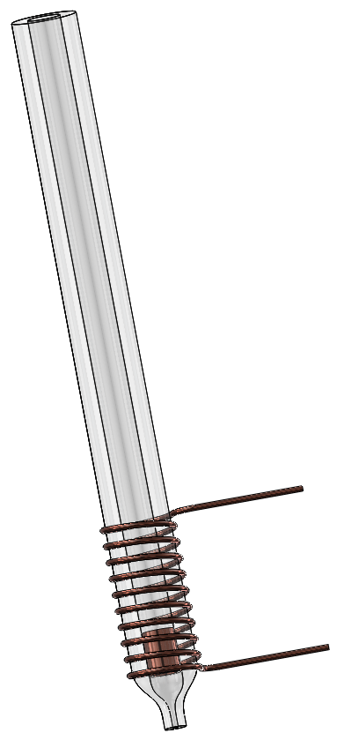The approach I’m hoping to take is to directly sense the temperature of the metal ring through the induction coil. No separate temperature sensor will be used, and since we’re sensing the temperature of the heated object directly, the response should be instantaneous.

All metals change resistivity by a small percentage as the temperature changes. So our goal would be to measure the changing resistivity of the metal ring. As the ring increases its resistivity, there should be some effect that can be observed as a change in voltage on the primary coil. In essence, the induction heater can be modeled as a resistor and an inductor in series, and the value of both depends on the temperature.

Before we can make a sensor to measure these, we need to know what the expected range will be, and how strong the temperature dependence is. Also we need to know what frequency is best for sensing the changes.

That’s why I’ve modelled the induction heater, below.

* 1. Modelling the induction heater

In order to figure out how much the inductance and resistance change, I’ve solved Maxwell’s equations for the system and written a program in Octave (like Matlab but open-source) that graphs these values at different temperatures and frequencies. For how I obtained the solutions, see ExactMaxwell.docx.

Here are some of the relevant graphs that should help us understand the system. These are examples for one specific extruder geometry, but we can put any numbers into Octave to see how these change when the design is different (eg, number of turns of coil, length of heating ring, copper vs steel ring, etc).

The solution is in cylindrical coordinates of course, and in the graphs below, the x-axis is the distance from the centre.

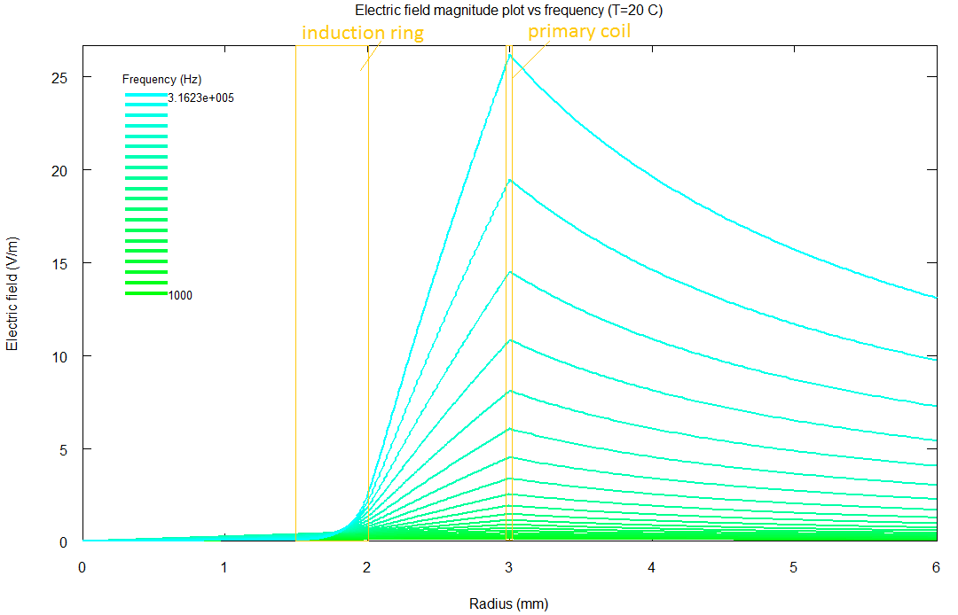

Here is the first graph, showing the electric field throughout the extruder for various frequencies. As you can see, the electric field only penetrates a short distance into the induction ring; this is an example of the skin effect. Keep in mind that the current density in the ring is proportional to the electric field. Note that the frequency is in log scale.

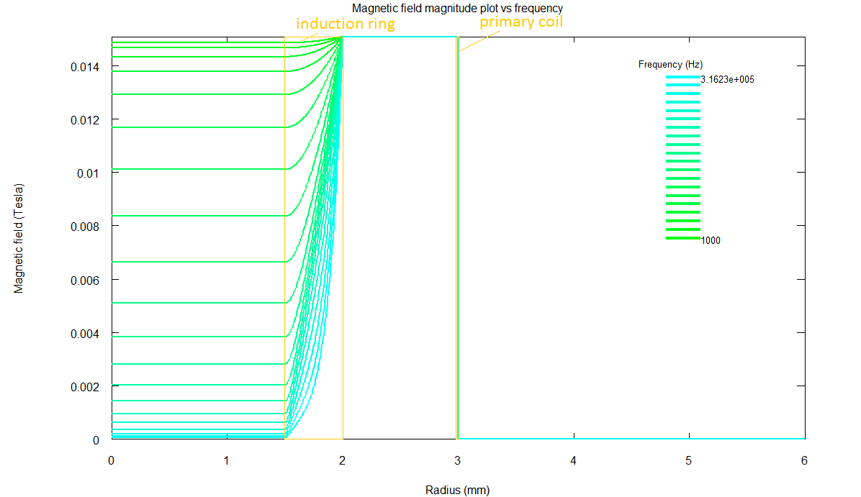

This shows the magnetic field. As you would expect it drops to zero outside the coil, and it’s constant between the coil and the glass. The important thing to notice how the magnetic field gets cancelled out by the current flowing in the induction ring. At low frequencies (green), very little current flows in the ring, so the magnetic field hardly gets cancelled. But at high frequencies it drops almost to zero inside the ring, meaning that all of the energy is being effectively absorbed.

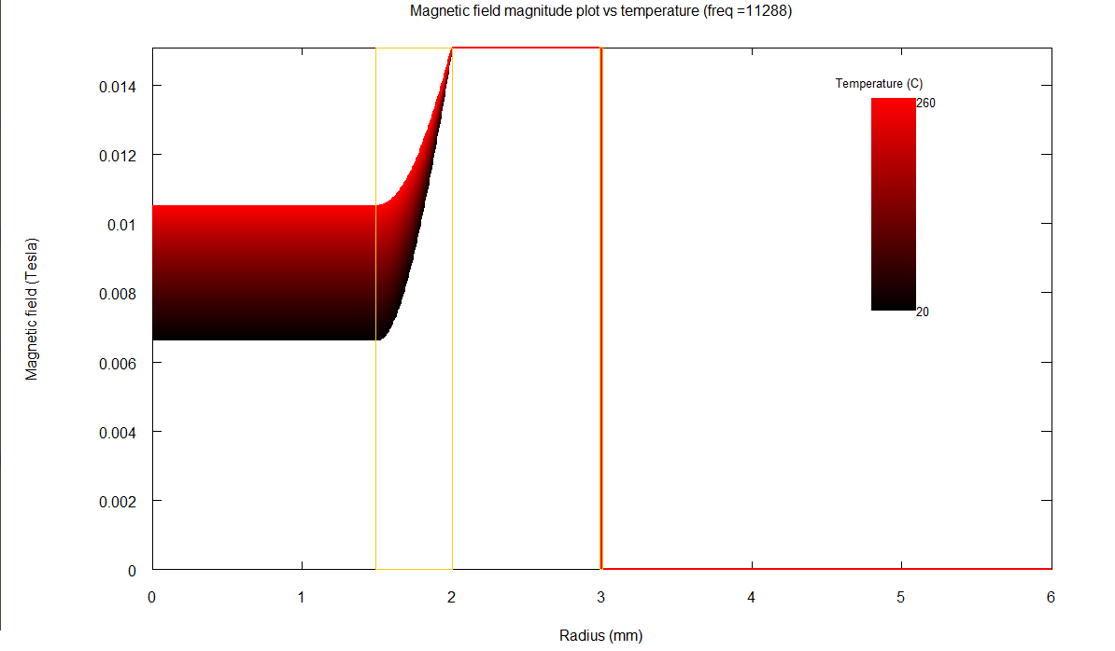

This is the same graph, but plotted versus temperature instead of frequency. As the temperature goes up, the metal becomes less conductive, so it absorbs the electromagnetic energy less efficiently. The frequency I’ve chosen to plot here (11288 Hz) is the one where this effect is most pronounced. At much higher frequencies, even a hot metal ring will still absorb all the power effectively, and at lower frequencies, even a cold metal ring will absorb very little. At this frequency it transitions steeply from absorbing a lot to absorbing very little of the power. This strong temperature sensitivity makes it a good frequency for sensing temperature. We’ll look at this more later.

Meanwhile, this is relevant for another reason. The inductance is of a coil proportional to the energy stored in the magnetic field when you run current through it. These graphs are all produced for a constant current, but since the magnetic field is changing dramatically in this graph as the temperature changes, that means the inductance is changing with temperature. You can see this in the graph below…

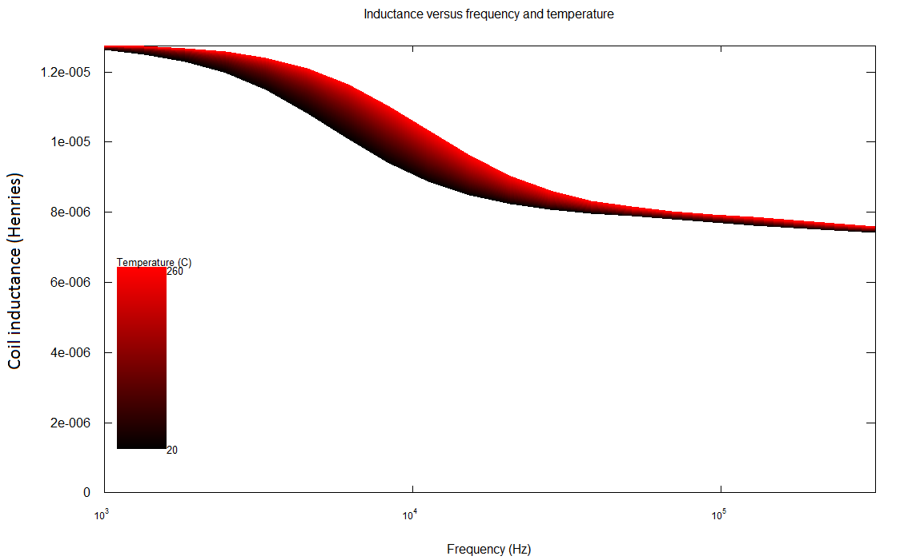

Here, you can see that there’s a certain band of frequencies around 10 kHz where the inductance changes a lot with temperature. The thickness of the line in this graph is basically a measurement of the temperature sensitivity of the inductance. We can look at the other circuit parameters too.

This image shows the “reflected” resistance at different frequencies. By this I mean that the primary coil will seem to have some resistance due to the heat being generated in the ring. Its temperature dependence seems to be a balance between two competing effects, because at one point it cancels out and becomes temperature-independent.

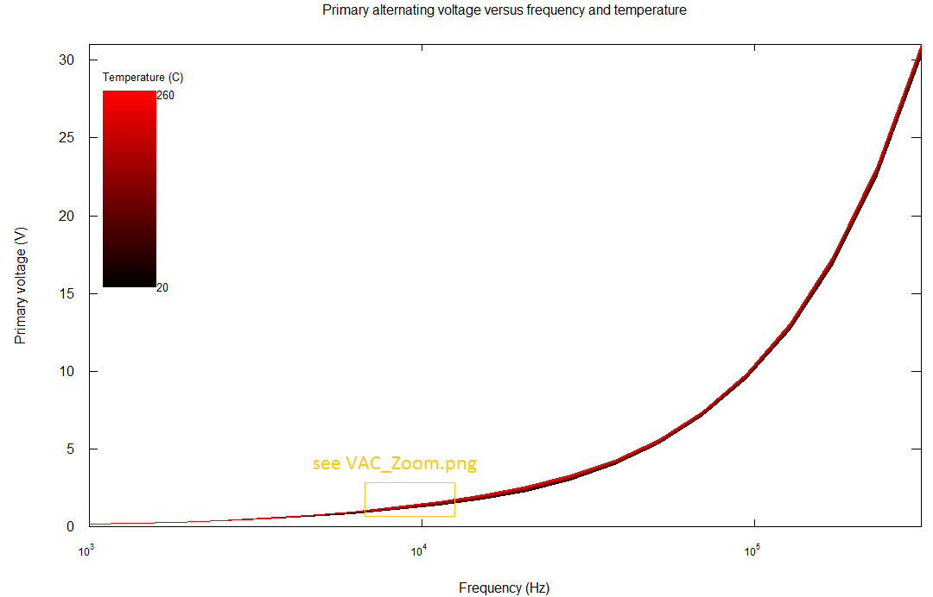

Anyway, the total voltage that the induction coil sees will come from both the resistance and the inductance in series, and that’s plotted here. The temperature dependence is a little bit hard to see; the line is very thin. So you can tell that it’s not a huge effect. But I think we can still sense it with good circuitry. First, let’s change this plot to show the thickness of this line at different frequencies.

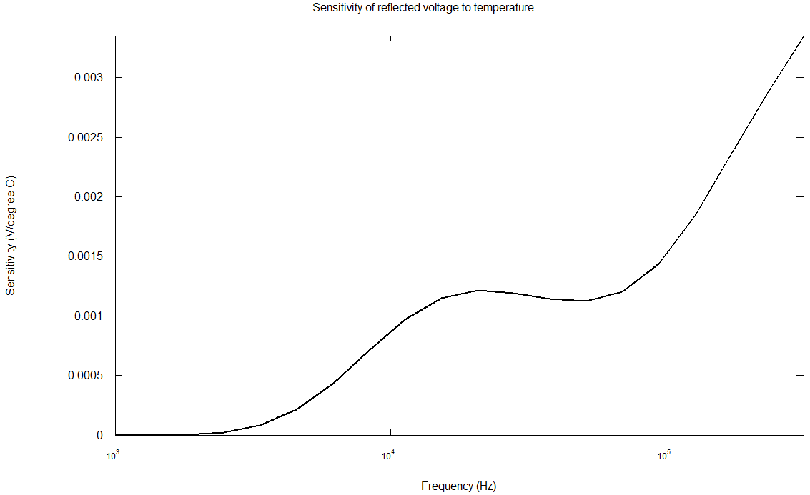

This shows that the temperature sensitivity has a maximum in the middle, and then increases again. But this shows the absolute change. We’re actually interested in where it changes the most as a percentage, which is the graph below…

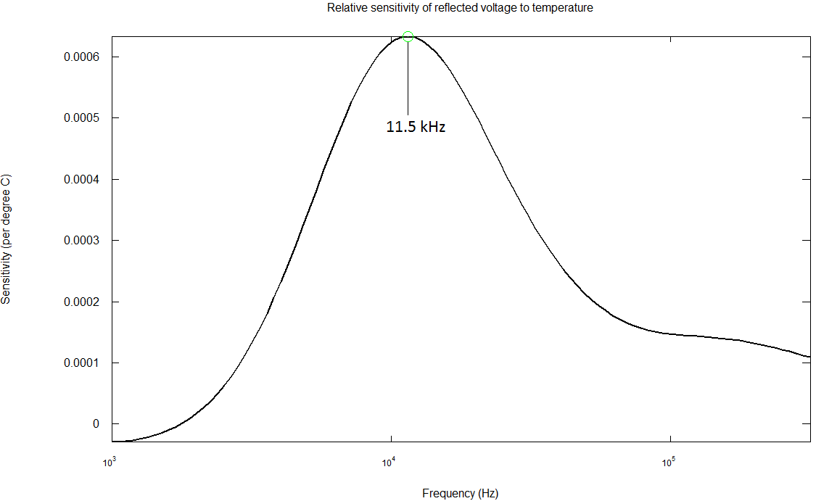

There, this shows the maximum sensitivity point is very clearly at about 11.5 kHz. So our best chance of success will be from driving it at this frequency.

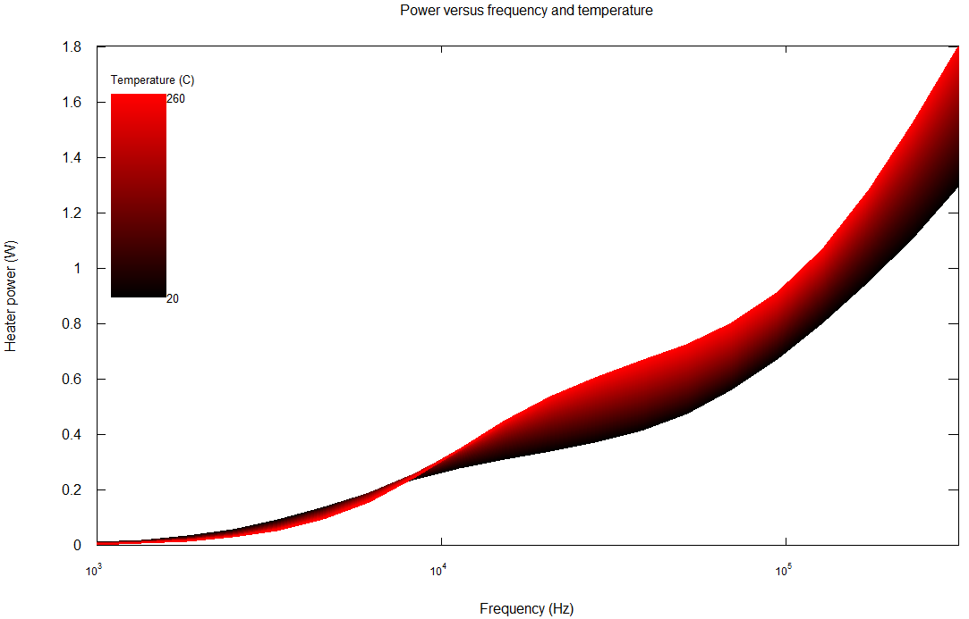

By the way, this shows the heat generated in the induction ring. From a heat generation point of view, the higher the frequency, the better. That’s because the skin depth of the metal decreases, so the current is flowing in a smaller cross-section, and the resistance goes up.

Okay, but even at the maximum point on the sensitivity graph, the voltage changes by just 0.06% per degree Celsius. Will we even be able to detect this at all?

I think so.

* 1. Sensing the temperature

The objective now is to construct a circuit that can amplify and measure those very small changes. The usual way to do this is by what is called a “bridge circuit”. When you’re measuring just a resistor, you can use a Wheatstone bridge – four resistors in a diamond shape, with one of an unknown value.

The standard wheatstone bridge is here:

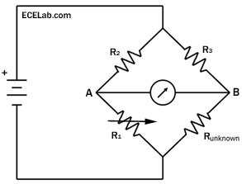

The voltmeter indicates the voltage. When the arms all have an equal resistance to R_unknown, the voltage between A and B is zero. When R_unknown changes slightly, that voltage will change, and the difference can be amplified by an op amp.

But we’re interested in sensing an inductance as well as a resistance. To do that, you can use either a “Maxwell Bridge” or an “Owen Bridge”.

In the circuits below, R4 and L1 represent the induction heater.

Wheatstone Bridge

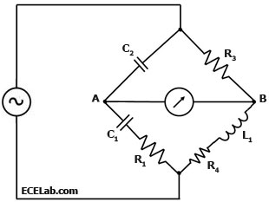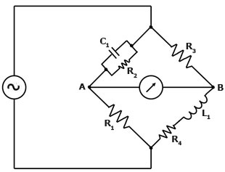

Maxwell Bridge Owen Bridge

So then the next question is, if we’re using these bridges, how good does the performance get? And what values of resistors and capacitors should we choose?

So far, to answer this question I’ve written a simulation for a balanced Maxwell bridge, although when there is time I’d also like to do the same for the Owen bridge. (I think the Owen bridge has some additional advantages). The simulation takes the resistance and inductance data right from the induction heating simulation, and picks the best values of the components and shows what voltage VAB will be.

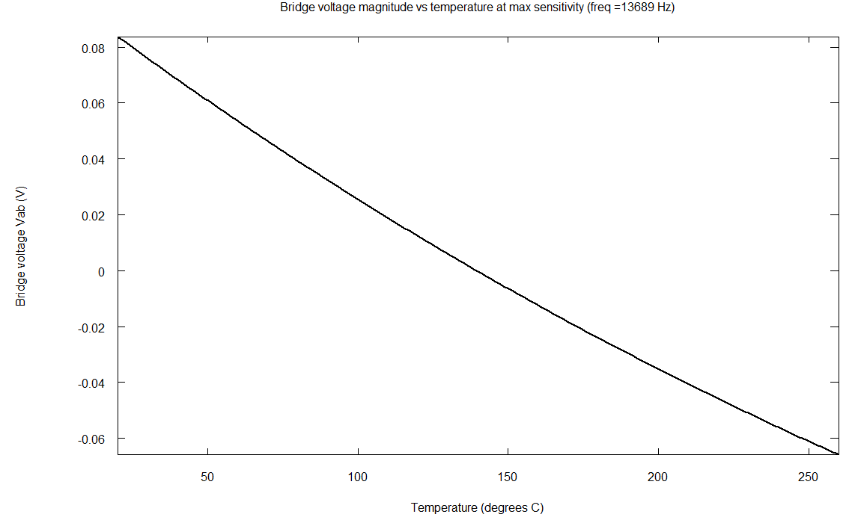

So this shows that using the bridge, you can get a big boost in sensitivity. Better yet, the output is centered around 0V, so it can be amplified a lot.

Putting this together, the basic temperature sensor circuit looks something like this:

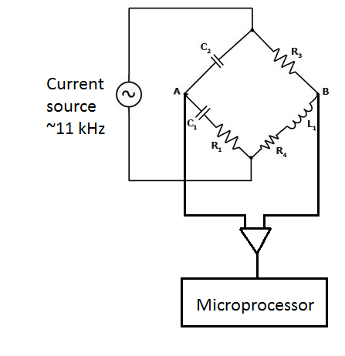

1. Remaining Work

But that’s not really enough on its own. First of all, the output waveform is AC, so it will need to be rectified, or else the microprocessor ADC won’t recognize it. Also, we need to be able to not just sense the temperature, but also have a separate frequency for heating power, and extract the temperature signal with a filter.

How can we have two different frequencies running through the same L and R?

Also, the microprocessor will need to be able to control the current in the primary coil.

Lastly, there’s another challenge. As the wires of the primary coil heat up, they’ll change resistance too. This will appear as a change in R4, making the temperature look higher than it actually is! Is there a way to compensate for this? I believe so. If we run a small amount of DC current through the induction heater, it won’t be picked up by the induction ring. So measuring the DC voltage will show exactly what the resistance of the primary coil is. Then the microprocessor can subtract this from the temperature reading.