#PRESTOinsieme across CoViD-19 outbreack period

Corrado Lanera

2020-08-03

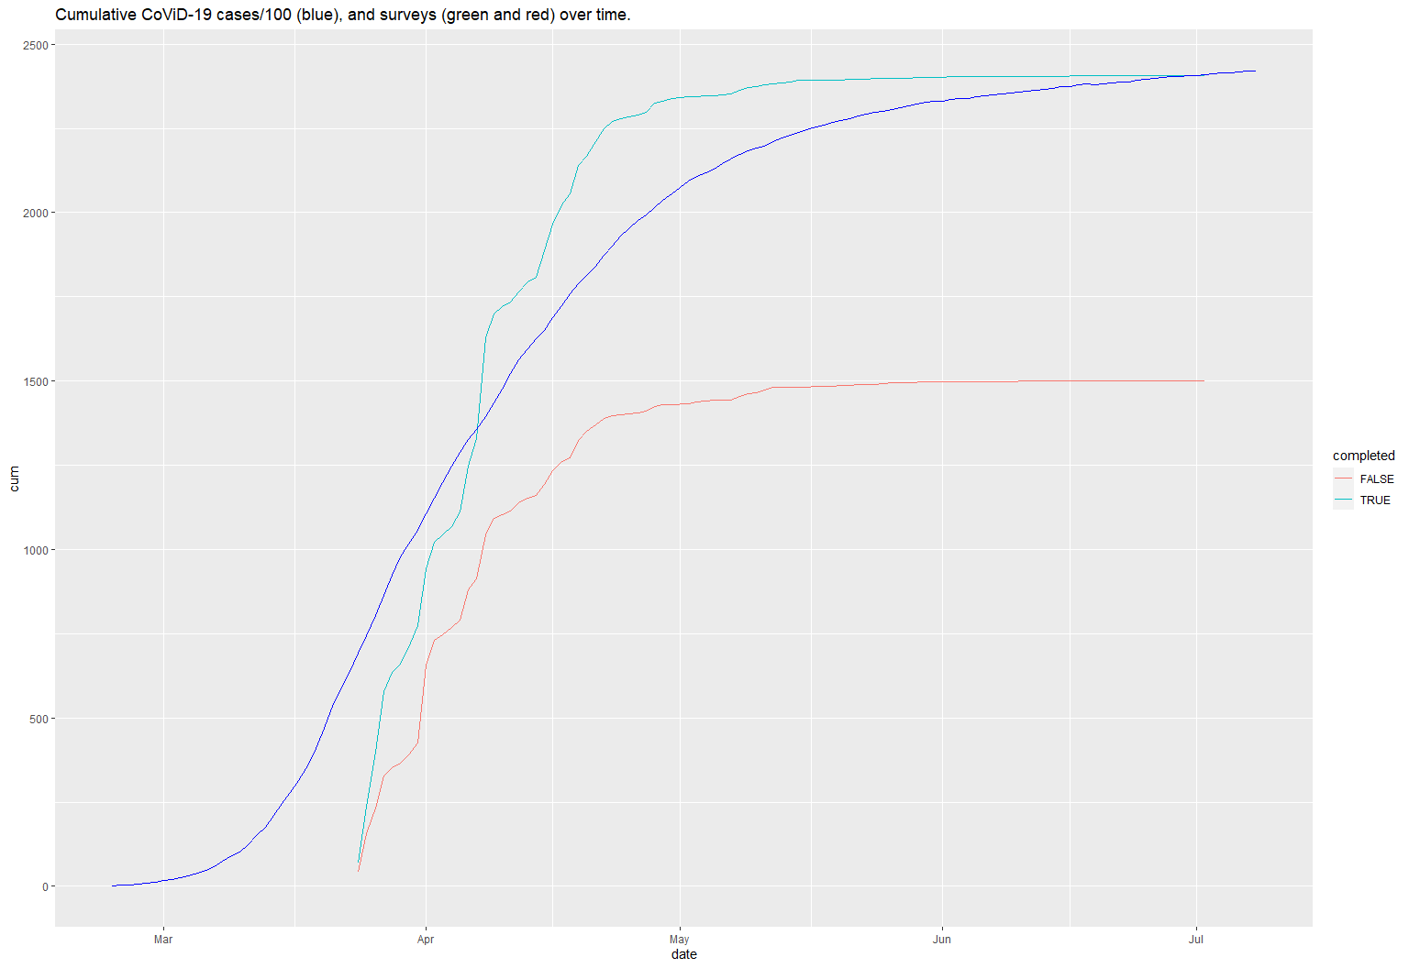

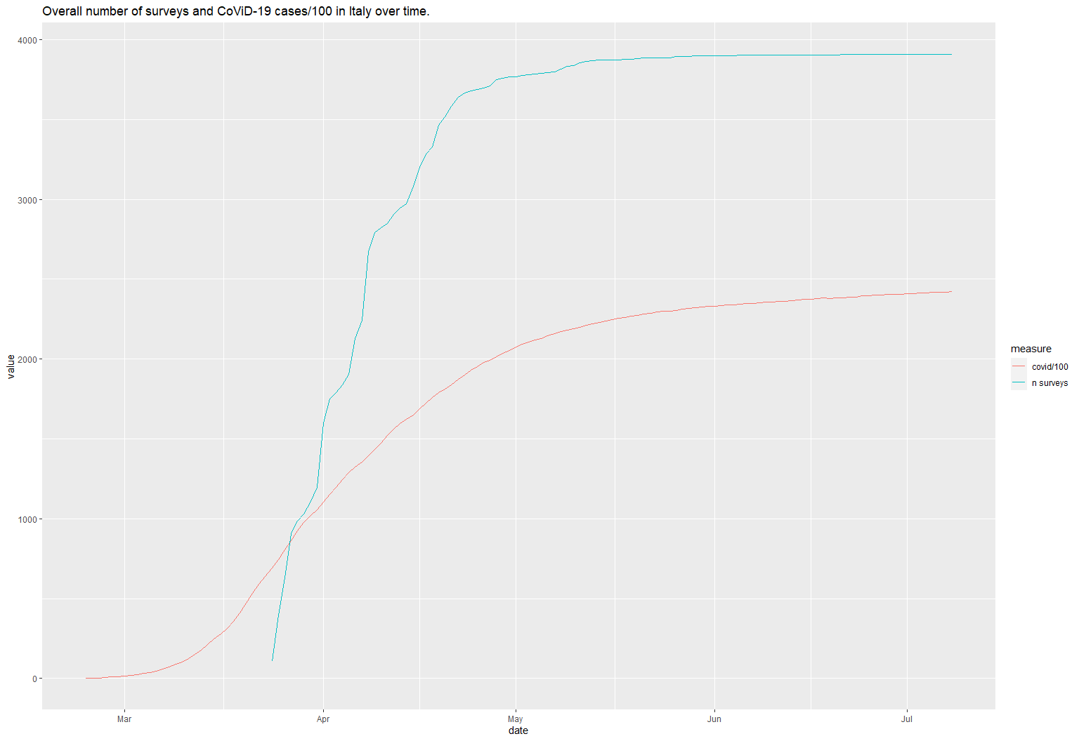

$Categorical

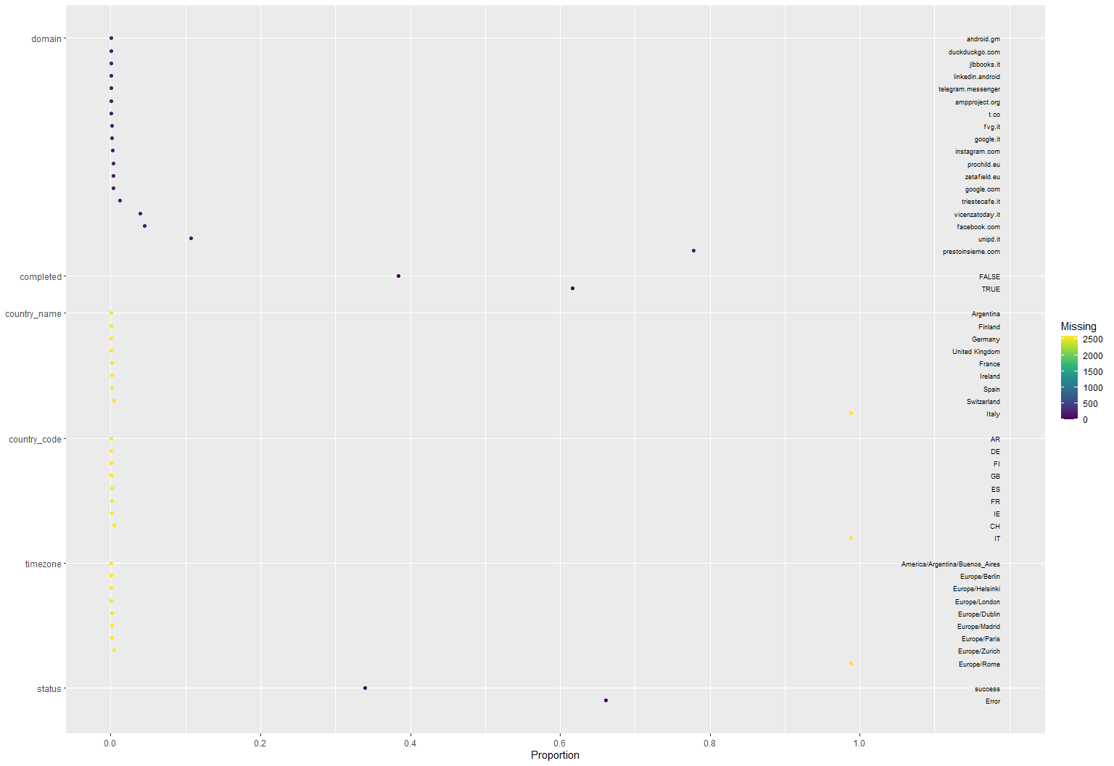

$Continuous

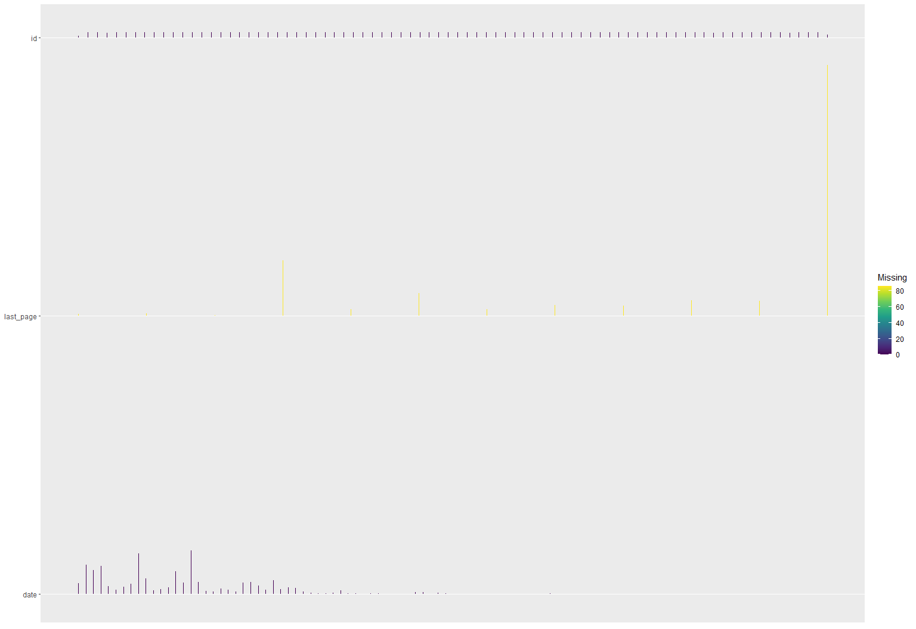

presto_base   
  
 19 Variables 3909 Observations  
--------------------------------------------------------------------------------  
id   
 n missing distinct Info Mean Gmd .05 .10   
 3909 0 3909 1 4030 1313 2258 2456   
 .25 .50 .75 .90 .95   
 3046 4031 5014 5603 5802   
  
lowest : 2059 2060 2061 2062 2063, highest: 5999 6000 6001 6002 6003  
--------------------------------------------------------------------------------  
last_page   
 n missing distinct Info Mean Gmd .05 .10   
 3823 86 12 0.747 7.917 3.03 2 2   
 .25 .50 .75 .90 .95   
 6 10 10 10 10   
  
lowest : -1 0 1 2 3, highest: 6 7 8 9 10  
   
Value -1 0 1 2 3 4 5 6 7 8 9  
Frequency 19 22 5 533 65 220 64 101 95 150 141  
Proportion 0.005 0.006 0.001 0.139 0.017 0.058 0.017 0.026 0.025 0.039 0.037  
   
Value 10  
Frequency 2408  
Proportion 0.630  
--------------------------------------------------------------------------------  
date   
 n missing distinct Info Mean Gmd .05   
 3909 0 69 0.996 2020-04-06 12.18 2020-03-25   
 .10 .25 .50 .75 .90 .95   
2020-03-25 2020-03-28 2020-04-06 2020-04-13 2020-04-21 2020-04-28   
  
lowest : 2020-03-24 2020-03-25 2020-03-26 2020-03-27 2020-03-28  
highest: 2020-06-09 2020-06-11 2020-06-19 2020-06-21 2020-07-02  
--------------------------------------------------------------------------------  
ip   
 n missing distinct   
 3909 0 3564   
  
lowest : 109.114.31.249 109.115.108.248 109.115.247.35 109.115.31.177 109.115.74.81   
highest: 95.74.24.36 95.74.26.104 95.74.27.204 95.74.88.209 95.74.97.74   
--------------------------------------------------------------------------------  
domain   
 n missing distinct   
 3679 230 18   
  
lowest : ampproject.org android.gm duckduckgo.com facebook.com fvg.it   
highest: telegram.messenger triestecafe.it unipd.it vicenzatoday.it zetafield.eu   
--------------------------------------------------------------------------------  
completed   
 n missing distinct   
 3909 0 2   
   
Value FALSE TRUE  
Frequency 1501 2408  
Proportion 0.384 0.616  
--------------------------------------------------------------------------------  
as_code   
 n missing distinct   
 1324 2585 69   
  
lowest : AS10481 Telecom Argentina S.A. AS12428 UniCredit Business Integrated Solutions S.C.p.A. AS12430 VODAFONE ESPANA S.A.U. AS1267 WIND TRE S.P.A. AS12874 Fastweb SpA   
highest: AS59699 Lenfiber S.p.A. AS6830 Liberty Global B.V. AS719 Elisa Oyj AS8612 Tiscali Italia S.P.A. AS9137 Uno Communications SpA   
--------------------------------------------------------------------------------  
city_name   
 n missing distinct   
 1325 2584 414   
  
lowest : Abano Terme Acerra Aci Catena Acireale Adro   
highest: Voghera Volta Mantovana Zeri Zona Industriale Zugliano   
--------------------------------------------------------------------------------  
country_name   
 n missing distinct   
 1325 2584 9   
  
lowest : Argentina Finland France Germany Ireland   
highest: Ireland Italy Spain Switzerland United Kingdom  
  
Argentina (1, 0.001), Finland (1, 0.001), France (2, 0.002), Germany (1,  
0.001), Ireland (2, 0.002), Italy (1309, 0.988), Spain (2, 0.002), Switzerland  
(6, 0.005), United Kingdom (1, 0.001)  
--------------------------------------------------------------------------------  
country_code   
 n missing distinct   
 1325 2584 9   
  
lowest : AR CH DE ES FI, highest: FI FR GB IE IT  
   
Value AR CH DE ES FI FR GB IE IT  
Frequency 1 6 1 2 1 2 1 2 1309  
Proportion 0.001 0.005 0.001 0.002 0.001 0.002 0.001 0.002 0.988  
--------------------------------------------------------------------------------  
isp   
 n missing distinct   
 1325 2584 111   
  
lowest : Acantho network AS49289-Network BBBell S.p.A - Telecommunication Services Brennercom SPA Bt-infonet-europe SMS   
highest: Wind TRE S.P.A Wind TRE S.P.A. Wireless Group Communications S.r.l. Witel Srl Z.G. Elettronica & Telecomunicazioni di Zilio  
--------------------------------------------------------------------------------  
latitude   
 n missing distinct   
 1325 2584 447   
  
lowest : -34.4706 37.0474 37.4925 37.543 37.5688   
highest: 51.2389 51.5598 53.3231 53.3338 60.2325   
--------------------------------------------------------------------------------  
longitude   
 n missing distinct   
 1325 2584 450   
  
lowest : -0.0096 -1.7894 -58.53 -6.2488 -6.3157  
highest: 9.9126 9.9487 9.9616 9.98352 9.9885   
--------------------------------------------------------------------------------  
organisation   
 n missing distinct   
 696 3213 127   
  
lowest : Abilene Static Custom Acantho Spa Ambrogio s.r.l. ASDASD srl a socio unico Azospd   
highest: WIND Telecomunicazioni S.p.A Wind Telecomunicazioni spa WINDTRE s.p.a Windtre SpA Wirelessgroup Communications  
--------------------------------------------------------------------------------  
region_code   
 n missing distinct   
 1325 2584 28   
  
lowest : 18 21 25 32 34 , highest: L NW PAC PV SG   
--------------------------------------------------------------------------------  
region_name   
 n missing distinct   
 1325 2584 28   
  
lowest : Abruzzo Apulia Basel-City Basilicate Basque Country   
highest: Trentino-Alto Adige Tuscany Umbria Uusimaa Veneto   
--------------------------------------------------------------------------------  
timezone   
 n missing distinct   
 1325 2584 9   
  
lowest : America/Argentina/Buenos_Aires Europe/Berlin Europe/Dublin Europe/Helsinki Europe/London   
highest: Europe/London Europe/Madrid Europe/Paris Europe/Rome Europe/Zurich   
  
America/Argentina/Buenos_Aires (1, 0.001), Europe/Berlin (1, 0.001),  
Europe/Dublin (2, 0.002), Europe/Helsinki (1, 0.001), Europe/London (1, 0.001),  
Europe/Madrid (2, 0.002), Europe/Paris (2, 0.002), Europe/Rome (1309, 0.988),  
Europe/Zurich (6, 0.005)  
--------------------------------------------------------------------------------  
zip_code   
 n missing distinct   
 1324 2585 551   
  
lowest : 00015 00042 00069 00118 00123, highest: 98100 98121 D02 D12 E10   
--------------------------------------------------------------------------------  
status   
 n missing distinct   
 3909 0 2   
   
Value Error success  
Frequency 2584 1325  
Proportion 0.661 0.339  
--------------------------------------------------------------------------------

|  |  |  |  |  |  |
| --- | --- | --- | --- | --- | --- |
|  | N | FALSE (N=1501) | TRUE (N=2408) | Combined (N=3909) | P-value |
| 2 | 3823 | 2/ 4/ 7 | 10/10/10 | 6/10/10 | <0.001 |
| 3 | 3679 |  |  |  | <0.001 |
| 4 |  | 0% ( 2) | 0% ( 0) | 0% ( 2) |  |
| 5 |  | 0% ( 1) | 0% ( 0) | 0% ( 1) |  |
| 6 |  | 0% ( 0) | 0% ( 1) | 0% ( 1) |  |
| 7 |  | 8% ( 105) | 3% ( 60) | 4% ( 165) |  |
| 8 |  | 0% ( 3) | 0% ( 1) | 0% ( 4) |  |
| 9 |  | 0% ( 3) | 0% ( 9) | 0% ( 12) |  |
| 10 |  | 0% ( 3) | 0% ( 3) | 0% ( 6) |  |
| 11 |  | 0% ( 4) | 0% ( 6) | 0% ( 10) |  |
| 12 |  | 0% ( 0) | 0% ( 1) | 0% ( 1) |  |
| 13 |  | 0% ( 0) | 0% ( 1) | 0% ( 1) |  |
| 14 |  | 78% (1096) | 78% (1768) | 78% (2864) |  |
| 15 |  | 0% ( 3) | 0% ( 8) | 0% ( 11) |  |
| 16 |  | 0% ( 0) | 0% ( 2) | 0% ( 2) |  |
| 17 |  | 0% ( 1) | 0% ( 0) | 0% ( 1) |  |
| 18 |  | 2% ( 22) | 1% ( 24) | 1% ( 46) |  |
| 19 |  | 7% ( 99) | 13% ( 296) | 11% ( 395) |  |
| 20 |  | 4% ( 54) | 4% ( 92) | 4% ( 146) |  |
| 21 |  | 0% ( 4) | 0% ( 7) | 0% ( 11) |  |
| 22 | 1325 |  |  |  | 0.319 |
| 23 |  | 0% ( 1) | 0% ( 0) | 0% ( 1) |  |
| 24 |  | 0% ( 1) | 0% ( 0) | 0% ( 1) |  |
| 25 |  | 0% ( 1) | 0% ( 1) | 0% ( 2) |  |
| 26 |  | 0% ( 0) | 0% ( 1) | 0% ( 1) |  |
| 27 |  | 0% ( 1) | 0% ( 1) | 0% ( 2) |  |
| 28 |  | 98% ( 498) | 99% ( 811) | 99% (1309) |  |
| 29 |  | 0% ( 2) | 0% ( 0) | 0% ( 2) |  |
| 30 |  | 1% ( 3) | 0% ( 3) | 0% ( 6) |  |
| 31 |  | 0% ( 1) | 0% ( 0) | 0% ( 1) |  |
| 32 | 1325 |  |  |  | <0.001 |
| 33 |  | 1% ( 5) | 1% ( 6) | 1% ( 11) |  |
| 34 |  | 1% ( 5) | 2% ( 14) | 1% ( 19) |  |
| 35 |  | 0% ( 2) | 0% ( 0) | 0% ( 2) |  |
| 36 |  | 1% ( 4) | 0% ( 1) | 0% ( 5) |  |
| 37 |  | 0% ( 2) | 0% ( 0) | 0% ( 2) |  |
| 38 |  | 0% ( 1) | 0% ( 0) | 0% ( 1) |  |
| 39 |  | 1% ( 3) | 0% ( 1) | 0% ( 4) |  |
| 40 |  | 15% ( 78) | 9% ( 71) | 11% (149) |  |
| 41 |  | 5% ( 24) | 5% ( 40) | 5% ( 64) |  |
| 42 |  | 0% ( 1) | 0% ( 0) | 0% ( 1) |  |
| 43 |  | 9% ( 44) | 10% ( 79) | 9% (123) |  |
| 44 |  | 0% ( 0) | 0% ( 1) | 0% ( 1) |  |
| 45 |  | 12% ( 63) | 9% ( 70) | 10% (133) |  |
| 46 |  | 0% ( 1) | 0% ( 1) | 0% ( 2) |  |
| 47 |  | 1% ( 7) | 1% ( 7) | 1% ( 14) |  |
| 48 |  | 17% ( 84) | 21% (170) | 19% (254) |  |
| 49 |  | 0% ( 0) | 0% ( 1) | 0% ( 1) |  |
| 50 |  | 3% ( 13) | 3% ( 25) | 3% ( 38) |  |
| 51 |  | 0% ( 1) | 0% ( 0) | 0% ( 1) |  |
| 52 |  | 0% ( 1) | 0% ( 3) | 0% ( 4) |  |
| 53 |  | 1% ( 4) | 0% ( 3) | 1% ( 7) |  |
| 54 |  | 2% ( 10) | 1% ( 8) | 1% ( 18) |  |
| 55 |  | 0% ( 2) | 0% ( 2) | 0% ( 4) |  |
| 56 |  | 1% ( 3) | 0% ( 3) | 0% ( 6) |  |
| 57 |  | 2% ( 12) | 2% ( 14) | 2% ( 26) |  |
| 58 |  | 0% ( 0) | 0% ( 3) | 0% ( 3) |  |
| 59 |  | 0% ( 1) | 0% ( 0) | 0% ( 1) |  |
| 60 |  | 27% (137) | 36% (294) | 33% (431) |  |
| 61 | 3909 |  |  |  | 0.957 |
| 62 |  | 66% ( 993) | 66% (1591) | 66% (2584) |  |
| 63 |  | 34% ( 508) | 34% ( 817) | 34% (1325) |  |