|  |  |
| --- | --- |
| The Effect of Sitagliptin on Carotid Artery Atherosclerosis in Type 2 Diabetes: The PROLOGUE Randomized Controlled Trial | A Randomized Controlled Trial Comparing the Effects of Sitagliptin and Glimepiride on Endothelial Function and Metabolic Parameters: Sapporo Athero-Incretin Study 1 (SAIS1) |
| * Data access:   <https://datadryad.org/resource/doi:10.5061/dryad.qt743/2> | * Data access:   <https://doi.org/10.1371/journal.pone.0164255.s004> (baseline)  <https://doi.org/10.1371/journal.pone.0164255.s005> (follow-up) |
| * N= 463 | * N=103 |
| * Time window: November 2010 and September 2012 | * Time window: March 2011 to 30 September 2013 |
| Inclusion criteria: | Inclusion criteria: |
| * age ≥ 30 y | * age >20 to 75 y |
| * HbA1c ≥ 6.2% and < 9.4% despite treatment with diet, exercise, and/or conventional antidiabetic agents (Sulfonylureas, Biguanides, α-Glucosidase inhibitors, Thiazolidinedione). | * HbA1c > 6.9 and < 8.4% despite treatment with diet, exercise, and/or metformin (biguanide antidiabetic agent) |
|  | * adequate control of blood pressure and dyslipidemia |
| Exclusion criteria: | Exclusion criteria: |
| * type 1 diabetes mellitus; |  |
| * undergoing insulin treatment; | * undergoing insulin treatment; |
| * administration of DPP-4 inhibitors and/or GLP-1 analogues before randomization | * history of hypersensitivity to insulin or GLP-1 receptor agonists |
| * heart failure with New York Heart Association functional class III or IV | * patients who take more than four antihypertensive medications; heart failure |
| * a history of diabetic ketoacidosis or diabetic coma within the 6 mo prior to randomization |  |
| * a history of myocardial infarction, angina pectoris, percutaneous transluminal coronary angioplasty, or bypass surgery | * atherosclerotic diseases (angina, myocardial infarction, cerebral infarction and peripheral arterial disease) |
| * a history of cerebral infarction, cerebral hemorrhage, subarachnoid hemorrhage, or transient ischemic attack within the 3 mo prior to randomization | * atherosclerotic diseases (angina, myocardial infarction, cerebral infarction and peripheral arterial disease) |
| * serious renal dysfunction (estimated glomerular filtration rate < 30 ml/min/1.73 m2 or dialysis) | * persistent elevation of their serum transaminase levels or had renal dysfunction |
| * pregnancy or possible pregnancy | * pregnancy |
| * lack of informed consent | * lack of informed consent |
| * judgment of the investigator that an individual is ineligible for inclusion in the study | * judgment of the investigator that an individual is ineligible for inclusion in the study |
| Treatment: randomly assigned (ratio 1:1) either to receive | Treatment: randomly assigned (ratio 1:1) either to receive |
| * conventional therapy plus sitagliptin (DPP-4 inhibitor)(sitagliptin group) | * once daily sitagliptin (50–100 mg/day) + (diet, exercise) |
| * only conventional therapy (diet, exercise, and/or antidiabetic agents, except for DPP-4 inhibitors, GLP-1 analogues, and insulin; conventional therapy group). | * glimepiride (0.5–2.0 mg/day) + (diet, exercise) |
| Randomization: modified minimization method with a biased-coin assignment balancing on age (<65 or ≥65 y), sex, use of statins, use of antidiabetic agents (nonpharmacological or pharmacological), HbA1c (<7.0% or ≥7.0%), office systolic blood pressure (<135 or ≥135 mm Hg), and maximum IMT (<1.0 or ≥1.0 mm). | Randomization balancing age, body mass index and results of FMD |
| Follow-up: 2 yrs | Follow-up: 24 weeks of treatment |
| Primary Endpoint at 24 months:   * % change in mean CCA IMT | Primary Endpoint at 24 weeks (6 months):   * the extent of change in FMD |
| Secondary endpoints at 12 and 24 months:   * the mean and maximum IMT values and changes at the CCA, bulb, and ICA (except for the primary endpoint); * plaque area and plaque gray scale median; * the values and changes in glycemic profiles (HbA1c, fasting glucose level, insulin concentration, 1,5-anhydroglucitol,1,4-anhydro-D-glucitol, HOMA-β, HOMA-R); lipoprotein profiles (total cholesterol, high-density lipoprotein cholesterol, triglyceride, small dense low-density lipoprotein, malondialdehyde-modified low-density lipoprotein, remnant-like particle cholesterol); renal function (creatinine, cystatin C, urinary albumin/creatinine ratio, estimated glomerular filtration rate); high molecular weight adiponectin; physiological parameters (body weight, blood pressure); * adjudicated clinical events and adverse events. | Secondary endpoints at 24 weeks (6 months):   * mean changes between baseline and post-treatment of endothelial and metabolic parameters (listed in table 4: BMI, HbA1c, SBP, DBP, HDL, LDL, …) |
| Predictors:   * Age, years * Sex * Body mass index, kg/m2 * Hypertension (history of) * Dyslipidemia (history of) * Adiponectin * Myocardial infarction * Percutaneous coronary intervention * Coronary artery bypass grafting * Chronic heart failure * Arrhythmia * Stroke * Systolic blood pressure, mm Hg * Diastolic blood pressure, mm Hg * HbA1c, percent * Fasting plasma glucose (FPG), mmol/l * Low-density lipoprotein cholesterol (LDL), mmol/l * Serum creatinine, μmol/l | Predictors:   * Age, years * Gender * BMI (kg/m2) * Hypertension (to calculate) * Dyslipidemia (to calculate) * Adiponectin     * SBP (mmHg) * DBP (mmHg) * HbA1c (%) * FPG (mmol/l) * LDL (mmol/l) |

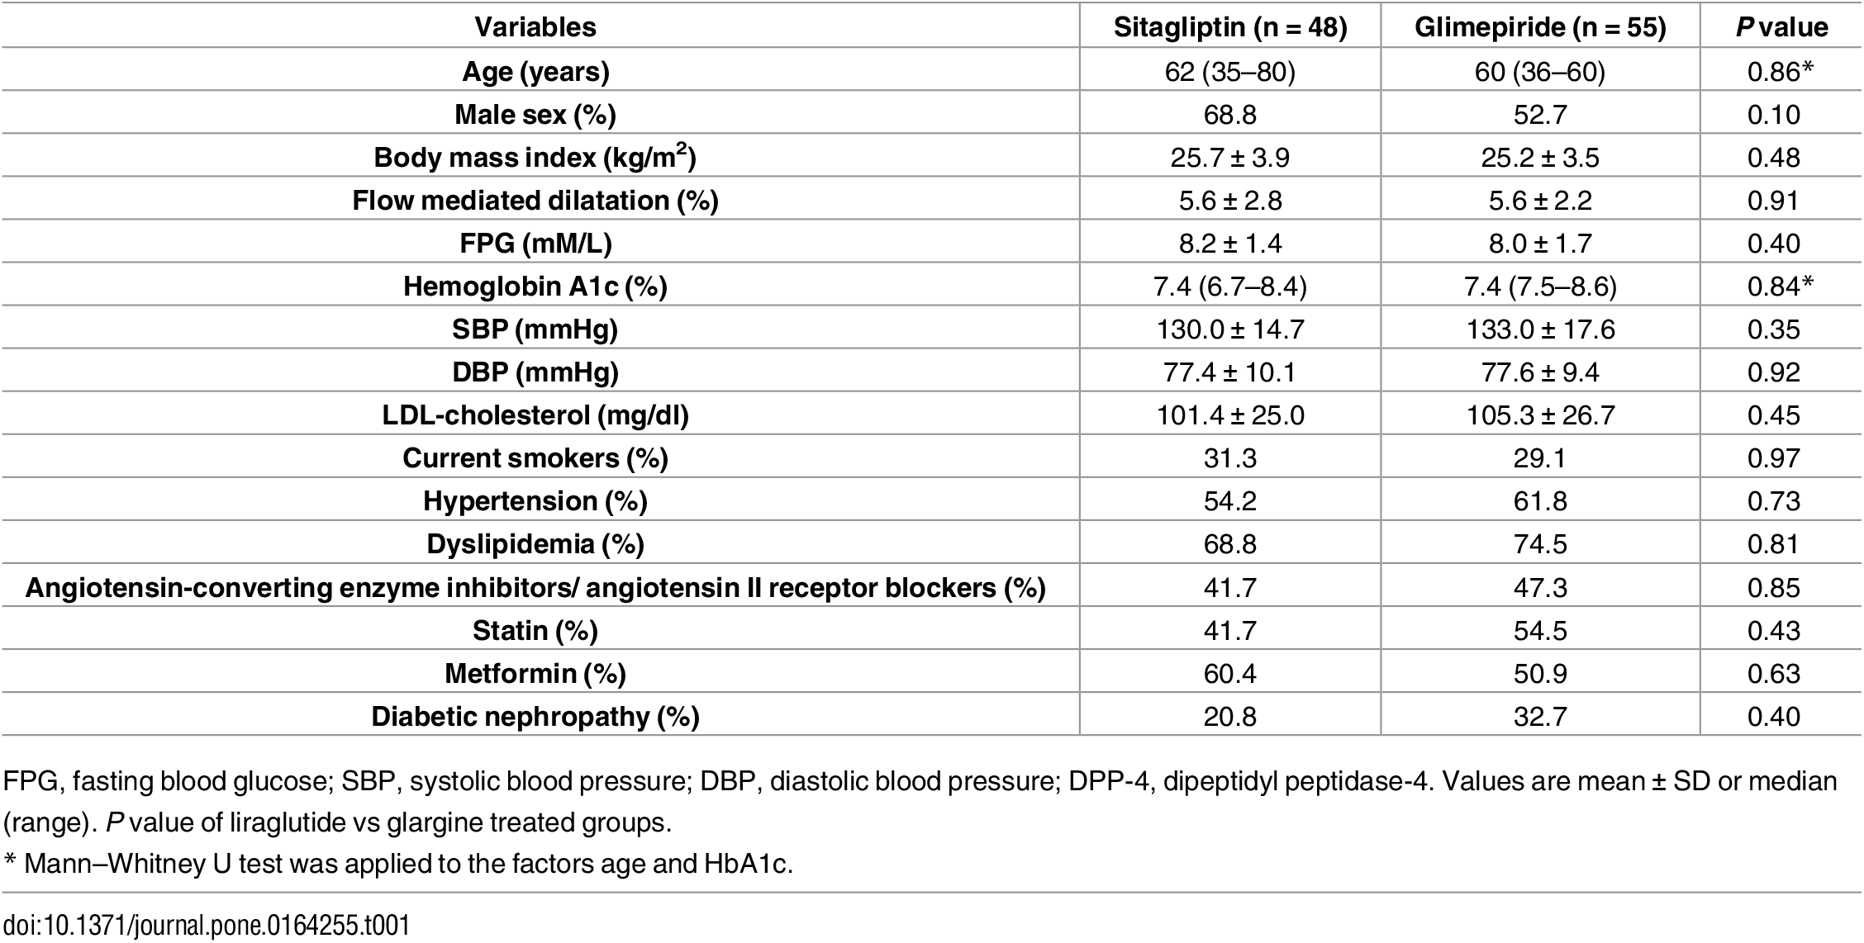

**Baseline demographics and clinical characteristics.**

| **Characteristic** | **Sitagliptin Group (n = 222)** | **Conventional Therapy Group (n = 220)** | **p-Value** |
| --- | --- | --- | --- |
| Age, years | 69.2 ± 9.3 | 69.5 ± 9.2 | 0.708 |
| Male | 146 (65.8%) | 151 (68.6%) | 0.544 |
| Body mass index, kg/m2 | 25.3 ± 4.1 | 24.9 ± 4.0 | 0.268 |
| Hypertension | 181 (81.5%) | 166 (75.5%) | 0.133 |
| Dyslipidemia | 163 (73.4%) | 148 (67.3%) | 0.176 |
| Myocardial infarction | 46 (20.7%) | 55 (25.0%) | 0.309 |
| Percutaneous coronary intervention | 58 (26.1%) | 69 (31.4%) | 0.248 |
| Coronary artery bypass grafting | 19 (8.6%) | 16 (7.3%) | 0.725 |
| Chronic heart failure | 15 (6.8%) | 26 (11.8%) | 0.073 |
| Arrhythmia | 32 (14.4%) | 32 (14.5%) | 1.000 |
| Stroke | 27 (12.2%) | 30 (13.6%) | 0.672 |
| Systolic blood pressure, mm Hg | 130.0 ± 15.7 | 128.8 ± 16.5 | 0.403 |
| Diastolic blood pressure, mm Hg | 72.8 ± 10.7 | 71.7 ± 11.5 | 0.278 |
| HbA1c, percent | 6.96 ± 0.64 | 6.96 ± 0.55 | 0.974 |
| Fasting plasma glucose, mmol/l | 7.67 ± 2.31 | 7.49 ± 2.05 | 0.396 |
| Low-density lipoprotein cholesterol, mmol/l | 2.45 ± 0.67 | 2.41 ± 0.73 | 0.602 |
| Serum creatinine, μmol/l | 75.5 ± 20.8 | 76.3 ± 23.0 | 0.683 |
| Estimated glomerular filtration rate, ml/min/1.73 m2 | 66.5 ± 17.4 | 66.8 ± 18.1 | 0.830 |
| Mean CCA IMT, mm | 0.829 ± 0.166 | 0.835 ± 0.190 | 0.725 |
| Mean bulb IMT, mm | 1.109 ± 0.469 | 1.114 ± 0.421 | 0.912 |
| Mean ICA IMT, mm | 0.775 ± 0.340 | 0.795 ± 0.316 | 0.557 |
| Maximum CCA IMT, mm | 1.052 ± 0.228 | 1.076 ± 0.264 | 0.298 |
| Maximum bulb IMT, mm | 1.583 ± 0.686 | 1.601 ± 0.635 | 0.787 |
| Maximum ICA IMT, mm | 1.039 ± 0.440 | 1.081 ± 0.448 | 0.360 |
| Plaque area, mm2 | 11.36 ± 7.41 | 11.72 ± 9.24 | 0.724 |
| Plaque gray scale median | 50.9 ± 22.5 | 52.5 ± 21.6 | 0.568 |

Data are presented as number (percent) or mean (SD).