Interface Design II Lab Report
You will add required screenshots and code snippets to this lab report for the guided practice activities and performance assessments. Submit this lab report following the submission instructions in Canvas.

Screenshots and Code Snippets
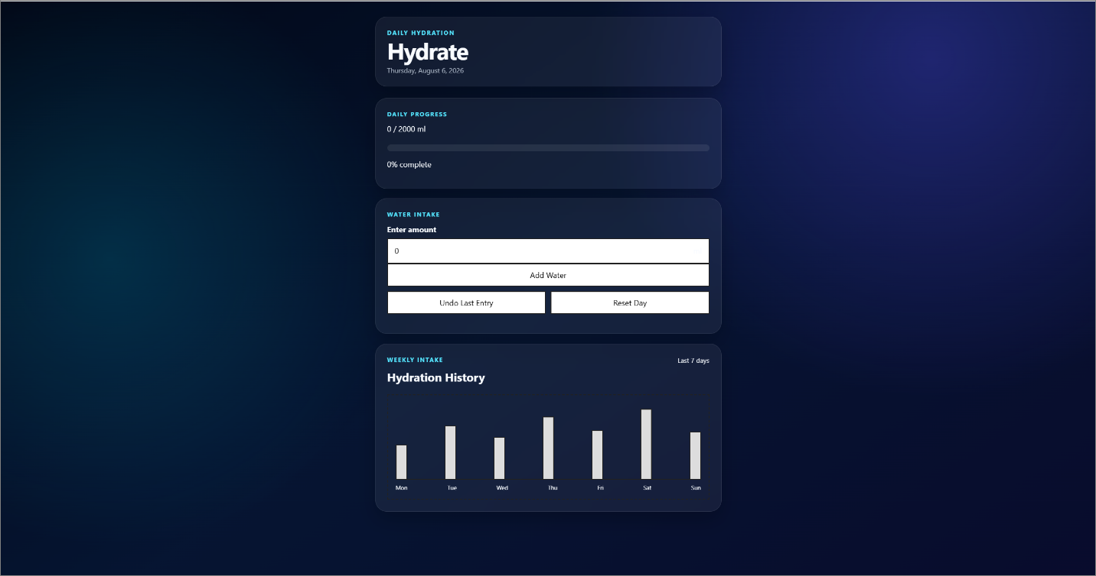
Button Implementation with Time Stamps to show progression - First, add - Second, Undo - Third, Reset
