**Halogen**

* There is an extra space after “by” and “multiple” in the description
* There is Nex throughout instead of offices
* There is a lot of trailing space after “traffic on”

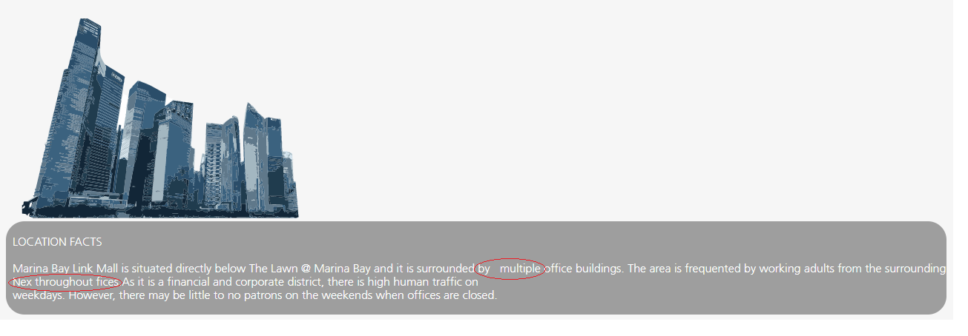

* Alignment can be better for Marina Bay

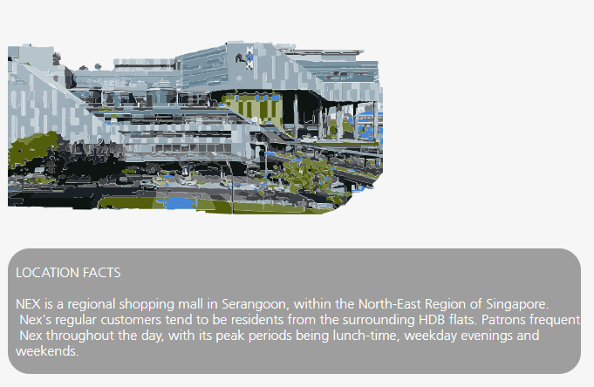

* Incorrect spelling – “ingredients”
* The tick mark appears behind the image in the item highlighted. Possible to send the image back?

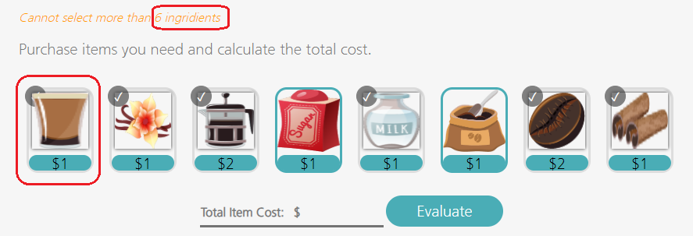

* In this case where the selling price and the variable expense is the same, the validation is successful even if nothing is entered in the Contribution margin field. Is this is ok? Shouldn’t we populate at least a 0? Also, in the next page, a zero value will cause division by 0 situation.
* To avoid this, can we have selling price always greater than “Variable Expense for One Unit”
* Also I am able to enter a 29 digit value on the selling price field.

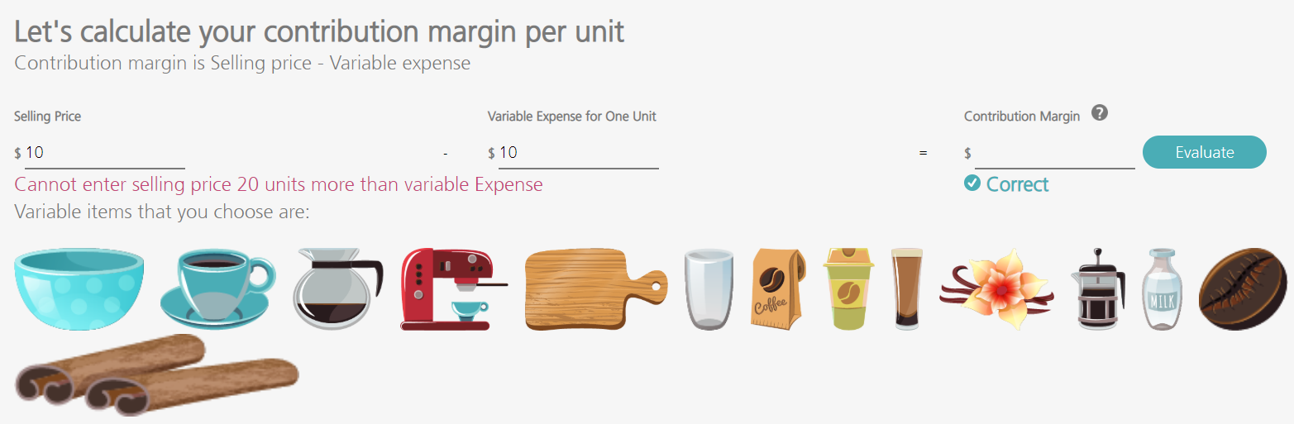

* I entered $38 manually and “evaluated” it. Correct appeared on the screen.
* Post this, I entered 25 in the calculator and pressed copy. $25 appeared on the “Total item cost” field and I was able to move to the next screen. Maybe we should disable the usage of calculator once the result has been validated

