**What is the Home Ice Advantage in the National Hockey League?**

W200 – Project 2

December 2018

Robert Bergan, Brent Biseda, Michael Hardy

**Overview**

In all almost all sports there is a phenomenon whereby the “home” team typically wins a higher percentage of games than the “away” team. This home-team advantage is predictable over a large enough sample size such that it is a major factor in sports betting. Here we seek to investigate this home-ice advantage for the National Hockey League (“NHL”) in order to quantify it, identify the drivers, and to see where the advantage manifests in various facets of the game. We are interested specifically in the NHL because hockey is known as the “most-random” of the major US sports, making it the least-analyzed sport from the perspective of data science. As can be seen in the figure below, there exists a demonstrable difference between the distribution of goals scored at home vs. away. As seen by table 1, through time there is roughly a 0.3 goal differential in favor of the home team.

Table - Goals at Home vs Away

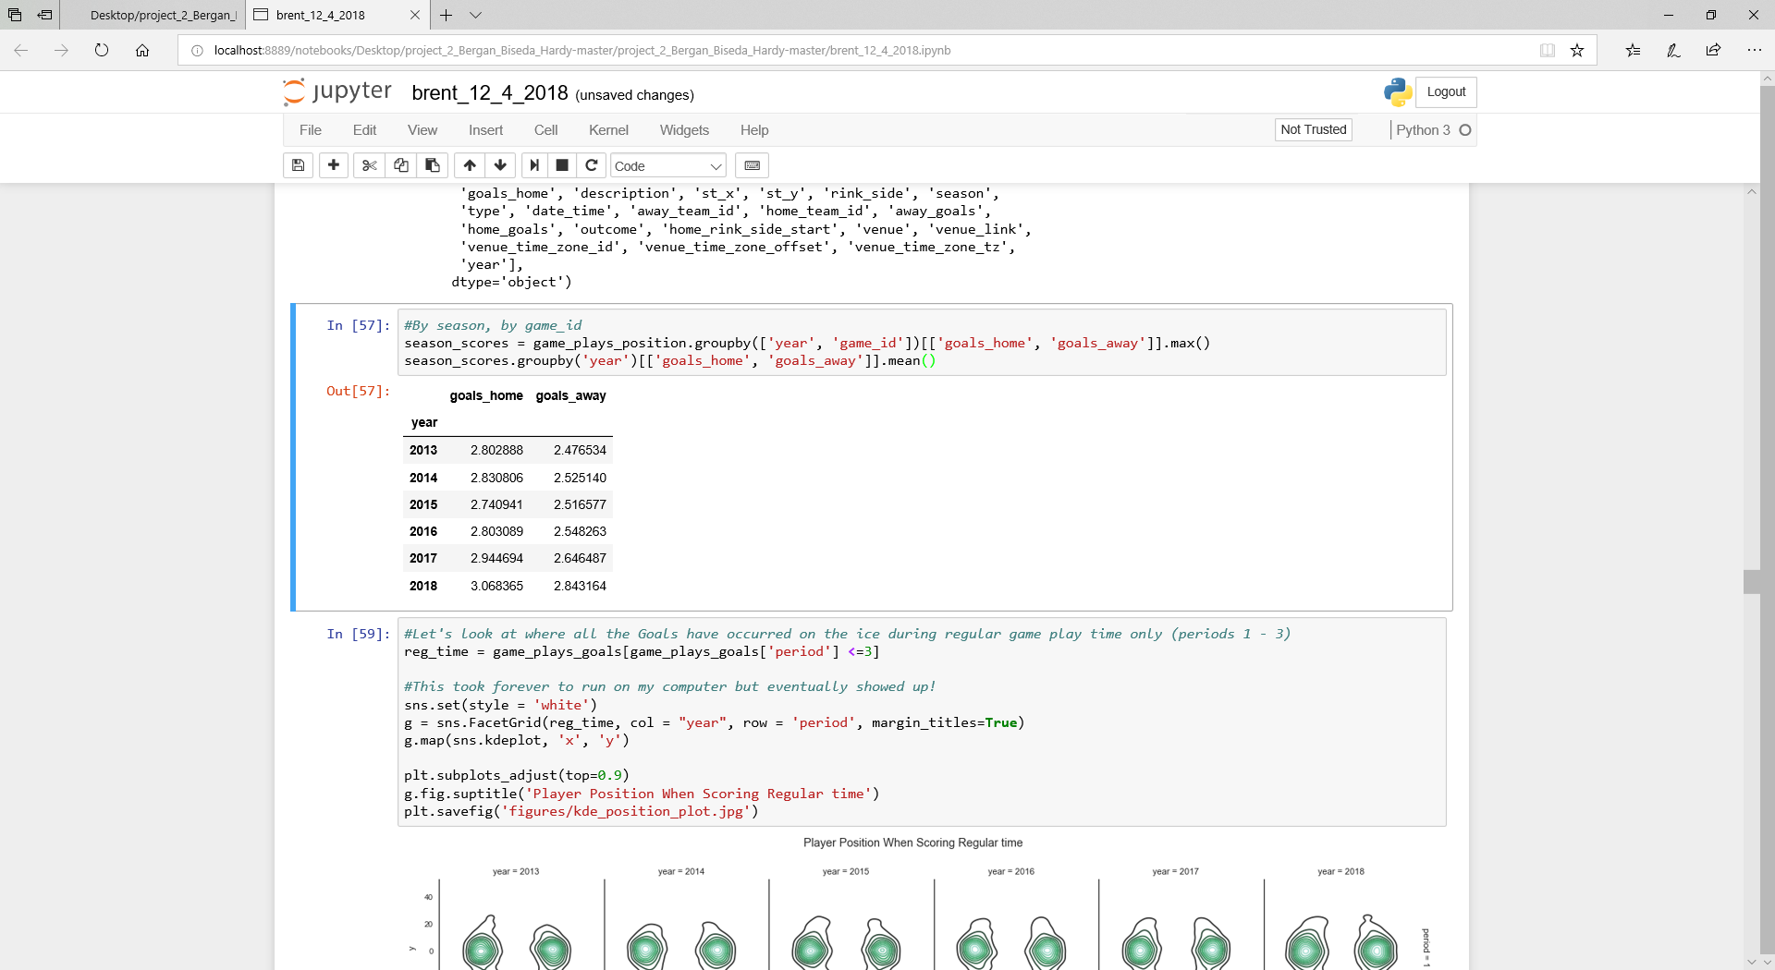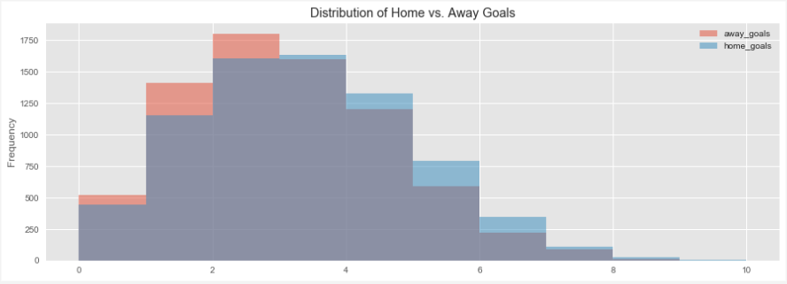

Figure - Distribution of Goals Scored (Home vs. Away)

**Focusing Questions**

Our focusing questions divide our report into two sections: a high-level look at the home-ice advantage and a deeper look at the drivers and manifestations of home-ice advantage.

* What is the magnitude of the home-ice advantage and can we see any differences or trends across seasons, during different parts of the season or between teams?
* How does the home-ice advantage manifest itself into different aspects of the game, such as face-offs, power-plays, hits and other factors?

**Dataset**

The dataset we used in our analysis was sourced from Kaggle, but its original source is directly from the NHL’s website API. The data includes all data collected for the six seasons from 2012/2013 season – 2017/2018 season.

The dataset includes nine separate tables, all in csv format, that include different data or summaries of data. Our analysis focuses primarily on game data (as opposed to data on individual players). The main tables used in this analysis are summarized below:

* ‘game’ table:
  + Summary data on each regular season and playoff game including date/time, season, teams involved (home and away), outcome, type (playoff vs. regular season), venue, goals scored
  + 7,441 rows, 16 columns
* ‘game_teams_stats’ table:
  + Additional detail on each game. Includes 1 row for each team in each game (so 2x rows of ‘game’ table, including coach, penalties, giveaways, takeaways, face-offs
  + 14,882 rows, 14 columns

**Data Validation and Preparation**

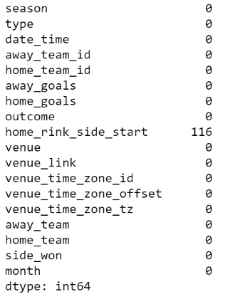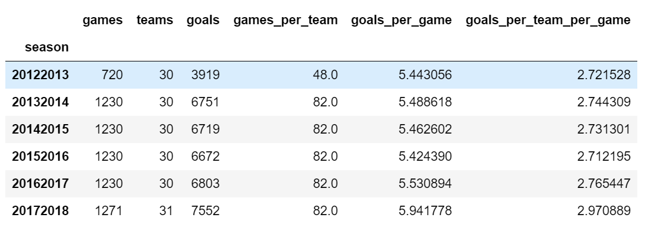As the dataset is bounded by the number of games per season and the associated statistics for those games, we can validate our data by cross-checking the aggregated data against these known bounds. In doing so we can confirm that all games and teams are present within the dataset for both the regular and playoff seasons. This data validation shown in the tables below, allows us to conclude that there are no missing games as each team played 82 games (except for 2012-2013 which was a shortened season) and that the detailed game statistics seem reasonable. We performed these types of analyses across our variables and could not find any issues with our source data.

Table - Missing Values

Table - Example Validation Table

Additionally, we looked for missing values across both tables and found no missing values in the “game_teams_stats” table and 116 in the “games” table. However, the missing variables in the “games” table does not impact our analysis as the variable is not useful to exploring our questions.

From a preparation perspective, our main task was to join / merge tables. Throughout our analysis we merged these two main tables, along with additional information tables such as the teams table to get the team names. The tables included keys for merging so we were able to merge or aggregate data across tables relatively seamlessly.

**Exploratory Questions**

**Section 1: What is the home ice advantage and how does it vary between season? in the regular season vs. playoff season?**

Overall and Regular Season vs. Playoffs

We knew there would be a home-ice advantage in the NHL, but we did not know the magnitude. From our data we can see that, on average, between the 2012-2013 season and the 2017-2018 season the home team has won 54.95% of all games. As a point of comparison, in the NFL, the average is closer to 60%. Intuitively, it makes sense that the NHL has less of a home-team advantage due to it being thought of as more random than the NFL and thus any advantage (home-ice, skill, etc.) should be smaller.

Of interest though is that the playoff advantage (54.84%) is almost 2 percentage points greater the regular season advantage (56.42%). However, as we will see below, the playoff percentage varies significantly by season, likely due to whether the championship team, which plays more games, wins more on the road or at home. In fact, there is most certainly bias in that the best teams have the opportunity to play additional games at home.

Trends by Time (Across Seasons and Within Seasons)

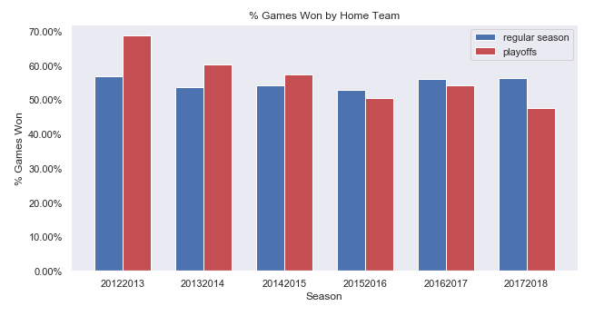In all seasons, the regular season percentage has hovered in a range between 52.9% (2015-2016) and 56.81% (2012-2013, the lockout season) while the playoff percentage has fluctuated more dramatically between 68.6% in 2012-2013 and 47.6% in 2017-2018 (see Figure 2). Though it is hard to tell how substantial the regular season difference is without doing further statistical analysis. We do note that a lot of the variance seems driven by a few outlier teams. For instance, in 2012-2013 the LA Kings and San Jose Sharks both had a greater than 40% difference in their home win rate vs. their road win rate, an amazingly high differential. We will discuss time zone impact later in our analysis but note that any travel related impact could be magnified in the lockout shortened season of 2012-2013 when the games were compressed into a short period of time.

Figure 2: Home Win Rate by Season

For the playoff data we assert that with a small number of games the percentage is skewed significantly by the team that has success in that particular year. For instance, the LA Kings played the most playoff games in 2012-2013 because they won the championship that year and had a significantly higher home win-rate, while the Washington Capitals won in 2017-2018 and played better on the road.

Our main takeaways from this portion of the analysis is that while we need to investigate the time zone impact, there is no specific trend across seasons that we need to further investigate.

In addition to checking trends across seasons, we examined trends within seasons and note that there appears to be little variance by the month of the season.

Advantage by Team

After exploring home ice advantage across the league, it is constructive to explore home ice advantage by team as this provides insight into other factors such as venue, style of play, time zone, and team skill level.

As shown in the figures below, there is substantial variation among teams at home compared to on the road both in the number of goals scored and win-rate. There are two interesting insights from these charts: first, the advantage does not appear to be based on the performance of the team as we know anecdotally that there are a number of teams that have been playoff contenders, such as the Blues that have a low differential while other playoff contenders, such as the Penguins have a high differential; second, the order of the teams by home vs. away goal differential does not always align to the order by win differential. For instance the Lightning, Maple Leafs, Penguins and Kings have a high win rate differential but a middling-to-low goal differential while the Golden Knights rank at the top in both categories. However, the Golden Knights are a new NHL expansion team with limited play history, another example of bias. This suggests to us that while teams may perform better or worse at home, they may do so in different ways i.e. they may play better defense on the road and let in fewer goals.

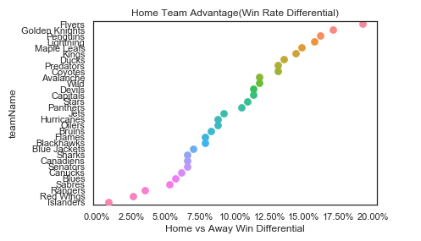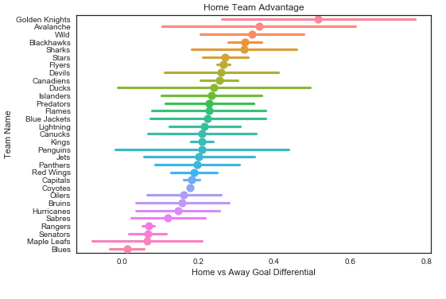

Figure 3: Home vs. Away Goal Differential Mean and 1 Std

Figure 4: Home vs. Away Win Differential

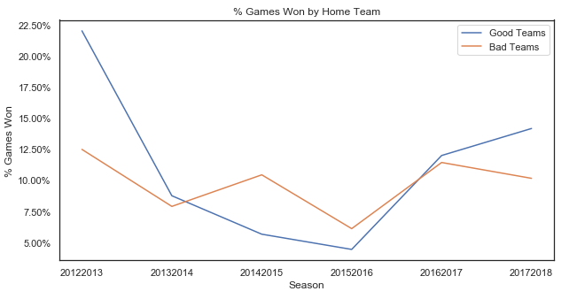

To further explore the advantage by team, first we will look at ‘good’ teams vs. ‘bad’ teams to verify whether overall performance is correlated with home vs. away differential. For this analysis we have defined good teams as the top 10 teams as ranked by win total. As shown in Figure 7 we do not see overall performance to be correlated with home win rate (note that 2012-2013 is the lockout season with fewer games and substantial outliers as noted above).

Figure 5: Win Differential by Good vs. Bad Teams

Second, we explore the advantage by team by looking at whether there is a larger difference in offense or defense when comparing home and away statistics. As a proxy for offense and defense we look at the difference in goals scored and the difference in goals given up at home vs. away. This may explain the difference discussed above in the home vs. away goal scored differential and the home vs. away win rate. Figure 8 below shows that there can be substantial difference in where the advantage comes from between teams. For instance, the Maple Leafs’ advantage seems to stem from offense as the team scores more goals at home relative to the number of goals it gives up. The Canadians advantage seems to stem from defense as they give up fewer goals at home relative to the increased number of goals scored at home. [Vegas flu]

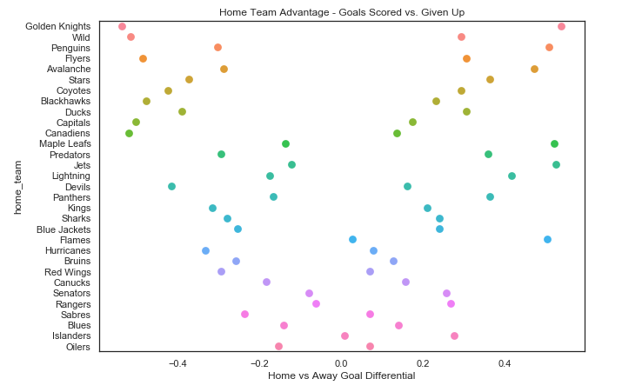

Figure 6: Goals Scored vs. Given Up, Home vs Away

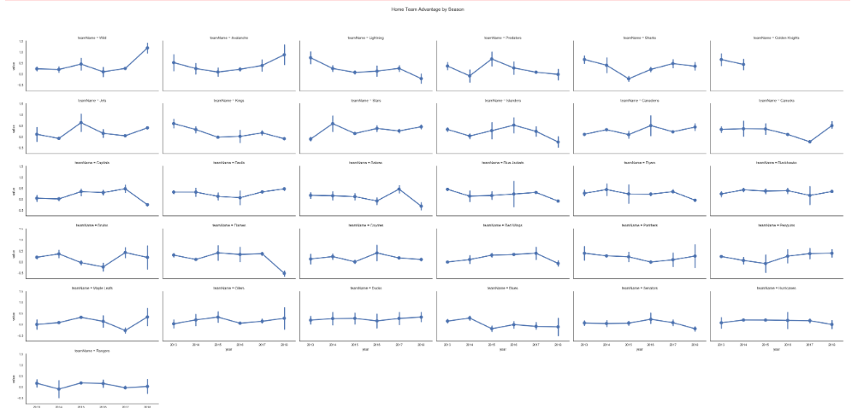

Figure 7 – Goal Differential by Team by Year

Based on our analysis in section 1 we can conclude that there is a persistent home ice advantage of approximately 10% (i.e. 55% home team wins, 45% away team wins), but that there do not seem to be any specific trends related to the change in the advantage either between seasons or within seasons. There does however seem to be a difference in the advantage between teams, as shown both in the outliers that indicate potential time-zone impact and in the differences between goal and win-rate differentials. In the next section we will take a deeper dive into detailed game statistics to examine whether we can find any factors that explain the advantage and the differences between teams.

**Section 2: How does the home-ice advantage manifest itself into different aspects of the game, such as face-offs, power-plays or venue?**

Time Zone

The figure below shows the impact that time zone differential has on the home team advantage. A time zone difference of -3, corresponds to a West Coast team traveling to the East Coast, while a time zone difference of +3 corresponds to an East Coast team traveling to the West Coast. The expectation would be that West Coast teams playing at home against an East Coast team would have the greatest advantage as the evening games could potentially last until 2 AM EST. In the figure below, we see that variance is higher as a result of travel in all cases outside of staying within a time zone (0), which, suggests that some of the variation in goal scoring can be attributable to travel.

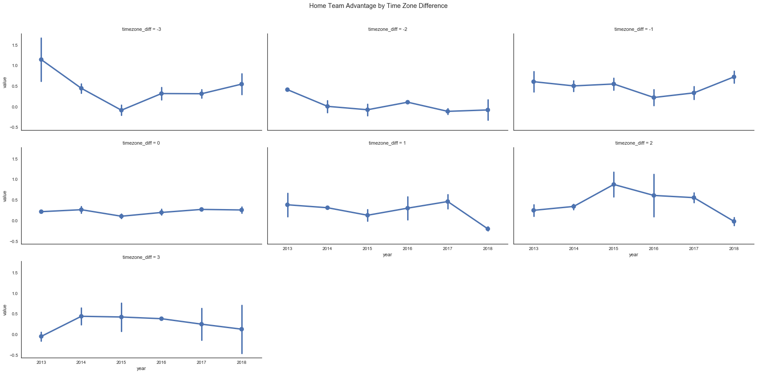

Figure 8 – Impact of Time Zone Differential on Goal Differential

By Venue?

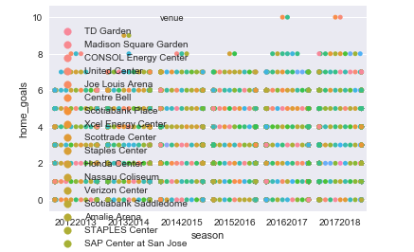

Figure 9 – Impact of Venue on Goal Differential

Other Variables

From each team’s perspective we can bin each game into one of four categories: home win, home loss, away win, or away loss. Based off of aggregated stats for each of these categories, we can produce a correlation matrix in order to determine which statistics are the principal contributors to the ultimate success of each team. For the sake of brevity, only the correlation table for home wins is shown in the figure below.

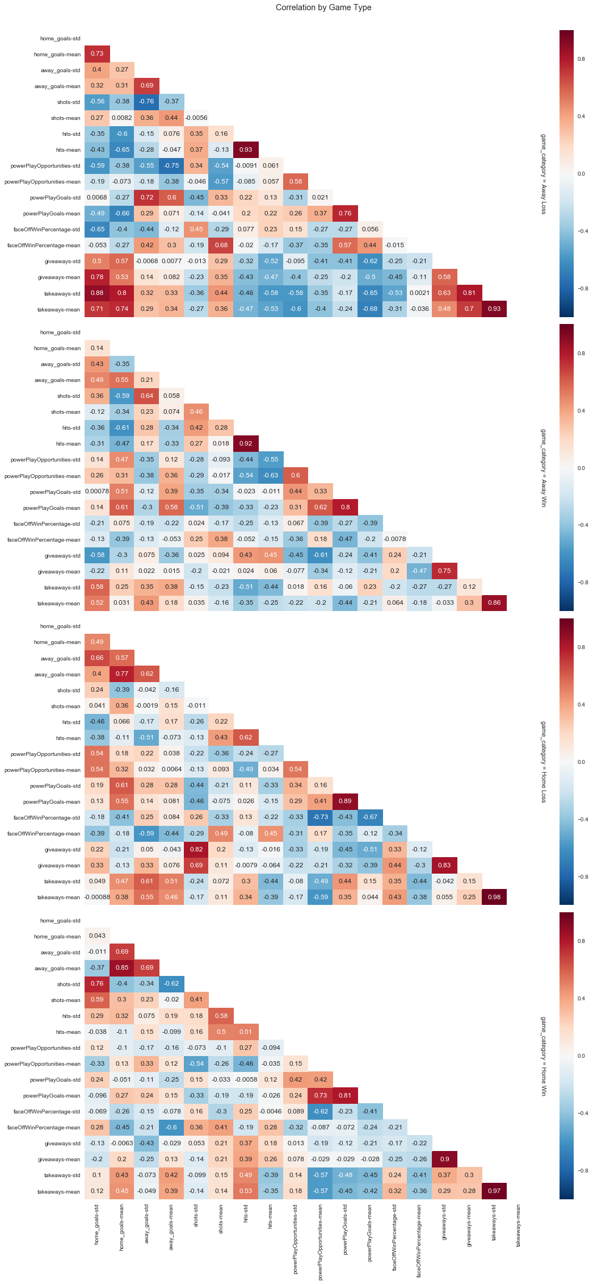

Figure 10 – Home Win Correlation Heat Map

Based off the correlation matrix, we may conclude that the mean number of home goals scored is affected by the number of takeaways (0.45), and the number of goals the away team scores (0.85). Interestingly, this phenomenon is understandable as teams seem to try harder if they are losing, and when they have a large lead, allow their top players to rest.

Analysis of Team Level Statistics:

Each of the stats present in the data source were analyzed when grouped into the four game categories. From the figures below, it becomes evident that there is no single statistic that is driving the home team advantage. Rather, the home team simply outperforms relative to the away across almost all of the stats, even when the home team loses!

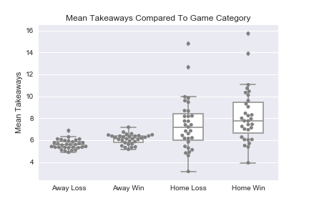 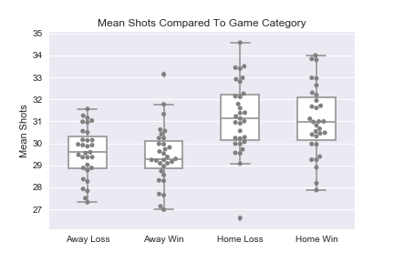 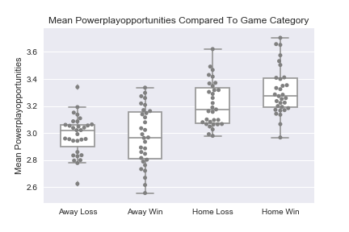 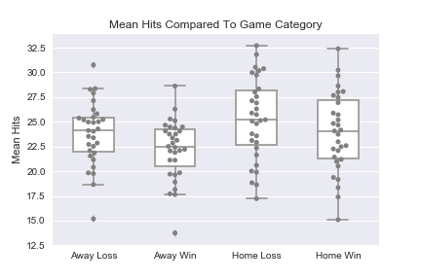

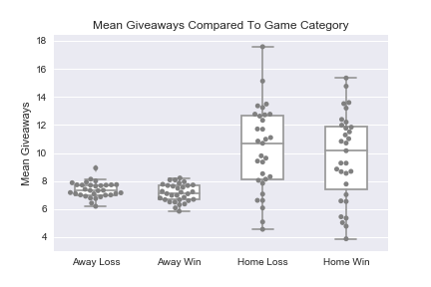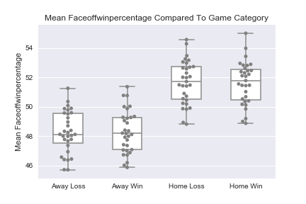

Figure 11 - Game Statistics by Category

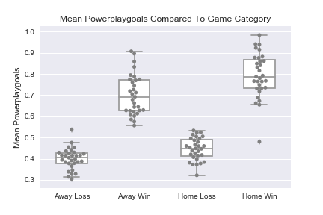Of interest is the figure shown to the left, which actually helps to identify one substantial driver in both home and away wins. This is the most impactful statistic to explain what can lead a team to win when playing away. This suggests that avoiding penalties while playing at home could be a winning strategy to further enhance the edge that playing at home imparts.

Figure 12 – Powerplay Goals Explains Home and Away wins

Analysis of Top Performing Players:

A similar analysis to that shown above was performed on the statistics available for the top fifty players in the league. This ranking was determined using lifetime Goals + Assists available within the data set. These statistics were then plotted using the methodology above where game outcome was split into the four categories: home win, home loss, away win, and away loss. Many more statistics are available for the players than the teams. Only a portion of the statistics that were shown to impact the home ice advantage are shown in this document for the sake of brevity.

As can be seen in the figures on the following page, Goals and Assists are the principal drivers of wins at home, an obvious conclusion. Again, another important contributor to victories, both home and away is the plus minus statistic. This statistic is a measure of the players on the ice scoring even handed or at a man disadvantage as a positive value. Therefore, this is an example of selection bias where the wining categories by definition had more goals scored.

Interestingly, when comparing players to teams, players have different factors that can predict the outcome of the game. The top 50 players hit more frequently while at home, and it manifests itself as a contributing factor to home wins. Teams could again try to improve their home ice advantage by focusing on reducing the frequency of giveaways.

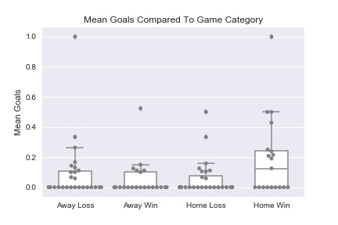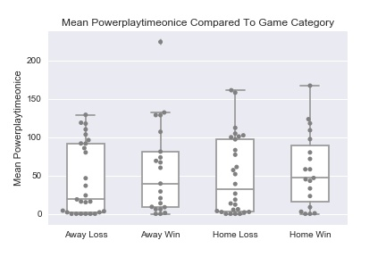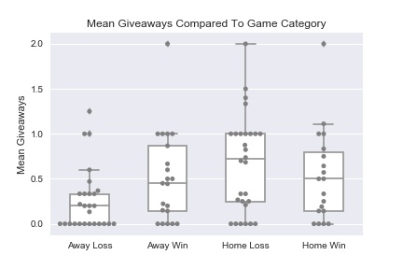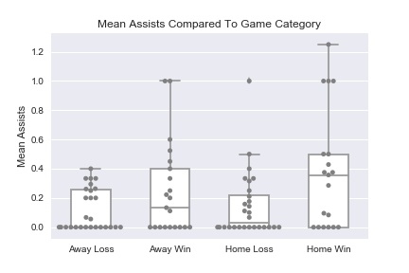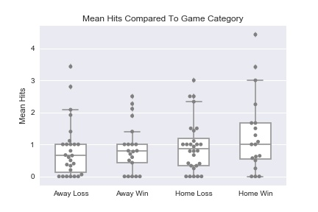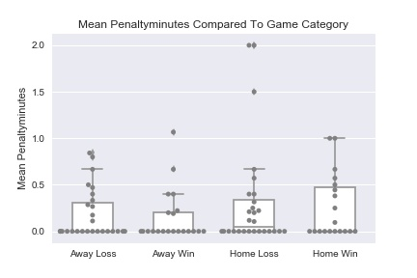

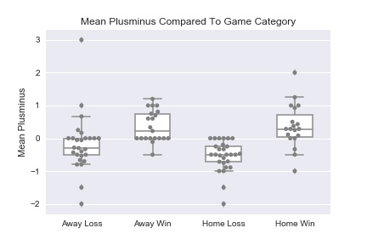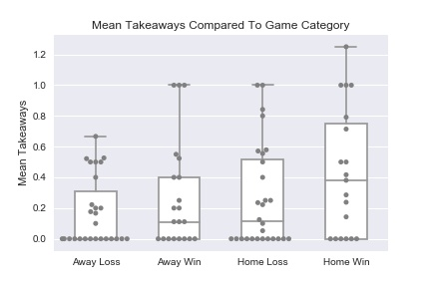

Figure 13 – Top 50 Player Statistics by Game Category