**Instructions**

Complete the following three tasks individually or as a team.

When completed, everyone must submit their work to the canvas page by the due date of **January 30, 2025, at 11:59 pm.**

There is a 24-hour late policy for homework per the course syllabus. No extensions will be given unless approved by the instructor of the course for legitimate reasons.

You must show work to earn full credit. Giving the answer by itself will only be awarded partial credit.

**You MAY USE:**

* Side Topics and Presentations Posted on Canvas
* Examples and Resources Posted on Canvas
* Any AI Tool, to which your usage must be documented with the submission of this homework assignment. Specify what AI tool was used and what prompts were given. Failure to document usage may result in academic misconduct. Note that you still will need to understand the content, even if AI is being utilized to help complete the assignment.

**Task 1 (of 3)**

Consider the circuit shown below.

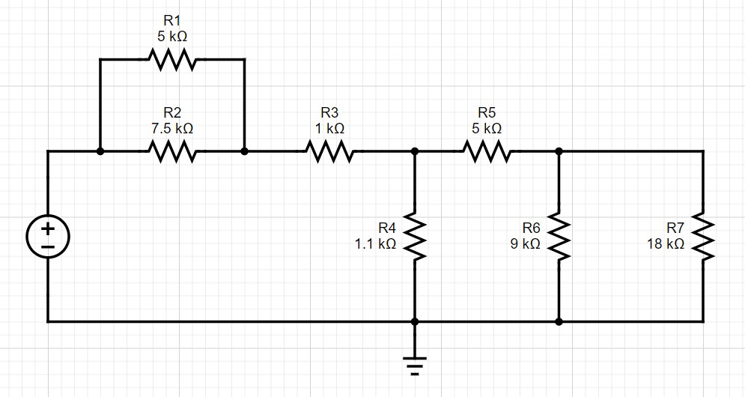

**V**

**S**

*Figure 1. Circuit with DC Power Supply and Seven Resistors*

Suppose the voltage supplied by the power source, VS, is 10V.

Determine the following:

1. Total Resistance, Req, for the circuit when viewed from the voltage source
2. Source Current, IS
3. Power, PS, supplied by the voltage source.

**Task 2 (of 3)**

Consider the circuit shown below.

*Figure*

*2*

*. Circuit with DC Power Supply and Seven Resistors*

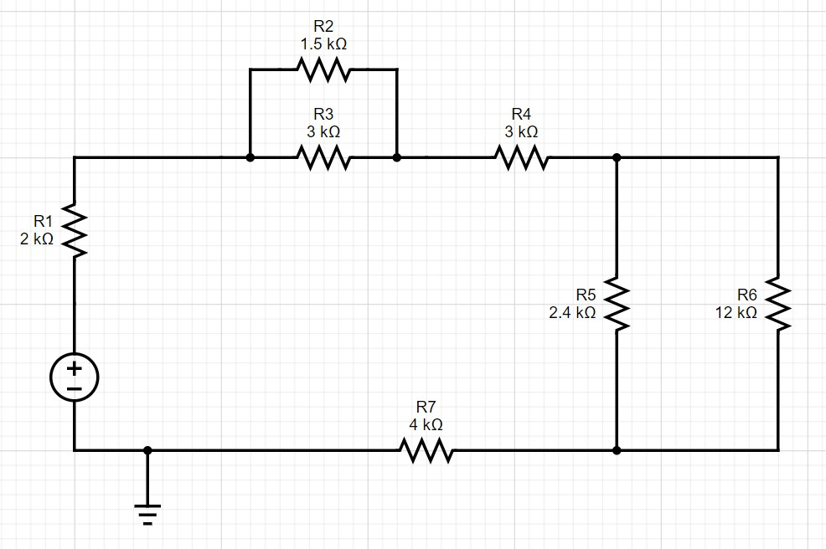

**I**

**S**



**V**

**S**

Suppose the voltage supplied by the power source, VS, is 240V, and the source current, IS, is 20 mA.

Determine the following:

1. The currents: IR1, IR2, IR5, and IR6
2. The voltages: VR1, VR3, VR5, and VR6
3. The power absorbed by the last resistor, PR7.

**Task 3 (of 3)**

Consider the circuit shown below.

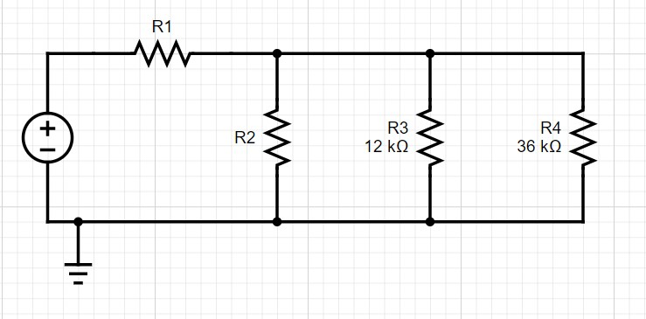

**V**

**S**

*Figure 3. Circuit with DC Power Supply and Two Unknown Resistors*

Suppose the voltage supplied by the power source, VS, is 40V.

Determine the following:

1. The resistance, R2, assuming the current through R2 is one half the current through R3R4 parallel circuit.
2. Using your value computed for R2 in part (a), compute the resistance, R1, that will result in a voltage drop of 20 V across the R3-R4 parallel circuit.