**Task 1 (of 1): Resistors, Voltages, and Currents**

**Kirchhoff’s Laws**

Kirchhoff's laws are fundamental principles in electrical circuit theory named after Gustav Kirchhoff, a German physicist. These laws are crucial for analyzing and solving electrical circuits. These laws have implications for circuits with resistors connected in series or parallel.

**Series Resistors:**

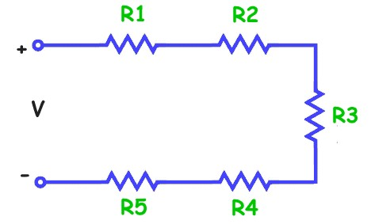Kirchhoff's Current Law (KCL) states that the total current entering a junction in a circuit must equal the total current leaving the junction, which implies that the current is constant in a series circuit. Therefore, according to KCL, the current across each resistor in a series circuit will remain constant.

The equivalent or total resistance of a series combination can be found with the following equation.

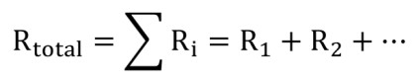

The Voltage on an individual resistor, if the source Current is known, can be found with the following equation.

 (We can use R_Total and Vs to find Is)

**Parallel Resistors:**

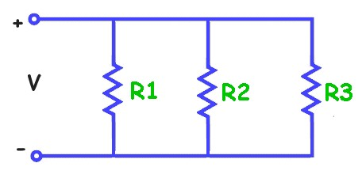In a parallel circuit, the voltage across each branch remains constant. This is in accordance with Kirchhoff's Voltage Law (KVL), which states that the sum of the voltages around any closed loop in a circuit is equal to zero. Since each branch in a parallel circuit forms a closed loop, the voltage across each branch remains constant regardless of the current flowing through it.

The equivalent or total resistance of a parallel combination can be found with the following equation.

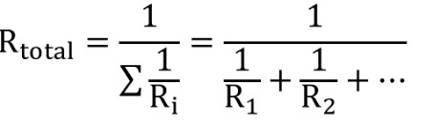

If there are only two resistors in parallel, a shortcut equation can be used to find the equivalent resistance. 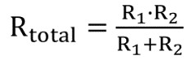

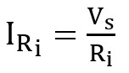Current on an individual resistor if source Voltage is known can be found with the following equation.

# Your VBA Conditional Task

Please use the provided starter file to develop a Macro that asks users to input either 2 ***OR*** 5 Resister values, and either the Source Voltage *OR* the Source Current to find out the Resultant Resistance, and Voltage and Current through each individual Resistor.

Please follow these steps:

* Declare your variables.
* Clear the output cells from previous data. use *ActiveSheet.Cells(4, 11) = ""* to clear individual cell and *ActiveSheet.Range("Provide the range of cells").ClearContents* to clear a range of cells.
* Ask the user for the inputs. For the resistors, they must either enter 2 resistors or 5. If they enter any other value, it may cause a division by zero error. For example, if they enter 4 values, the program will be expecting 5 values and will automatically assign the 5th Resistor a “zero”.
* Make a count of how many resistor values are entered. Please use this worksheet function: *Count = WorksheetFunction.Count(Range("D4:D8"))*
* Ask users to select either “Series” or “Parallel” circuits with the data validator in the G10 cell.
* While calculating the outputs, there are total five conditions to check. 1 and 2: If the count is 2 or 5 and the circuit is in Parallel. 3 and 4: if the count is 2 or 5 and the circuit is in Series. 5: if there is a different number of Resistors, display a MsgBox saying “Please enter values for either 2 or 5 Resistors”.
* Use the appropriate equations while remembering that Current remains constant through Series circuits while Voltage remains constant through Parallel circuits.

**Test Cases**

Inputs: Voltage = 5V, R1 = 2Ω, R2 = 3Ω, R3 = 4Ω, R4 = 5Ω, R5 = 6Ω

Outputs: Series: R_Total = 20Ω, V1 = 0.5V, V2 = 0.75V, V3 = 1V, V4 = 1.25V, V5 = 1.5V.

Current same for all = 0.25A

Parallel: R_Total = 0.69Ω, I1 = 2.50A, I2 = 1.67A, I3 = 1.25A, I4 = 1A, I5= 0.83A.

Voltage same for all: 5V