**Reference Frames**

Ascending-descending accelerometry (ADA) analyzes *in-track* accelerations in the satellite body frame (SBF)

Accelerometer Data

x = in-track; y = cross-track; z = vertical

**Figure 1:** CHAMP Satellite Body Frame (SBF)

Relevant atmospheric motion are thermospheric winds, which are organized in local coordinates (East, North, Up) in addition to co-rotating atmospheric winds

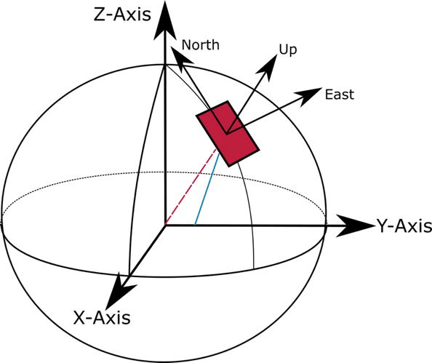

Thermospheric Winds

u=zonal, v=meridional, w=vertical

λ= geographic latitude

**Figure 2:** Thermospheric wind organization in

the East-North-Up (ENU) frame

**Figure 3:** Organization of ascending (a) and descending (b) passes from the perspective of the north pole. Q1 = early morning sector, Q2-Q3 is the dayside sector, and Q4 is the premidnight sector.

**Relevant Equations and Definitions**

Expansion of the In-Track Drag Acceleration

* Inverse Ballistic Coefficient
$$B= \frac{C_{d}A}{m}$$

* Angle between the in-track direction and the meridian
$$θ=\cos^{-1}{(\hat{v_{r}} ∙ \hat{j})}$$

* Satellite velocity with respect to the co-rotating atmosphere

* + - * Satellite velocity (aligned with in-track for CHAMP)

* + - * Co-rotating atmospheric winds

* + - * Neutral winds

$v_{w} \hat{x}=u\left(\hat{i}∙\hat{x}\right)+ v\left(\hat{j}∙\hat{x}\right)+ w\left(\hat{k}∙\hat{x}\right)$

$v_{w} \hat{x}=u\sin{θ}+ v\cos{θ}$

$$v_{r}= v_{sc}-492 \cos\left(λ\right)-u\sin{θ}- v\cos{θ}$$

$$\boxed{a_{d,x}=-\frac{C_{d}A}{2m}ρ{(v_{sc}-492 \cos\left(λ\right)-u\sin{θ}- v\cos{θ})}^{2} \hat{x}}$$

Background acceleration

$$a_{d,o}=-\frac{1}{2}B_{o}ρ_{o}v_{r,o}^{2} \hat{x}$$

* $B_{o} and ρ_{o}$ are the background inverse ballistic coefficient and mass density, respectively. These will not be computed directly.
* $v_{r,o}$ is the background satellite velocity with respect to the co-rotating atmosphere. This can be estimated as $v_{sc}-v_{cor}-v_{w,o}$, where $v_{w,o}$ is estimated using a model.

Linearization of the in-track drag acceleration



$$a_{d,x}= a_{d,o}+ \frac{∂a_{d,x}}{∂ρ}Δρ+\frac{∂a_{d,x}}{∂B}ΔB+\frac{∂a_{d,x}}{∂v_{r}}Δv_{r}$$

$$\frac{a_{d,x}}{a_{d,o}}-1= \frac{\frac{∂a_{d,x}}{∂ρ}Δρ+\frac{∂a_{d,x}}{∂B}ΔB+\frac{∂a_{d,x}}{∂v_{r}}Δv_{r}}{a_{d,o}}$$

$$\frac{a_{d,x}}{a_{d,o}}-1= \frac{\frac{-B_{o}v_{r,o}^{2}}{2}Δρ+\frac{-ρ_{o}v_{r,o}^{2}}{2}ΔB+(-ρ_{o}B_{o}v_{r})Δv_{r}}{-\frac{1}{2}B_{o}ρ_{o}v_{r,o}^{2}}$$

$$\frac{a_{d,x}}{a_{d,o}}-1= \frac{Δρ}{ρ_{o}}+ \frac{ΔB}{B_{o}}+ \frac{2Δv_{r}}{v_{r,o}}$$

$δρ= \frac{Δρ}{ρ_{o}}$

$δB= \frac{ΔB}{B_{o}}$

$δv_{r}=\frac{2Δv_{r}}{v_{r,o}}$

$$\frac{a_{d,x}}{a_{d,o}}-1= δρ+ δB+ δv_{r}$$

$a_{rel}= \frac{a_{d,x}}{a_{d,o}}-1$

$\boxed{a_{rel}= δρ+ δB+ δv_{r}}$

This equation is the basis for observing how perturbations in mass density, inverse ballistic coefficient, and velocity affect the relative acceleration. The following page describes how $a_{rel}$ can be computed empirically.

Computing $a_{rel}$ empirically

$$a_{rel}= \frac{a_{h,x}}{a_{filt}}$$

* $a_{h,x}$ is the in-track accelerometer data normalized to a constant altitude, h
* $a_{filt}$ is the normalized in-track accelerometer filtered using a moving average filter corresponding to the desired scale length

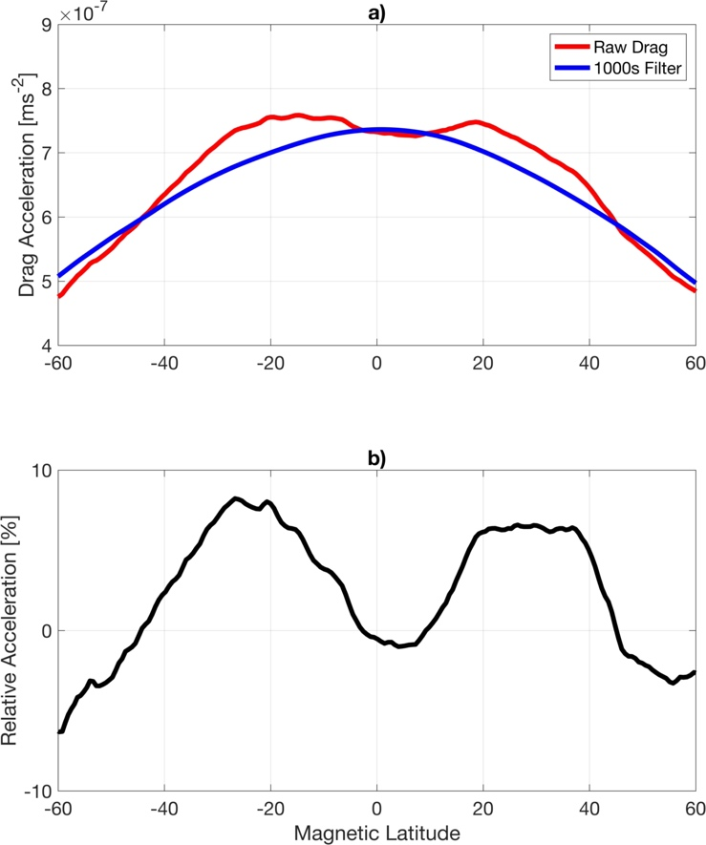

**Figure:** Example of deriving the relative acceleration empirically. (a) raw and 1000s filtered accelerometer measurements with respect to magnetic latitude at the equatorial dayside for a single orbit and (b) relative acceleration.

Deriving the density-wind dominance indicator for ADA

$$a_{rel,asc}- a_{rel,des}=\left(δρ_{asc}- δρ_{des}\right)+\left(δB_{asc}- δB_{des}\right)+ \left(δv_{r,asc}- δv_{r,des}\right)$$

* Density-dominated (i.e., $δB= δv_{r}=0$)

Here, the assumption is that ascending and descending relative acceleration accelerations are equal if only considering mass density perturbations over a region.

$a_{rel,asc}- a_{rel,asc}=$ $δρ_{asc}- δρ_{des}$ = 0

$$δρ=\frac{δρ_{asc}+ δρ_{des}}{2}= \frac{a_{rel,asc}+ a_{rel,des}}{2}$$

Density-dominated condition

* Wind-dominated (i.e., $δB= δρ=0$)

Here, the assumption is that changes in the velocity between ascending and descending passes are solely due to wind, given that the satellite velocity is constant.

* + - * Assume

The meridional wind component is responsible for changes between ascending and descending.

Implies $Δv_{r,asc}=-Δv_{r,asc}$

$$a_{rel,asc}- a_{rel,des}= \frac{2\left(2Δv_{r,asc}\right)}{v_{r,o}}$$

$$a_{rel,asc}- a_{rel,des}= 2δv_{r,asc}$$

$$δv_{r,asc}= \frac{δv_{r,asc}- δv_{r,des}}{2} =\frac{a_{rel,asc}- a_{rel,des}}{2}$$

Wind-dominated condition

* Density-Wind Dominance Indicator (
  + - * indicates density-dominance
      * $I_{bin}=1$ indicates wind-dominance

Deriving the in-track wind extraction for ADA

* + - * (+) are northward winds
      * (-) are southward winds