Software Application Profile: serodynamics, an R package for modeling longitudinal antibody kinetics from confirmed infection data
Kwan Ho Lee
Samuel Schildhauer
Peter F.M. Teunis
Kristen Aiemjoy
Douglas Ezra Morrison
2026-06-05
Table of contents

Abstract
Motivation: Estimating seroincidence, or the rate at which new infections occur in a population, from cross-sectional serological data requires well-characterized models of post-infection antibody kinetics. Fitting these models using longitudinal data from confirmed cases requires statistical implementations for each pathogen, limiting reproducibility and accessibility.
Implementation: serodynamics is an open-source R package that fits two-phase within-host antibody kinetic models using a Bayesian hierarchical framework and Markov chain Monte Carlo (MCMC) sampling via JAGS. The package estimates five kinetic parameters per antigen–isotype combination: baseline antibody level, peak concentration, time to peak, decay rate, and decay shape.
General features: The package supports data preparation, case data simulation, prior specification, stratified model fitting, convergence diagnostics, and posterior visualization. Output is directly compatible with the serocalculator package for downstream seroincidence estimation from cross-sectional surveys.
Availability: The package serodynamics is freely available on GitHub (https://github.com/UCD-SERG/serodynamics), with documentation at https://UCD-SERG.github.io/serodynamics/.
Supplementary information:
Keywords: antibody kinetics, seroepidemiology, Bayesian hierarchical model, seroincidence, R package, MCMC
 | Note to reviewers (to be removed before submission)  All three numbered figures in the Use section are rendered live from the R code chunks shown directly above them, using the nepal_sees case data and the nepal_sees_jags_output pre-fitted MCMC output that are shipped with the package. Two code chunks are intentionally not executed at render time: the full run_mod() call (because a four-chain × 30,000-iteration fit takes hours), and the end-to-end postprocess_jags_output() → serocalculator::est_seroincidence_by() pipeline (because it requires the raw jags.post object — saved only when run_mod() is called with with_post = TRUE — together with cross-sectional survey data). For the camera-ready version we will execute the full pipeline once and cache the results so all chunks render reproducibly (tracked in #238).

Introduction
Serological surveys, or serosurveys, are epidemiologic studies that can be used to measure population-level antibody responses to characterize infection burden (Simonsen et al. 2009; Teunis et al. 2012). Following exposure to a pathogen, the adaptive immune system generates antigen-specific antibodies, which increase rapidly after infection and gradually wane over time (de Graaf et al. 2014; Teunis et al. 2016). The concentration of antibodies against a given pathogen can often be used to estimate time since infection (Hay et al. 2024). In cross-sectional serosurveys, a large proportion of individuals with high antibody concentrations suggests a high burden of infection, while a smaller proportion indicates lower burden. However, the magnitude and speed of an individual’s immune response to infection is complex and dynamic, shaped by infectious dose, age, disease severity, prior exposures, vaccination history, among many other factors, complicating the interpretation of these measurements.
Population-level antibody responses are typically characterized using two key epidemiological measures: seroprevalence, the proportion of individuals with antibody levels above a defined threshold; and seroincidence, the rate at which new infections occur in the population (Simonsen et al. 2009; Teunis et al. 2012). Most analytic methods used to estimate seroprevalence dichotomize quantitative antibody levels into binary outcomes—seropositive or seronegative. While simple and widely used, this approach ignores temporal changes in antibody concentrations, individual-level heterogeneity, and immunological cross-reactivity between pathogens. In contrast, seroincidence rates quantify the rate at which new infections occur and are increasingly favored by epidemiologists, modelers, and public health professionals (Aiemjoy et al. 2022; Lai et al. 2025). Seroincidence rates can help determine whether a disease has been eliminated, differentiate between endemic and epidemic scenarios, and identify risk factors for transmission, helping locate areas where interventions are most needed.
New statistical methods have been developed to estimate seroincidence rates from cross-sectional serosurveys by incorporating models of antibody decay dynamics from confirmed cases (Simonsen et al. 2009; Teunis and van Eijkeren 2020). A critical upstream input for these methods is a set of previously estimated longitudinal seroresponse parameters describing how antibodies rise, peak, and decay following confirmed infection. Seroincidence can then be estimated from serosurveys as a function of peak antibody response and decay rate using previously estimated antibody kinetic parameters while accounting for heterogeneity in immunity, responses to multiple antigens, and laboratory assay variability (Teunis et al. 2016; Teunis and van Eijkeren 2020).
To model post-infection antibody kinetics a two-phase within-host model is deployed. Originally developed by de Graaf et al. (de Graaf et al. 2014) and extended by Teunis et al. (Teunis et al. 2016; Teunis and van Eijkeren 2020), this model describes the post-infection antibody response as an exponential rise driven by antigenic stimulation followed by power-law decay reflecting heterogeneous plasma-cell lifespans and prolonged immunity. When fitted within a Bayesian hierarchical structure, individual-level parameters are stabilized by borrowing strength across participants—important when longitudinal data are sparse. This framework has previously been applied to pertussis (de Graaf et al. 2014), typhoid fever (Aiemjoy et al. 2022), scrub typhus (Aiemjoy et al. 2024), and Shigella (Lee et al., n.d.). However, each application required investigators to independently implement the JAGS model specification, data formatting, prior calibration, and post-processing, which is difficult to reproduce and inaccessible to researchers without advanced statistical programming expertise.
The serocalculator R package implements the downstream step: estimating seroincidence rates from cross-sectional data using pre-estimated kinetic parameters (Lai et al. 2025). However, generating these upstream kinetic parameters has lacked a standardized tool. Here, we introduce serodynamics, a complementary open-source R package that provides a validated, end-to-end workflow for fitting two-phase Bayesian hierarchical models to longitudinal confirmed-case data to generate the seroresponse parameters that serocalculator requires. Together, serodynamics and serocalculator form a complete analytical framework for translating longitudinal case data and cross-sectional serosurveys into population-level infection rate estimates.

Implementation
serodynamics can be installed from GitHub using the pak package manager. The package requires JAGS (Just Another Gibbs Sampler) to be installed on the user’s system for Bayesian MCMC computation. Exported functions guide users from data import and simulation to model fitting, diagnostics, and visualization. All functions in the current version of serodynamics are described on the package website. The general workflow is: (1) import or simulate data, (2) inspect and visualize data, (3) prepare MCMC inputs, (4) fit the model, (5) assess convergence, and (6) postprocess and export results. Example input datasets and formatting guidance are provided in Supplement S1 (tracked in #233).

Import Data
Longitudinal serological data from individuals with confirmed infections are required for modeling, consisting of repeated quantitative antibody measurements collected at multiple time points following infection onset.

Longitudinal Case Data
Longitudinal serologic case data describe how antibodies rise and fall after confirmed infection in individual patients. Users import their data in standard tabular format (CSV or RDS) as a long form data set and apply as_case_data(), which converts the dataset into a validated case_data object (a subclass of tibble::tbl_df with added metadata attributes) and ensures required variables are present and in the correct format. The required variables are: a unique participant identifier (id), time since infection onset measured in days (timeindays), quantitative antibody response values (result), and an antigen–isotype biomarker label (antigen_iso). The as_case_data() function detects the required variables or allows users to specify them via function arguments. Case data objects can include additional variables for stratification, such as age group, infecting serotype, or study site.

Simulated Case Data
The sim_case_data() function generates synthetic longitudinal antibody data from a specified set of kinetic curve parameters. This function supports study design evaluation, method validation, and pedagogical use. Users define the number of simulated individuals (n), the maximum number of observations per individual (max_n_obs), the interval between follow-up visits in days (followup_interval), and a set of population-level kinetic curve parameters (curve_params). For convenience, serocalculator curve parameter objects can be passed directly as input, enabling users to simulate data from previously estimated kinetic models. Simulated data objects inherit the case_data class and can be passed directly to all downstream functions in the same workflow as observed data.

Built-in Example Data
For testing purposes, the package includes the nepal_sees dataset from the Surveillance for Enteric Fever in Asia Project (SEPA), containing longitudinal IgA and IgG antibody responses to the HlyE antigen from individuals with blood-culture-confirmed Salmonella Typhi infection in Nepal (Aiemjoy et al. 2022; Garrett et al. 2022). A pre-fitted model output (nepal_sees_jags_output) is also included for rapid demonstration of diagnostic and visualisation functions. Additional example files can be accessed using the serodynamics_example() function.

Inspect and Visualize Data
Users can inspect and visualize their case data using the built-in autoplot() method for case_data objects, which generates longitudinal trajectory plots of antibody responses faceted by antigen–isotype combination. This step provides a visual check of data quality, the number of available time points per individual, and the general shape of antibody responses before model fitting.

Prepare Data for Analysis
Two preparatory functions transform data and prior specifications into the inputs required for Bayesian MCMC estimation.
prep_data() converts a case_data object into the structured list format required by JAGS, constructing three-dimensional arrays for antibody levels (log-transformed) and sample collection times indexed by subject, visit, and antigen–isotype combination. Antibody values of zero are replaced with 0.01 prior to log-transformation. The function additionally appends a dummy individual (newperson) with missing antibody values at standard time points (days 5, 30, and 90), enabling posterior predictive sampling for a hypothetical new individual from the population distribution—the mechanism that generates the population-level kinetic parameter draws used by serocalculator.
prep_priors() generates weakly informative prior distributions for population-level parameters. Five prior components are specified: hyperprior means for the log-transformed population-level parameters (mu_hyp_param; defaults: $y_{0}=1.0$, $y_{1}=7.0$, $t_{1}=1.0$, $ρ=−4.0$, $α=−1.0$); precision hyperpriors (prec_hyp_param); Wishart scale matrices for between-individual variability (omega_param); Wishart degrees of freedom (wishdf_param; default: 20); and measurement precision hyperpriors (prec_logy_hyp_param). All prior components are customizable, and the prior specifications used in model fitting are stored as an attribute of the output for reproducibility. Further mathematical details are provided in Supplement S3 (tracked in #235).

Model Seroresponse
The core modelling function, run_mod(), fits the two-phase Bayesian hierarchical model using MCMC sampling via JAGS, interfaced through the runjags package. The model captures five key parameters per individual $i$ and antigen–isotype combination $j$: baseline antibody level ($y_{0}$), peak antibody concentration ($y_{1}$), time to peak ($t_{1}$), decay rate ($α$), and decay shape ($ρ$). During the rising phase ($t≤t_{1}$), antibody concentration grows exponentially at rate $β=log(y_{1}/y_{0})/t_{1}$. During the decay phase ($t>t_{1}$), concentrations decline according to a power-law function governed by $α$ and $ρ$, which captures the continuous distribution of plasma-cell lifespans (Teunis et al. 2016). The full mathematical specification is given in Supplement S2 (tracked in #234).
Individual-level kinetic parameters are modelled hierarchically: for each individual $i$ and biomarker $j$, the vector of log-transformed parameters $θ_{ij}=(logy_{0}, log(y_{1}−y_{0}), logt_{1}, logα, log(ρ−1))^{⊤}$ follows $θ_{ij}∼N(μ_{j},Σ_{j})$, where $μ_{j}$ is the population-level mean vector and $Σ_{j}$ is a biomarker-specific covariance matrix. A multivariate normal hyperprior is placed on $μ_{j}$, a Wishart prior on the precision matrix $Σ_{j}^{−1}$, and a gamma prior on measurement precision. This partial pooling approach stabilises inference for individuals with sparse measurements while preserving meaningful inter-individual variability. Separate models are fitted for each antigen–isotype combination.
Users specify the number of MCMC chains (nchain, 1–4), adaptation iterations (nadapt), burn-in iterations (nburn), retained samples per chain (nmc), and total iterations (niter), with thinning computed as niter / nmc. Chains are executed in parallel for computational efficiency. Stratified seroresponse models can be generated by specifying a covariate via the strat argument, enabling separate model fits for subgroups defined by age group, serotype, geography, or other covariates—a feature that has proved essential when kinetic parameters vary across populations (Lee et al., n.d.).

Model Diagnostics
serodynamics provides four built-in diagnostic visualization functions to assess MCMC convergence: plot_jags_trace() for visual inspection of chain mixing across all monitored parameters; plot_jags_dens() for posterior density plots to assess distributional shape and multimodality; plot_jags_Rhat() for the potential scale reduction factor ($\hat{R}$), with values below 1.05 indicating adequate convergence (Vehtari et al. 2021); and plot_jags_effect() for effective sample size plots to evaluate sampling efficiency. Diagnostic functions return stratified outputs if a stratification variable is specified in run_mod().

Postprocess and Export Results
The output from run_mod() is an sr_model object: a subclass of tibble::tbl_df containing MCMC samples from the joint posterior distribution, with columns for iteration, chain, parameter, antigen–isotype, stratification level, subject identifier, and parameter value. Fitted values and residuals are computed automatically when run_mod() completes, via calc_fit_mod(), and stored as attributes of the output object alongside the prior specification used in model fitting.
The post_summ() function produces a summary table of posterior estimates including mean, median, standard deviation, and credible intervals for all population-level parameters. The plot_predicted_curve() function generates individual-level predicted antibody trajectories with median curves and 95% credible interval ribbons overlaid on observed data points, supporting visualisation of multiple individuals and antigen–isotype combinations with optional faceting.
For downstream seroincidence estimation, postprocess_jags_output() extracts posterior predictive draws for the newperson dummy individual—representing a hypothetical new individual from the population—and reformats them into a curve_params object with columns antigen_iso, iter, chain, y0, y1, t1, alpha, and r. This output is directly compatible with the serocalculator package as sr_params input for seroincidence estimation from cross-sectional survey data (Lai et al. 2025).

Use
We demonstrate the use of serodynamics with a reproducible example using the built-in Nepal SEES typhoid dataset (Aiemjoy et al. 2022; Garrett et al. 2022). Additional details on these data are available in Supplement S4 (tracked in #236). This example is also available as an article on the serodynamics package website. All figures in this section are rendered directly by the corresponding R code chunks; the run_mod() chunk is shown but not executed at render time because a full fit requires hours of computation. Diagnostic and visualisation chunks use the pre-fitted MCMC output (nepal_sees_jags_output) shipped with the package.
library(serodynamics)
library(serocalculator)
library(ggplot2)
data(nepal_sees)
data(nepal_sees_jags_output)
We first visualise the raw longitudinal antibody responses with the autoplot() method for case_data objects (Figure 1):
autoplot(nepal_sees)
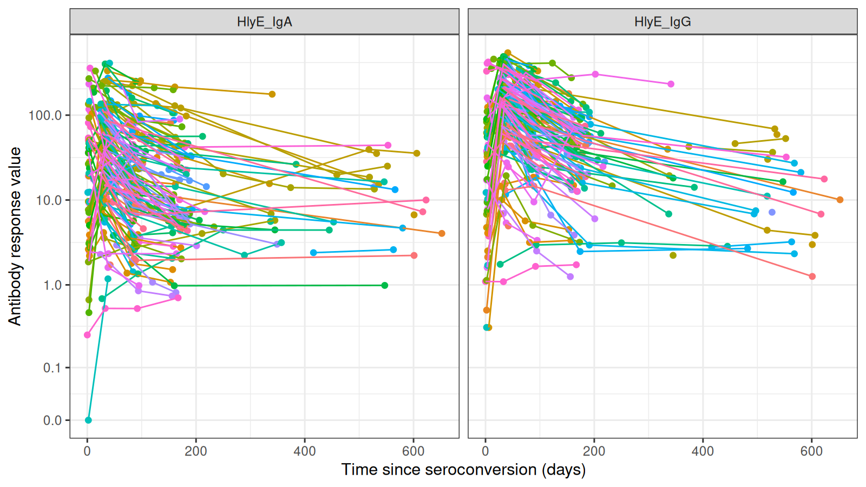
Figure 1: Longitudinal IgG and IgA responses to the Salmonella Typhi hemolysin E (HlyE) antigen from blood-culture-confirmed cases in the Nepal SEES cohort (n = 145 subjects, 689 observations), rendered by autoplot() on the nepal_sees case_data object. Each line connects repeated measurements for one subject; panels separate the two antibody isotypes.
We then fit the two-phase hierarchical model by specifying MCMC settings and calling run_mod(). In a typical analysis, we would fit models for HlyE IgA and IgG responses with four parallel chains:
fitted <- run_mod(
data = nepal_sees,
file_mod = serodynamics_example("model.jags"),
nchain = 4, nadapt = 25000,
nburn = 50000, nmc = 15000, niter = 30000
)
The MCMC settings shown here are recommended for final analyses and may require several hours of computation depending on dataset size and hardware. For initial exploration, users can reduce these values for shorter runs. The package also includes the pre-fitted model output nepal_sees_jags_output (2 chains × 500 retained samples, stratified by bldculres), allowing users to explore diagnostic and visualisation functions without running the full model. We use this object for the remaining chunks in this section.
After fitting, we assess MCMC convergence using the potential scale reduction factor $\hat{R}$, where values below 1.05 indicate adequate convergence (Vehtari et al. 2021) (Figure 2):
plot_jags_Rhat(
nepal_sees_jags_output,
iso = "HlyE_IgA",
strat = "typhi"
)
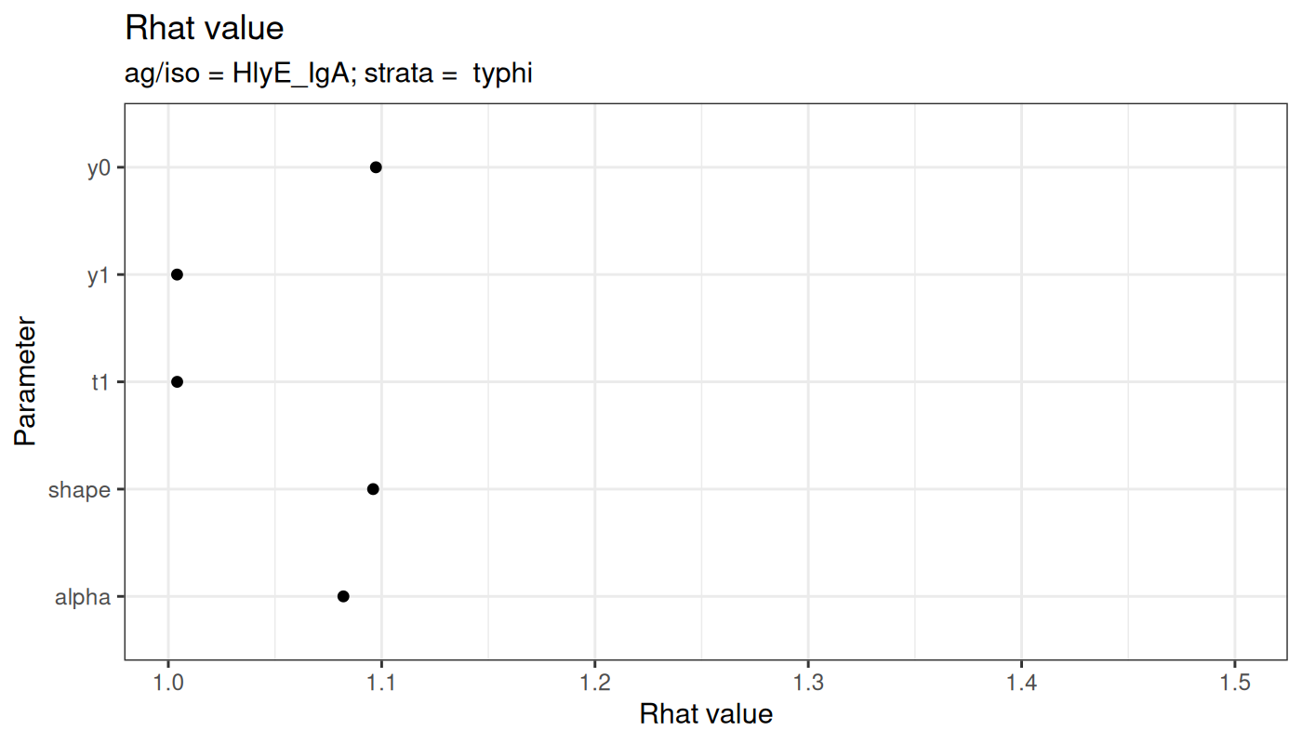
Figure 2: Convergence diagnostic produced by plot_jags_Rhat() for the population-level kinetic parameters ($y_{0}$, $y_{1}$, $t_{1}$, $α$, $ρ$) on the HlyE_IgA biomarker in the typhoid stratum of the pre-fitted Nepal SEES output. Values close to 1.0 indicate that the MCMC chains have converged.
A numerical summary of all population-level parameters is produced by post_summ():
post_summ(nepal_sees_jags_output)
We then visualise the predicted antibody trajectory for an individual participant with median curves, the 95% credible interval ribbon, and a thinned subset of individual posterior draws, overlaid on observed measurements (Figure 3):
plot_predicted_curve(
model = nepal_sees_jags_output,
dataset = nepal_sees,
ids = "sees_npl_2",
antigen_iso = "HlyE_IgA",
show_quantiles = TRUE,
show_all_curves = TRUE,
log_y = TRUE
)
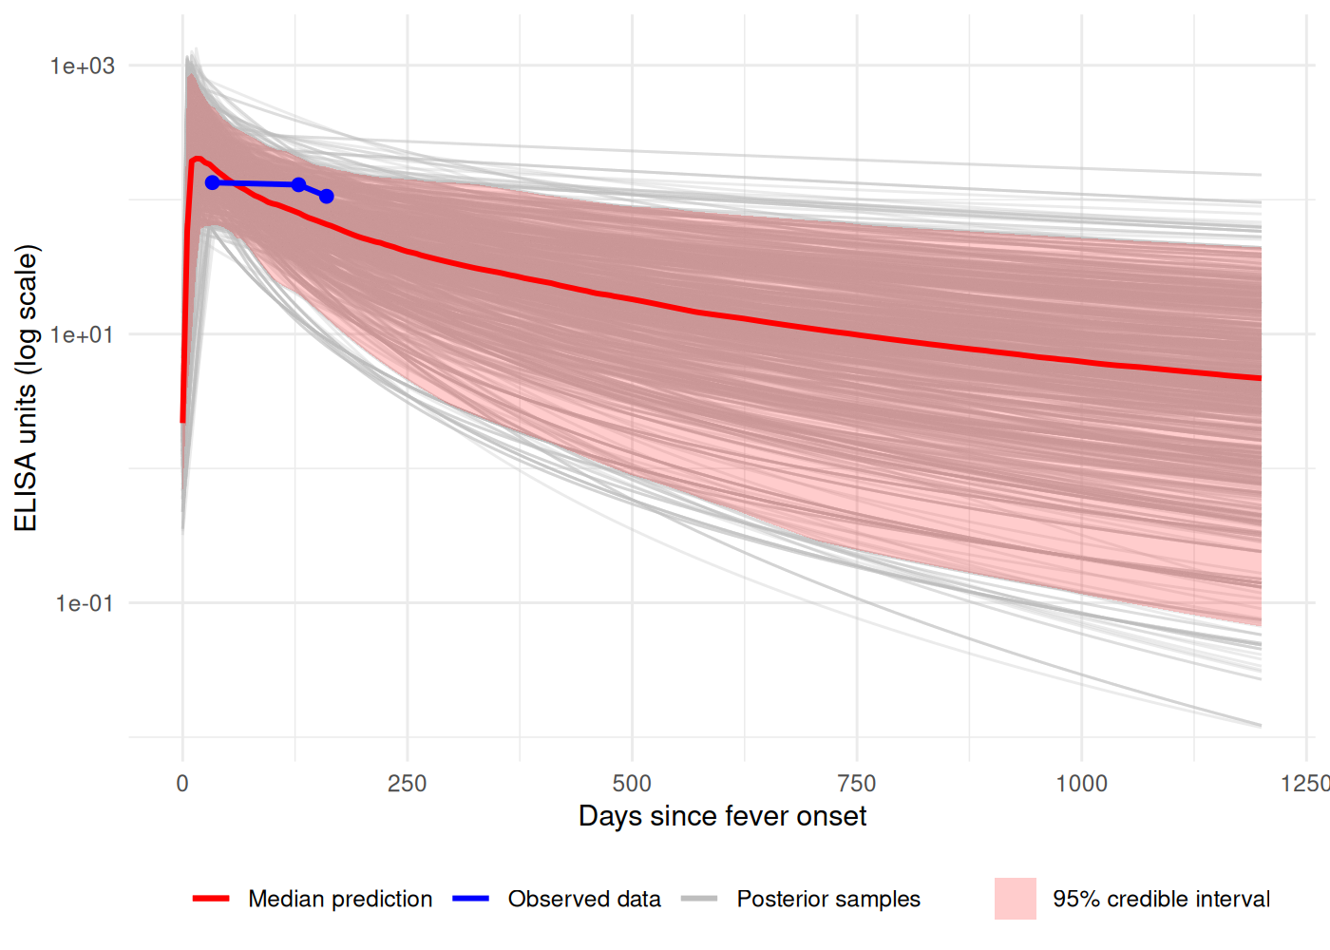
Figure 3: Posterior predicted antibody trajectory for subject sees_npl_2 and biomarker HlyE_IgA, rendered by plot_predicted_curve(). The dark line is the posterior median, the shaded band is the 95% credible interval, light lines are individual posterior draws, and points are the observed measurements for this subject.
Model outputs from run_mod() can be summarised and visualised using the corresponding post_summ() and diagnostic plotting methods, respectively. The estimated population-level seroresponse parameters can then be exported using postprocess_jags_output() for direct use as sr_params input to serocalculator, enabling seroincidence estimation from cross-sectional serosurvey data (Lai et al. 2025). The pipeline below illustrates the end-to-end integration; the chunk is shown for reference and is not executed at render time because it requires the raw jags.post object (saved when run_mod() is called with with_post = TRUE) together with cross-sectional survey data (tracked in #238):
# Reshape posterior draws for the dummy "newperson" into the
# format expected by serocalculator
curve_params <- postprocess_jags_output(
jags_output = fitted_with_post,
ids = attr(prepped_data, "ids"),
antigen_isos = attr(prepped_data, "antigens")
)
# Cross-sectional survey and assay noise (Surveillance for Enteric Fever in
# Asia Project; hosted on Open Science Framework)
xs_data <- load_pop_data("https://osf.io/download/n6cp3/")
noise <- load_noise_params("https://osf.io/download/hqy4v/")
# Stratified seroincidence estimation
est <- est_seroincidence_by(
strata = c("Country", "ageCat"),
pop_data = xs_data,
curve_params = curve_params,
noise_params = noise,
antigen_isos = c("HlyE_IgA", "HlyE_IgG")
)
autoplot(est, type = "bar", yvar = "ageCat", color_var = "Country", CIs = TRUE)

Discussion
serodynamics provides a standardized, open-source implementation of a two-phase Bayesian hierarchical framework for modelling longitudinal antibody kinetics following confirmed infection. Building upon the foundational methods of de Graaf et al. (de Graaf et al. 2014) and Teunis et al. (Teunis et al. 2016; Teunis and van Eijkeren 2020), the package makes these statistical implementations accessible and reproducible.
Several groups have developed R packages to support seroepidemiologic analysis. The serocalculator package estimates seroincidence from cross-sectional data but requires pre-estimated longitudinal seroresponse parameters (Lai et al. 2025). serosolver reconstructs individual infection histories from longitudinal data using reversible jump MCMC (Hay et al. 2020). serosim simulates serological data for study design (Menezes et al. 2023). RSero estimates force of infection from age-stratified seroprevalence using serocatalytic models (Hozé et al. 2025). serojump infers infection timing from longitudinal serological data (Hodgson et al. 2025). Collectively, these packages expand access to seroepidemiologic tools. Among these tools, serodynamics is distinctive in implementing the mechanistic two-phase within-host model using a hierarchical population structure, with output directly compatible with downstream seroincidence estimation tools.
Future enhancements will address current methodological limitations and expand usability. While serodynamics estimates kinetic parameters from single-infection episodes, its application is constrained in high-burden settings where repeated exposures alter the distribution of seroresponse patterns. We are actively working to incorporate approximate Bayesian computation techniques to enhance estimation in areas with high force of infection (Teunis et al. 2023).
The serodynamics package has been applied to studies of typhoid fever (Aiemjoy et al. 2022) and Shigella (Lee et al., n.d.), and its methods are currently being adopted by research teams to characterize seroresponse dynamics for additional enteric and vector-borne pathogens. serodynamics provides a free, open-source, and user-friendly tool for estimating longitudinal antibody kinetic parameters from confirmed-case data. Additional documentation and tutorials are available at https://UCD-SERG.github.io/serodynamics/.

Supplementary data

Funding
Funding acknowledgements will be added prior to submission (tracked in #237).

Conflict of interest
None declared.

Data availability
Source code for the serodynamics package is available on GitHub: https://github.com/UCD-SERG/serodynamics. Package documentation and tutorials are available at https://UCD-SERG.github.io/serodynamics/.

References
Aiemjoy, K., N. Katuwal, K. Vaidya, et al. 2024. “Estimating the Seroincidence of Scrub Typhus Using Antibody Dynamics After Infection.” American Journal of Tropical Medicine and Hygiene 111: 267–76. https://doi.org/10.4269/ajtmh.23-0475.
Aiemjoy, K., J. C. Seidman, S. Saha, et al. 2022. “Estimating Typhoid Incidence from Community-Based Serosurveys: A Multicohort Study.” The Lancet Microbe 3: e578–87. https://doi.org/10.1016/S2666-5247(22)00114-8.
de Graaf, W. F., M. E. Kretzschmar, P. F. Teunis, and O. Diekmann. 2014. “A Two-Phase Within-Host Model for Immune Response and Its Application to Serological Profiles of Pertussis.” Epidemics 9: 1–7. https://doi.org/10.1016/j.epidem.2014.08.002.
Garrett, D. O., A. T. Longley, K. Aiemjoy, et al. 2022. “Incidence of Typhoid and Paratyphoid Fever in Bangladesh, Nepal, and Pakistan: Results of the Surveillance for Enteric Fever in Asia Project.” The Lancet Global Health 10: e978–88. https://doi.org/10.1016/S2214-109X(22)00119-X.
Hay, J. A., A. Minter, K. E. Ainslie, et al. 2020. “An Open Source Tool to Infer Epidemiological and Immunological Dynamics from Serological Data: Serosolver.” PLOS Computational Biology 16: e1007840. https://doi.org/10.1371/journal.pcbi.1007840.
Hay, J. A., I. Routledge, and S. Takahashi. 2024. “Serodynamics: A Primer and Synthetic Review of Methods for Epidemiological Inference Using Serological Data.” Epidemics 49: 100806. https://doi.org/10.1016/j.epidem.2024.100806.
Hodgson, D., J. Hay, S. Jarju, et al. 2025. Serojump: A Bayesian Tool for Inferring Infection Timing and Antibody Kinetics from Longitudinal Serological Data.
Hozé, N., M. Pons-Salort, C. J. E. Metcalf, M. White, H. Salje, and S. Cauchemez. 2025. “RSero: A User-Friendly R Package to Reconstruct Pathogen Circulation History from Seroprevalence Studies.” PLOS Computational Biology 21: e1012777. https://doi.org/10.1371/journal.pcbi.1012777.
Lai, K. W., C. Orwa, J. C. Seidman, et al. 2025. “Serocalculator, an R Package for Estimating Seroincidence from Cross-Sectional Serological Data.” medRxiv, ahead of print. https://doi.org/10.1101/2025.06.04.25328941.
Lee, Kwan Ho et al. n.d. “Manuscript in Preparation.” Unpublished manuscript.
Menezes, A., S. Takahashi, I. Routledge, C. J. E. Metcalf, A. L. Graham, and J. A. Hay. 2023. “Serosim: An R Package for Simulating Serological Data Arising from Vaccination, Epidemiological and Antibody Kinetics Processes.” PLOS Computational Biology 19: e1011384. https://doi.org/10.1371/journal.pcbi.1011384.
Simonsen, J., K. Mølbak, G. Falkenhorst, K. A. Krogfelt, A. Linneberg, and P. F. Teunis. 2009. “Estimation of Incidences of Infectious Diseases Based on Antibody Measurements.” Statistics in Medicine 28: 1882–95. https://doi.org/10.1002/sim.3592.
Teunis, P. F., and J. C. van Eijkeren. 2020. “Estimation of Seroconversion Rates for Infectious Diseases: Effects of Age and Noise.” Statistics in Medicine 39: 2799–814. https://doi.org/10.1002/sim.8578.
Teunis, P. F., J. C. van Eijkeren, C. W. Ang, et al. 2012. “Biomarker Dynamics: Estimating Infection Rates from Serological Data.” Statistics in Medicine 31: 2240–48. https://doi.org/10.1002/sim.5322.
Teunis, P. F., J. C. van Eijkeren, W. F. de Graaf, A. Bonačić Marinović, and M. E. Kretzschmar. 2016. “Linking the Seroresponse to Infection to Within-Host Heterogeneity in Antibody Production.” Epidemics 16: 33–39. https://doi.org/10.1016/j.epidem.2016.04.001.
Teunis, P. F., Y. Wang, K. Aiemjoy, M. Kretzschmar, and M. Aerts. 2023. “Estimating Seroconversion Rates Accounting for Repeated Infections by Approximate Bayesian Computation.” Statistics in Medicine 42: 5160–88. https://doi.org/10.1002/sim.9906.
Vehtari, A., A. Gelman, D. Simpson, B. Carpenter, and P.-C. Bürkner. 2021. “Rank-Normalization, Folding, and Localization: An Improved R-hat for Assessing Convergence of MCMC (with Discussion).” Bayesian Analysis 16: 667–718. https://doi.org/10.1214/20-BA1221.

