ggplot2_Akiva_042517

Akiva Shalit-Kaneh

April 25, 2017

## 3.2.2 Creating a GGplot with the mpg dataframe

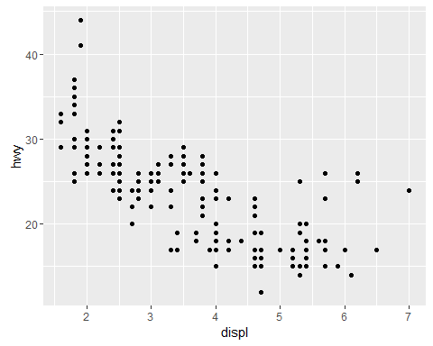

Car fuel efficiency (miles/gallon) vs Engine size (Liters)

## 3.2.4 Exercises

1. An empty graph.
2. Number of rows in mtcars is 32 and the number of columns is 11.
3. drv stands for drive. Types of drv are: f = front-wheel drive, r = rear wheel drive, 4 = 4wd

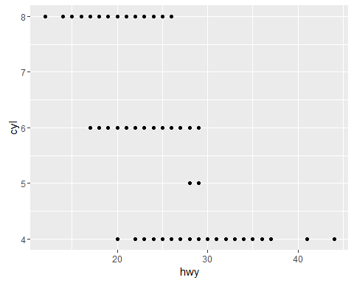

Car fuel efficiency (miles/gallon) vs Number of Cylinders

1. GGplot cannot graph Class vs drv since both are chr data.

## 3.3.1 Exercises

1.What’s gone wrong with this code? Why are the points not blue?

ggplot(data = mpg) + geom_point(mapping = aes(x = displ, y = hwy, color = "blue"))

color = "blue" should be outside of the inner aes parentheses.

1. Continuous variables in mpg are: displ. engine displacement, in litres cty. city miles per gallon hwy. highway miles per gallon

The rest are categorical

1. **Mapping continuous variable cty to color**

ggplot(data = mpg) +   
 geom_point(mapping = aes(x = hwy, y = cyl, color = cty ))

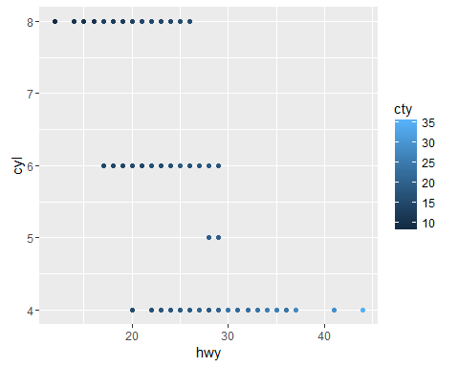

Car fuel efficiency (miles/gallon) vs Number of Cylinders with colored cty (miles per galon in the city)

**Mapping continuous variable cty to shape**

Returns an Error saying a continuous variable can not be mapped to shape.

**Mapping continuous variable cty to size**

ggplot(data = mpg) +   
 geom_point(mapping = aes(x = hwy, y = cyl, size = cty ))

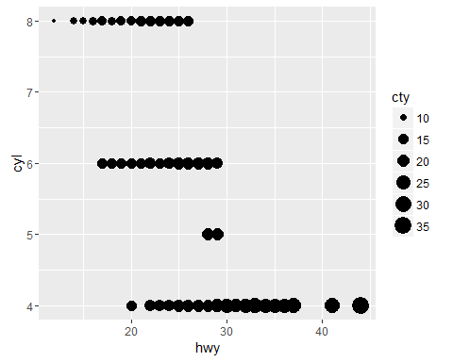

Car fuel efficiency (miles/gallon) vs Number of Cylinders with size cty (miles per galon in the city)

## Continuous variables need continuous representation, this is why size and color work for cty but not shape.

1. **Mappin the same variabe to multiple aesthetics**

ggplot(data = mpg) +   
 geom_point(mapping = aes(x = hwy, y = cyl, size = cty, color = cty ))

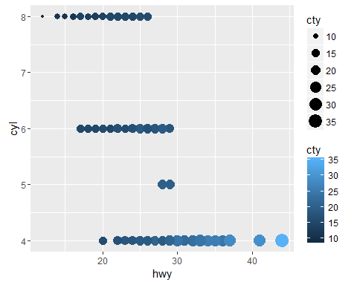

Car fuel efficiency (miles/gallon) vs Number of Cylinders with size cty (miles per galon in the city)

## Both aesthetics are used.

1. The stroke aesthetic is used to modify the width of the border of a shape.
2. When a you map an aesthetic to something other than a variable name you get FALSE for a single aesthetic such as color below.

ggplot(data = mpg) +   
 geom_point(mapping = aes(x = hwy, y = cyl, color = cty<5 ))

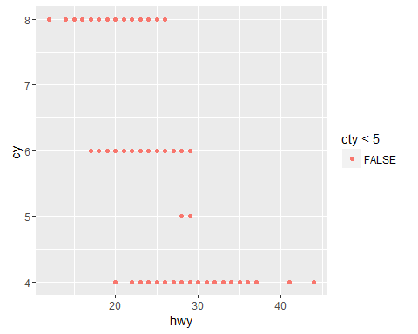

Car fuel efficiency (miles/gallon) vs Number of Cylinders with color cty<5 (miles per galon in the city)

## 3.5.1 Exercises

1. Faceting on a continuous variable works.

ggplot(data = mpg) +   
 geom_point(mapping = aes(x = displ, y = hwy)) +   
 facet_wrap(~ cty, nrow = 2)

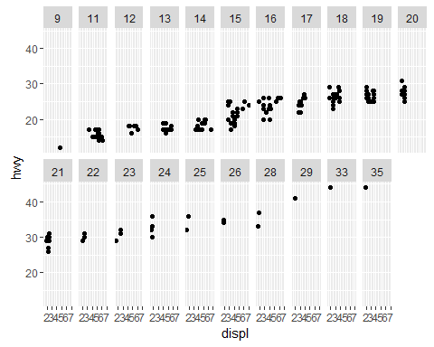

Engin displacement (Liters) vs Number of gallons/mile consumend on the highway with faceting by continuous cty (miles per galon in the city)

1. The below plot explains why there were empty cells in drv~cyl faceting, certain combinations do not exist.

ggplot(data = mpg) +   
 geom_point(mapping = aes(x = drv, y = cyl))

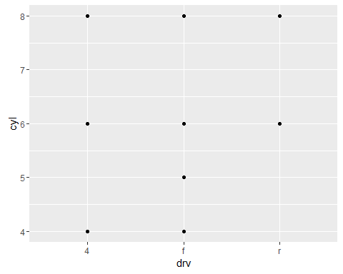

Combinations of drv with cyl

1. The below codes use ~. to facet with only one categorical variable and to choose whether to facet to rows of cells or columns.

ggplot(data = mpg) +   
 geom_point(mapping = aes(x = displ, y = hwy)) +  
 facet_grid(drv ~ .)

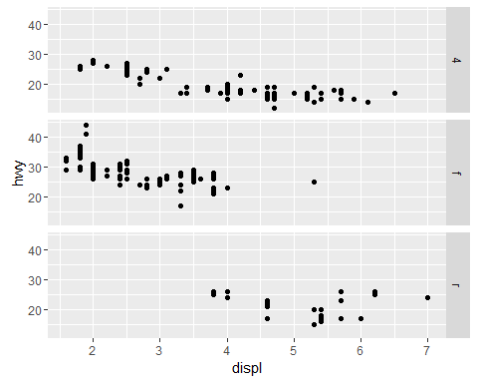

testing the above code

ggplot(data = mpg) +   
 geom_point(mapping = aes(x = displ, y = hwy)) +  
 facet_grid(. ~ cyl)

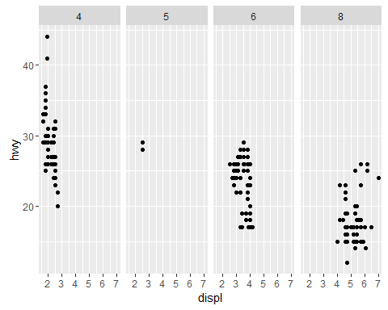

testing the above code

1. When faceting instead of coloring you have more focus on each category. On the other hand you do not have all the data on the same graph. The larger the data set the more important it will be to facet due to overcrowded plots.

5.In facetwrap nrow and ncol control the number of rowns and columns the facets appear in. This does not exist in facetgrid because there the number of categries withing the category variable chosen dictates the number of rows or columns.

6.For best use of space.