BioE 3090 Junior Design

Incubator Circuit Lab

2/8/2018

# Objective

The objective of this lab is to build and test the circuit you will be using to heat the incubator prototype and to begin tuning the PID controller to control the incubator temperature. This will probably take 2 class periods.

# Parts

|  |  |
| --- | --- |
| Part | Quantity |
| DS18B20 Temperature Sensor | 2 |
| Heater Kapton Tape | 1 |
| MOSFET 20N06L | 1 |
| Heat Sink for TO220 | 1 |
| Arduino Uno | 1 |
| USB | 1 |
| LED | 1 |
| Resistor 4.7, 3.3M, 2.2.M, 10k, 390 | 1 ea |
| Doide Schottkey | 1 |
| Fuse Holder | 1 |
| Breadboard | 1 |
| Heat Sink TO220 | 1 |
| Glass Fuse 2A | 1 |
| Switch | 1 |
| Power Jack | 1 |

# What to Turn In / Lab Output

1. A screenshot of the Matlab UI running. (5-pts)
2. Adjust P, I, D values in real time to better tune the system. (5-pts)
   1. Describe how the system is behaving. Are you able to get it tuned so that the temperature measured tracks exactly with the setpoint temperature.
3. An Excel plot of Inside Temp and Outside temperature vs Time on the Left Axis, Plot of Battery Voltage in time on the Right Axis. (10 pts)
   1. You can get this data from your saved text file.

# Electronics Diagram

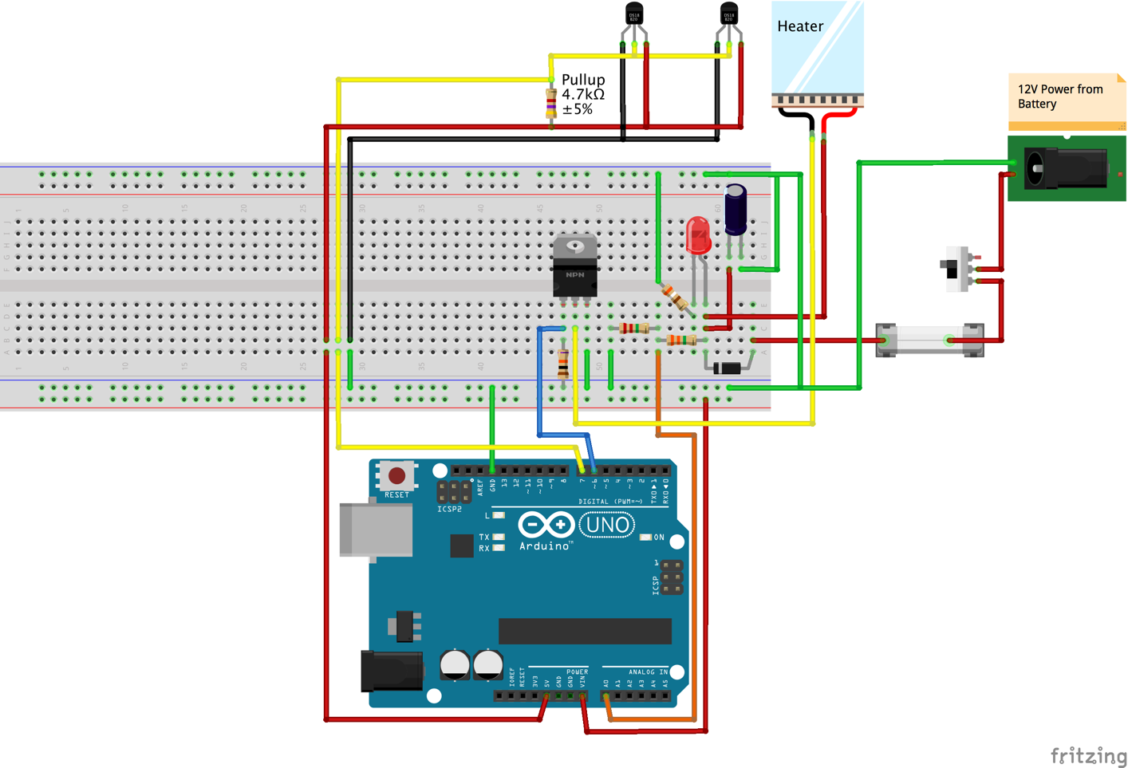

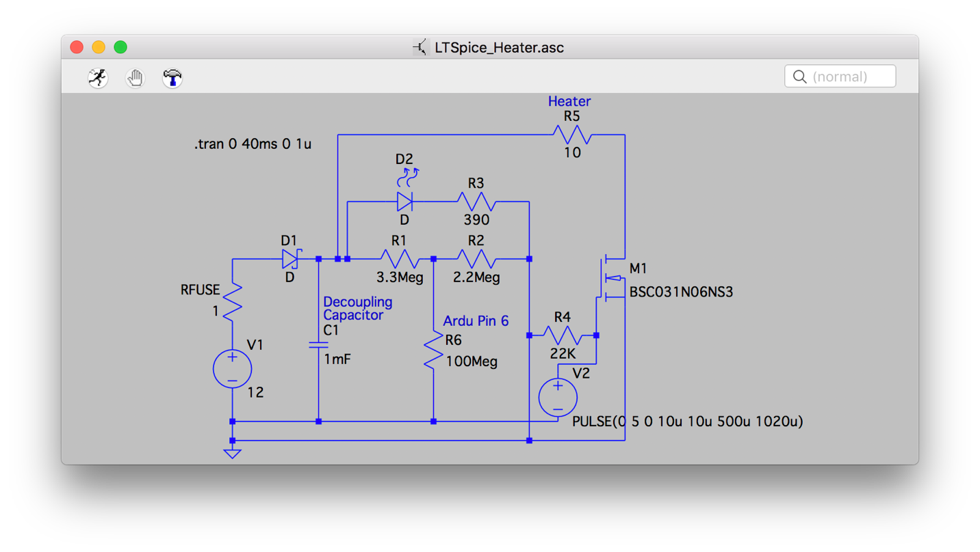

# Work Plan

1. Station Rotation – Soldering
   1. One group at a time, soldering training.
2. Build Power Supply Circuit
   1. Use 22Ga solid core hookup wire for breadboard connections.
   2. Wire power supply circuit to breadboard. Test voltage and grounds.
      1. Power jack, fuse, protection diode, decoupling capacitor and ground buses.
   3. Test Power Supply circuit before building the rest of the circuit
      1. You can layout the rest of the circuit components just ensure they cannot get powered before testing the power circuitry.
      2. Are your breadboard ground and power rails reading +12V as expected?
   4. Unplug power supply circuit and measure voltage
      1. There may be remaining power on the breadboard, some power supplies have internal capacitors that will remain charged for a short time after unplugging the circuit.
3. Layout the remaining components
4. Attach temperature sensors and heater to incubator.
   1. Heaters are power elements, so you’ll need to us wire that has sufficient cross sectional area to carry the necessary current.
   2. The heaters are not attached to the breadboard, so it makes better sense to use stranded wire, instead of solid core hookup wire.
   3. 22Ga Stranded wire should work well for the heater, but you will need to solder / heat shrink a small section of hookup wire to be able to push it into the breadboard.
   4. DS18B20 temperature sensors are digital electronics and do not require high currents. 22Ga wire would be overkill, cost more, and would be less flexible.
      1. Use 28Ga wire for these low-power electronics.
   5. It is Styrofoam, so should be pretty easy to make penetrations.
   6. The supplied heater is fairly low power, so avoid unnecessary holes.
      1. Probably not a great idea to just run the wires under the lid.
5. Flash the firmware onto the Arduino
   1. Firmware is located in Bioe3090_Incubator -> Bioe3090_Incubator.ino
6. Load and run the Matlab UI
   1. Bioe3090_Incubator -> Matlab -> PID_Datalogger -> Plot_Serial.m
   2. A dialog box will pop up to select the Arduino connection port. This will have the same name as the Port on the Arduino IDE -> Tools -> Port menu.
   3. When you run the software the UI should automatically begin collecting data after 1-2 seconds and the plots will begin updating.
   4. If you change the P, I, D, or Temperature Setpoint then these values will be updated in the Arduino in real time.
7. To write data to file
   1. The “Write to File” button opens a dialog box to save a text file.
   2. The text file will write any data stored in cache within the Matlab program and will then proceed to log every datum as it is received by the UI.