- Which resolution is more important for creating a topography map?
- Temporal resolution
- Radiometric resolution
- Spectral resolution
- Spatial resolution

- How many dimensions does an RGB image feature space have?
- 3
- 1
- 2
- 4

- You used an unsupervised learning algorithm to cluster the training data into three clusters. Once you developed your model, you are given a test sample shown as a star. To which cluster do you assign this test sample?
- C1
- C2
- C3
- None of the clusters

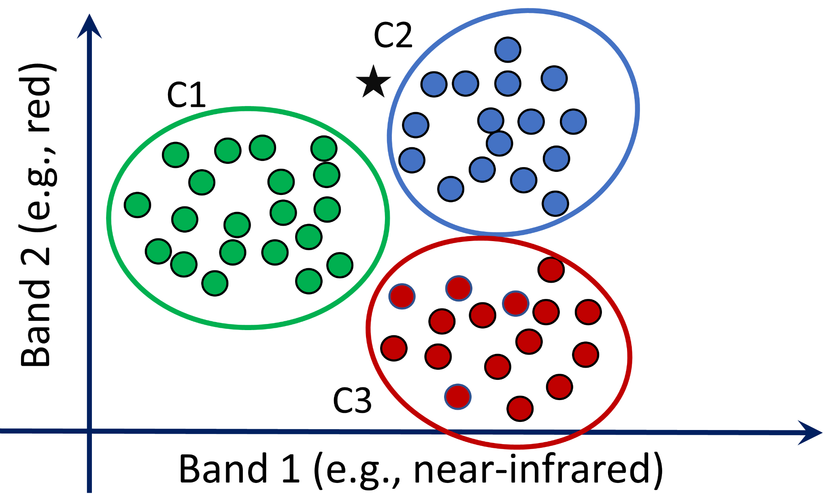

- For a supervised land cover identification, what type of machine learning technique will you implement?
- Classification
- Regression
- Clustering
- Association

- In a network with the following architecture, how many weights do we have that should be identified?

- 3
- 6
- 7
- 12

- A reasonable performance on both training and test datasets is described as:
- Underfitting
- Overfitting
- Optimum

- In k-fold Cross Validation, the test data changes k times.
- True
- False

- Which parameter is NOT considered a hyperparameter in training a deep learning network (hyperparameters are those defined by users)?
- Number of hidden layers
- Number of nodes (neurons) in each hidden layer
- Selecting the activation function (e.g., sigmoid or RELU)
- Weights for each layer

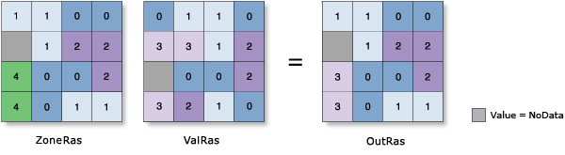
- If we calculate the ‘median’ using zonal statistics (gray cell: no data), what would be the value for zone 1?
- 0
- 1
- 2
- 3

- A company approached you to help them identify dry spots in a large forest with a high risk of fire using satellite data. If you don't have ground-truth data (labels), which machine learning algorithm do you use to identify those spots?
- Random forest
- Neural network
- K-means
- Linear regression

- Which statement is true about zonal statistics?
- Zonal raster (zonal extent) must be a raster file.
- Zonal raster and value raster must have the same spatial resolution.
- Value raster must be a raster file.
- The output of zonal statistics is raster.

- A dataset in which you calculate a statistic must be __________ .
- Raster
- Vector
- Standalone table
- All of the above

- You are tasked to use satellite imagery to identify the soil type and soil moisture content in a large field. What type of machine learning algorithm do you use for these two applications?
- Classification, Classification
- Classification, regression
- Regression, classification
- Regression, regression

- What is the Turing test?
  - It’s a test of a machine’s ability to exhibit intelligent behavior.
  - It’s a test to judge human intelligence in an automated way.
  - It’s a test of the speed of a machine in rendering text datasets.
  - It’s a test to judge the processing power and speed of a machine.

- If our machine learning algorithm predicts a continuous quantity, then it’s a …..
  - Classification problem
  - Regression problem
  - Clustering problem
  - Association problem

- You are tasked with writing a Python script using ArcPy to iterate through all feature classes in a geodatabase named "SanJuan.gdb". The script should print the name of each feature class, its geometry type (such as Polyline, Polygon, etc.), and the name of its spatial reference system (for example, "NAD_1983_UTM_Zone_13N"). Below is a partially completed script. How would you complete this script to meet the requirements?
import arcpy
# Set the workspace to SanJuan.gdb
arcpy.env.workspace = "path/to/SanJuan.gdb"
# List all feature classes in SanJuan.gdb
featureClasses = arcpy.ListFeatureClasses()
# Loop through each feature class
for featureClass in featureClasses:
# Get the geometry type of the feature class
# Get the spatial reference of the feature class
# Print the name, geometry type, and spatial reference name
Which of the following code snippets correctly completes the script?
a)
desc = arcpy.Describe(featureClass)
print(f"{featureClass}: {desc.shapeType}")
print(f"{featureClass}: {desc.spatialReference.name}")
b)
geometryType = arcpy.GetGeometryType(featureClass)
spatialRef = arcpy.GetSpatialReference(featureClass)
print(f"{featureClass}: {geometryType}")
print(f"{featureClass}: {spatialRef}")
c)
desc = arcpy.Describe(featureClass)
print(f"{desc.name}: {desc.geometryType}")
print(f"{desc.name}: {desc.spatialRef.name}")
d)
desc = arcpy.Describe(featureClass)
print(f"{featureClass}: {desc.featureType}")
print(f"{featureClass}: {desc.spatialReferenceName}")

- Which of the following is NOT a Python IDE?
- PyCharm
- Jupyter
- Visual Studio Code
- ArcGIS Pro

- In what classifier, the objective is to find a model that maximizes the margin between the samples of classes?
- SVM
- Random Forest
- Decision Trees
- K-means
- Which Python library is commonly used for performing zonal statistics on raster data?
- pandas
- scipy
- rasterstats
- rasterio

- Given this NDVI histogram, what would be my threshold to segment vegetation pixels?
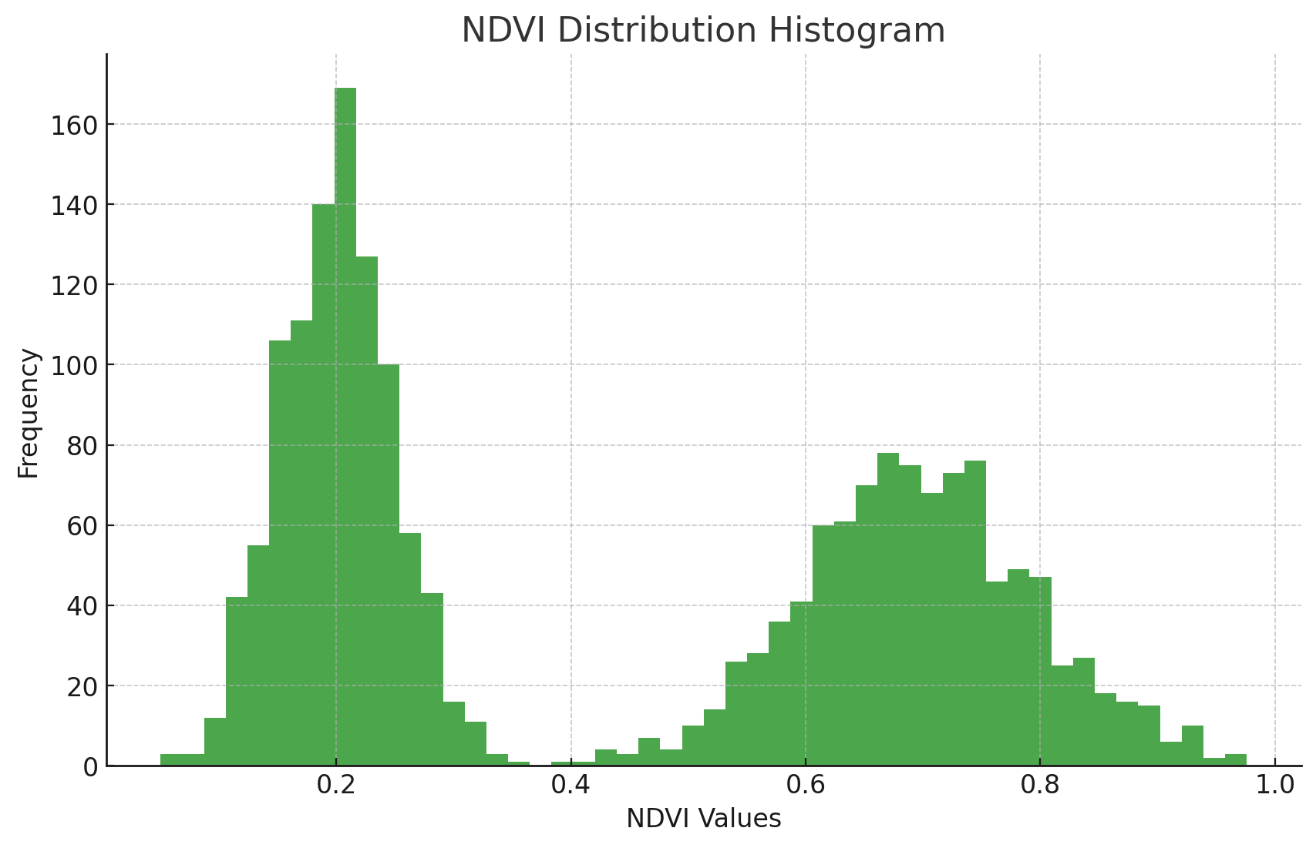
- 0.2
- 1.0
- 0.5
- 0.1

21. Which of the following techniques is commonly used for image segmentation based on pixel intensity?
- Principal Component Analysis (PCA)
- K-means clustering
- Linear regression
- Decision tree classification

22. What does CNN stand for in the context of deep learning?
- Convolutional Neural Network
- Convolutional Number Network
- Complex Neural Network
- Concurrent Neural Network

23. What does the Zonal Statistics tool in ArcGIS Pro calculate?
- Only the area of zones
- The mean, median, sum, minimum, and maximum of cell values within zones
- Only the perimeter of zones
- None of the above
24. Which of the following is an example of supervised learning in GIS?
- Clustering land cover types without labels
- Classifying satellite images into land cover categories with known labels
- Reducing the dimensionality of hyperspectral images
- Discovering patterns in spatial data without specific outcomes

25. K-means clustering is an example of:
- Supervised learning
- Unsupervised learning
- Reinforcement learning
- Semi-supervised learning

26. Which resolution describes the ability to distinguish different levels of brightness in remotely sensed imagery?
A. Spatial resolution
B. Spectral resolution
C. Temporal resolution
D. Radiometric resolution

27. For predicting crop yield from satellite-derived vegetation indices, what type of machine learning approach would you use?
A. Classification
B. Regression
C. Clustering
D. Dimensionality reduction

28. When a model performs well on training data but poorly on test data, this is called:
A. Underfitting
B. Optimum fit
C. Overfitting
D. Cross-validation

29. Which of the following is an example of unsupervised learning in remote sensing?
A. Land cover classification with training samples
B. Crop yield prediction using historical data
C. K-means clustering of spectral signatures
D. Object detection with labeled imagery

30. What does the Zonal Statistics tool in ArcGIS Pro calculate for each zone?
A. Only the area and perimeter
B. The mean, median, sum, minimum, and maximum of cell values within zones
C. Only the count of cells
D. The standard deviation only

31. Which Python library is commonly used for reading and writing raster data?
A. geopandas
B. rasterstats
C. rasterio
D. arcpy

32. In a neural network, which of the following is a hyperparameter (defined by the user before training)?
A. Weights between neurons
B. Number of hidden layers
C. Bias values
D. Output activations

33. How many bands does a standard true-color composite image use?
A. 1
B. 2
C. 3
D. 4 or more

34. Which classifier aims to maximize the margin between different classes?
A. K-means
B. Decision Tree
C. Support Vector Machine (SVM)
D. Random Forest

35. What type of machine learning is used when you have labeled training data and want to predict discrete categories?
A. Unsupervised learning
B. Supervised classification
C. Reinforcement learning
D. Clustering
36. Which resolution refers to how often a satellite revisits the same location?
A. Spatial
B. Spectral
C. Temporal
D. Radiometric

37. For zonal statistics, the value raster must be:
A. A vector file
B. A raster file
C. A CSV table
D. Either raster or vector

38. What does CNN stand for in the context of deep learning for image analysis?
A. Complex Neural Network
B. Convolutional Neural Network
C. Concurrent Number Network
D. Categorical Neural Network

39. Which of the following is NOT typically a Python IDE for GIS development?
A. Jupyter Notebook
B. PyCharm
C. ArcGIS Pro
D. Visual Studio Code

40. If you need to identify fire-prone areas in a forest using satellite data but have no ground-truth labels, which algorithm is most appropriate?
A. Random Forest classification
B. Linear regression
C. K-means clustering
D. Support Vector Machine

- What are the benefits of ArcGIS Python integration?
- What is spatial, spectral, temporal, and radiometric resolution?
- What is the difference between True color and False color composite?
- Write 2 vegetation indices that are commonly used and their formula
- Give 2 examples of supervised classification
- Given a 3 x 3 NDRE matrix and the task to create a binary mask where any NDRE value less than 0.5 is set to 0, and any value 0.5 or higher is set to 1, consider the generated binary mask based on the NDRE values below:
NDRE Values:
0.3 0.5 0.2
0.6 0.1 0.8
0.4 0.7 0.2
Binary Mask (NDRE < 0.5 becomes 0, NDRE >= 0.5 becomes 1):
0 1 0
1 0 1
0 1 0
Applying this binary mask to the original NDRE values (multiplying element-wise), what would be the final output matrix?
- Which Python library is commonly used for
      - Zonal statistics
      - Reading raster data
      - Reading vector data
      - Machine learning
      - Using ArcGIS Pro tools in Python

- What is the main difference between multispectral and hyperspectral imaging?
- List one of the many benefits of using ArcGIS Notebooks.
- What is an Integrated Development Environment (IDE)?
- How does supervised learning differ from unsupervised learning?
- What are the benefits of ArcGIS Python integration? List at least three.
- Define spatial, spectral, temporal, and radiometric resolution in the context of remote sensing.
- What is the difference between True color and False color composite imagery? Give one example of when false color is useful.
- Write the formula for NDVI and explain what it measures. Name one other commonly used vegetation index.
- How does supervised learning differ from unsupervised learning? Give one example of each in a GIS context.

