**Epistemic Cue Guidelines v1 (6/12/18)**

**Overview**

The goal of this work is to identify and classify epistemic cues in the scientific literature. Epistemic cues are words or phrases that signify uncertainty, speculation, hedging, incomplete evidence, current ongoing research, future directions or predictions, an unexpected result, a recommendation, or that not much is known about a topic. Statements of fact or methodology do not generally have epistemic cues because the statement is certain or explaining the experimental design. The first task is to identify the epistemic cues and then to classify them within an ontology of ignorance, mapping words and phrases to a dictionary to add more meaning.

1. **Task at hand**

You will be provided with scientific articles that include many sentences. Please identify and map any epistemic cues in the sentences to the ontology of ignorance. Epistemic cues are words or phrases that signify uncertainty, speculation, hedging, incomplete evidence, current ongoing research, future directions or predictions, an unexpected result, a recommendation, or that not much is known about a topic. Statements of fact or methodology do not generally have epistemic cues because the statement is certain or explaining the experimental design. This does not mean skip the methods section, but there may be no epistemic cues in it.

1. **Identification examples**

The table below has multiple examples with the epistemic cues in highlighted yellow, the epistemic cue written out, and an explanation of why it is identified as an epistemic cue. Note that epistemic cues are not keywords and one cannot simply search for these terms in the sentences.

|  |  |  |
| --- | --- | --- |
| **Sentence** | **Epistemic Cue** | **Explanation** |
| Little is known about genetic factors affecting intraocular pressure (IOP) | Little is known | Not much known about topic |
| Its molecular etiology is poorly understood | Poorly understood | Not much known about topic |
| These IOP differences are likely due to interstrain genetic differences | likely | Speculation |
| It is becoming increasingly clear that many forms of glaucoma have a genetic component | It is becoming increasingly clear | Incomplete evidence |
| This is in agreement with a number of human studies | This is in agreement | Incomplete evidence |
| Some but not all human studies have reported a positive association between IOP and blood pressure | Some but not all | Incomplete evidence |
| Much current research is focused on identifying chromosomal regions and genes that contribute to glaucoma | Current research | Current ongoing research |
| An effect of anesthesia in these very old mice cannot be ruled out | Cannot be ruled out | Current ongoing research |
| Animal models will provide systems for subsequent hypothesis testing and experimental dissection of pathogenesis | Will | Future directions or prediction |
| Further studies of B6 mice are necessary to understand this gene | Further studies | Future directions or predictions |
| Interestingly, the IOP of strain CBA/CaJ does not appear to increase in the dark. | Interestingly/ does not appear to | An unexpected result |
| all measurements should be made within a window of up to 12 minutes after anesthetic administration | Should be | Recommendation |
| Small changes in the resistance to aqueous humor drainage may also contribute to diurnal differences in IOP | May | hedging |

1. **Classifying examples**

Second task is to classify the type of ignorance. Below is a network highlighting the different classes of epistemic cues. The Ontology of Ignorance in total can be found in OWL format: <../OntologyOfIgnorance/Ontology_Of_Ignorance.owl>

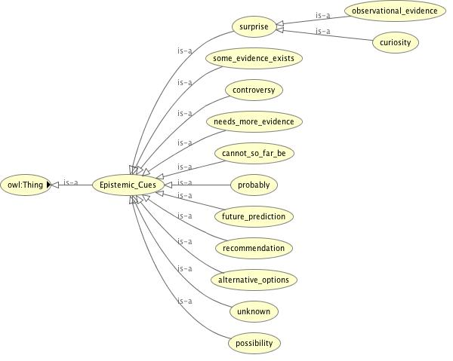

Continuing with the examples from above, the classification is shown below.

|  |  |  |  |
| --- | --- | --- | --- |
| **Sentence** | **Epistemic Cue** | **Explanation** | **Classification** |
| Little is known about genetic factors affecting intraocular pressure (IOP) | Little is known | Not much known about topic | Unknown |
| Its molecular etiology is poorly understood | Poorly understood | Not much known about topic | Unknown |
| These IOP differences are likely due to interstrain genetic differences | likely | Speculation | Probably |
| It is becoming increasingly clear that many forms of glaucoma have a genetic component | It is becoming increasingly clear | Incomplete evidence | Probably |
| This is in agreement with a number of human studies | This is in agreement | Incomplete evidence | Some evidence exists |
| Some but not all human studies have reported a positive association between IOP and blood pressure | Some but not all | Incomplete evidence | Controversy |
| Much current research is focused on identifying chromosomal regions and genes that contribute to glaucoma | Current research | Current ongoing research | Some evidence exists |
| An effect of anesthesia in these very old mice cannot be ruled out | Cannot be ruled out | Current ongoing research | Alternative options |
| Animal models will provide systems for subsequent hypothesis testing and experimental dissection of pathogenesis | Will | Future directions or prediction | Future prediction |
| Further studies of B6 mice are necessary to understand this gene | Further studies | Future directions or predictions | Needs more evidence |
| Interestingly, the IOP of strain CBA/CaJ does not appear to increase in the dark. | Interestingly/ does not appear to | An unexpected result | Curiosity/ observational evidence |
| all measurements should be made within a window of up to 12 minutes after anesthetic administration | Should be | Recommendation | Recommendation |
| Small changes in the resistance to aqueous humor drainage may also contribute to diurnal differences in IOP | May | hedging | possibility |

1. **Confusing distinctions**
2. **Possibility vs. Probably**

Possibility means that there are multiple options to explain something and the statement may present one possible option. The statement is more proposing options and not staking a claim as to which is correct. This includes epistemic cues such as could, can be, have potential, it is possible, and might. In the sentence, “Small changes in the resistance to aqueous humor drainage may also contribute to diurnal differences in IOP” the researchers offer another possible contributor to diurnal differences in IOP.

Probably means that the statement indicates the most likely option – the statement does stake a claim as to which option is correct. This includes epistemic cues such as it is becoming increasingly clear and likely. In the sentence “It is becoming increasingly clear that many forms of glaucoma have a genetic component” the researchers stake a claim that probably many forms of glaucoma have a genetic component.

1. **Needs more evidence vs. some evidence exists**

Needs more evidence is an explicit statement of work that is needed or next to do. Given the statement a researcher would know what to do next. This includes epistemic cues such as additional studies, detailed studies are needed, further studies, more information… is needed, needed to verify, need to be investigated, and should be explored. In the sentence “Further studies of B6 mice are necessary to understand this gene”, the next explicit step is to study B6 mice to understand the gene. Necessary also indicates the need for more evidence.

Some evidence exists is a statement that provides more evidence to support a claim. This includes epistemic cues such as agree, arguing, in agreement with this finding, in support of, suggest, and current research. Usually these statements explain how the current findings fit into the previous literature, adding support to a previous claim. This also adds confidence to the claim itself. In the sentence “Much current research is focused on identifying chromosomal regions and genes that contribute to glaucoma” some evidence already exists identifying chromosomal regions and genes that contribute to glaucoma since current research is focusing on it.

1. **Curiosity vs. observational evidence**

Curiosity is an epistemic cue that indicates a surprising result or conclusion. This includes epistemic cues such as curious, interestingly, surprisingly, and suspected. The researchers were not expecting the result or conclusion.

Observational evidence is an observational statement with an element of surprise. This includes epistemic cues such as apparently, appear, appears to be, seems to be, and does not appear to be. The statement describes an observable phenomenon that they did not expect.

In the sentence “Interestingly, the IOP of strain CBA/CaJ does not appear to increase in the dark.” Interestingly is classified as curiosity because it indicates a result that the researchers did not expect. Does not appear to is classified as observational evidence because they observed that the IOP not increasing in the dark but they are not certain if this observable phenomenon is repeatable.

1. **Controversy vs. alternative options**

Controversy is a statement of disagreement amongst researchers or a lack of consensus. There are at least two possible answers already presented as results from different researchers. This is usually in reference to previous works findings and stated when findings disagree with each other. This includes epistemic cues such as do not agree, have been variably, some but not all, some but not other studies, have been implicated, and but. In the sentence “Some but not all human studies have reported a positive association between IOP and blood pressure” there is disagreement on the association between IOP and blood pressure.

Alternative options is a statement that indicates there are other options, not just one. These options have not yet been studied and so there cannot be disagreements yet about which one is correct. The statement only introduces the options. This includes epistemic cues such as alternatively, cannot be ruled out, though, either, and whether. In the sentence “An effect of anesthesia in these very old mice cannot be ruled out” the researcher indicates an anesthesia affect is an alternative option for explaining some phenomenon in very old mice.