Access to Raspberry Pi plus other useful information

To access the Raspberry Pi you need to use the ‘ssh’ command in command line.
In command line type: ssh pi@10.208.250.219 and the computer will prompt you for password. The password is: skyscanner . This is the result:

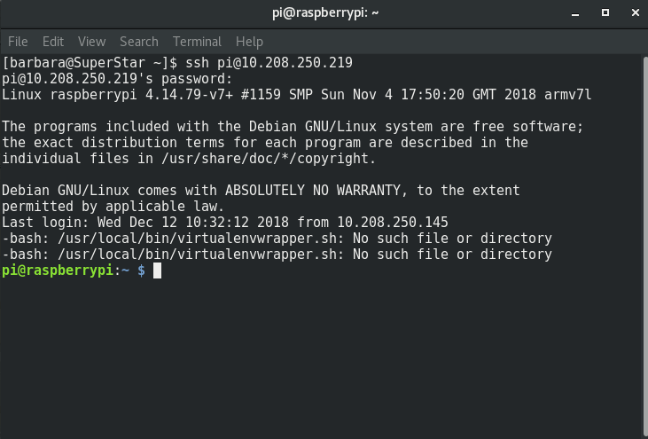
Supervisor activates when you plug in the raspberry. But if you want to control it here are your options:

Commands like stop,start,restart, reload will prompt for password again. Also it will ask you to choose identity, always choose option number 1. This is what you need to do:
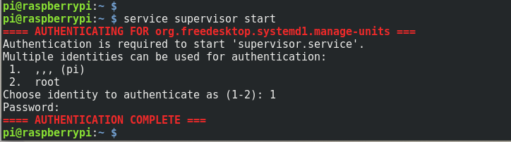
You can check the status of the running scripts like this:
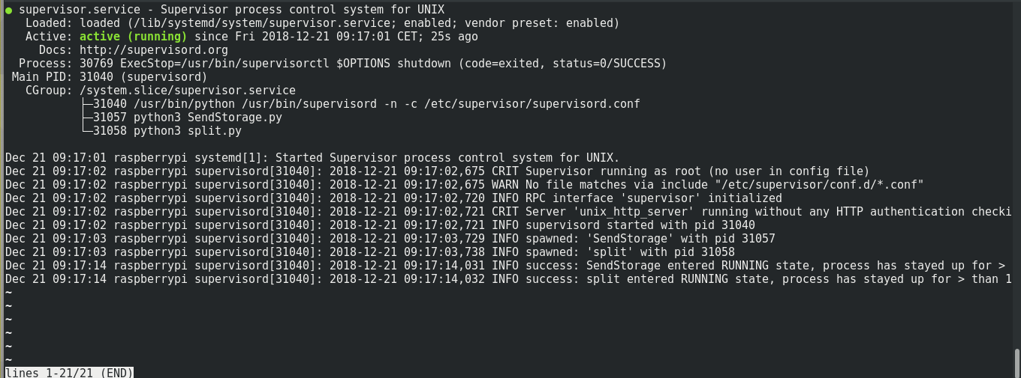
And if for some reason other then the obvious (no internet, camera unplugged, etc.) it stops and you want to check it you can go to the log and check it like this:

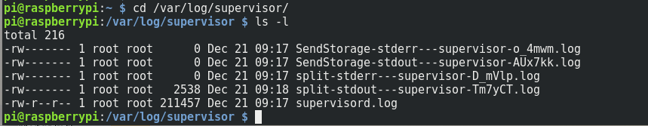
Type in: sudo vim name_of_log_you_want.log to access the logs. Like this:
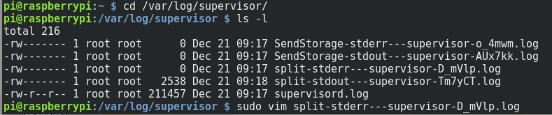
If you use vim you might need this cheat sheet: https://vim.rtorr.com/ .

Also Sky-Imager-Aggregator folder on the Raspberry Pi is a git folder so you can use it as such.
