Satellite Ground Station

Misc. Notes/Documentation
What devices will have wires running down:
- Yagi Antenna
  - N-type coax (Male)
  - 70cm
- Rotator
  - 2 x motor control wires (M)
  - Power wire

- ~100 ft wire distance to GS from lab. specifications on the 100’ run.

IC-R8600: Software Defined Radio

Computer Interface Setup:
- Power on Astron 2 PDU
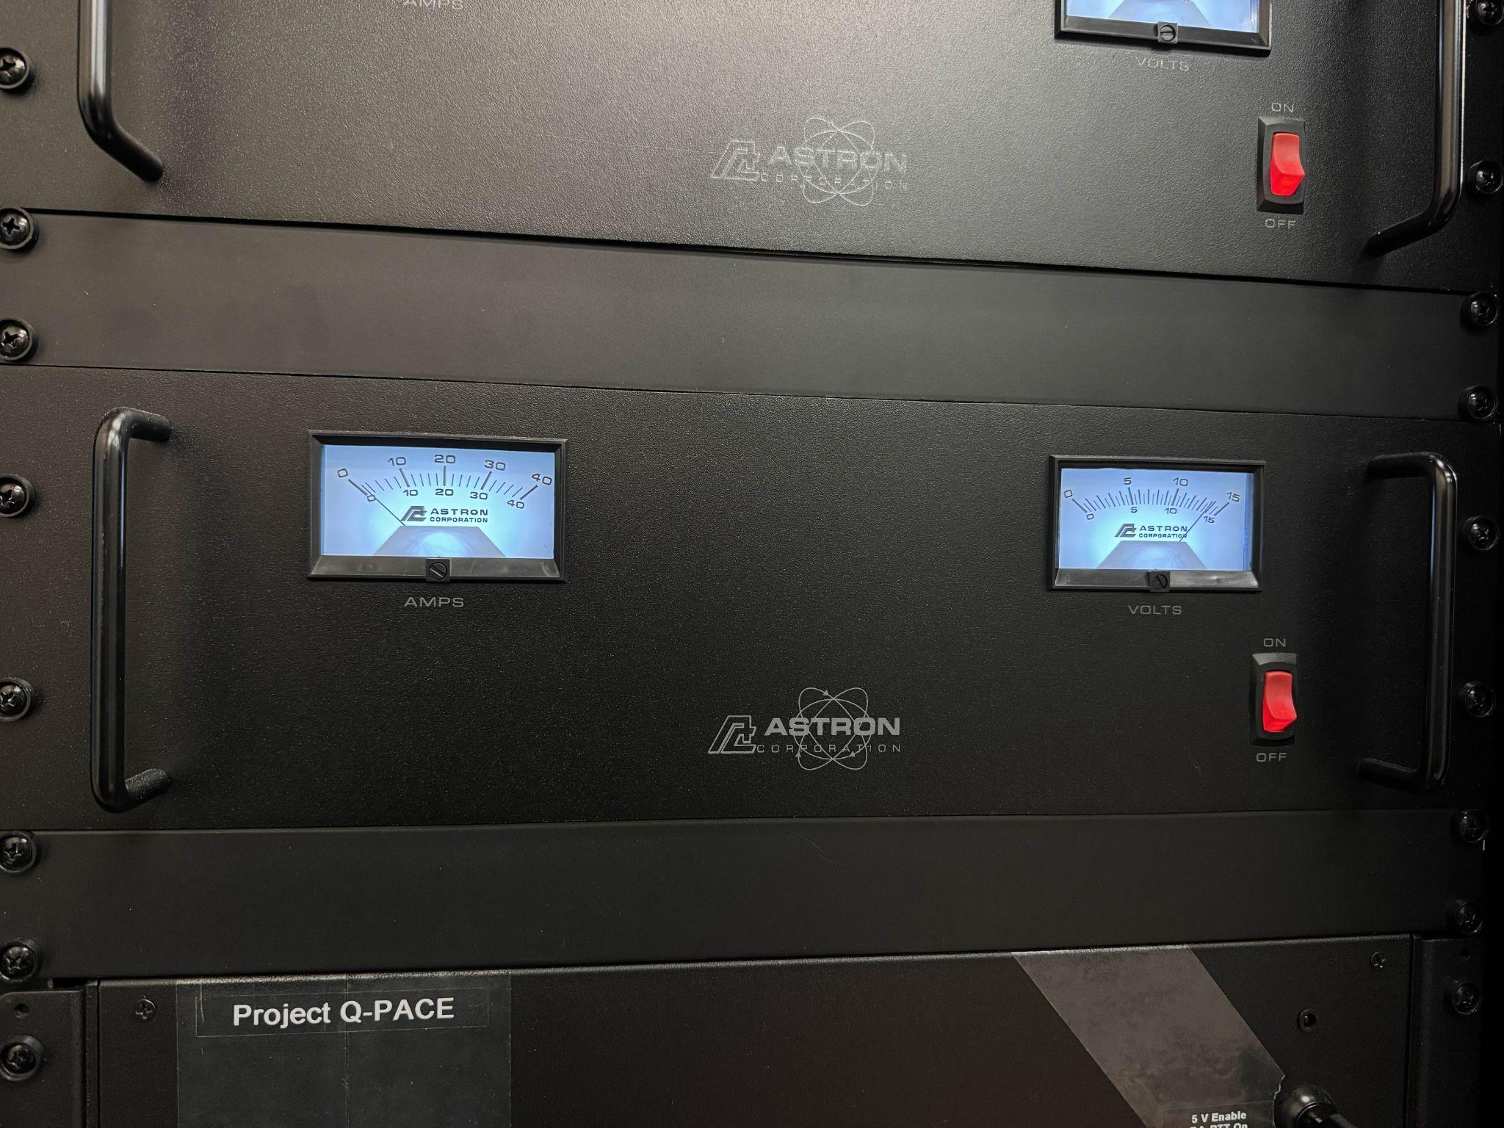
- Power on radio
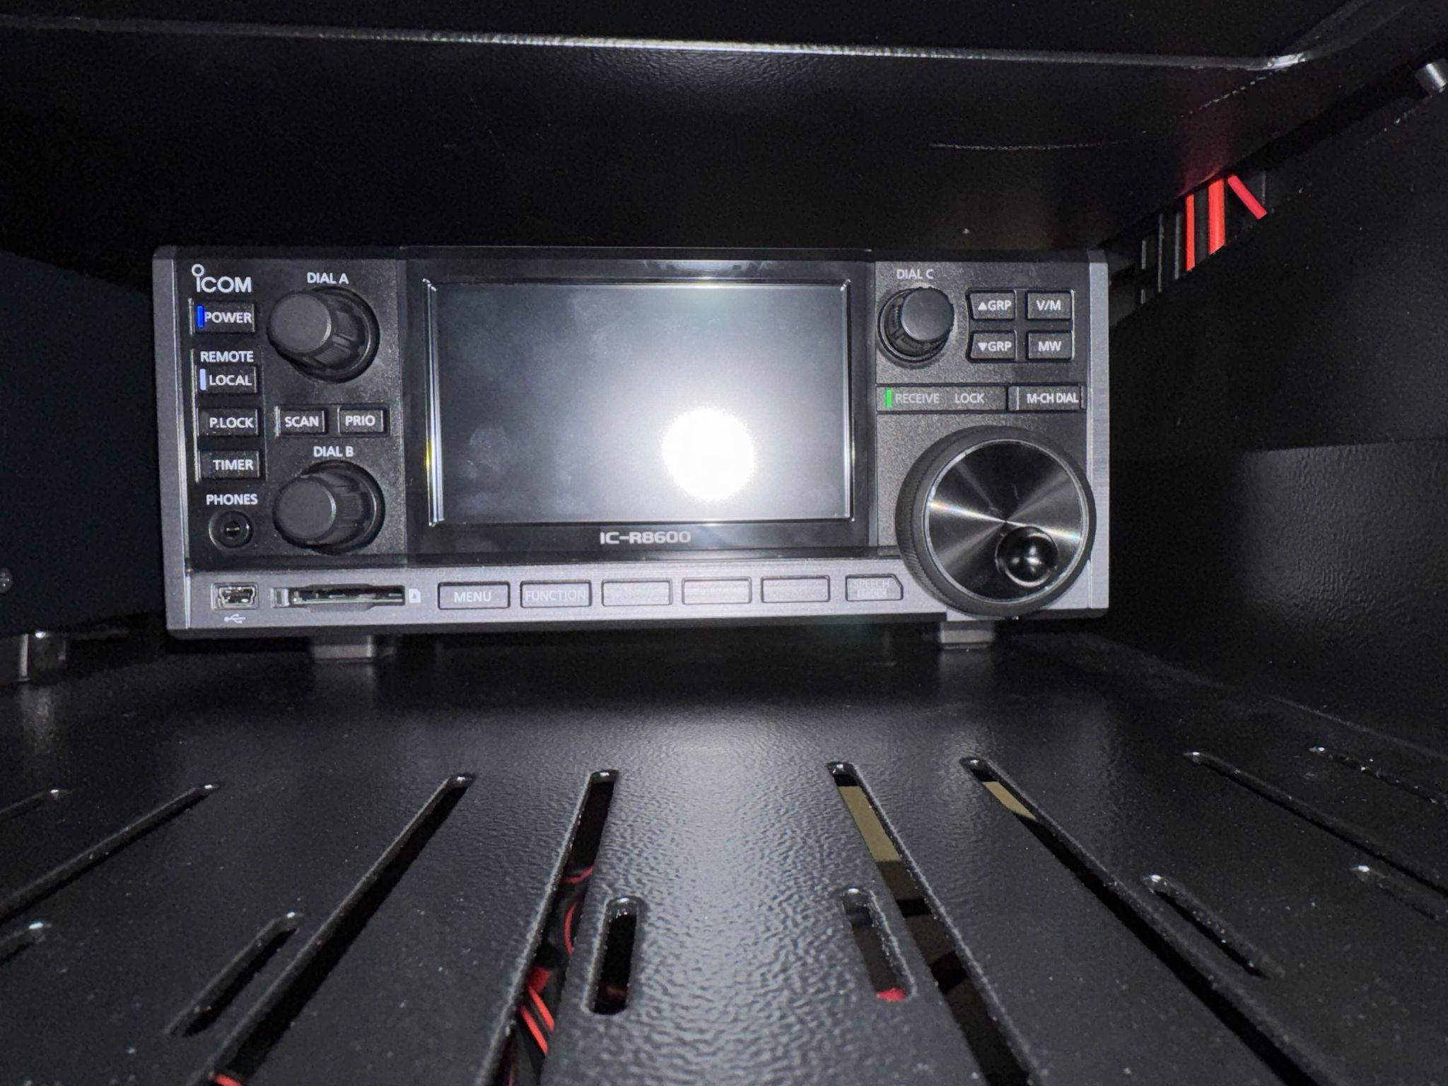
- USB A (computer port) to USB B (radio I/Q OUT port) cable connection.
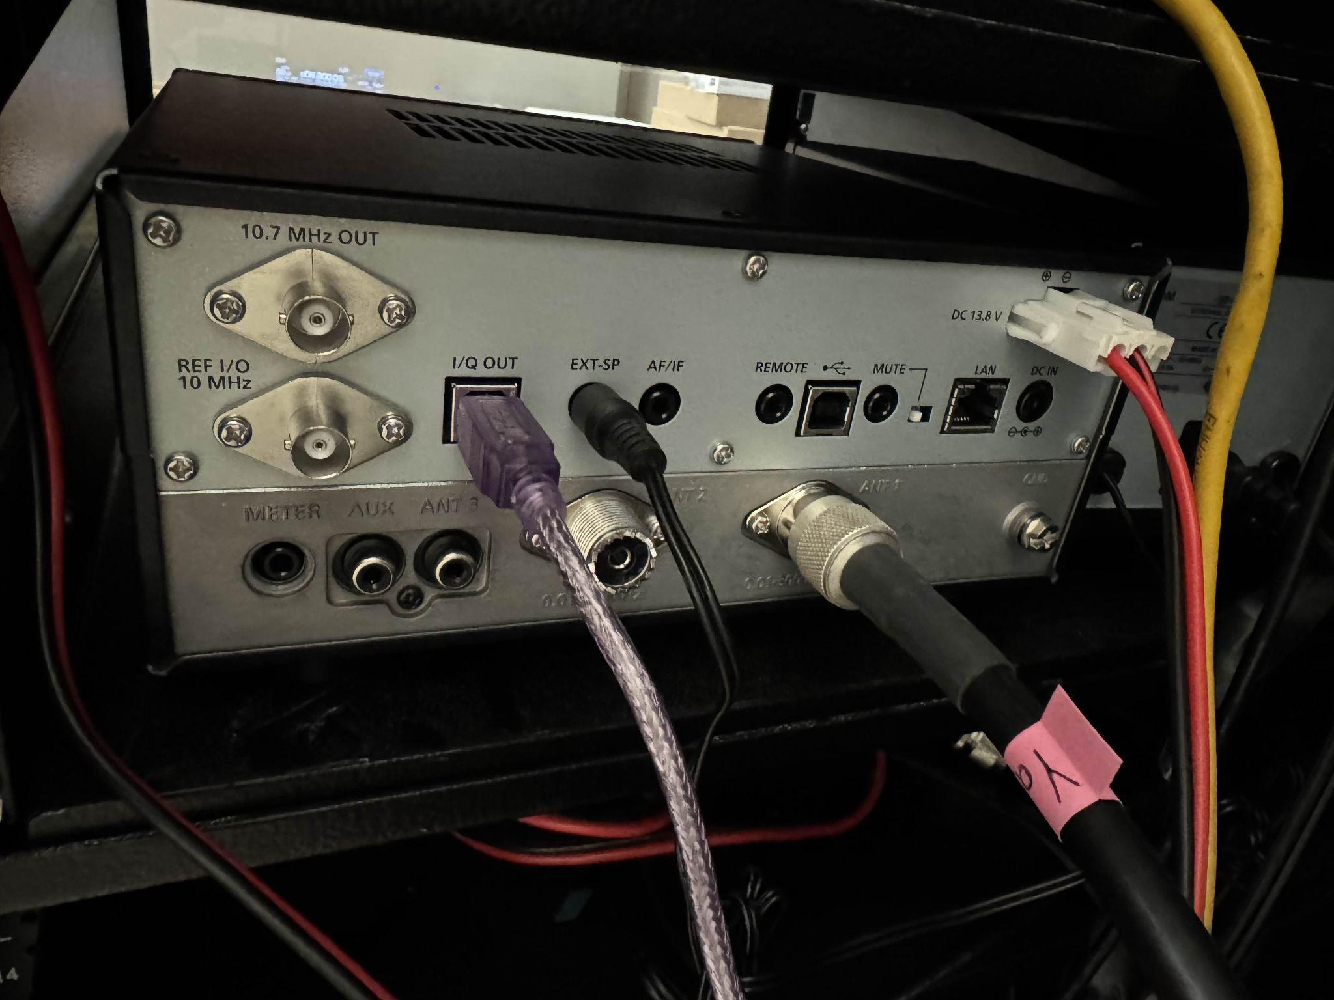
- Power on / setup rotator controller (SEPARATE INSTRUCTION SECTION)
- Ensure radio is powered on, launch SDR Console v3.2, select radio. (IMAGE)
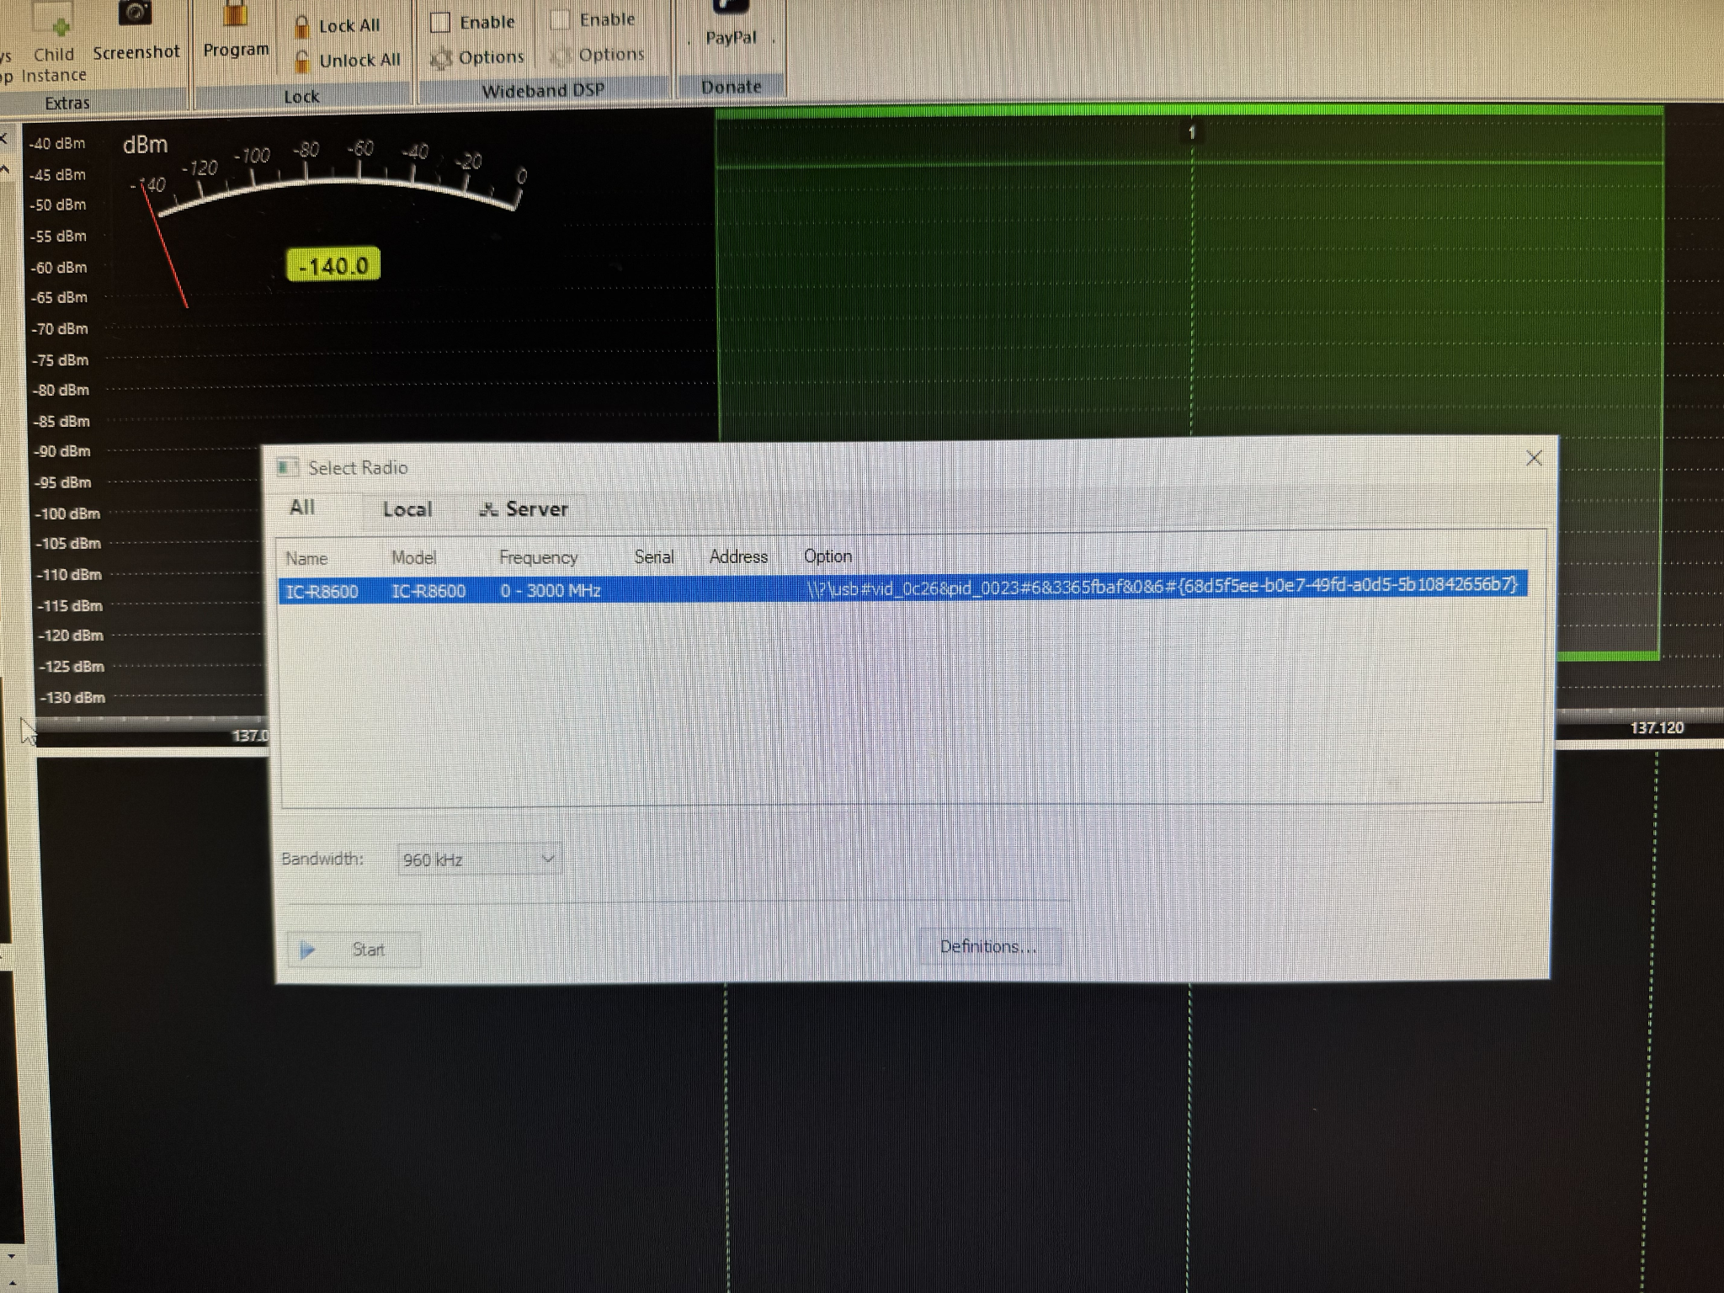

Note: As rotator documentation states support for Orbitron (which required SpidAlfa 0.97 driver) that will be the main program we use to control the rotator for satellite tracking. Another reason is that SDR Console’s built in satellite interface also supports Orbitron rotor control so through SDR Console you have a full satellite tracking interface for both radio and rotor (through the use of Orbitron in the background).

- Select the “Satellites” button to open the satellite tracking interface (under the View menu). (IMAGE)

IC-9700

IC-9700: Radio Transceiver

Computer Interface Setup:
- Power on Astron 1 PDU
- Power on radio

Rotator

