**CIWS-EWM Datalogger**

Hardware Documentation

Hardware ver. 1.0.0

# Overview

1. The CIWS-EWM-Logger device is a datalogger designed for gathering water flow data from residential buildings on Utah State University's campus with 4 - 20 mA current loop output meters. Two configurations appear in this repository:

* A configuration which reads a single 4 - 20 mA current loop output meter.
* A configuration which reads two 4 - 20 mA current loop output meters and a pulsed-output meter, along with three DS18B20 temperature sensors.

These devices are based on Raspberry Pi 3 Model B embedded computers. Additional electronics are assembled on an Adafruit Perma-Proto HAT (Adafruit product ID 2310). Both devices make use of the ADS1015 Analog-to-Digital Converter (ADC), which is also available from Adafruit (product ID 1083).

# Principle of Functioning

Both devices are designed to measure the output of 4 - 20 mA current loops. The current loop module used is designed for Master Meter's Octave ultrasonic water meters. A diagram of the current loop module connected to the datalogger is shown here:

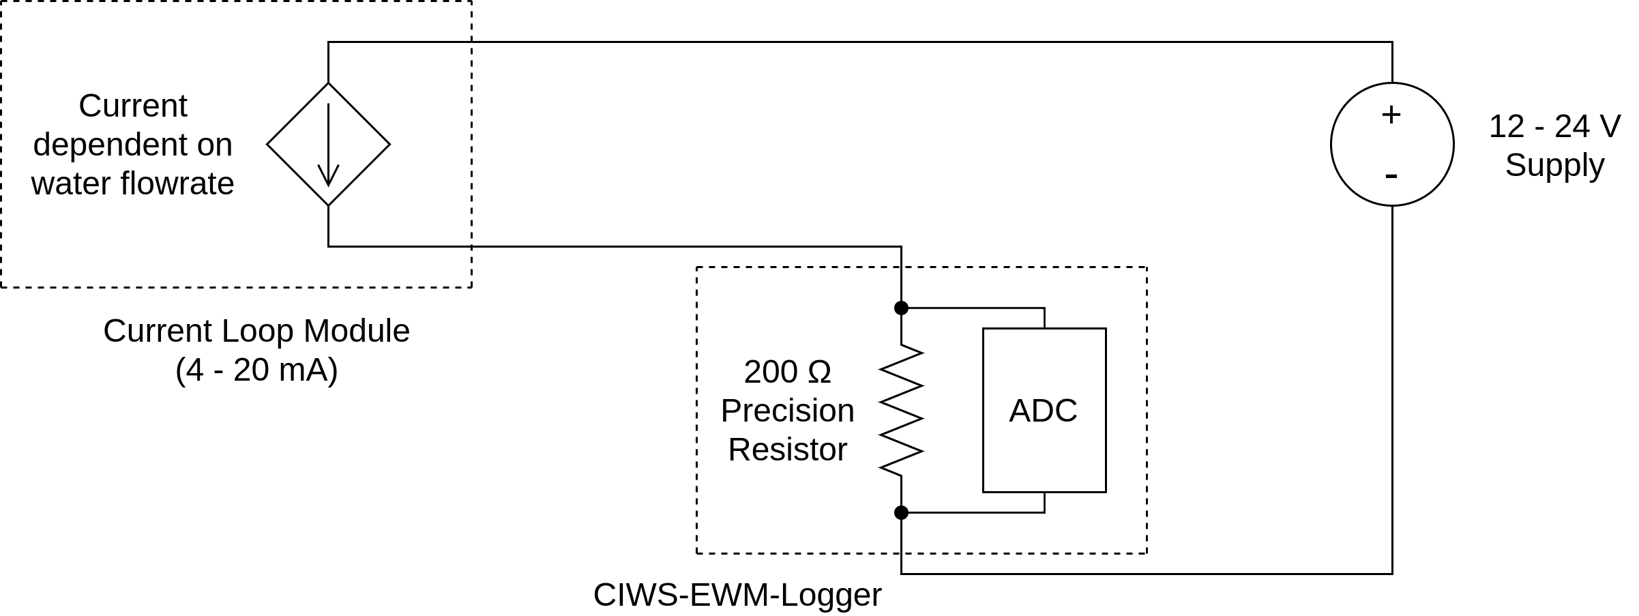The current loop module, powered by a 12 - 24 V power supply, regulates current through the circuit based on the water flow rate. A 200 Ω precision resistor is placed in series with the loop module. Current through the resistor drops a voltage across the resistor's terminals. The relationship for voltage, current, and resistance is given in the following equation:

$v=i⋅R$

In other words, the voltage across the resistor terminals is equal to the resistor's resistance times the amount of current flowing through the resistor. In this way, the current loop output is converted into a value detectable by the ADC on the datalogger. From the voltage value, it is then converted to a value corresponding to the meter flow rate in gallons per minute (GPM).

# Hardware Description

### Hardware Connections

Many on-campus residential units at our university have at least one meter with a current loop module attached. Among these units, some have a cold supply, a hot supply, and a hot return meter. In these buildings, the cold supply and hot supply are metered by Master Meter Octave meters with a current loop module, and the hot return meter has a magnetic reed switch, which closes once per rotation of the meter. Some of these units have a Building Automation System (BAS), which is monitoring the current loop output and the pulsed output meters. A visual diagram of a set of three meters without a BAS is given here:

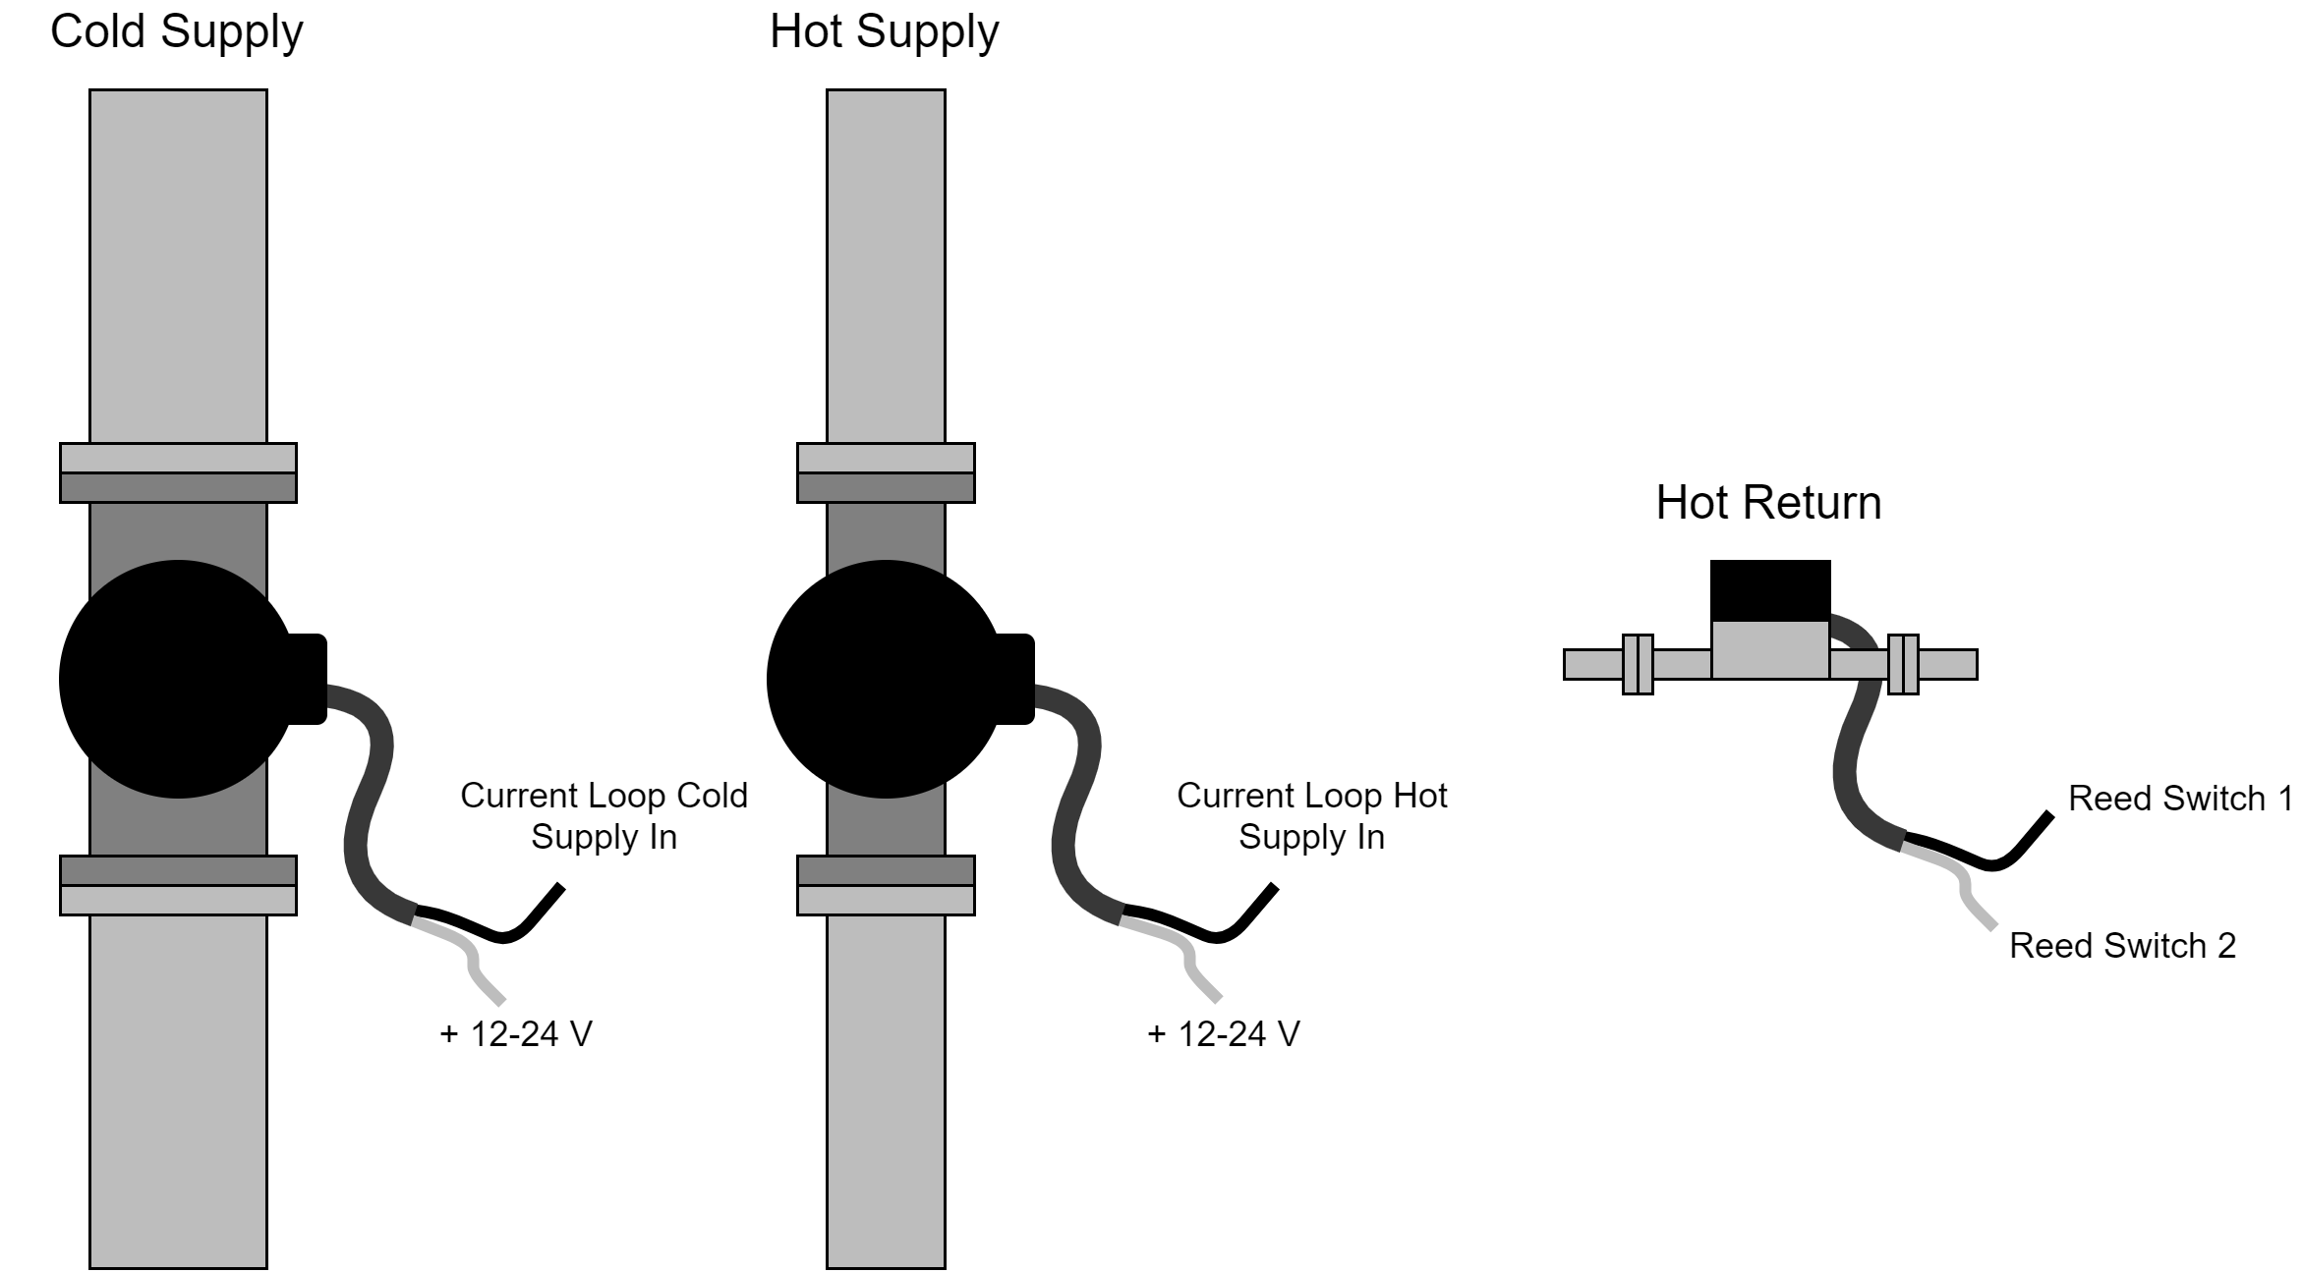Each current loop module has two wires. The red wire should be connected to a 12-24 V power supply. The black wire should be connected to the datalogger's current loop input. These modules often have a third shield conductor, and is available as an uninsulated wire. This is not necessary to connect for this application. The wires in the above diagram are labeled to match where they would connect to the datalogger as shown in the diagram here:

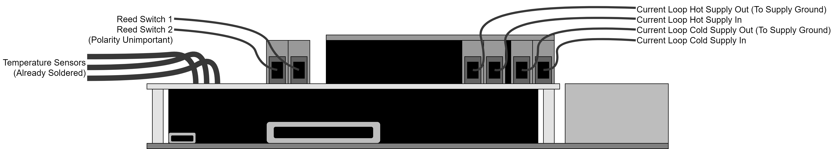The wires labeled 'Current Loop Hot Supply Out' and 'Current Loop Cold Supply Out' should be connected to the negative terminal of the 12-24 V power supply.

Some units are monitored by a BAS. The current loop modules are powered at 24 V by the BAS, and the reed switch is pulled to 24 V by a pull-up resistor by the BAS. Because the BAS is now a factor, the datalogger must be *integratable* with the BAS, such that both devices operate without interfering with each other. Fortunately, because the current in a current loop is regulated by the module relative to the water flow, multiple devices can read the current in a current loop, so long as the all of the devices combined don't drop more than the supply voltage; therefore, it is perfectly acceptable to insert the CIWS-EWM-Logger device in series with the BAS. Because the signal from the hot return reed switch is between 0-24 V, enough voltage to damage the GPIO pins of the device, an optocoupler chip was used to translate the logic from 24 V to 3.3 V. A diagram of the meters with the BAS is shown below:

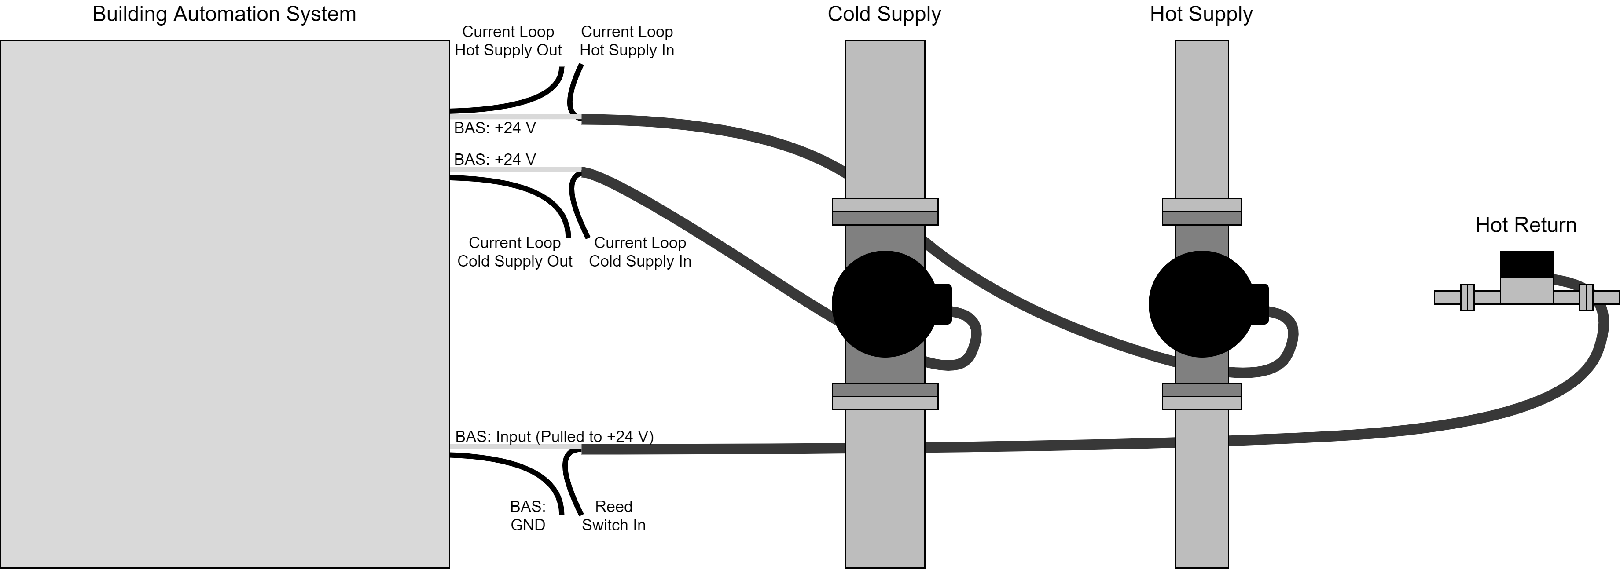How these wires are connected to the device is shown in the diagram below:

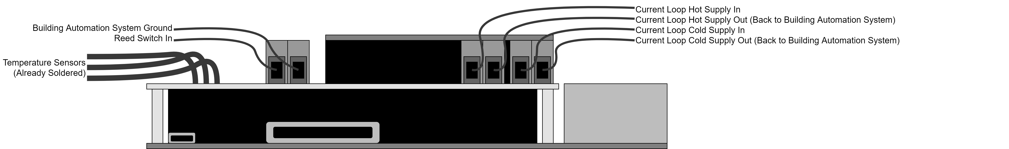Notice that the DS18B20 sensors are already soldered onto the board. This was done to get the sensors installed on the datalogger in time. If the device is made a second time, it is recommended that the sensors be attached using terminal blocks, similar to the way the other peripheral devices are connected.

Electronic schematics of these dataloggers, including the single-sensor configuration, are included in the Hardware directory of the GitHub repository for this project: UCHIC/CIWS-EWM-Logger.