**CIWS-EWM Datalogger**

Hardware Documentation

Hardware ver. 1.0.0

# Overview

1. The CIWS-EWM-Logger device is a datalogger designed for gathering water flow data from residential buildings on Utah State University's campus with 4 - 20 mA current loop output meters. Two configurations appear in this repository:

* A configuration which reads a single 4 - 20 mA current loop output meter.
* A configuration which reads two 4 - 20 mA current loop output meters and a pulsed-output meter, along with three DS18B20 temperature sensors.

These devices are based on Raspberry Pi 3 Model B embedded computers. Additional electronics are assembled on an Adafruit Perma-Proto HAT (Adafruit product ID 2310). Both devices make use of the ADS1015 Analog-to-Digital Converter (ADC), which is also available from Adafruit (product ID 1083).

# Principle of Functioning

Both devices are designed to measure the output of 4 - 20 mA current loops. The current loop module used is designed for Master Meter's Octave ultrasonic water meters. A diagram of the current loop module connected to the datalogger is shown here:

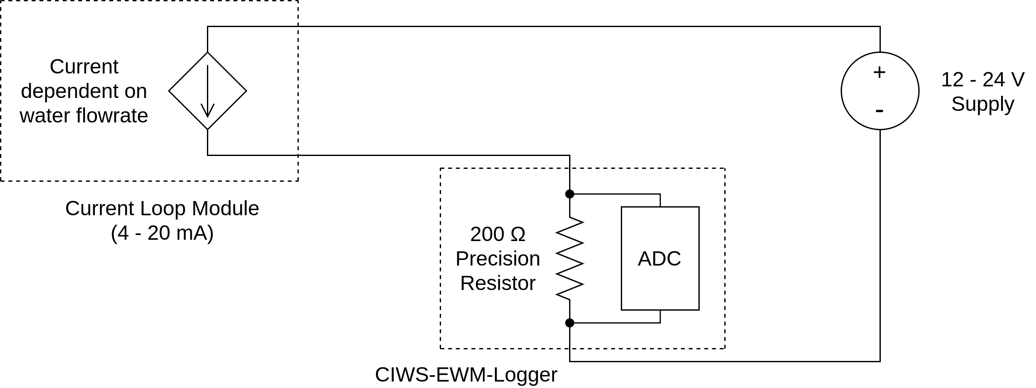The current loop module, powered by a 12 - 24 V power supply, regulates current through the circuit based on the water flow rate. A 200 Ω precision resistor is placed in series with the loop module. Current through the resistor drops a voltage across the resistor's terminals. The relationship for voltage, current, and resistance is given in the following equation:

$v=i⋅R$

In other words, the voltage across the resistor terminals is equal to the resistor's resistance times the amount of current flowing through the resistor. In this way, the current loop output is converted into a value detectable by the ADC on the datalogger. From the voltage value, it is then converted to a value corresponding to the meter flow rate in gallons per minute (GPM).

# Hardware Description

### Hardware Connections

Many on-campus residential units at our university have only one meter with a current loop module attached, as shown in the following diagram:

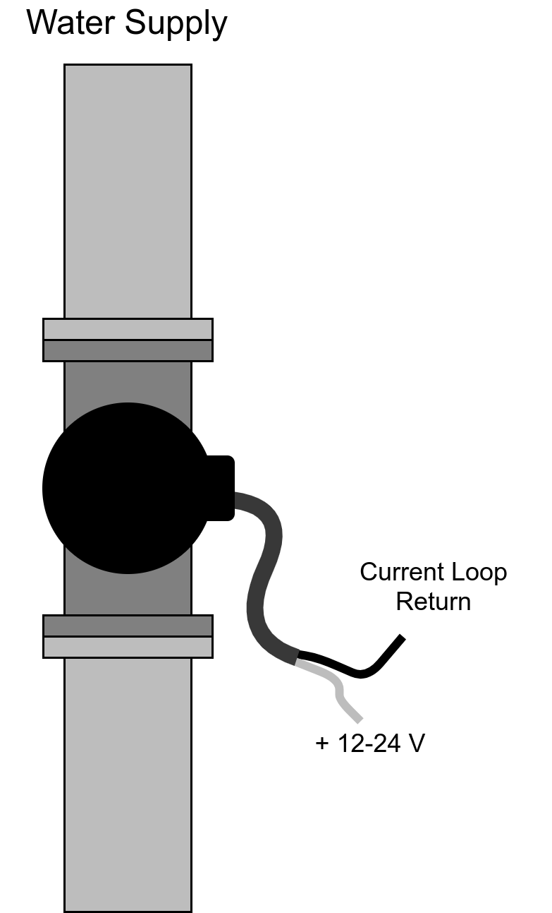Each current loop module has two wires. The red wire should be connected to a 12-24 V power supply. The black wire should be connected to the datalogger's current loop input. These modules often have a third shield conductor, and is available as an uninsulated wire. This is not necessary to connect for this application. The wires in the above diagram are labeled to match where they would connect to the datalogger as shown in the diagram here:

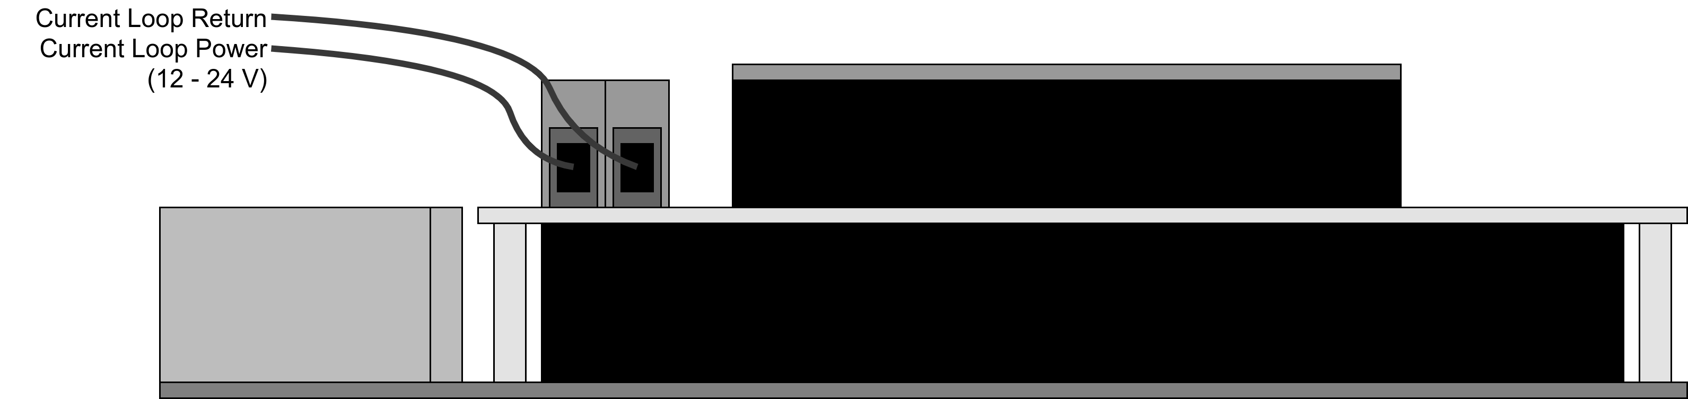Electronic schematics of the single-sensor configuration, are included in the Hardware directory of the GitHub repository for this project: UCHIC/CIWS-EWM-Logger.