**CIWS-WM-Node Datalogger**

Firmware Documentation

Firmware ver. 1.0.0

# Project Organization

1. The CIWS-WM-Node Datalogger project is organized using the standard approach using header files and source files, applied to an Arduino IDE environment. For those unfamiliar, C/C++ code is separated into header files and source files. The following example aims to make it clear why this is the case.
2. Consider the following C code:
3. int main()
4. {
5. int a = 2;
   1. int b = a * 4;
   2. printf(“The result is %d\n”, b);
   3. int c = b * 4;
   4. printf(“The result is %d\n”, c);
   5. return 0;
6. }
7. Obviously, this is a trivial example to illustrate how much more complex code is handled in this project. This code can be much more modular (and readable) by introducing a function:
8. int times4(int input)
9. {
10. return input * 4;
11. }

int main()

{

int a = 2;

int b = times4(a);

printf(“The result is %d\n”, b);

int c = times4(b);

printf(“The result is %d\n”, c);

return 0;

}

The code is now more readable and modular, but now the main() function is at the bottom of the file (and it has to be, otherwise the function times4() would not be recognized in main(). Fortunately, programmers are good at finding ways around problems. The following code listing works just as well as the previous example:

1. int times4(int input);

int main()

{

int a = 2;

int b = times4(a);

printf(“The result is %d\n”, b);

int c = times4(b);

printf(“The result is %d\n”, c);

return 0;

}

1. int times4(int input)
2. {
3. return input * 4;
4. }
5. Now, the main() function is much closer to the top of the file, making it easy to find the program’s starting point. The main() function recognizes the times4() function because it’s declared above main() using what’s called a function prototype, while the rest of times4() is defined below main(). This works really well for a handful of functions, but defining every function in one file becomes a mess in a project like the CIWS-MWM firmware. To counter this, two new files are created: times4.h and times4.cpp. The function prototype goes in times4.h, and the function definition goes in times4.cpp, leaving the file containing main() nice and clean:
6. #include “times4.h”

int main()

{

int a = 2;

int b = times4(a);

printf(“The result is %d\n”, b);

int c = times4(b);

printf(“The result is %d\n”, c);

return 0;

}

Again, though this example seems trivial, it is a very good way to organize a large firmware project like CIWS-MWM. The aim of this section was to illustrate why the project is organized the way it is.

# Main Loop: Computational_Firmware.ino

The file Computational_Firmware.ino is the program’s starting point. All Arduino projects have a .ino file. Ours contains four functions:

* void setup()
* void loop()
* void INT0_ISR()
* void INT1_ISR()

The functions setup() and void() in the .ino file are actually called in the following manner:

int main()

{  
 setup();

while(1)

{

loop();

}

}

This way, setup() is called once, and loop() is called repeatedly until the microcontroller is reset. A flowchart of this process is shown here:

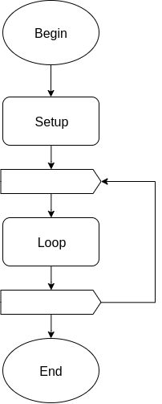

The setup() function does the following:

* Initializes the GPIO pins and peripherals
* Initializes the system state data structure
* Initializes the magnetometer
* Initializes the real-time clock
* Sets up the magnetometer and real-time clock interrupt handlers
* Stops the clock for all unused peripherals

A flow chart of the setup() function is shown on the next page.

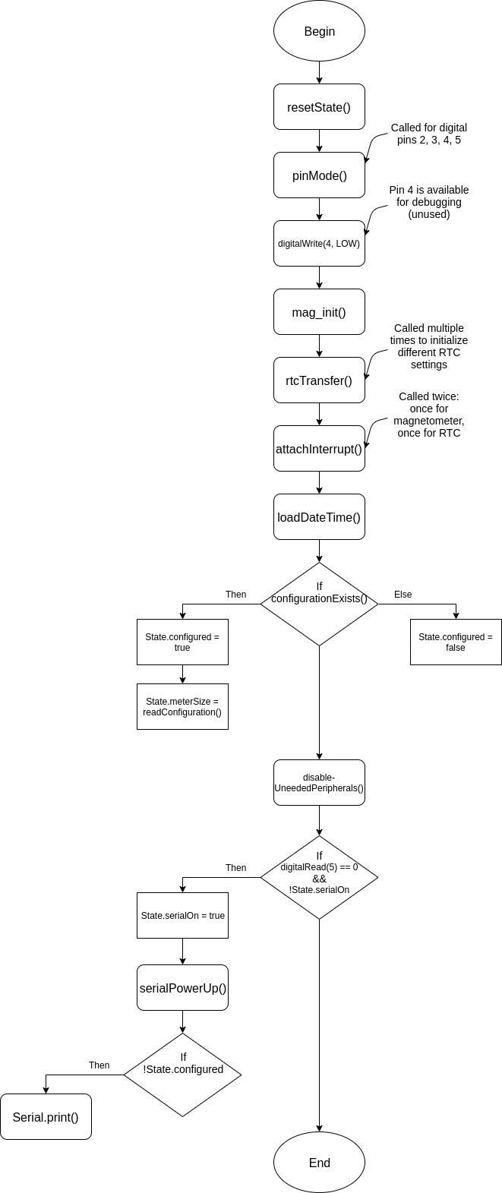

The loop() function is the datalogger firmware’s main loop, and performs the following actions:

1. Check if the Raspberry Pi should be activated
2. Run the serial communication between the datalogger and the Raspberry Pi
3. Monitor signals from the Raspberry Pi
4. Check if four seconds are up
5. Check if magnetometer data is ready
6. Process incoming data to count peaks

A flowchart of the loop() function is shown on the next page.

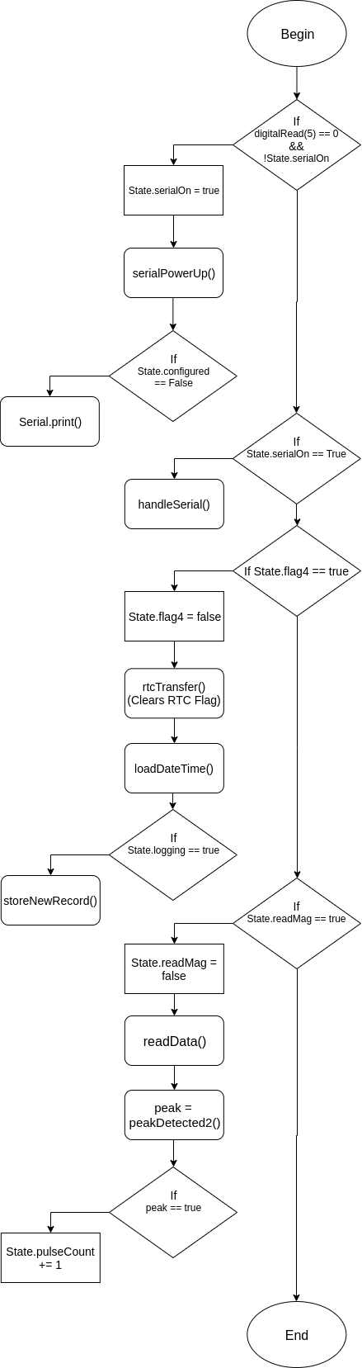

The functions INT0_ISR() and INT1_ISR() are both interrupt service routines. For those unfamiliar with interrupts, an interrupt service routine is a function executed when an event in hardware occurs. INT0_ISR() code executes when the voltage on digital pin 2 transitions from low to high, and INT1_ISR() code executes when the voltage on digital pin 3 transitions from high to low.

The voltage signal on digital pin 2 is controlled by the magnetometer. When the magnetometer has new data ready to report, it sets the voltage on pin 2 high, causing INT0_ISR() to execute.

The voltage signal on digital pin 3 is controlled by the real time clock. When four seconds have elapsed, the real time clock sets the voltage on pin 3 low, causing INT1_ISR() to execute.

Both interrupt service routines simply set a flag to true. The main loop checks these flags, and if they are set, responds accordingly. This is good practice; interrupt service routines need to be kept as short as possible.

# System State: state.h and state.cpp

1. These files define two C/C++ structs, State and SignalState.
2. State keeps track of several important values:

* byte pulseCount – The number of pulses in the current sample period.
* byte lastCount – The number of pulses in the previous sample period.
* unsigned int totalCount – The number of pulses since logging started.
* unsigned long recordNum – The record number of the current sample period.
* bool logging – Boolean flag: True if the device is logging, false if it is not.
* bool flag4 – Boolean flag: True if four seconds has passed, false if not.
* bool serialOn – Boolean flag: True if serial interface is active, false if it is not.
* bool SDin – Boolean flag: True if an SD card has been initialized, false if not.
* bool readMag – Boolean flag: True if magnetometer data is ready, false if it is not.
* char meterSize – Stores the meter size, used to compute water flow.
* bool configured – Boolean flag: True if valid configuration data exists in memory.
* char filename[13] – Stores the current filename.

This State struct is initialized using the function void resetState(volatile State_t* State). The pulse counts are initialized to zero, the record number is initialized to one, and the boolean flags are initialized to false.

SignalState keeps track of values used for processing the magnetometer signal. A few values are left over from an older signal processing algorithm. These are noted, and will be removed in a future release.

* float x[2] = {0, 0}; – Input signal from the magnetometer.
* float s = 0; - From old algorithm.
* float sf[2] = {0, 0}; - From old algorithm.
* float a = 0.95; - DC Removal filter pole.
* float y[2] = {0, 0}; - Output signal from DC Removal filter.
* float offset = -0.005; - From old algorithm.
* bool slopeWasPositive = false; - From old algorithm.
* bool slopeIsPositive = false; - From old algorithm.
* bool triggered = false; - Boolean flag for software-based schmitt trigger.

The use of these values is detailed in the next section, **Peak Detection**.

# Peak Detection: detectPeaks.h and detectPeaks.cpp

These files define the function bool peakDetected(volatile SignalState_t* signalState)

The function peakDetected() is responsible for detecting peaks corresponding to water flow in the signal read by the magnetometer. Before going over the code, it is crucial to understand the filtering algorithm implemented by the code.

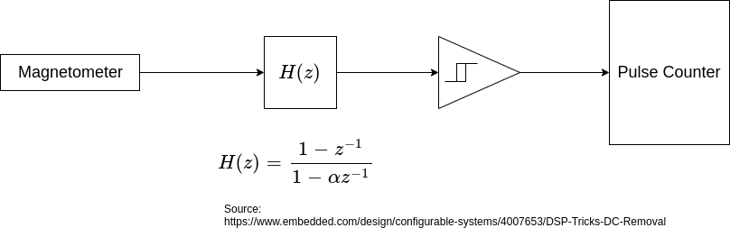The function peakDetected() implements the two middle blocks of the above diagram. The block *H(z)* removes the signal’s DC offset. This centers the signal at zero, which permits a simple peak-detecting algorithm called a software schmitt trigger, the triangular block in the diagram.

The schmitt trigger watches for the signal to cross its high and low thresholds. When the signal crosses the high threshold, the schmitt trigger will count it as a peak, but will not count any other high-threshold crossing as a peak until the signal crosses the low threshold. This ensures that noise in the magnetometer’s signal cannot be counted as extra peaks. This peak detection is implemented in the following way:

Begin:

/** H(z) **/

y[n] = a * y[n - 1] + x[n] - x[n - 1]

/** Schmitt Trigger **/

If triggered:

If y[n] < -1:

triggered is false

If not triggered:

If y[1] > 1:

triggered is true

return peak = true

End

1. A C/C++ struct called SignalState stores the current input sample (x[n]), the previous input sample (x[n - 1]), and the previous output sample (y[n – 1]). SignalState also holds a and triggered. Threshold values for the Schmitt Trigger are declared inside the function peakDetected(). This information is all that is necessary to detect if a peak is occurring in the magnetometer’s signal. SignalState is defined in the file state.h.
2. The value a is the pole of *H(z)*. For this filter, it is desirable for the pole to be close to, but not equal to, one. For any digital filter, a pole greater than or equal to one causes instability.

This function is only called once every time a data sample is collected from the magnetometer.

# Magnetometer: magnetometer.h and magnetometer.cpp

The following functions are defined in magnetometer.cpp and magnetometer.h:

1. bool mag_init()
2. void read_mag(int8_t* data)
3. void mag_transfer(int8_t* data, uint8_t reg, uint8_t numBytes, uint8_t RW)
4. readData(volatile SignalState_t* SignalState)
5. initializeData(volatile SignalState_t* SignalState)

These functions are responsible for the initialization and reading of an LIS3MDL magnetometer. Above, they are listed in order of appearance, but in the following sections, they will be covered in order from low-level to high-level functionality.

The function mag_transfer() takes an array of data, a register number, the length of the array of data, and a read/write flag as input, and is responsible for writing data and reading data to and from the magnetometer. Most of the time, data will be read from the magnetometer, but data does get written to the magnetometer when initialized on startup. The data is read and written via an I2C serial bus, and the Arduino IDE’s Wire library is used for I2C communication.

The function mag_init() does not take any input, and is responsible for initializing the magnetometer when the datalogger is started up. It utilizes the function mag_transfer() to write initialization data to the magnetometer. The following table lists the data written to each of the magnetometer’s control registers, along with the behavior due to the data written.

|  |  |  |
| --- | --- | --- |
| **Register** | **Data** | **Behavior** |
| Control Register 1 | 0x32 | - Temperature sensor disabled  - X-Axis in Medium Performance Mode  - Y-Axis in Medium Performance Mode  - Output data rate ~560-570 Hz  - Self-test disabled |
| Control Register 2 | 0x00 (Default) | - Output data scaled to +/- 4 gauss |
| Control Register 3 | 0x00 | - Low-power mode disabled  - Sample: Continuous-conversion mode |
| Control Register 4 | 0x04 | - Z-Axis in Medium Performance Mode |
| Control Register 5 | 0x80 | - Set FAST READ |

More data for these registers can be found in section 7 of the LIS3MDL datasheet. The key takeaway from this table is that the magnetometer is set to a high output data rate, medium performance mode for all axes, reads on a +/- 4 gauss scale, and does what the datasheet refers to as FAST READ. FAST READ means that only the top half of the two-byte data sample are reported by the magnetometer. This is beneficial in part because most signal noise is contained in the lower half byte; however, the resulting signal is less smooth, so a signal consisting of two-byte data samples is being considered for a future version. The combination of a fast output data rate and all axes set to medium performance mode results in an output data rate of about 570 Hz (measured experimentally).

The function read_mag() takes an array of data, which it will populate with data from the magnetometer by calling mag_transfer(data, OUT_X_H, 3, MAG_READ); This reads the data output of the X, Y, and Z axes of the magnetometer.

The function readData() takes a SignalState structure, described previously. The function calls read_mag() and stores the output byte from the x axis in the SignalState structure as a floating point number, allowing it to be processed by the functions in detectPeaks.cpp.

The function initializeData() actually does the same thing as the function readData(). They are likely to be merged in a future version.

# Real Time Clock: RTC_PCF8523.h and RTC_PCF8523.cpp

The following functions are defined in RTC_PCF8532.h and RTC_PCF8523.cpp:

* byte rtcTransfer(byte reg, byte flag, byte value)
* void registerDump()
* void loadDateTime(Date_t* Date)

These files also define a list of hexadecimal addresses for the RTC’s registers and a Date structure, which holds the current year, month, day, hour, minute, and second (updated every four seconds).

The function rtcTransfer() is responsible for transferring data to the RTC, and takes an eight-bit register number, a read/write flag, and an eight-bit value to write. This function utilizes the Arduino IDE’s Wire library for I2C communication with the RTC.

The function registerDump() prints the data in each register to a serial terminal, and is used to verify the contents of each RTC register.

The function loadDateTime() reads all of the RTC’s date and time registers, and stores the resulting data in a Date_t structure. This function is called every four seconds.

The RTC is initialized in Firmware.ino using the following calls to rtcTransfer():

rtcTransfer(reg_Tmr_CLKOUT_ctrl, WRITE, 0x3A);

rtcTransfer(reg_Tmr_A_freq_ctrl, WRITE, 0x02);

rtcTransfer(reg_Tmr_A_reg, WRITE, 0x04);

rtcTransfer(reg_Control_2, WRITE, 0x02);

rtcTransfer(reg_Control_3, WRITE, 0x80);

These calls are likely to be combined into a single function in a future release. Below is a table detailing what each register configuration does:

|  |  |  |
| --- | --- | --- |
| **Register** | **Data** | **Behavior** |
| Timer CLOCKOUT Control | 0x3A | - Disable 1-second clock output  - Configure Timer A as countdown timer.  - Disable Timer B |
| Timer A Frequency Control | 0x02 | - Use a 1 Hz source clock for Timer A countdown. |
| Timer A Register | 0x04 | - Set Timer A to countdown from 4 (4-second timer). |
| Control Register 2 | 0x02 | - Clears any interrupt flags  - Enables Timer A Countdown Interrupt  - Disables all other interrupts in Control Register 2 |
| Control Register 3 | 0x80 | - Enables battery switch-over function in standard mode  - Clears any interrupt flags  - Disables interrupts in Control Register 3 |

# Configuration Data: configuration.h and configuration.cpp

The ATmega328p microcontroller used for this datalogger has a small chunk of Electrically Erasable Programmable Read-Only Memory, or EEPROM, in which datalogger configuration data is stored. 15 bytes of EEPROM are used, laid out in the following organization:

|  |  |
| --- | --- |
| **Address** | **Data** |
| 0x0 | Site Number (100’s Place) |
| 0x1 | Site Number (10’s Place) |
| 0x2 | Site Number (1’s Place) |
| 0x3 | Meter Size |
| 0x4 | Datalogger ID (100’s Place) |
| 0x5 | Datalogger ID (10’s Place) |
| 0x6 | Datalogger ID (1’s Place) |
| 0x7 | File Number (1000’s Place) |
| 0x8 | File Number (100’s Place) |
| 0x9 | File Number (10’s Place) |
| 0xA | File Number (1’s Place) |
| 0xB | Checksum 0 |
| 0xC | Checksum 1 |
| 0xD | Checksum 2 |
| 0xE | Checksum 3 |

Three functions are used in relation to this configuration data:

* bool configurationExists();
* uint8_t readConfiguration(uint8_t segment);
* void writeConfiguration(uint8_t segment, char data);

The function configurationExists() checks the EEPROM for valid configuration data by reading the checksum bytes in addresses 0xB – 0xE using the readConfiguration() function. It then calculates two different values: Checksum 0 + Checksum 1 and Checksum 2 + Checksum 3. If they both equal 0xFF, then the configuration data is considered present and valid.

The function readConfiguration() first waits for completion of any EEPROM writes in progress. It then loads a read address into the EEPROM Address Register (EEAR) and initiates an EEPROM Read operation. It then returns the data in EEDR, the register in which data read from the EEPROM is stored.

The function writeConfiguration() takes both an address and a data byte. It first waits for completion of any EEPROM writes in progress. It loads a read address into the EEAR, loads data into the EEDR, enables EEPROM writes, and starts an EEPROM write.

# Power Reduction: powerSleep.h and powerSleep.cpp

The MWM Datalogger is a battery-powered logger, and as such, it is crucial that energy is saved in every possible part of the device to prolong the possible logging period. This is done in part with the functions listed here:

* void enterSleep();
* void disableUnneededPeripherals();
* void twiPowerUp();
* void twiPowerDown();
* void serialPowerUp();
* void serialPowerDown();
* void SDPowerUp();
* void SDPowerDown();

If you’ve been examining the source code, you’ve no doubt encountered these functions. That’s because most peripherals are powered down on start-up, and are only powered on when needed. These functions make use of functions from <avr/sleep.h> and <avr/power.h>. These libraries are available through the Arduino IDE, or by installing avr-libc. Power-up and power-down are accomplished by activating and deactivating the clock, respectively. When a peripheral receives no clock signal, it does nothing, and is effectively powered off.

The function enterSleep() puts the microcontroller into a standby mode in which very little power is consumed. The mode SLEEP_MODE_STANDBY is selected, sleep is enabled, and the microcontroller is put to sleep. The program is halted at this point. On wake-up, sleep is disabled and the function returns control. ***Use of this function causes data samples to be recorded incorrectly, and as such is unused. This function will be put in use again once the error is corrected.***

The function disableUnneededPeripherals() is called on startup in Firmware.ino. This function first disables the ADC by writing 0x00 to the ADCSRA register. Once this is done, this function calls the following functions from <avr/power.h>:

power_adc_disable();

power_timer0_disable();

power_timer1_disable();

power_timer2_disable();

power_twi_disable();

power_usart0_disable();

power_spi_disable();

This deactivates the clock to all of the above peripherals.

All of these peripherals are turned on again when needed using the corresponding PowerUp() function:

* I2C bus: twiPowerUp()
* Serial Port: serialPowerUp()
* SD Interface (SPI): SDPowerUp()

Each PowerUp() function is similar:

I2C Bus:

void twiPowerUp(){

power_twi_enable(); // From <avr/power.h>

_delay_us(1); // Pause execution for peripheral to start

Wire.begin(); // Initialize Arduino’s Wire library

_delay_us(1); // Pause execution for peripheral to start

return;

}

Serial Port:

void serialPowerUp(){

power_usart0_enable(); // From <avr/power.h>

_delay_ms(10); // Pause execution for peripheral to start

Serial.begin(9600); // Initialize Arduino’s Serial library

_delay_ms(10); // Pause execution for peripheral to start

Serial.print(F(">> Logger: Logger ready.\n>> User: "));

return;

}

SD Interface (SPI):

void SDPowerUp(){

power_spi_enable(); // From <avr/power.h>

return;

}

All of these peripherals are turned off again when needed using the corresponding PowerDown() function:

* I2C bus: twiPowerDown()
* Serial Port: serialPowerDown()
* SD Interface (SPI): SDPowerDown()

All of the PowerDown() functions simply call their respective power_xxx_disable() function from the <avr/power.h> library (as seen in disableUnneededPeripherals()).

# Table of Functions and Structs (Lexicographical Order)

|  |  |  |
| --- | --- | --- |
| **Function or Struct Name** | **Declaration** | **Definition** |
| bcdtobin() | storeNewRecord.h  Line 5 | Firmware.ino  Lines 406 - 417 |
| cleanSD() | handleSerial.h  Line 20 | handleSerial.cpp  Lines 270 - 324 |
| configurationExists() | configuration.h  Line 25 | configuration.cpp  Lines 3 - 25 |
| createHeader() | handleSerial.h  Line 35 | handleSerial.cpp  Lines 1028 - 1065 |
| Date_t | RTC_PCF8523.h  Lines 44 - 53 | RTC_PCF8523.h  Lines 44 - 53 |
| disableUnneededPeripherals() | powerSleep.h  Line 8 | powerSleep.cpp  Lines 58 - 71 |
| ejectSD() | handleSerial.h  Line 23 | handleSerial.cpp  Lines 410 - 426 |
| enterSleep() | powerSleep.h  Line 7 | powerSleep.cpp  Lines 21 - 37 |
| exitSerial() | handleSerial.h  Line 22 | handleSerial.cpp  Lines 381 - 390 |
| getInput() | handleSerial.h  Line 31 | handleSerial.cpp  Lines 878 - 885 |
| getNestedInput() | handleSerial.h  Line 32 | handleSerial.cpp  Lines 904 - 919 |
| handleSerial() | handleSerial.h  Line 18 | handleSerial.cpp  Lines 53 - 143 |
| INT0_ISR() | Firmware.ino  Lines 230 - 234 | Firmware.ino  Lines 230 - 234 |
| INT1_ISR() | Firmware.ino  Lines 245 - 248 | Firmware.ino  Lines 245 - 248 |
| incrementFileNumber() | handleSerial.h  Line 37 | handleSerial.cpp  Lines 1088 - 1106 |
| initializeData() | magnetometer.h  Line 78 | magnetometer.cpp  Lines 320 - 331 |
| initSD() | handleSerial.h  Line 25 | handleSerial.cpp  Lines 483 - 499 |
| listFiles() | handleSerial.h  Line 26 | handleSerial.cpp  Lines 501 - 545 |
| loadDateTime() | RTC_PCF8523.h  Line 57 | RTC_PCF8523.cpp  Lines 137 - 170 |
| loop() | Firmware.ino  Lines 150 - 220 | Firmware.ino  Lines 150 - 220 |
| mag_init() | magnetometer.h  Line 72 | magnetometer.cpp  Lines 85 - 167 |
| mag_transfer() | magnetometer.h  Line 74 | magnetometer.cpp  Lines 231 - 258 |
| nameFile() | handleSerial.h  Line 36 | handleSerial.cpp  Lines 1067 - 1086 |
| peakDetected2() | detectPeaks.h  Line 15 | detectPeaks.cpp  Lines 98 - 126 |
| printConfig() | handleSerial.h  Line 34 | handleSerial.cpp  Lines 973 - 1009 |
| printHelp() | handleSerial.h  Line 24 | handleSerial.cpp  Lines 441 - 460 |
| printWater() | handleSerial.h  Line 33 | handleSerial.cpp  Lines 921 - 971 |
| RTC_Doctor() | handleSerial.h  Line 30 | handleSerial.cpp  Lines 547 - 697 |
| readConfiguration() | configuration.h  Line 26 | configuration.cpp  Lines 27 - 34 |
| readData() | magnetometer.h  Line 77 | magnetometer.cpp  Lines 284 - 295 |
| read_mag() | magnetometer.h  Line 73 | magnetometer.cpp  Lines 189 - 194 |
| registerDump() | RTC_PCF8523.h  Line 56 | RTC_PCF8523.cpp  Lines 76 - 101 |
| resetState() | state.h  Line 39 | state.cpp  Lines 3 - 17 |
| rtcTransfer() | RTC_PCF8523.h  Line 55 | RTC_PCF8523.cpp  Lines 36 - 55 |
| SDPowerDown() | powerSleep.h  Line 14 | powerSleep.cpp  Lines 192 - 197 |
| SDPowerUp() | powerSleep.h  Line 13 | powerSleep.cpp  Lines 173 - 178 |
| SignalState_t | state.h  Lines 26 - 37 | state.h  Lines 26 - 37 |
| State_t | state.h  Lines 8 - 22 | state.h  Lines 8 - 22 |
| serialPowerDown() | powerSleep.h  Line 12 | powerSleep.cpp  Lines 154 - 159 |
| serialPowerUp() | powerSleep.h  Line 11 | powerSleep.cpp  Lines 131 - 140 |
| setConfiguration() | handleSerial.h  Line 19 | handleSerial.cpp  Lines 176 - 248 |
| setup() | Firmware.ino  Lines 105 - 148 | Firmware.ino  Lines 105 - 148 |
| startLogging() | handleSerial.h  Line 27 | handleSerial.cpp  Lines 718 - 757 |
| stopLogging() | handleSerial.h  Line 28 | handleSerial.cpp  Lines 778 - 792 |
| storeNewRecord() | storeNewRecord.h  Line 4 | Firmware.ino  Lines 307 - 360 |
| twiPowerDown() | powerSleep.h  Line 10 | powerSleep.cpp  Lines 108 - 113 |
| twiPowerUp() | powerSleep.h  Line 9 | powerSleep.cpp  Lines 86 - 94 |
| updateDateTime() | handleSerial.h  Line 29 | handleSerial.cpp  Lines 808 - 864 |
| viewDateTime() | handleSerial.h  Line 21 | handleSerial.cpp  Lines 340 - 362 |
| writeConfiguration() | configuration.h  Line 27 | configuration.cpp  Lines 36 - 45 |