**CIWS-WM-Node**

Off-The-Shelf Build Instructions

Hardware ver. 1.0.0

# Overview

1. This document covers the construction of a CIWS-WM-Node using mainly off-the-shelf parts. If desired, design files for a printed circuit board solution are included in the repository, and may be used instead. The CIWS-WM-Node built using off-the-shelf parts consists of two main units:

* Data aquisition device
* Computational node

# Data Aquisition Device

The data aquisition device is similar to the CIWS-MWM-Logger device. It is built using an Arduino Pro (Sparkfun part #DEV-10914) development board and a Datalogging Shield (Adafruit part #1141). The following must be soldered on the Datalogging Shield's prototyping area, along with their associated connections to the microcontroller pins:

* EEPROM chip
* 5 position terminal block connector for Magnetometer
* 2 position terminal block connector for 12 V battery power
* Button circuit

The following diagram shows the connections required, including wires to the computational node:

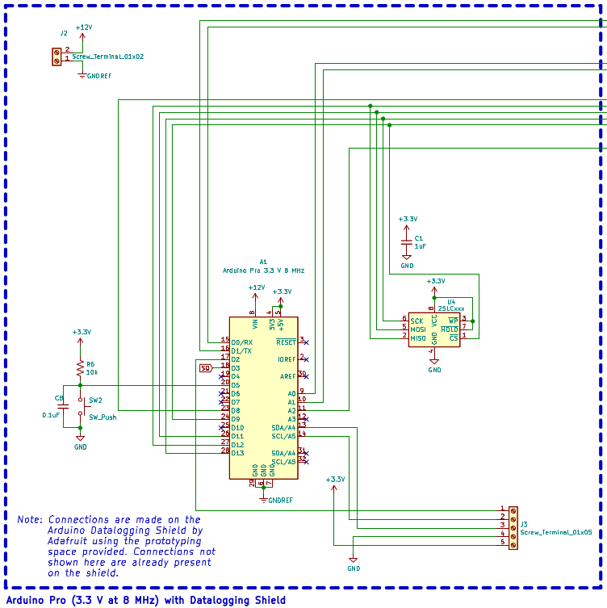

Along with these connections, the following must also be made:

* Solder the 3V, 5V, and Vio (or IOr) pads together (on the top side of the board, near the RTC chip)
* Bridge the I2C pads on the underside of the board, near the analog pin bank.

# Computational Node

The computational node is constructed using a Raspberry Pi 3B and a Perma-Proto HAT (Adafruit part #2310). The following must be soldered onto the Perma-Proto HAT, along with their associated connections to the Raspberry Pi's GPIO pins:

* Bus buffer chip (74HC125)
* Power control circuit
* 5 V regulator
* 2 position terminal block connector for 12 V battery power

The following diagram shows the required connections, including wires to the data aquisition device:

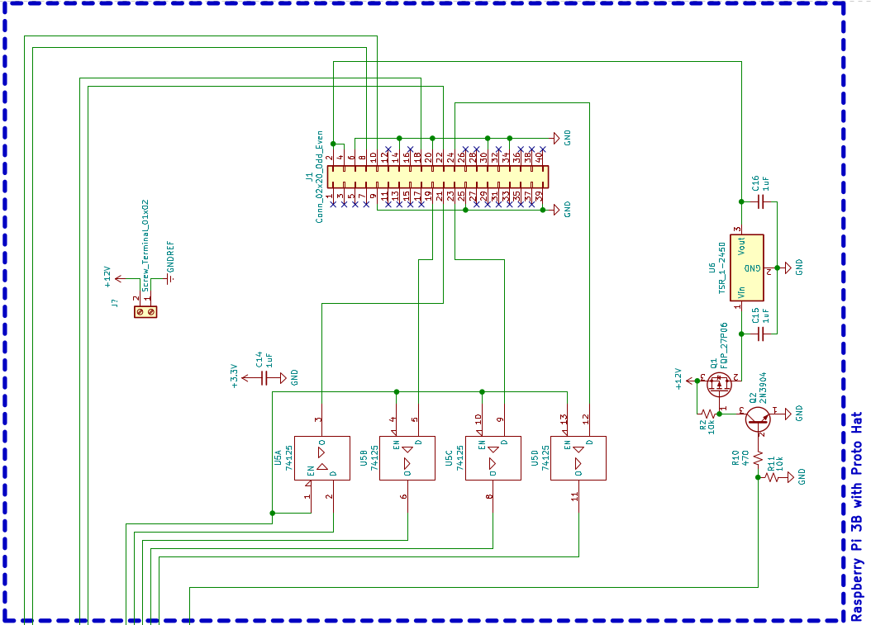

Notice that the symbols used for the bus buffer chip (74HC125) do not include power connections; however, this chip must be connected to 3.3 V and GND in order to function.

Unlike the updated design files, our off-the-shelf prototypes do not have an ADC connected for reading the battery voltage. If the ability to read battery voltage is desired, the ADC can be added. The ADC used, MCP3425, only comes in a surface-mount package. For ease of assembly, use a breakout board / development kit for the MCP3425. Connect the ADC board to the Raspberry Pi's I2C bus, and pull the lines up to 3.3 V using resistors. Step down the battery voltage with a voltage divider before the ADC input in order to keep the voltage reading within the ADC's range, and remember the conversion ratio for your software application.

At the end of this document is included the full electrical schematic of the two devices from off-the-shelf parts.