**Private Space for you (informal title of app)**

Main page (new-chat-maker-media.html)

**Navigation:**

1. About: Introduce about app

2. Video Calling: tab for video calling

3. File Sharing: tab for file sharing

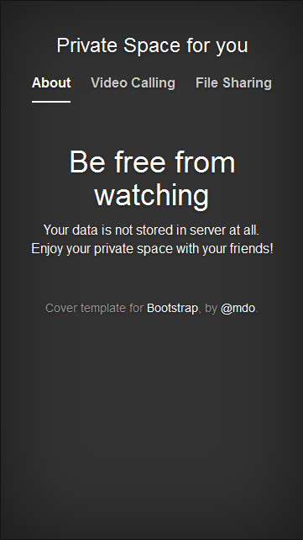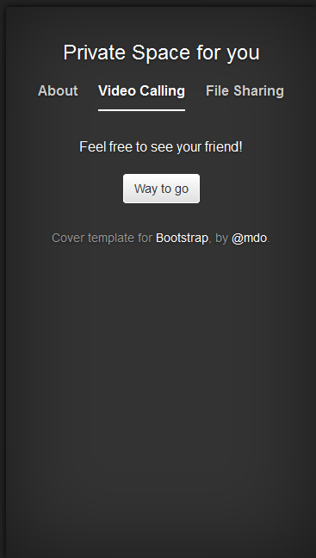

**1) About**

Include introduce about app and rights.

**2) Video Calling**

Include introduce about video calling, Button to start video calling.

**Different procedure:**

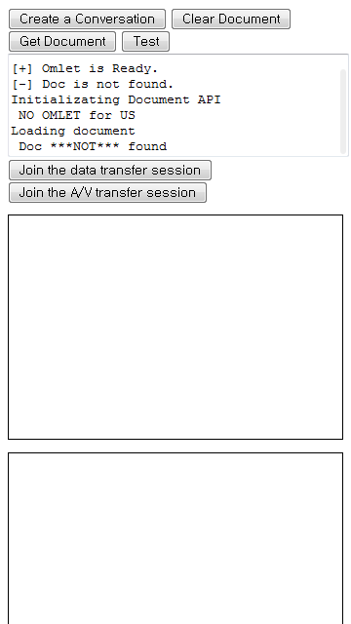

In original version,

a. Click ‘Create a conversation button’ then request message goes to everyone to the people in the room.

b. Your screen moves to chatting room again.

*Local video*

c. Click the request then you see the app’s main page

d. If you want data sharing or video calling then click one of the button and wait for other.

e. Enough people (two now) joined, it starts the function.

*Remote video*

But we aim,

a. Click ‘Way to go’ button to start video calling.

b. Your screen changes for video calling. It doesn’t move to chatting room.

c. Request message goes to the people in the room.

d. Only the first person can join the room and is able to call with you.

The other people will see a message kind of ‘This room is already full’

**3) File Sharing**

In original version,

Not available yet.

We aim,

