DSN AI Bootcamp 2026 Project Participation – Data Analytics Track
Answer & Submission Sheet
Participant Name | UGOCHUKWU JOSHUA TOLUWALEKE
Dashboard tool used | POWER BI
.
Part A - Data Cleaning Review
Identify at least three meaningful data-quality issues you found. For each issue, explain what you found, what you did, and why your action was appropriate.
Data-quality issue | What you found | What you did | Why this action was appropriate
Duplicate transactions | 432 raw rows contained 12 duplicated Transaction IDs; the duplicated records were exact duplicates. | Removed the duplicate rows in Clean_Data while retaining Raw_Data unchanged. | Each transaction should be represented once. This prevents double-counting revenue, transactions and return metrics.
Missing cost values | 31 records had missing Cost_Per_Unit_NGN values, while product-level costs were otherwise consistent. | Validated cost by Product and populated missing values from the validated product-level cost reference. | This provides a consistent, traceable value for cost calculations without altering valid existing costs.
Revenue inconsistencies | 22 transactions did not reconcile between Revenue_Reported_NGN and Units × Unit Price × (1 − Discount). | Calculated Revenue_Calculated_NGN, flagged failed reconciliations, and used the calculated value for corrected revenue. | Revenue should reconcile to its underlying transaction inputs. Keeping reported and calculated fields preserves an audit trail.
Which data-quality issue had the greatest impact on your analysis?
The duplicated transactions had the greatest overall impact because they affected transaction counts, revenue and return-rate calculations. Removing the 12 excess duplicate rows reduced the dataset from 432 to 420 records and removed ₦1.13 million of duplicated reported revenue.
Explain how correcting that issue changed or affected the analysis.
After deduplication, the transaction base became 420 unique transactions. This changed the overall return rate from 8.8% to 8.6% and ensured that revenue, profit and channel-level metrics were not inflated by repeated records. Revenue reconciliation then produced corrected revenue of ₦46.68 million.
Part B - Dashboard Audit
For each management claim, state your verdict, provide the corrected result where applicable, and explain the evidence supporting your conclusion.
1. Abuja is the most profitable market.
Verdict
Incorrect
Corrected answer / result
Lagos is the most profitable market, with corrected gross profit of ₦4.58 million. Abuja generated about ₦1.70 million.
Explanation / evidence
The corrected state-level profit analysis places Lagos first, followed by Kano, Ibadan, Port Harcourt and Abuja. The original statement also contradicted the figures displayed in the original dashboard.
2. Electronics is the strongest-performing product category and should receive more budget.
Verdict
Misleading
Corrected answer / result
Electronics is the largest category by corrected revenue (₦29.35 million) and gross profit (₦8.99 million), but the data alone does not establish that it should automatically receive more budget.
Explanation / evidence
Electronics clearly leads on revenue and profit. However, budget allocation should also consider margin, demand, inventory capacity, returns and incremental return on investment. The performance claim is supported; the automatic budget recommendation is not established.
3. Higher discounting is improving profitability.
Verdict
Incorrect
Corrected answer / result
The corrected data does not support this claim. Gross margin falls from about 35.7% at 0% discount to 33.0% at 5%, 28.4% at 10%, 27.1% at 15% and 15.3% at 25%.
Explanation / evidence
Higher discounts reduce realized selling price and are associated with lower profitability margins in this dataset. The analysis does not establish a causal relationship, but it clearly does not support the original conclusion.
4. The Online channel has the lowest return rate.
Verdict
Incorrect
Corrected answer / result
In-store has the lowest corrected return rate at 6.44%. Online is 9.70% and WhatsApp is 11.90%.
Explanation / evidence
The rates are calculated as returned unique transactions divided by unique transactions within each channel. Online is therefore not the lowest-return channel.
5. August is the strongest sales month.
Verdict
Incorrect
Corrected answer / result
May is the strongest month by corrected revenue at ₦7.01 million. August is the weakest at ₦3.17 million.
Explanation / evidence
The corrected monthly revenue series peaks in May and falls sharply in August, directly contradicting the original statement.
6. Lagos is underperforming compared with other markets.
Verdict
Incorrect
Corrected answer / result
Lagos is the strongest market, with about ₦13.69 million corrected revenue and ₦4.58 million gross profit.
Explanation / evidence
Lagos leads the five states in both corrected revenue and gross profit, so the statement is inconsistent with the cleaned data.

7. The reported Revenue field can be used directly for decision-making.
Verdict
Incorrect
Corrected answer / result
The reported revenue field should not be used directly without validation. Corrected revenue is ₦46.68 million versus ₦46.37 million in the cleaned reported field.
Explanation / evidence
After duplicate removal, 22 transactions still failed the revenue reconciliation test. The net correction is ₦309,755, so management reporting should use the validated calculation rather than the reported field alone.
8. The dashboard is sufficiently reliable for management to act on without further data cleaning.
Verdict
Incorrect
Corrected answer / result
The dashboard required cleaning and calculation corrections before management use.
Explanation / evidence
The audit identified duplicate transactions, missing costs, inconsistent labels and 22 revenue discrepancies. Several management statements were also contradicted by the data. The corrected dataset and validated measures should therefore be used for decisions.
Part C - Corrected Dashboard
Insert a clear snapshot of your corrected dashboard below. The dashboard may be created in Power BI or Excel.
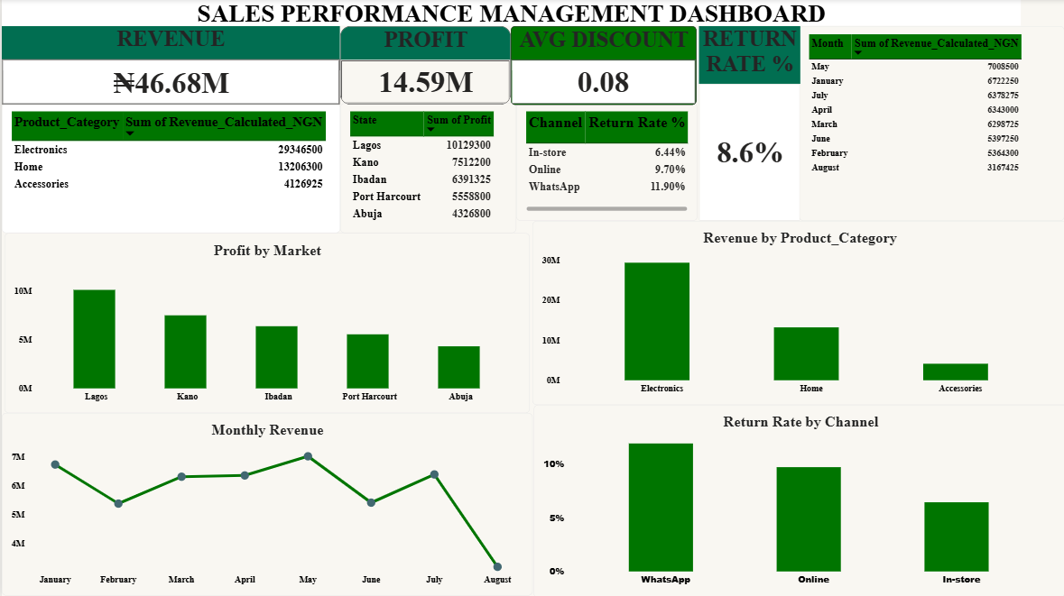
Part D - Final Analysis Questions
1. Which conclusion in the original dashboard was the most misleading, and why?
Answer
Higher discounting is improving profitability.
Explanation / evidence
This could encourage management to use deeper discounts without evidence of sufficient incremental volume. The corrected analysis shows margins generally declining as discount levels increase, from about 35.7% at 0% discount to 15.3% at 25%.
2. What changed most materially after you cleaned and corrected the data?
Answer
The transaction base and financial calculations became materially more reliable.
Explanation / evidence
The dataset reduced from 432 to 420 unique transactions. Corrected revenue is ₦46.68 million, while corrected gross profit is ₦14.59 million and gross margin is about 31.3%. The return rate also changed from 8.8% to 8.6%.
3. If management had acted on the original dashboard, what decision could have created the greatest business risk?
Answer
Increasing discounts on the assumption that higher discounting improves profitability.
Explanation / evidence
The original conclusion could lead to broader or deeper discounting. In the corrected data, higher discount levels are generally associated with lower margins, creating a risk of sacrificing contribution without sufficient incremental sales.
4. Based on your corrected analysis, what is the most important driver of business performance in this dataset?
Answer
Product mix, particularly Electronics, is the dominant driver of revenue and profit.
Explanation / evidence
Electronics generated about ₦29.35 million of corrected revenue and ₦8.99 million of gross profit, substantially more than the other categories. Product mix therefore explains a large share of observed business performance, while discounting and returns remain important profitability controls.
5. What three actions should management take next based on the evidence from your corrected dashboard?
Answer
1) Strengthen data controls and revenue reconciliation.
2) Manage discounts using margin and incremental-volume evidence.
3) Allocate resources using both revenue and profitability performance.
Explanation / evidence
Introduce duplicate checks, validated cost fields and automated revenue reconciliation before management reporting. Evaluate discounts by product and channel using contribution margin and incremental sales. Maintain strong commercial focus on Electronics and Lagos while monitoring margins, inventory capacity and return rates.

