The 1-WL Test for Directed Hypergraphs
We treat the hypergraph as a Bipartite System. Information flows back and forth between nodes and edges until a stable signature (histogram) of the graph is formed.

A. Bipartite View
- Nodes: (Prevs, Nexts) unordered
- Hyperedges: (sources, targets) ordered max 8 each
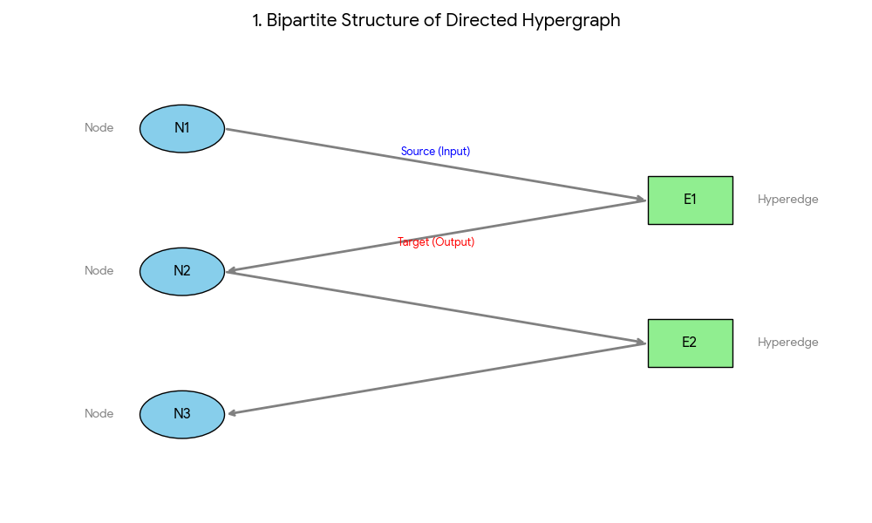

B. Iterative Color Refinement
The goal is to assign a unique "Color" (implemented as a 64-bit hash) to every node and hyperedge. If two nodes have the same color, they are structurally indistinguishable.

Phase 0: Initialization
We assign an Initial Color based on local properties.
- Node_InitColor: Hash of (Label, Role, Prevs, Nexts).
- Edge_InitColor: Hash of (EdgeLabel).

Phase 1: The Iteration Loop
In each step, objects update their colors by absorbing the colors of their neighbors. This is done in two half-steps.

Step A: Edges Read from Nodes
Every hyperedge looks at its connected nodes. It gathers the colors of its sources and targets using fnv1a_hash_64 hash
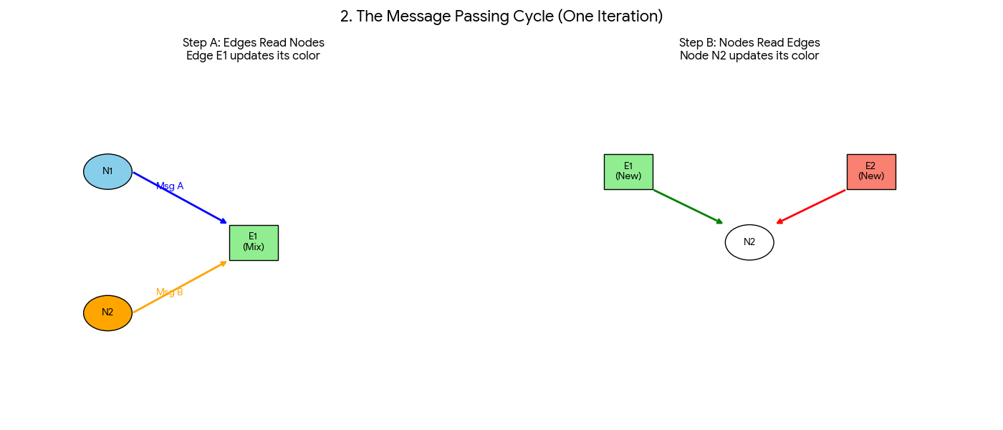

Step B: Nodes Read from Edges
Every node looks at the hyperedges it is connected to. It gathers the colors of the edges it connects to.

- Mix Summation We use ( Mix+Sum hash) due to the number of connections (multiplicity). Connecting to two identical nodes is different than connecting to one.
- The set of sources is unordered, unlike edges sorting is not feasible. So the current hash will ensure aims to reduce collisions.

Phase 3: Termination and Stability
After every iteration, we count how many nodes have each specific color (we build a Histogram).
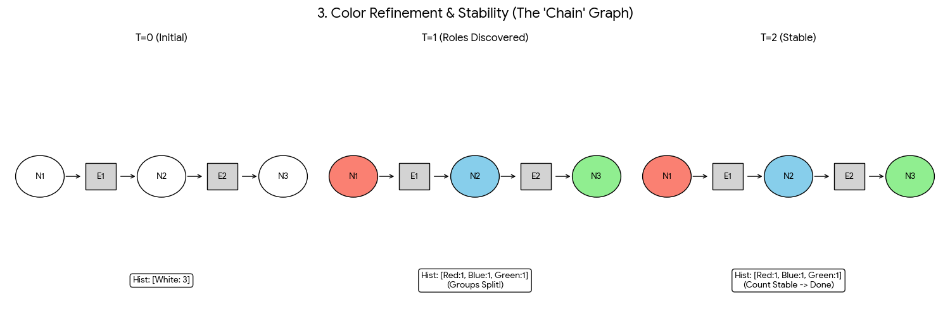
- Color Fluctuation: In the first few steps, the number of unique colors increases rapidly as nodes discover they are different from their neighbors.
- Stabilization: The colors stop splitting into new groups. The number of bins remains constant (e.g., 47 bins in our test case).
- The Signature: The sorted histogram of the final colors is the unique signature of the graph.

C. POC

We have two graphs that have the same number of nodes (3) and edges (2) but different connections.
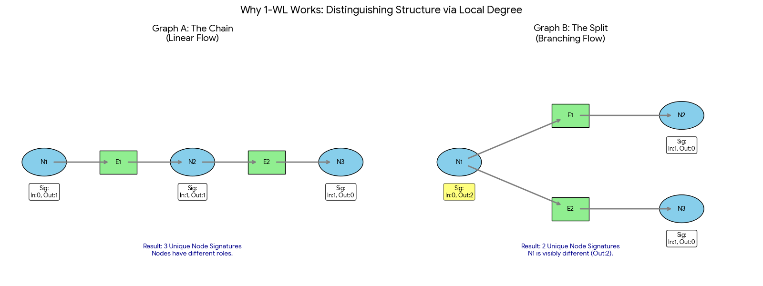
Iteration 0 (Root):
- Graph A: Nodes N1 and N3 are "1-degree". Node N2 is "2-degree".
- Graph B: Node N1 is "2-degree". Nodes N2 and N3 are "1-degree".
- Result: The initial histograms are different. Thus they cannot be isomorphic based on Node Degree.

Limit of WL-1:
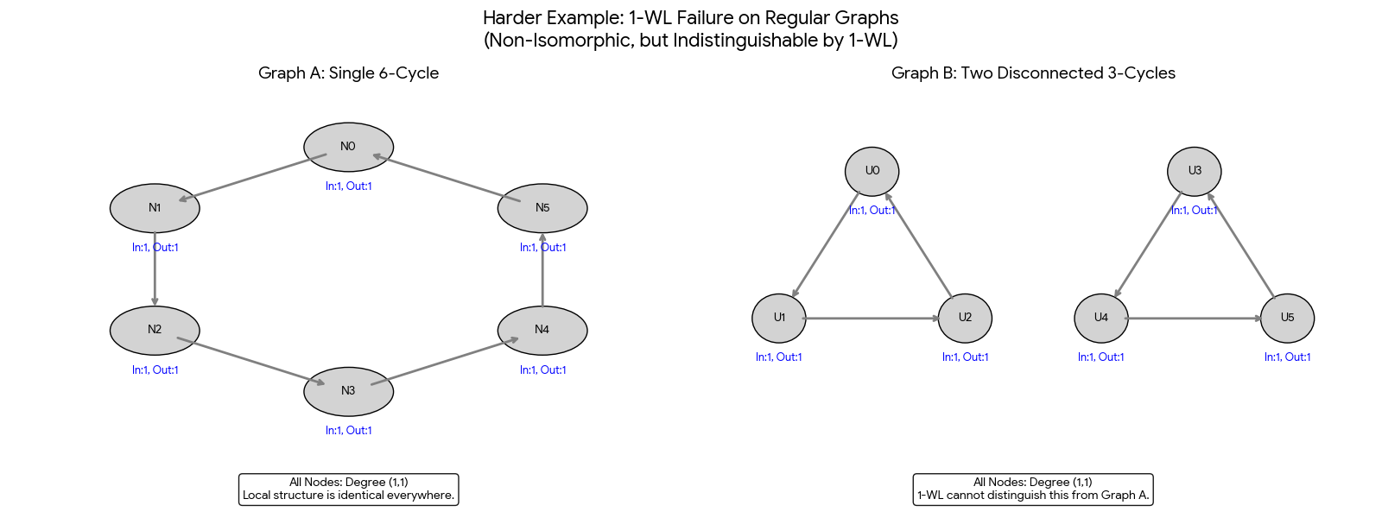
Every node has In-Degree 1 and Out-Degree 1.

- Iteration 0: All nodes are identical in number of connections.
- Iteration 1: Colors update, but they remain identical across the graph.
- Result: 1-WL cannot distinguish these graphs. This is the theoretical limit of the test. (WL-2 or Tuple Coloring is required).

