AWS Cost Estimation

# COST SUMMARY

Based on standard components used in Web applications the estimated costs run between ca $1700 per annum to $2900 per annum.

This is based on a minimum viable AWS architecture shown in Figure 1 below.

# Introduction

In this document a range of cost estimates is developed for cloud-hosted research applications.

In particular:

* Web applications requiring the following
  + Hosting and DNS services
  + User authentication/management
  + Storage of media, images etc
  + A database (DB) to hold mutable data
  + Security (firewall, private cloud services etc)
* Mobile applications, either mobile only or including an additional web app/service. The requirements for cloud services would be similar to web-app applications mentioned above.

## Service Assumptions

Research projects get funding for a limited period and usually have a limited reach. For the purpose of this estimation, it is assumed, that web/-mobile apps for research projects have a short to medium life span and require limited computing and storage solutions.

In particular:

* Length of service: up to 3 years
* Daily active users: up to 10000
* Requests made per day (for API/HTML services) < 1,000,000
* Database <10GB
* Deployment to a single AWS availability zone/region

## Minimum Viable Architecture

As mentioned above, it is expected that most research application have less demand on cloud services and that the architecture can therefore be simplified. An example of a simplified AWS architecture is shown in Fig 1. The cost estimation will be based on this model. A full AWS recommended application architecture can be found in the Appendix of this document.

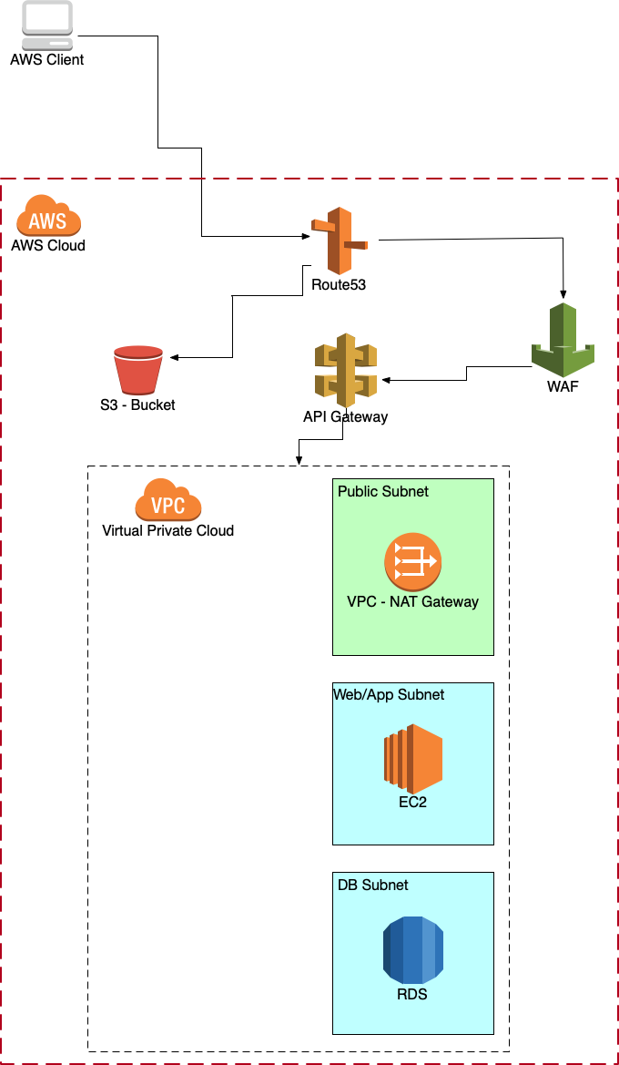

***Fig 1: A simplified model for a cloud-based web/mobile research application. The application will be deployed in a single AWS availability region/zone***

## Components for a Minimum Viable Architecture

Specifically, the following service components will be discussed:

* AWS Route 53 for DNS services
* S3 bucket for storing data such as media (images, video, audio) or HTML pages
* EC2 instance(s) for the computing aspects
* Database for data persistence
* Firewall to protect the website
* Virtual Private Cloud
* API Gateway for providing HTML/REST APIs

The following will be used in the calculations/costs:

* Region: EU-London
* Costs are per month (CPM)

## API-Gateway

API services, using REST APIs, HTTP APIs

* Build/deploy/test APIs: REST APIs, HTTP APIs
* Costs are based on number of API calls
* They recommend using HTTP APIs as they claim it’s ca 70% cheaper

#### Assumptions

* 1 million requests per month
* 34 kb size (for HTTP requests)
* No cache used, or 1.16GB used (for REST)

#### Costs per Month

HTTP: $1.16

**REST no cache: $3.5**

REST 1.6GB cache: $31.24

## Elastic Compute Cloud (EC2)

EC2 instances are used as cloud-based computing resources.

There is a wide variety of machine types available for EC2 instances. Which is chosen will depend on the kind of application. The cost will vary accordingly (and widely).

Here I list the ‘t4g’ instance types (ARM based). I found ‘m4’ (Intel based) nearly twice as expensive. The use case for t4g is (acc to AWS):

*Micro-services, low-latency interactive applications, small and medium databases, virtual desktops, development environments, code repositories, and business-critical applications.*

#### Costs per month and 1 instance

##### t4g.xlarge

4 CPUs, Mem 16 GiB, 30 GB SSD storage, 1 year reservation: $72.76

4 CPUs, Mem 16 GiB, 30 GB SSD storage, 3 year reservation: $50.78

##### t4g.medium

2 CPUs, Mem 4GiB, 30 GB SSD storage, 1 year reservation: $12.17

2 CPUs, Mem 4GiB, 30 GB SSD storage, 3 year reservation: $20.78

##### t4g.small

2 CPUs, Mem 2GiB, 30 GB SSD storage, 1 year reservation: $12.17

2 CPUs, Mem 2GiB, 30 GB SSD storage, 3 year reservation: $9.39

## DynamoDB

* noSQL DB service
* includes backups, multizone/region deployment
* cost depends strongly on read/write per second

#### Assumptions

* DB Size: 1GB
* Backup: 1GB
* To S3: 1GB
* 1 million read/write per month
* For provisioned DynamoDB
* Off peak read/write: 10 per second
* Peak read/write: 40 per second
* (default is 10x as much)

#### Costs per month

Upfront: $ 213.60

Per month: $47.25

## AWS RDS for PostgreSQL

An alternative to DynamoDB

Cost heavily depend on the machine type chosen, which in return depends on the demands on the DB.

Here the following type is chosen:

db.t4g.small (see the specs for EC2 instances above)

#### Assumptions

* 3GB per month
* 1 node

#### Costs per month

$53.36

## AWS Route 53

DNS service (i.e. giving your website a named URL)

#### Assumptions

* 2 zones
* 1 million/month standard traffic
* Route Resolver DNS Firewall, 1 million requests/month

#### Costs

$3.5

## AWS Web Application Firewall (WAF)

Security measures around a web application

#### Assumptions

* 2 access control lists
* 5 rules added per month
* 2 rule groups/month
* 10 rules in each group
* 1 million/months web requests

#### Costs per month

$37.6

## AWS Simple Storage Solution (S3)

For storing static content (html pages, media etc)

* Standard S3
* Data Transfer enabled

#### Assumptions

* 1 million requests for GET, SELECT, PUT, COPY, POST, LIST per month

#### Costs per month

$5.75

## AWS Virtual Private Cloud (VPC)

No charges used for VPC itself. However, the AWS white paper on web applications (see Figure 1) uses 2 NAT Gateways. Following the pricing example given on <https://aws.amazon.com/vpc/pricing/>

NAT Gateways for EU-London region are charged at $0.045 per hour

#### Costs per month

$32.4

# Total Estimated Cost

|  |  |  |  |
| --- | --- | --- | --- |
| Component | Min Price [$/month] | Max Price [$/month] | Upfront [$] |
| API Gateway | 1.16 | 31.24 |  |
| Elastic Compute Cloud (EC2) | 9.39 | 72.76 |  |
| Relational Database Services (DynamoDB or PostgreSQL) | 47.25 | 53.36 | 213.6 for DynamoDB |
| Web Appliction Firewall | 37.60 | 37.60 |  |
| AWS Route 53 | 3.50 | 3.50 |  |
| AWS Simple Storage Solution S3 | 5.75 | 5.75 |  |
| Virtual Private Cloud | 32.40 | 32.40 |  |
|  |  |  |  |
| **Total per month** | **137.05** | **236.61** |  |
| **Total per year** | **1644.60** | **2839.32** |  |

# AWS Amplify

<https://aws.amazon.com/amplify/pricing/>

Amplify deserves a special mention, as it allows an easy way to ramp up AWS components for a cloud based service within the development of a client app consuming these services.

Amplify itself is free of charge. However, it is likely that the services required for the application will be similar to those described above. Therefore, we may assume that the app will have the same (or very similar) cost profile.

# 

# Appendix A: AWS Recommended Architecture for a Web Application

The whitepaper for a recommended architecture for AWS web applications can be found at

<https://docs.aws.amazon.com/whitepapers/latest/web-application-hosting-best-practices/welcome.html>

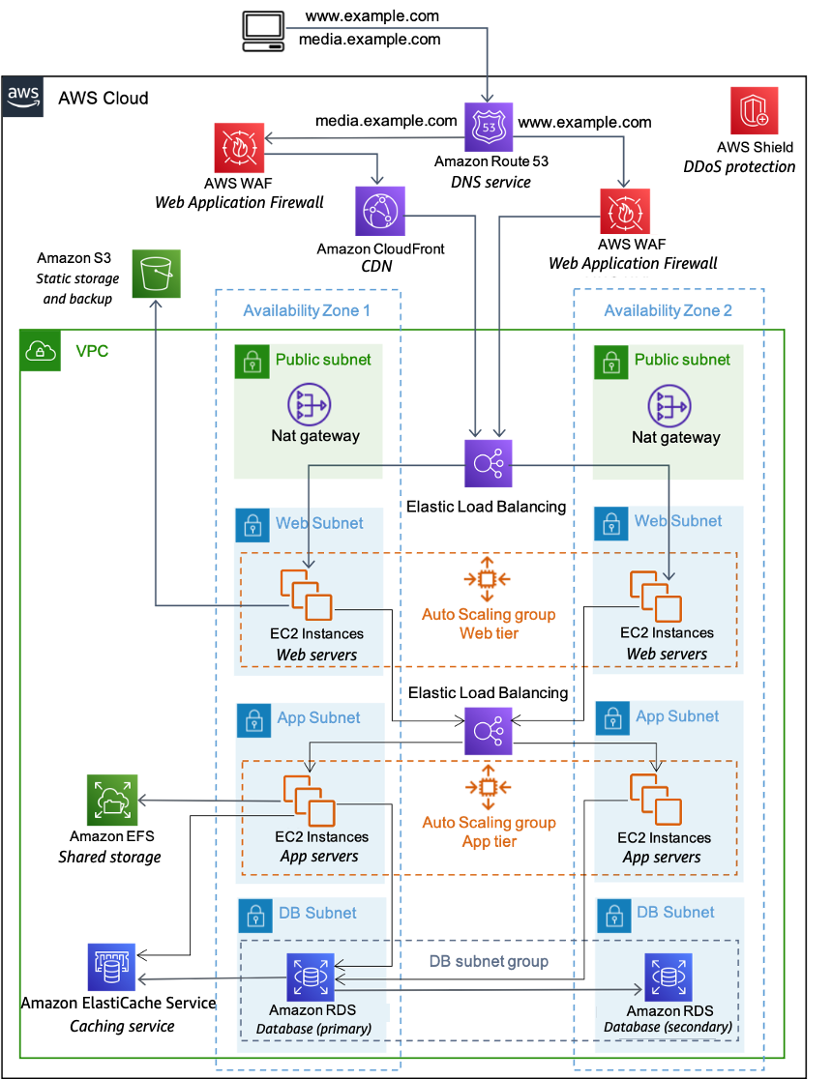

***Figure 2:*** *AWS architecture proposal (white paper) for a web hosting application*

# Appendix B: Elastic Load Balancing

In case the application has a high demand on usage, deploying an Elastic Load Balancer might be needed.

<https://aws.amazon.com/elasticloadbalancing/pricing/>

A basic cost estimate for ELB is given below

#### Assumptions

The site above contains 4 pricing examples. The assumption in this paper will be based on examnple 1 and 2, i.e.:

* Example 1: 1 new connection per second, lasting 2min, processed bytes response/requests 300kb
* Example 2: 100 new connections/second, lasting 3 min, processed bytes per response/requests 1000kb

#### Costs per month

Example 1: $22.42

Example 2: $34.56

TOTAL COSTS

MIN ca $129.27

MAX ca $238.41