ELEC0136 – DAPS 2023 – Lab 4

Create a Hugging Face account and copy your free-tier API key

# Step 1:

Go to <https://huggingface.co/join> and sign up with the email of your choice. You’ll be sent a confirmation email.

# Step 2:

Once logged in, go to <https://huggingface.co/settings/profile>, and click on Access Token

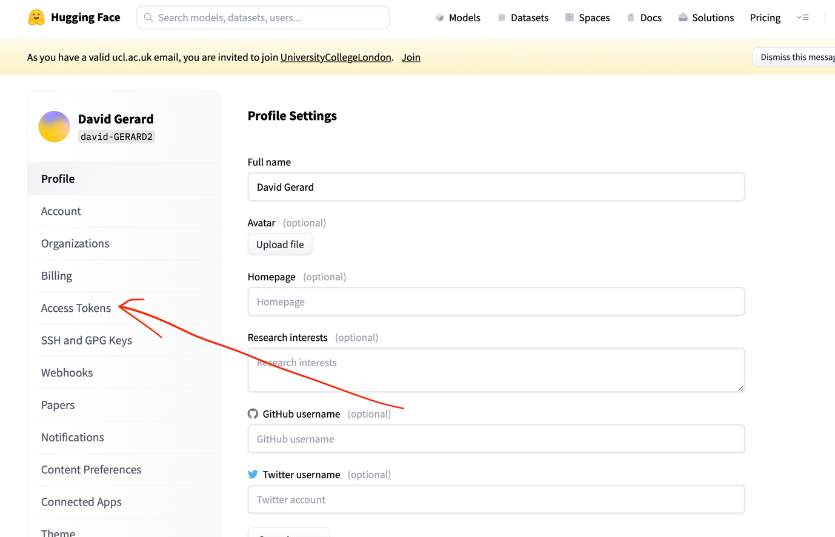

# Step 3:

Click on New Token, name the token and set write as the token role. Click on Generate a token.

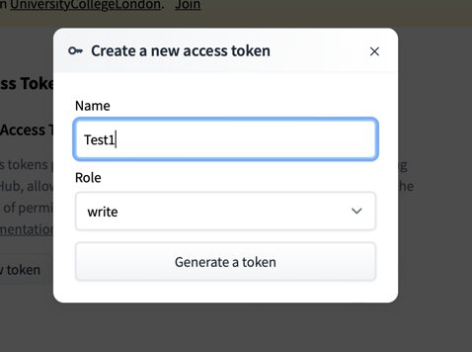

# Step 4:

Click on copy to copy your access token to the Hugging Face API. Paste the token in the cell in part. 0.2 of the Jupyter Notebook.

