ELEC0136 – DAPS 2023 – Lab 4

Create an OpenAI account and copy your 3 months free-tier API key

# Step 0:

OpenAI’s API free tier is valid for 3 months, if you’ve created an account within that timeframe (or if you have an account with a payed membership) you can use that account for this lab. Otherwise, follow these instructions to create an account and generate your API key.

# Step 1:

Go to <https://platform.openai.com/playground> and click on Sign Up. Use a method of your choice to sign up.

# Step 2:

Once signed up, you should be redirected to <https://platform.openai.com/docs/overview>. Once on this page, look for a lock icon on the upper left part of your screen. This is the API key tab. Click on it.

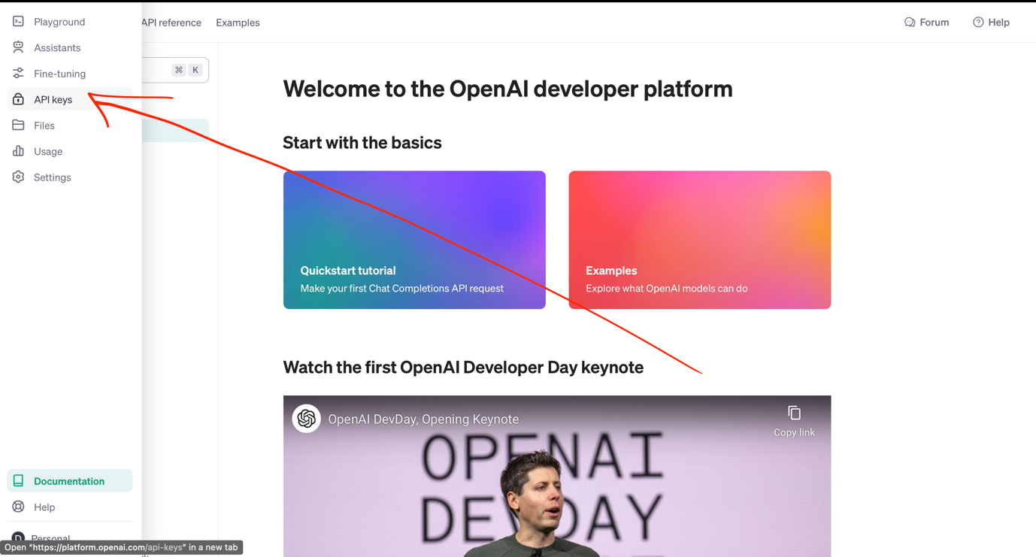

# Step 3:

Create an API key. You can name it whatever you want, however **MAKE SURE TO COPY THE KEY AND SAVE IT SOMEWHERE, YOU WILL NEED IT IN THE NOTEBOOK.**

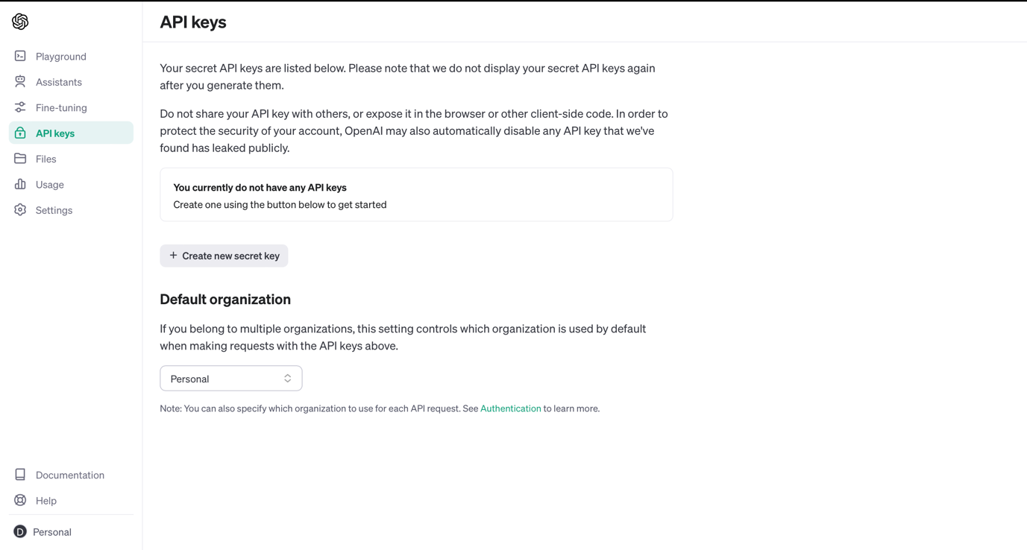

# Step 4:

Paste the API key in the cell in part 0.3 of the Jupyter Notebook.