ELEC0136 – DAPS 2023 – Lab 4

Create a Pinecone account and copy your free-tier API key

# Step 1:

Go to <https://www.pinecone.io> and click on Sign Up Free.

# Step 2:

Sign up using your preferred method (Google account, GitHub or Microsoft).

# Step 3:

Once signed up, go to API keys.

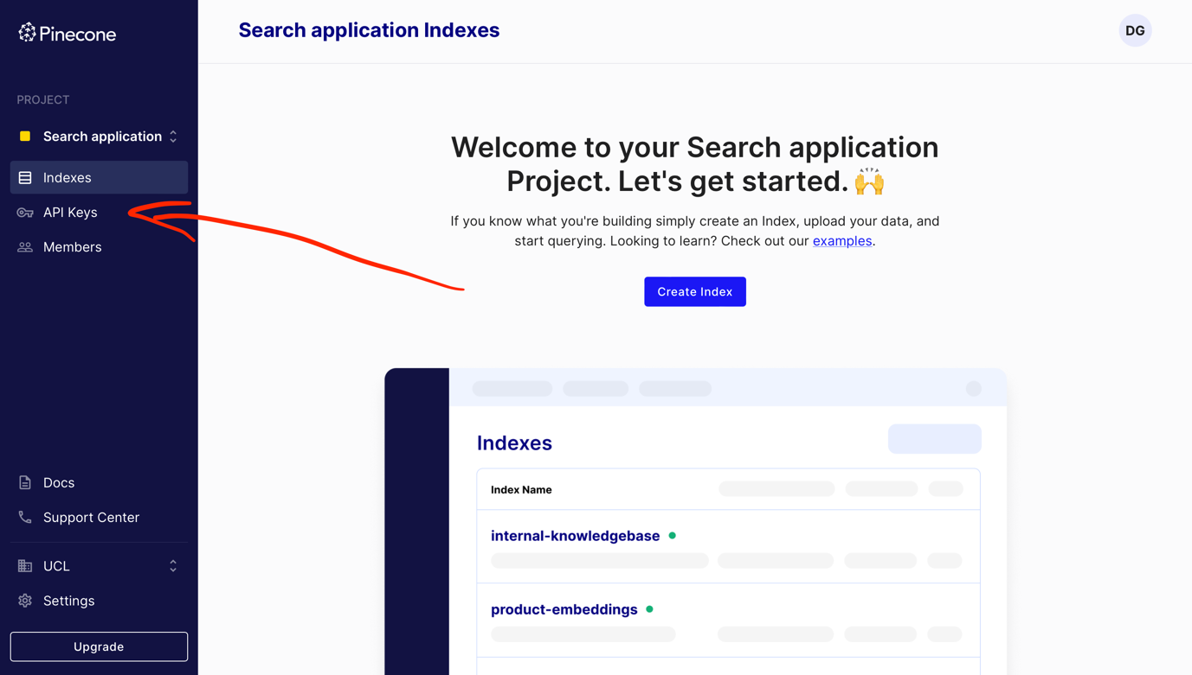

# Step 4:

You should already have a key called default (if you don’t see any key, create one).

Click on the Copy Key Value and paste the key in the appropriate cell in the Notebook.

