**Usage Guidelines**

This document is for use as a foundation for JOLLY project paper prototyping and *Participatory Design Workshops.* It contains the implementation methodology and content for paper based games and related development exercises.

**Assumptions**

(i) Spoken and/or written English can present particular challenges to young L2 learners due to the relationship between graphemes (the letters that represent a sound) and phonemes (the sounds). For example, the words *bough, through and trough* all end –*ough* but each is pronounced differently.

(ii) Phonemic awareness (the ability to ‘hear’ and distinguish between phonemes in words) is an important foundation skill for learning to read, write and spell. The skill paves the way for understanding how to segment, blend and manipulate sounds to create or read new words.

(iii) Using rhyme requires phonemic awareness. Research with younger children suggests that expressive vocabulary is correlated with rhyming ability (*Stadler, Watson & Skahan, 2007*)

(iv) Generating rhymes is a difficult skill to master. Encouraging nonsense rhymes is a good way for children to begin to generate and produce rhyme. When children experiment with nonsense rhymes they are not confined by their own learned versions of words and so can tune into and produce rhyming patterns.

To explore children's rhyming awareness number of open and closed games have been designed. Further details are below.

**Learning Objectives**

The games below are designed to explore aspects of children’s phonemic awareness. Specifically, through rhyme the tasks aim to explore the following questions: -

(i) How well can children correctly identify groups of rhyming words within songs they are familiar with?

(ii) How well can children map the sounds of rhyming words in the songs to the spellings of those words?

(iii) How well can children recognize differences between groups of words that rhyme perfectly and imperfectly?

(iv) How well can children create groups of new rhyming words based on existing words they are given?

(v) How well can children modify groups of rhyming words so that the words no longer rhyme?

**Approach**

*Closed Rhyme Games**:* Closed Rhyme Games (CRGs) explore the children’s ability to detect rhyme. They are a form of puzzle[1] with single correct solutions. The games are played by listening to songs and identifying rhymed words within the lyrics: games are played on paper and the lyrics written alongside the instructions so that children have a visual clue. Ideally, the songs should be listened to a number of times immediately before children play the game. As a variant, if there is opportunity to do so children could listen to the songs (on a personal device) while playing the game. The critical thing is that there ought to be *some familiarity* with the song.

The artists and songs for CRGs were selected based on data from 900 students at two schools in Metro Manila.

*Semi-Open Rhyme Games**:* Semi-Open Rhyme Games (SORGs) explore the children’s ability to produce rhyme including nonsense. Nonsense has particular significance because the use of humour is central to the overall JOLLY project construction. SORGs should be played after CRGs and using the same song texts. This is to ensure that (1) there is some practice of rhyme detection and (2) children have a context within which to place the words they create.

SORGs are puzzles with multiple (though still finite) solutions and played by using cards to create new words based on rhyming words identified within the song lyrics.

*Scoring System*

Both CRGs and SORGs have a points system for successful solutions. At this stage, points are for basic motivation purposes rather than mapping onto any formally recognized language assessments.

PRE-TEST SCHEDULE

**SESSION ONE, PART ONE**

|  |  |  |
| --- | --- | --- |
| **No.** | **Activity** | **Duration** |
|  | **FAMILIARISATION (CRG ONE)** |  |
|  | Explanation of the task which is to identify  perfect rhyme | 3 minutes |
|  | Example which involves the first 60 seconds  of the Katy Perry song | 1 minute |
|  | CRG ONE (playing of song)  Children have text in front of them | 10 minutes |
|  |  |  |
|  | INDIVIDUAL ATTEMPT |  |
|  | Children go through CRG ONE on their own | 10 minutes |
|  |  |  |
|  | **FAMILIARISATION (CRG TWO)** |  |
|  | Explanation of the task which is to identify  imperfect rhymes. including example | 5 minutes |
|  | INDIVIDUAL ATTEMPT CRG TWO | 10 minutes |
|  |  |  |
|  | **FAMILIARATION (CRG THREE)** | 5 minutes |
|  | Explanation of the task which is to identify  perfect and imperfect rhymes |  |
|  | INDIVIDUAL ATTEMPT CRG THREE | 10 minutes |
|  |  |  |
|  | **TOTAL** | **50 minutes** |

**General Information.** *(Pangkalahatang impormasyon)*

|  |  |  |
| --- | --- | --- |
| 1. | Age */ Edad* |  |
| 2. | Sex *(Please encircle)*  *Kasarian (Bilugan)* | M F |
| 3. | Languages used at home / outside school  *Mga lengguwaheng ginagamit sa bahay / labas ng paaralan* |  |
| 4. | Grade/School |  |
|  |  |  |

|  |  |  |  |  |  |  |
| --- | --- | --- | --- | --- | --- | --- |
| **Familiarity**  **Likeability** | | | | | | |
| Song | Know song very well | Don’t know song well | Never heard song | Like song a lot | Like song somewhat | Don’t like song |
| Roar (Katy Perry) |  |  |  |  |  |  |
| Flashlight (Jessie J) |  |  |  |  |  |  |
| Price Tag (Jessie J) |  |  |  |  |  |  |

*Familiarity:* measured as high, medium or low according to how recently many times the song has been heard.

* *Know very well:* more than more than 40 times ever or ten times in the past month
* *Don’t know well:* than 20 times ever or only a few times in the past month

**Scorecard**

|  |  |  |  |
| --- | --- | --- | --- |
| Game code | Points score | Familiarity | Notes |
| CRG ONE |  |  |  |
| CRG TWO |  |  |  |
| CRG THREE |  |  |  |
|  |  |  |  |
|  |  |  |  |
| TOTAL |  |  |  |

**Part I. CRG ONE**

|  |  |
| --- | --- |
| **Katy Perry “Roar”** | **Game Rules** |
| **I used to bite my tongue and hold my breath**  **Scared to rock the boat and make a mess**  **So I sat quietly, agreed politely**  **I guess that I forgot I had a choice**  **I let you push me past the breaking point**  **I stood for nothing, so I fell for everything**  **You held me down, but I got up (hey!)**  **Already brushing off the dust**  **You hear my voice, your hear that sound**  **Like thunder, gonna shake your ground**  **You held me down, but I got up**  **Get ready 'cause I've had enough**  **I see it all, I see it now**  **I got the eye of the tiger, a fighter**  **Dancing through the fire**  **'Cause I am the champion, and you're gonna hear me roar**  **Louder, louder than a lion**  **'Cause I am a champion, and you're gonna hear me roar!**  **Oh oh oh oh oh oh oh oh**  **Oh oh oh oh oh oh oh oh**  **Oh oh oh oh oh oh oh oh**  **You're gonna hear me roar!**  **Now I'm floating like a butterfly**  **Stinging like a bee I earned my stripes**  **I went from zero, to my own hero**  **You held me down, but I got up (hey!)**  **Already brushing off the dust**  **You hear my voice, your hear that sound**  **Like thunder, gonna shake the ground**  **You held me down, but I got up**  **Get ready 'cause I've had enough**  **I see it all, I see it now**  **I got the eye of the tiger, a fighter**  **Dancing through the fire**  **'Cause I am the champion, and you're gonna hear me roar**  **Louder, louder than a lion**  **'Cause I am a champion, and you're gonna hear me roar!**  **Oh oh oh oh oh oh oh oh**  **Oh oh oh oh oh oh oh oh**  **Oh oh oh oh oh oh oh oh**  **You're gonna hear me roar!**  **Oh oh oh oh oh oh oh oh**  **Oh oh oh oh oh oh oh oh**  **Oh oh oh oh oh oh oh oh**  **You're gonna hear me roar!**  **Roar, roar, roar, roar, roar!**  **I got the eye of the tiger, a fighter**  **Dancing through the fire**  **'Cause I am the champion, and you're gonna hear me roar**  **Louder, louder than a lion**  **'Cause I am a champion, and you're gonna hear me roar!**  **Oh oh oh oh oh oh oh oh**  **Oh oh oh oh oh oh oh oh**  **Oh oh oh oh oh oh oh oh**  **You're gonna hear me roar!**  **Oh oh oh oh oh oh oh oh**  **Oh oh oh oh oh oh oh oh**  **Oh oh oh oh oh oh oh oh**  **You're gonna hear me roar!** | 1. Listen to (or read) the song and try to identify all the words that rhyme.  2.In the space below write down all the words that rhyme with each other.  3.10 points for each correct rhyming word you identify.  4.A full rhyme is something like cat – hat, block – rock.  5. In the song for instance **mess** and **guess** rhyme and would score 20 points ☺  *Words like mess and guess are called perfect rhymes.*  **WRITE ANSWERS BELOW**  **WRITE ANSWERS BELOW** |

**Part II. CRG TWO**

|  |  |
| --- | --- |
| **Jessie J “Flashlight”** | **Game Rules** |
| **When tomorrow comes**  **I'll be on my own**  **Feeling frightened of**  **The things that I don't know**  **When tomorrow comes**  **Tomorrow comes**  **Tomorrow comes**  **And though the road is long**  **I look up to the sky**  **And in the dark I found, lost hope that I won't fly**  **And I sing along, I sing along, and I sing along**  **I got all I need when I got you and I**  **I look around me, and see a sweet life**  **I'm stuck in the dark but you're my flashlight**  **You're getting me, getting me, through the night**  **Kick start my heart when you shine it in my eyes**  **Can't lie, it's a sweet life**  **Stuck in the dark but you're my flashlight**  **You're getting me, getting me, through the night**  **'Cause you're my flashlight (flashlight)**  **You're my flashlight (flashlight), you're my flashlight**  **Ooh**  **I see the shadows long beneath the mountain top**  **I'm not afraid when the rain won't stop**  **'Cause you light the way**  **You light the way,**  **You light the way**  **I got all I need when I got you and I**  **I look around me, and see a sweet life**  **I'm stuck in the dark but you're my flashlight**  **You're getting me, getting me, through the night**  **Kick start my heart when you shine it in my eyes**  **Can't lie, it's a sweet life**  **Stuck in the dark but you're my flashlight**  **You're getting me, getting me, through the night**  **(Light, light, light, you're my flashlight)**  **Light, light, you're my flashlight**  **Light, light, light, light, light, oh**  **(Light light light you're my flashlight)**  **You're my flash, oh**  **I got all I need when I got you and I**  **I look around me, and see a sweet life**  **I'm stuck in the dark but you're my flashlight**  **You're getting me, getting me, through the night**  **Kick start my heart when you shine it in my eyes**  **Can't lie, it's a sweet life**  **Stuck in the dark but you're my flashlight**  **(You're my flashlight)**  **You're getting me, getting me through the night**  **'Cause you're my flashlight**  **'Cause you're my flashlight**  **You're my flashlight**  **Ooh ooh**  **Ooh ooh**  **Ooh ooh ooh ooh ooh**  **Ooh oh oh**  **You're my flashlight**  **Light, light**  **You're my flashlight**  **Light light ye-yeah**  **(Light light light**  **You're my flashlight**  **Light light)**  **You're my flashlight** | 1. This song has some more words that rhyme.  2. Sometimes rhymes can be in threes, not just pairs.  Example **I,** **sky** and **fly**.  3. Also, a word can nearly rhyme with another word.  Example **stop** – **got.** *These are called imperfect rhymes.*  4. If you can find words that nearly rhyme with each other you get an extra 20 points.  5. Write down all the perfect and imperfect rhymes you can find in the song.  **WRITE ANSWERS BELOW**    **WRITE ANSWERS BELOW** |

**Part III. CRG THREE**

|  |  |
| --- | --- |
| **Jessie J Featuring B.o.B “Price Tag”** | **Game Rules** |
| **Seems like everybody's got a price**  **I wonder how they sleep at night**  **When the sale comes first**  **And the truth comes second**  **Just stop for a minute and smile**  **Why is everybody so serious**  **Acting so damn mysterious**  **Got shades on your eyes**  **And your heels so high that you can't even have a good time**  **Everybody look to their left**  **Everybody look to their right**  **Can you feel that, yeah**  **We're paying with love tonight**  **It's not about the money money money**  **We don't need your money money money**  **We just wanna make the world dance**  **Forget about the price tag**  **Ain't about the uh cha-ching cha-ching**  **Ain't about the yeah b-bling b-bling**  **Wanna make the world dance**  **Forget about the price tag**  **We need to take it back in time**  **When music made us all unite**  **And it wasn't low blows and video hoes**  **Am I the only the one getting tired**  **Why is everybody so obsessed**  **Money can't buy us happiness**  **Can we all slow down and enjoy right now**  **Guarantee we'll be feeling alright**  **Everybody look to their left**  **Everybody look to their right**  **Can you feel, yeah**  **We're paying with love tonight**  **It's not about the money money money**  **We don't need your money money money**  **We just wanna make the world dance**  **Forget about the price tag**  **Ain't about the uh cha-ching cha-ching**  **Ain't about the yeah b-bling b-bling**  **Wanna make the world dance**  **Forget about the price tag**  **Well keep the price tag**  **And take the cash back**  **Just give me six strings**  **And a half stack**  **And you can, can keep the cars**  **Leave me the garage**  **And all I, yes all I need are keys and guitars**  **And guess what, in thirty seconds I'm leaving to Mars**  **Yeah we leaping across these undefeatable odds**  **It's like this man, you can't put a price on the life**  **We do this for the love so we fight and sacrifice every night**  **So we ain't gonna stumble and fall never**  **Waiting to see us in a sign of defeat uh uh**  **So we gonna keep everyone moving they feet**  **So bring back the beat and then everyone sing**  **It's not about the money**  **It's not about the money money money**  **We don't need your money money money**  **We just wanna make the world dance**  **Forget about the price tag**  **Ain't about the uh cha-ching cha-ching**  **Ain't about the yeah b-bling b-bling**  **Wanna make the world dance**  **Forget about the price tag**  **Yeah, yeah, oo-oooh**  **Forget the price tag** | 1. This song has more perfect and imperfect rhymes.  2. Score 10 points for perfect rhymes, 20 points for imperfect rhymes.  3. Write down as many rhymes as you can find.  4. Good luck and thanks for playing.  **WRITE ANSWERS BELOW**  **WRITE ANSWERS BELOW** |

**Part IV. CRG FOUR**

**Provide examples of two of more rhymes and fit them in the table below.**

|  |  |  |
| --- | --- | --- |
|  | **Perfect Rhymes** | **Imperfect Rhymes** |
|  | **guess, mess**  **perfect rhyme 1, perfect rhyme 2** | **got, stop**  **imperfect rhyme 1, imperfect rhyme 2** |

**Song Credits**

**Roar**

Writer(s): Lukasz Gottwald, Max Martin, Bonnie Leigh McKee, Katy Perry, Henry Walter

Copyright © Kobalt Music Publishing Ltd., Warner/Chappell Music, Inc, Cypmp

**Flashlight**

Writer(s): Sam Smith, Sia Furler, Jason Moore, Christian Guzman

Copyright © Sony/ATV Music Publishing LLC, Universal Music Publishing Group

**Price Tag**

Writer(s): Bobby RaySimmons Jr, Lukasz Gottwald, Jessica Cornish, Claude Kelly

Copyright © Universal Republic Records

**RHYME PRODUCTION (SESSION ONE, PART TWO)**

**1. BACKGROUND**

Having explored rhyme detection though Closed Rhyme Games (CRGs) the next stage of development is to look at rhyme production.

*Semi-Open Rhyme Games* (SORGs) explore the children’s ability to produce rhyme including nonsense. Nonsense has particular significance because the use of humour is central to the overall JOLLY project construction. SORGs should be played after CRGs and using the same song texts. This is to ensure that (1) there is some practice of rhyme detection and (2) children have a context within which to place the words they create.

SORGs are puzzles with multiple (though finite) solutions. They are played using cards to create new words based on rhyming words identified within the song lyrics.

**2. SORGs Overview**

2.1 Aim of the game(s) is to create words using the cards.

2.2 Start with at least two words (from the songs) and use the cards to modify them.

2.3 Words are modified by placing card(s) on top of them

2.4 Blank cards can also be used to modify words

*Game Mechanics*

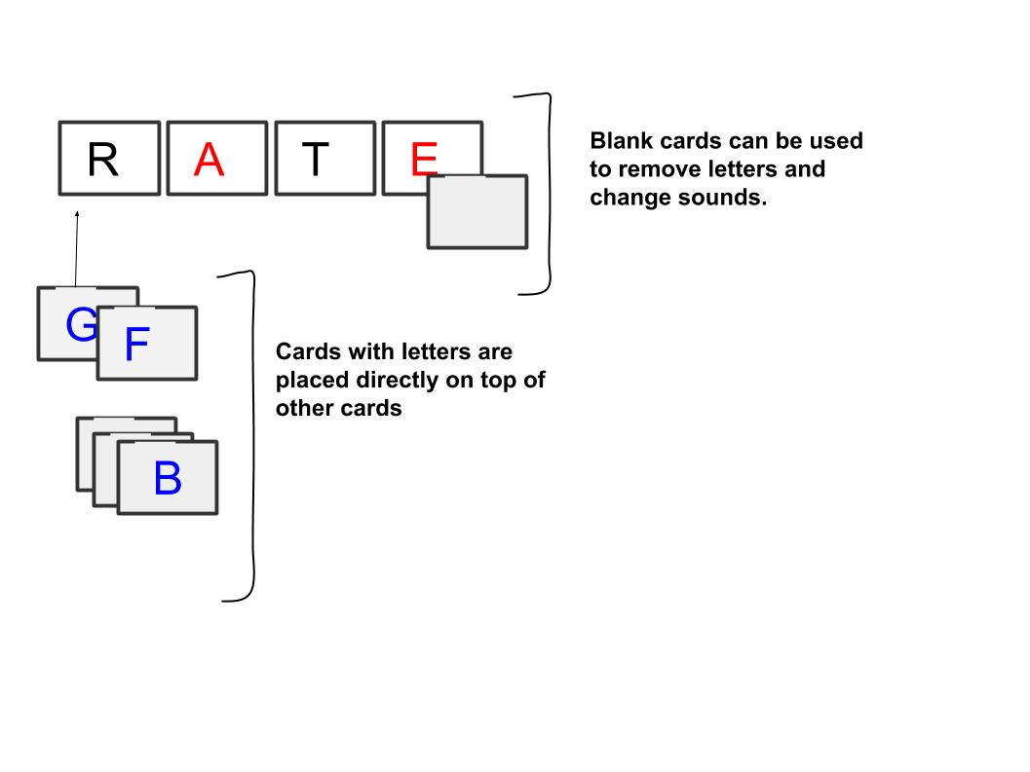

**3.SORG ONE**

3.1 Identify two or more words that rhyme with each other in the song. The rhymes can be perfect or imperfect.

3.2 Create the words using the vowel and consonant phoneme cards

3.3 See how many other rhyming words you can create using both the vowel and consonant phoneme cards

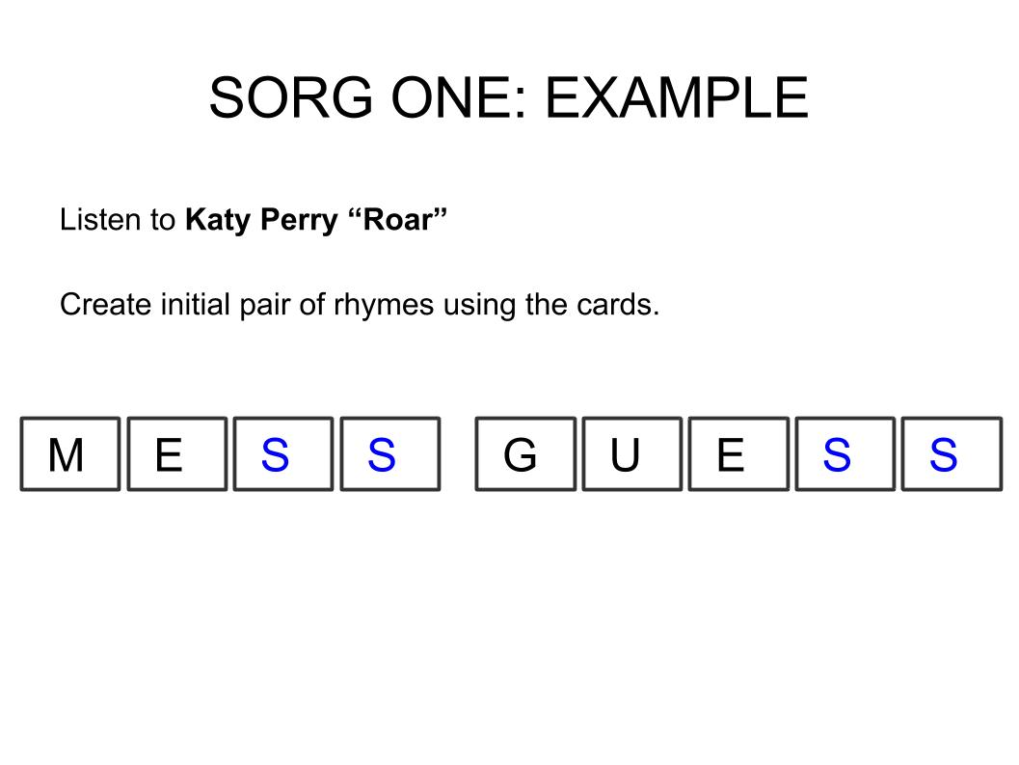

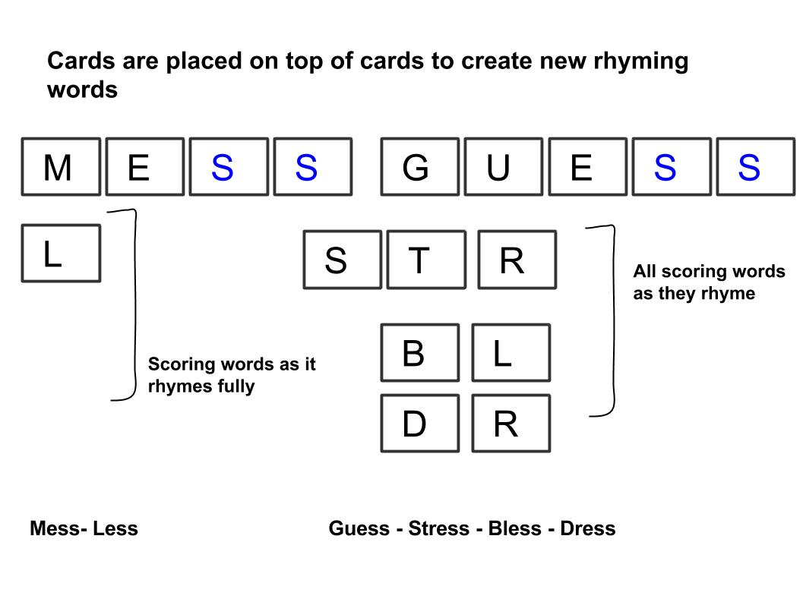

**4. RHYME PRODUCTION GAME SCHEDULE (SESSION ONE, PART TWO)**

As a guide, the following activities should be undertaken.

*Table 1: Session Activities and Duration*

|  |  |  |
| --- | --- | --- |
| **No.** | **Activity** | **Duration** |
| 4.1 | **FAMILIARISATION SORG ONE** |  |
| 4.1.1 | Explanation of the task which is to produce perfect and/or imperfect rhymes | 10 mins |
| 4.1.2 | Example using the first 60 seconds  of Jessie J song | 1 minute |
| 4.1.3  4.1.4 | Playing of Jessie J “Price Tag”  Children have text in front of them  Researchers demonstrate rhyme(s) and mechanics of cards. | 10 minutes |
| 4.2 | **GROUP PLAY SORG ONE** |  |
| 4.2.1 | Playing of song (Jessie J – “Price Tag”)  Children and researchers have text in front of them | 4 minutes |
| 4.2.2 | Children play in a group with researchers as team members | 35 minutes |
|  |  |  |
|  | **TOTAL** | **60 minutes** |

**5. LEARNING OUTCOMES**

*Methodology*

This is the beginning of the Participatory Design (PD) process and as it is vital that students are also partners as well as participants. That said, researchers will obviously have a far greater degree of expertise in the rhyme production tasks. Without being prescriptive it seems that *playfulness* is perhaps a guiding principle for the PD Design Sprints.

*Learning Outcomes*

The goal is to get the students comfortable playing with and exploring the activities below each of which will be evaluated.

*Table 6: Learning Outcomes*

|  |  |  |
| --- | --- | --- |
| **No.** | **Question** | **Evaluation** |
| 5.1 | Producing rhymes in English based on songs | SORG ONE |
| 5.2 | Sharing and discussing rhymes they produce with their peers | Recording of PD creation activities and discussions |
| 5.3 | Considering the different ways in which English words rhyme | Recording of discussions |
| 5.4 | Asking questions about the different ways English words rhyme | Recording of discussions |
| 5.5 | Considering ways in which English rhyming words might differ from their own language(s) | Recording of discussions |
| 5.6 | Improved understanding of how English words rhyme. | Pre-Test CRG  SORG ONE |
| 5.7 | Awareness of Grapheme Phoneme Correspondences (GPCs). | SORG ONE |
| 5.8 | Recognition of English vowel and consonant phonemes | SORG ONE |

**6. POST-GAME GROUP DISCUSSION (SESSION ONE, PART THREE)**

Group scoring including discussion that involves children and researchers exploring their strategies for devising solutions including exploring the questions in the table below.

*Table 2 Post-Game Questions*

|  |  |  |
| --- | --- | --- |
| **No.** | **Question** | **Evaluation** |
| 6.1 | Any difficulties the children encountered | Questionnaire, recording of discussion |
| 6.2 | How they overcame the challenges | Questionnaire, recording of discussion |
| 6.3 | What they understand by perfect and imperfect rhyme? | Questionnaire, recording of discussion |
| 6.4 | Which aspects of the game were fun? | Questionnaire, recording of discussion |
| 6.5 | Which aspects of the game were hard and why? | Questionnaire, recording of discussion |
|  | **DURATION** | **30 Minutes** |

**7. EXPECTED OUTCOMES**

*Table 4: Summary of Session One Outcomes*

|  |  |  |  |
| --- | --- | --- | --- |
| **Ref.** | **Heading** | **Qualitative/**  **Quantitative** | **Notes** |
|  | **PRE-TEST RHYME GAME** |  |  |
|  | Detecting rhymes in English based on songs |  |  |
|  | Identifying perfect and imperfect rhymes |  |  |
|  |  |  |  |
|  |  |  |  |
|  | **RHYME PRODUCTION GAME**  **(SORG ONE)** |  |  |
| 5.1 | Producing rhymes in English based on songs |  |  |
| 5.2 | Sharing and discussing rhymes they produce with their peers |  |  |
| 5.3 | Considering the different ways in which English words rhyme |  |  |
| 5.4 | Asking questions about the different ways English words rhyme |  |  |
| 5.5 | Considering ways in which English rhyming words might differ from their own language(s) |  |  |
| 5.6 | Improved understanding of how English words rhyme. |  |  |
| 5.7 | Awareness of Grapheme Phoneme Correspondences (GPCs). |  |  |
| 5.8 | Recognition of English vowel and consonant phonemes |  |  |
|  |  |  |  |
|  | **POST-GAME GROUP DISCUSSION** |  |  |
| 6.1 | Any difficulties the children encountered |  |  |
| 6.2 | How they overcame the challenges |  |  |
| 6.3 | What they understand by perfect and imperfect rhyme? |  |  |
| 6.4 | Which aspects of the game were fun? |  |  |
| 6.5 | Which aspects of the game were hard and why? |  |  |

**SESSION TWO**

**1. SCHEDULE (SESSION TWO, PART ONE)**

*Table 1: Session Activities and Duration*

|  |  |  |
| --- | --- | --- |
| **No.** | **Activity** | **Duration** |
|  | **FAMILIARISATION SORG TWO** |  |
|  | Explanation of the task which is to modify perfect and/or imperfect rhyming pairs/groups | 10 mins |
|  | Example using the first 60 seconds of Jessie J song | 1 minute |
|  | Playing of Jessie J “Price Tag”  Children have text in front of them  Researchers demonstrate rhyme modification and mechanics of cards. | 10 minutes |
|  | **GROUP PLAY SORG TWO** |  |
|  | Playing of song (Jessie J – “Price Tag”)  Children and researchers have text in front of them | 4 minutes |
|  | Children play in a group with researchers as team members | 35 minutes |
|  |  |  |
|  | **TOTAL** | **60 minutes** |

**2. SORG TWO DESCRIPTION**

2.1 Take two or more words that rhyme with each other from the song.

2.2 Create the words (or similar sounding ones) with the cards

2.3 Use the cards to change one or more of the words so that it does not rhyme with the other word.

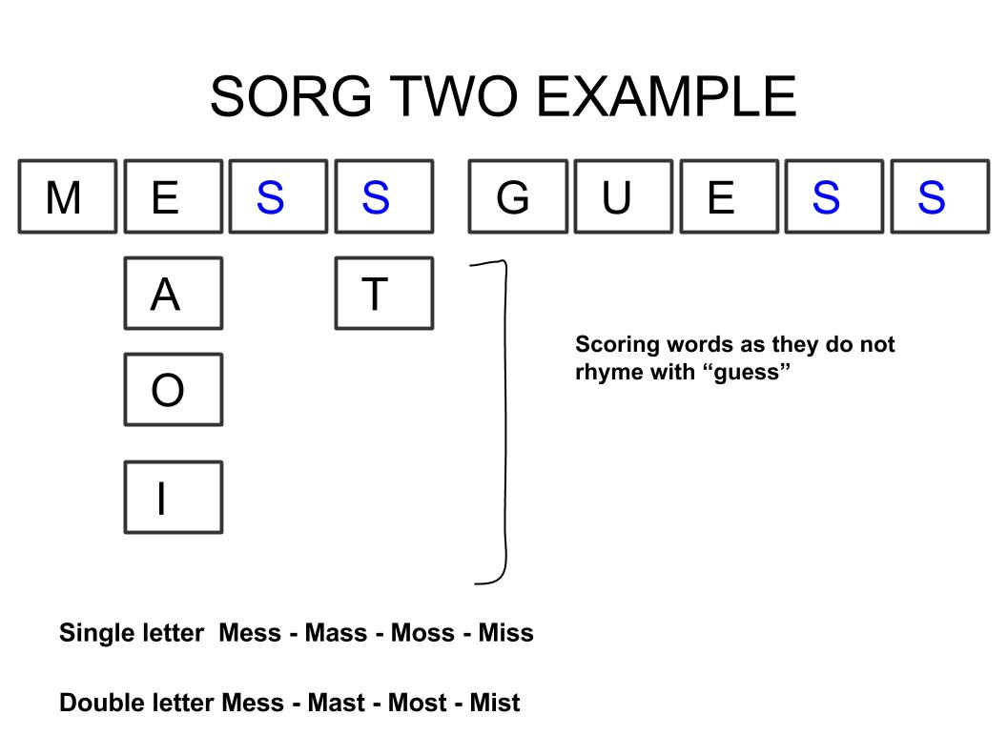

**3. LEARNING OUTCOMES**

The goal is to get the students comfortable playing with and exploring the activities below each of which will be evaluated.

*Table 2: Learning Outcomes*

|  |  |  |
| --- | --- | --- |
| **No.** | **Question** | **Evaluation** |
| 3.1 | Modifying rhymes in English based on songs | SORG TWO |
| 3.2 | Sharing and discussing word modifications they produce with their peers | Recording of PD creation activities and discussions |
| 3.3 | Considering the different ways in which English words rhyme and do not rhyme | Recording of discussions |
| 3.4 | Asking questions about the different ways English words rhyme and/or do not rhyme | Recording of discussions |
| 3.5 | Considering ways in which English rhyming words might differ from their own language(s) | Recording of discussions |
| 3.6 | Improved understanding of how English words rhyme and/or do not rhyme | Pre-Test CRG  SORG TWO  Post-Test CRG |
| 3.7 | Awareness of Grapheme Phoneme Correspondences (GPCs). | SORG TWO |
| 3.8 | Recognition of English vowel and consonant phonemes | SORG TWO |

**4. POST-GAME GROUP DISCUSSION (SESSION TWO, PART TWO)**

Group scoring including discussion that involves children and researchers exploring their strategies for devising solutions including exploring the questions in the table below.

*Table 3: Post-Game Questions*

|  |  |  |
| --- | --- | --- |
| **No.** | **Question** | **Evaluation** |
| 4.1 | Any difficulties the children encountered | Questionnaire, recording of discussion |
| 4.2 | How they overcame the challenges | Questionnaire, recording of discussion |
| 4.3 | What they understand by perfect and imperfect rhyme? | Questionnaire, recording of discussion |
| 4.4 | Which aspects of the game were fun? | Questionnaire, recording of discussion |
| 4.5 | Which aspects of the game were hard and why? | Questionnaire, recording of discussion |
|  |  |  |
|  | **DURATION** | **30 minutes** |

**5. EXPECTED OUTCOMES (SESSION TWO, PART TWO)**

*Table 4: Summary of Session Outcomes*

|  |  |  |  |
| --- | --- | --- | --- |
| **Ref.** | **Heading** | **Qualitative/**  **Quantitative** | **Notes** |
|  | **RHYME PRODUCTION GAME**  **(SORG TWO)** |  |  |
| 3.1 | Producing rhymes in English based on songs |  |  |
| 3.2 | Sharing and discussing word modifications they produce with their peers |  |  |
| 3.3 | Considering the different ways in which English words rhyme and do not rhyme |  |  |
| 3.4 | Asking questions about the different ways English words rhyme and/or do not rhyme |  |  |
| 3.5 | Considering ways in which English rhyming words might differ from their own language(s) |  |  |
| 3.6 | Improved understanding of how English words rhyme and/or do not rhyme |  |  |
| 3.7 | Awareness of Grapheme Phoneme Correspondences (GPCs). |  |  |
| 3.8 | Recognition of English vowel and consonant phonemes |  |  |
|  |  |  |  |
|  | **POST-GAME GROUP DISCUSSION** |  |  |
| 3.1 | Any difficulties the children encountered |  |  |
| 3.2 | How they overcame the challenges |  |  |
| 3.3 | What they understand by perfect and imperfect rhyme? |  |  |
| 3.4 | Which aspects of the game were fun? |  |  |
| 3.5 | Which aspects of the game were hard and why? |  |  |

**6. SCHEDULE (SESSION TWO, PART THREE)**

*Table 5: Session Activities and Duration*

|  |  |  |
| --- | --- | --- |
| **No.** | **Activity** | **Duration** |
| 4.1 | **FAMILIARISATION** |  |
| 4.1.1 | Explanation of the task which is to modify song lyrics | 10 mins |
| 4.1.2 | Example using the first 60 seconds  of Jessie J song | 1 minute |
| 4.1.3  4.1.4 | Playing of Jessie J “Price Tag”  Children have text in front of them  Researchers demonstrate word modification and/or mechanics of cards. | 10 minutes |
| 4.2 | **GROUP PLAY** |  |
| 4.2.1 | Playing of song (Jessie J – “Price Tag”)  Children and researchers have text in front of them | 4 minutes |
| 4.2.2 | Children play in a group with researchers as team members | 35 minutes |
|  |  |  |
|  | **TOTAL** | **60 minutes** |

**7. SORG THREE**

7.1 Take some words from the song.

7.2 Create the words with the cards

7.3 Use letters to change the words so that they are different from, but **sound similar to**, the words in the song.

7.4 Sing the song with the new words. How does it sound?

7.5 Invent rules for changing the words. Make a note of the different rules your group invents.

*Jessie J “Price Tag” Example*

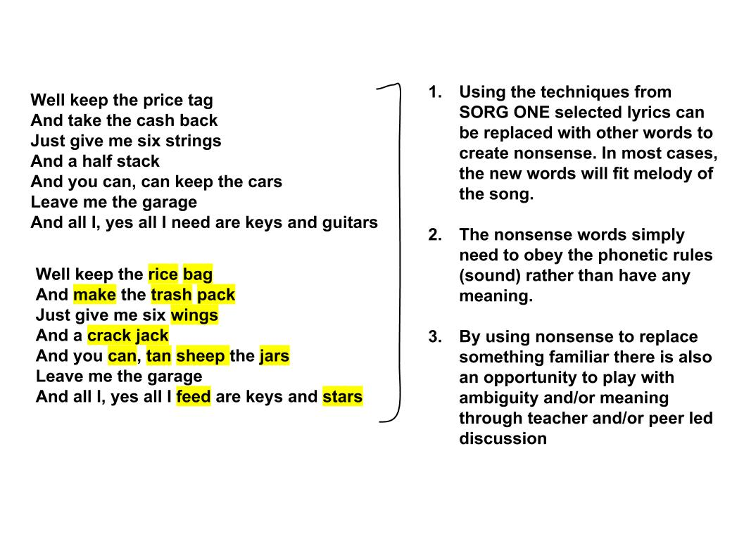

**SCHEDULE (SESSION THREE, PART ONE)**

*Table 1: Session Activities and Duration*

|  |  |  |
| --- | --- | --- |
| **No.** | **Activity** | **Duration** |
|  | **FAMILIARISATION** |  |
|  | Recap of the task which is to modify song lyrics with rules invented during the previous session (SORG THREE) | 10 mins |
|  | Example using the first 60 seconds  of Jessie J song | 1 minute |
|  | Playing of Jessie J “Price Tag”, “Flashlight” or Katy Perry “Roar”  Children have text in front of them  Researchers demonstrate word modification and/or mechanics of cards. | 10 minutes |
|  | **GROUP PLAY SORG THREE VARIATION(S)** |  |
|  | Playing of song  Children and researchers have text in front of them | 4 minutes |
|  | Children play in a group with researchers as team members | 20 minutes |
|  |  |  |
|  | **TOTAL** | **45 minutes** |

**3. POST-GAME GROUP DISCUSSION (SESSION THREE, PART TWO)**

Group scoring including discussion that involves children and researchers exploring their strategies for devising solutions including exploring the questions in the table below.

*Table 2: Post-Game Questions*

|  |  |  |
| --- | --- | --- |
| **No.** | **Question** | **Evaluation** |
| 3.1 | Any difficulties the children encountered | Questionnaire, recording of discussion |
| 3.2 | How they overcame the challenges | Questionnaire, recording of discussion |
| 3.3 | How did they determine which words to change? | Questionnaire, recording of discussion |
| 3.4 | How did they modify the words they selected? |  |
| 3.5 | How important was meaning for the modified words? |  |
| 3.6 | How do they evaluate the meaning of the new lyrics? |  |
| 3.7 | How do they evaluate the sound of the new lyrics? |  |
| 3.8 | Which aspects of the game were fun? | Questionnaire, recording of discussion |
| 3.9 | Which aspects of the game were hard and why? | Questionnaire, recording of discussion |
|  |  |  |
|  | **DURATION** | **20 minutes** |

**4. LEARNING OUTCOMES**

*Table 3: Learning Outcomes*

|  |  |  |
| --- | --- | --- |
| **No.** | **Question** | **Evaluation** |
| 4.1 | Producing rhymes in English based on songs | SORG THREE |
| 4.2 | Sharing and discussing rhymes they produce with their peers | Recording of PD creation activities and discussions |
| 4.3 | Considering the different ways in which English words rhyme | Recording of discussions |
| 4.4 | Asking questions about the different ways English words rhyme | Recording of discussions |
| 4.5 | Considering ways in which English rhyming words might differ from their own language(s) | Recording of discussions |
| 4.6 | Producing their own rules for English rhyming word games | SORG THREE, Recording of PD creation activities |
| 4.7 | Playing English rhyming word games that they have created | Recording of PD creation activities |
| 4.8 | Sharing and discussing the games they have created | SORG THREE, Recording of PD creation activities |
| 4.9 | Improved understanding of how English words rhyme. | Pre-Test CRG  SORG ONE, SORG THREE  Post-Test CRG |
| 5.0 | Awareness of Grapheme Phoneme Correspondences (GPCs). | SORG THREE |
| 5.1 | Recognition of English vowel and consonant phonemes | SORG THREE |

**5. EXPECTED OUTCOMES (SESSION THREE PARTS ONE & TWO)**

*Table 4: Summary of Session Outcomes*

|  |  |  |  |
| --- | --- | --- | --- |
| **Ref.** | **Heading** | **Qualitative/**  **Quantitative** | **Notes** |
|  | **RHYME PRODUCTION & GAME CREATION (SORG THREE)** |  |  |
| 4.1 | Producing rhymes in English based on songs |  |  |
| 4.2 | Sharing and discussing rhymes they produce with their peers |  |  |
| 4.3 | Considering the different ways in which English words rhyme |  |  |
| 4.4 | Asking questions about the different ways English words rhyme |  |  |
| 4.5 | Considering ways in which English rhyming words might differ from their own language(s) |  |  |
| 4.6 | Producing their own rules for English rhyming word games |  |  |
| 4.7 | Playing English rhyming word games that they have created |  |  |
| 4.8 | Sharing and discussing the games they have created |  |  |
| 4.9 | Improved understanding of how English words rhyme. |  |  |
| 5.0 | Awareness of Grapheme Phoneme Correspondences (GPCs). |  |  |
| 5.1 | Recognition of English vowel and consonant phonemes |  |  |
|  |  |  |  |
|  | **POST GAME GROUP DISCUSSION** |  |  |
|  |  |  |  |
| 3.1 | Any difficulties the children encountered |  |  |
| 3.2 | How they overcame the challenges |  |  |
| 3.3 | How did they determine which words to change? |  |  |
| 3.4 | How did they modify the words they selected? |  |  |
| 3.5 | How important was meaning for the modified words? |  |  |
| 3.6 | How do they evaluate the meaning of the new lyrics? |  |  |
| 3.7 | How do they evaluate the sound of the new lyrics? |  |  |
| 3.8 | Which aspects of the game were fun? |  |  |
| 3.9 | Which aspects of the game were hard and why? |  |  |

**RHYME GAME CREATION (SESSION THREE, PART THREE)**

**DURATION: 80 minutes**

**1. BACKGROUND**

The final part of session three is focused on the creation of original rhyme games that use English song lyrics. Prior to this session, students will have demonstrated a number of competencies with regards to language.

*Table1: Pre-requisite Student Competencies*

|  |  |  |
| --- | --- | --- |
| **Competence** | **Evaluation** | **Comments** |
| Identify and differentiate between types of English rhyme within song(s) | Through Closed Rhyme Games (CRGs One, Two and Three) |  |
| Produce different types of rhyme and/or non-rhyme in response to song(s) | Through Semi-Open Rhyme Games (SORGs One, Two) |  |
| Create rule(s) for rhyming game | Through SORG Three |  |

Games from previous Design Sprints are intended as a contribution to the question: *how can children and their teachers design games?* Data from the schools in Metro Manila indicates that children like playing games; it is plausible that they would enjoy creating games as well. The SORGs can be adapted by creating new usage rules. The game play mechanic can also be changed although initially it is likely that focusing on rules will be both easier and quicker. One way to consider the generation of new rules is in terms of constraints:

**2. CONSTRAINTS**

Constraints that are *intrinsic* to the core game elements will be better for the language development. For instance, the cards represent sounds and so constraining the use of cards will require players to think about sound and how it is represented by letter combinations. This provides a richer learning context than say a time constraint which for many learners might simply resulting in them rushing for any solution rather than thinking more deeply about a number of solutions.

*Table 2: Player Constraint Examples*

|  |  |  |
| --- | --- | --- |
| **Player constraints** | **Example** | **Comments** |
| Duration (limited amount of time) | Player has x minutes to complete task | Ideally time constraints would adapt to player success |
| Duration (limited number of turns | Player has x turns to complete task | See above |
| Frequency (limited by frequency of word(s) within lyrics) | Player’s tasks is based on most/least frequent words occurring within song |  |
| Rhyme (limited by type of rhyme; perfect and/or imperfect) | Player’s task includes perfect and/or imperfect rhyme | Software should adapt based on player success |
| Rhyme (limited by presence or absence of rhyme) | Player’s task includes or excludes rhyme |  |
| Letter type (limited by type of letter that can be used; vowel, consonant) | Player’s task requires modifying vowels and/or consonants |  |
| Phoneme type (limited by type of phoneme that can be used; vowel or consonant) | Player’s task involves modifying vowel and/or consonant phonemes |  |
| Word type (limited by Part of Speech – noun, verb, adverb etc) | Player’s task is based on specific Parts of Speech | Software NLP tools such as WordNet |
| Meaning (limited by similarity to or distance from a target word; synonyms, antonyms) | Player’s task involves understanding or changing the meaning of words within a song | Software NLP tools such as WordNet |

**4. DESIGN GUIDELINES**

There are a number of ways to create rules and prototypes but ultimately the process consists of:

*Playing with the cards and a set of rules*

*Seeing what works (or not); what is engaging or fun, what is hard or boring*

*Discussing why some variants are fun and other not?*

*Adapting rules in light of the discussion and*

*Trying again*

Within this process, it is critical that changes to game rules, comments and engagement levels are recorded.

*Illustration: Game Prototype Development Cycle*

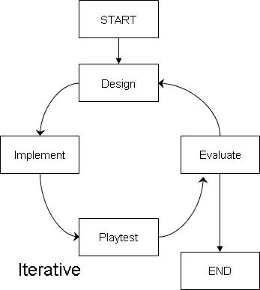

POST-TEST SCHEDULE

|  |  |  |
| --- | --- | --- |
| **No.** | **Activity** | **Duration** |
|  | **FAMILIARISATION (CRG FOUR)** |  |
|  | Explanation of the task which is to identify  perfect rhyme | 3 minutes |
|  | Example which involves the first 60 seconds  of the Mark Ronson song | 1 minute |
|  | CRG ONE (playing of song)  Children have text in front of them | 10 minutes |
|  |  |  |
|  | INDIVIDUAL ATTEMPT |  |
|  | Children go through CRG ONE on their own | 10 minutes |
|  |  |  |
|  | **FAMILIARISATION (CRG FIVE)** |  |
|  | Explanation of the task which is to identify  imperfect rhymes. including example | 5 minutes |
|  | INDIVIDUAL ATTEMPT CRG TWO | 10 minutes |
|  |  |  |
|  | **FAMILIARISATION (CRG SIX)** | 5 minutes |
|  | Explanation of the task which is to identify  perfect and imperfect rhymes |  |
|  | INDIVIDUAL ATTEMPT CRG THREE | 10 minutes |
|  |  |  |
|  | **TOTAL** | **50 minutes** |

***General Information.*** *(Pangkalahatang impormasyon)*

|  |  |  |
| --- | --- | --- |
| *1.* | *Age / Edad* |  |
| *2.* | *Sex (Please encircle)*  *Kasarian (Bilugan)* | *M F* |
| *3.* | *Languages used at home / outside school*  *Mga lengguwaheng ginagamit sa bahay / labas ng paaralan* |  |
| *4.* | *Grade/School* |  |

|  |  |  |  |  |  |  |
| --- | --- | --- | --- | --- | --- | --- |
| ***Familiarity*** ***Likeability*** | | | | | | |
| *Song* | *Know song very well* | *Don’t know song well* | *Never heard song* | *Like song a lot* | *Like song somewhat* | *Don’t like song* |
| *Uptown Funk*  *(Mark Ronson)* |  |  |  |  |  |  |
| *7 Years*  *(Lukas Graham)* |  |  |  |  |  |  |
| *Shape Of You*  *(Ed Sheeran)* |  |  |  |  |  |  |

*Familiarity: measured as high, medium or low according to how recently many times the song has been heard.*

* *Know very well: more than more than 40 times ever or ten times in the past month*
* *Don’t know well: than 20 times ever or only a few times in the past month*

***Scorecard***

|  |  |  |  |
| --- | --- | --- | --- |
| *Game code* | *Points score* | *Familiarity* | *Notes* |
| *CRG ONE* |  |  |  |
| *CRG TWO* |  |  |  |
| *CRG THREE* |  |  |  |
|  |  |  |  |
| *TOTAL* |  |  |  |

**Part I. CRG FOUR**

|  |  |
| --- | --- |
| **Mark Ronson Ft. Bruno Mars “Uptown Funk”** | **Game Rules** |
| **This hit, that ice cold**  **Michelle Pfeiffer, that white gold**  **This one for them hood girls**  **Them good girls straight masterpieces**  **Stylin', whilen, livin' it up in the city**  **Got Chucks on with Saint Laurent**  **Got kiss myself, I'm so pretty**  **I'm too hot (hot damn)**  **Called a police and a fireman**  **I'm too hot (hot damn)**  **Make a dragon wanna retire man**  **I'm too hot (hot damn)**  **Say my name you know who I am**  **I'm too hot (hot damn)**  **Am I bad 'bout that money, break it down**  **Girls hit your hallelujah (whoo)**  **Girls hit your hallelujah (whoo)**  **Girls hit your hallelujah (whoo)**  **'Cause uptown funk gon' give it to you**  **'Cause uptown funk gon' give it to you**  **'Cause uptown funk gon' give it to you**  **Saturday night and we in the spot**  **Don't believe me just watch (come on)**  **Don't believe me just watch uh**  **Don't believe me just watch**  **Don't believe me just watch**  **Don't believe me just watch**  **Don't believe me just watch**  **Hey, hey, hey, oh**  **Stop, wait a minute**  **Fill my cup, put some liquor in it**  **Take a sip, sign a check**  **Julio, get the stretch**  **Ride to Harlem, Hollywood**  **Jackson, Mississippi**  **If we show up, we gon' show out**  **Smoother than a fresh dry skippy**  **I'm too hot (hot damn)**  **Called a police and a fireman**  **I'm too hot (hot damn)**  **Make a dragon wanna retire man**  **I'm too hot (hot damn)**  **Bitch say my name you know who I am**  **I'm too hot (hot damn)**  **Am I bad 'bout that money**  **Break it down**  **Girls hit your hallelujah (whoo)**  **Girls hit your hallelujah (whoo)**  **Girls hit your hallelujah (whoo)**  **'Cause uptown funk gon' give it to you**  **'Cause uptown funk gon' give it to you**  **'Cause uptown funk gon' give it to you**  **Saturday night and we in the spot**  **Don't believe me just watch (come on)**  **Don't believe me just watch uh**  **Don't believe me just watch uh**  **Don't believe me just watch uh**  **Don't believe me just watch**  **Don't believe me just watch**  **Hey, hey, hey, oh**  **Before we leave**  **Lemmi tell y'all a lil' something**  **Uptown funk you up**  **Uptown funk you up**  **Uptown funk you up**  **Uptown funk you up uh**  **I said uptown funk you up**  **Uptown funk you up**  **Uptown funk you up**  **Uptown funk you up**  **Come on, dance, jump on it**  **If you sexy then flaunt it**  **If you freaky then own it**  **Don't brag about it, come show me**  **Come on, dance**  **Jump on it**  **If you sexy then flaunt it**  **Well it's Saturday night and we in the spot**  **Don't believe me just watch come on!**  **Don't believe me just watch uh**  **Don't believe me just watch uh**  **Don't believe me just watch uh**  **Don't believe me just watch**  **Don't believe me just watch**  **Hey, hey, hey, oh**  **Uptown funk you up**  **Uptown funk you up (say what?)**  **Uptown funk you up**  **Uptown funk you up**  **Uptown funk you up**  **Uptown funk you up (say what?)**  **Uptown funk you up**  **Uptown funk you up**  **Uptown funk you up**  **Uptown funk you up (say what?)**  **Uptown funk you up**  **Uptown funk you up**  **Uptown funk you up**  **Uptown funk you up (say what?)**  **Uptown funk you up** | 1. Listen to (or read) the song and try to identify all the words that rhyme.  2.In the space below write down all the words that rhyme with each other.  3.10 points for each correct rhyming word you identify.  4.A full rhyme is something like cat – hat, block – rock.  5. In the song for instance **cold** and **gold** rhyme and would score 20 points  *Words like mess and guess are called perfect rhymes.*  **WRITE ANSWERS BELOW**  **WRITE ANSWERS BELOW** |

**Part II. CRG FIVE**

|  |  |
| --- | --- |
| **Lukas Graham “7 Years”** | **Game Rules** |
| **Once I was seven years old my momma told me**  **Go make yourself some friends or you'll be lonely**  **Once I was seven years old**  **It was a big big world, but we thought we were bigger**  **Pushing each other to the limits, we were learning quicker**  **By eleven smoking herb and drinking burning liquor**  **Never rich so we were out to make that steady figure**  **Once I was eleven years old my daddy told me**  **Go get yourself a wife or you'll be lonely**  **Once I was eleven years old**  **I always had that dream like my daddy before me**  **So I started writing songs, I started writing stories**  **Something about that glory just always seemed to bore me**  **'Cause only those I really love will ever really know me**  **Once I was twenty years old, my story got told**  **Before the morning sun, when life was lonely**  **Once I was twenty years old**  **I only see my goals, I don't believe in failure**  **'Cause I know the smallest voices, they can make it major**  **I got my boys with me at least those in favor**  **And if we don't meet before I leave, I hope I'll see you later**  **Once I was twenty years old, my story got told**  **I was writing about everything, I saw before me**  **Once I was twenty years old**  **Soon we'll be thirty years old, our songs have been sold**  **We've traveled around the world and we're still roaming**  **Soon we'll be thirty years old**  **I'm still learning about life**  **My woman brought children for me**  **So I can sing them all my songs**  **And I can tell them stories**  **Most of my boys are with me**  **Some are still out seeking glory**  **And some I had to leave behind**  **My brother I'm still sorry**  **Soon I'll be sixty years old, my daddy got sixty-one**  **Remember life and then your life becomes a better one**  **I made a man so happy when I wrote a letter once**  **I hope my children come and visit, once or twice a month**  **Soon I'll be sixty years old, will I think the world is cold**  **Or will I have a lot of children who can warm me**  **Soon I'll be sixty years old**  **Soon I'll be sixty years old, will I think the world is cold**  **Or will I have a lot of children who can warm me**  **Soon I'll be sixty years old**  **Once I was seven years old, momma told me**  **Go make yourself some friends or you'll be lonely**  **Once I was seven years old**  **Once I was seven years old** | 1. This song has some more words that rhyme.  2. Sometimes rhymes can be in threes, not just pairs.  Example **I,** **sky** and **fly**.  3. Also, a word can nearly rhyme with another word.  Example **stop** – **got.** *These are called imperfect rhymes.*  4. If you can find words that nearly rhyme with each other you get an extra 20 points.  5. Write down all the **perfect** and **imperfect** rhymes you can find in the song.  **WRITE ANSWERS BELOW**  **WRITE ANSWERS BELOW** |

**Part III. CRG SIX**

|  |  |
| --- | --- |
| **Hamilton (Original Broadway Recording)**  **“Alexander Hamilton”** | **Game Rules** |
| **How does a bastard, orphan, son of a whore   And a Scotsman, dropped in the middle of a forgotten spot in the Caribbean by providence impoverished, In squalor, grow up to be a hero and a scholar?**  **The ten-dollar founding father without a father Got a lot farther by working a lot harder By being a lot smarter By being a self-starter By fourteen, they placed him in charge of a trading charter**  **And every day while slaves were being slaughtered and carted away Across the waves, he struggled and kept his guard up Inside, he was longing for something to be a part of The brother was ready to beg, steal, borrow, or barter**  **Then a hurricane came, and devastation reigned Our man saw his future drip, dripping down the drain Put a pencil to his temple, connected it to his brain And he wrote his first refrain, a testament to his pain**  **Well, the word got around, they said, this kid is insane, man Took up a collection just to send him to the mainland Get your education, don’t forget from whence you came  And the world is gonna know your name What’s your name, man?**  **Alexander Hamilton My name is Alexander Hamilton And there’s a million things I haven’t done But just you wait, just you wait**  **When he was ten his father split, full of it, debt-ridden Two years later, see Alex and his mother bed-ridden Half-dead sittin' in their own sick, the scent thick**  **And Alex got better but his mother went quick**  **Moved in with a cousin, the cousin committed suicide Left him with nothin' but ruined pride, something new inside voice saying Alex, you gotta fend for yourself**  **He started retreatin' and readin' every treatise on the shelf**  **There would have been nothin' left to do for someone less astute He woulda been dead or destitute without a cent of restitution Started workin', clerkin' for his late mother’s landlord Tradin' sugar cane and rum and all the things he can’t afford Scammin' for every book he can get his hands on Plannin' for the future see him now as he stands on the bow of a ship headed for a new land In New York you can be a new man**  **In New York you can be a new man In New York you can be a new man  In New York you can be a new man In New York you can be a new man   Just you wait**  **Alexander Hamilton**  **We are waiting in the wings for you**  **You could never back down You never learned to take your time**  **Oh, Alexander Hamilton**  **When America sings for you Will they know what you overcame? Will they know you rewrote your game? The world will never be the same, oh**  **The ship is in the harbor now See if you can spot him**  **Another immigrant comin' up from the bottom**  **His enemies destroyed his rep America forgot him**  **We fought with him**  **Me, I died for him**  **Me, I trusted him**  **Me, I loved him**  **And me, I’m the damn fool that shot him**  **There’s a million things I haven’t done But just you wait**  **What’s your name, man?**  **Alexander Hamilton** | 1. This song has more perfect and imperfect rhymes.  2. Score 10 points for perfect rhymes, 20 points for imperfect rhymes.  3. Write down as many rhymes as you can find.  4. Good luck and thanks for playing.  **WRITE ANSWERS BELOW**    **WRITE ANSWERS BELOW** |

**Part IV. CRG SEVEN**

**Provide examples of two of more rhymes and fit them in the table below.**

|  |  |  |
| --- | --- | --- |
|  | **Perfect Rhymes** | **Imperfect Rhymes** |
|  | **guess, mess**  **perfect rhyme 1, perfect rhyme 2** | **got, stop**  **imperfect rhyme 1, imperfect rhyme 2** |

**Song Credits**

**Uptown Funk**

Writer(s); Bruno Mars, Devon Gallaspy, Jeff Bhasker, Mark Ronson, Nicholas Williams, Phillip Lawrence,

Ronnie Wilson, Charles Wilson, Robert Wilson, Rudolph Taylor, Lonnie Simmons.

℗ 2015 Mark Ronson Under Exclusive Licence To Sony Music Entertainment UK Limited & © 2015 Sony Music Entertainment UK Limited

**7 Years**

Writer(s): Christopher Brown, David Labrel, Lukas Forchhammer, Morten Pilegaard, Morten Ristorp Jensen,Stefan Forrest © Warner/Chappell Music, Inc

**Alexander Hamilton**

Writer: Lin-Manuel Miranda

© Warner/Chappell Music, Inc

1. *Defined as ‘a game, toy, or problem designed to test ingenuity or knowledge.’*