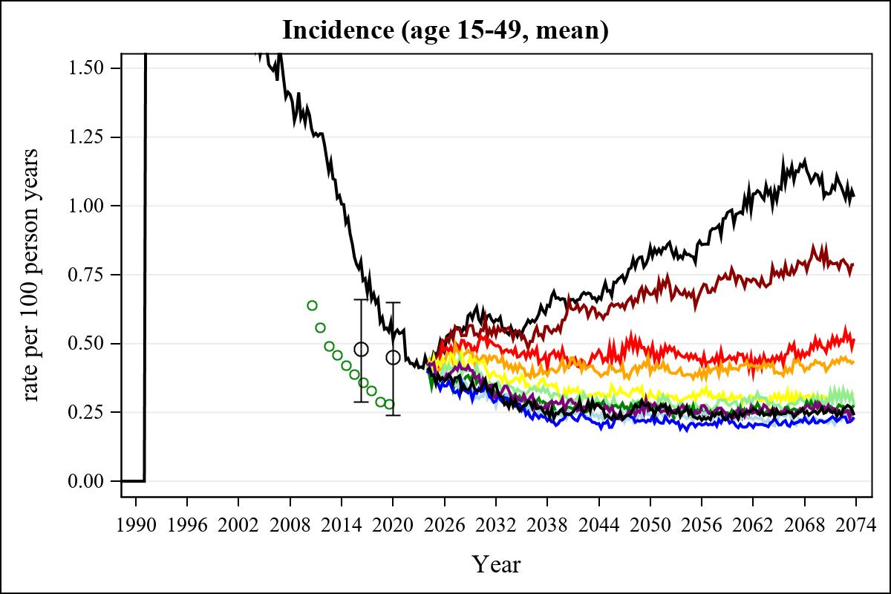

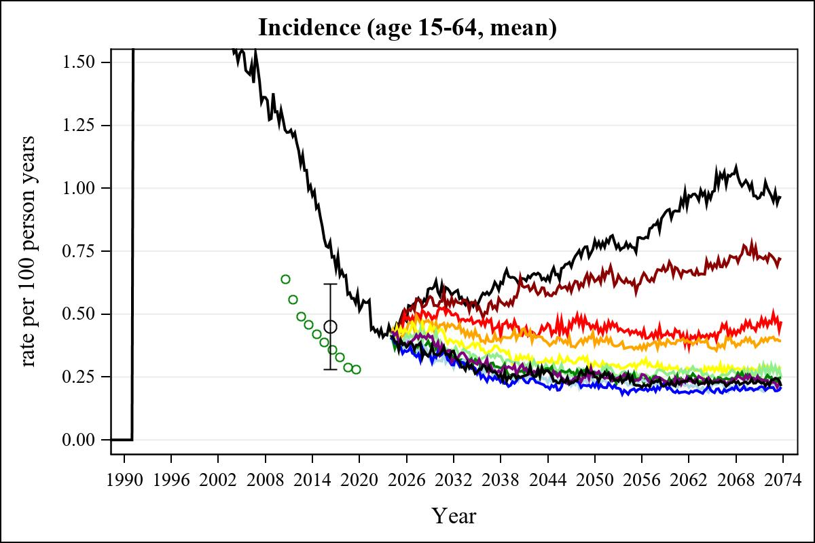

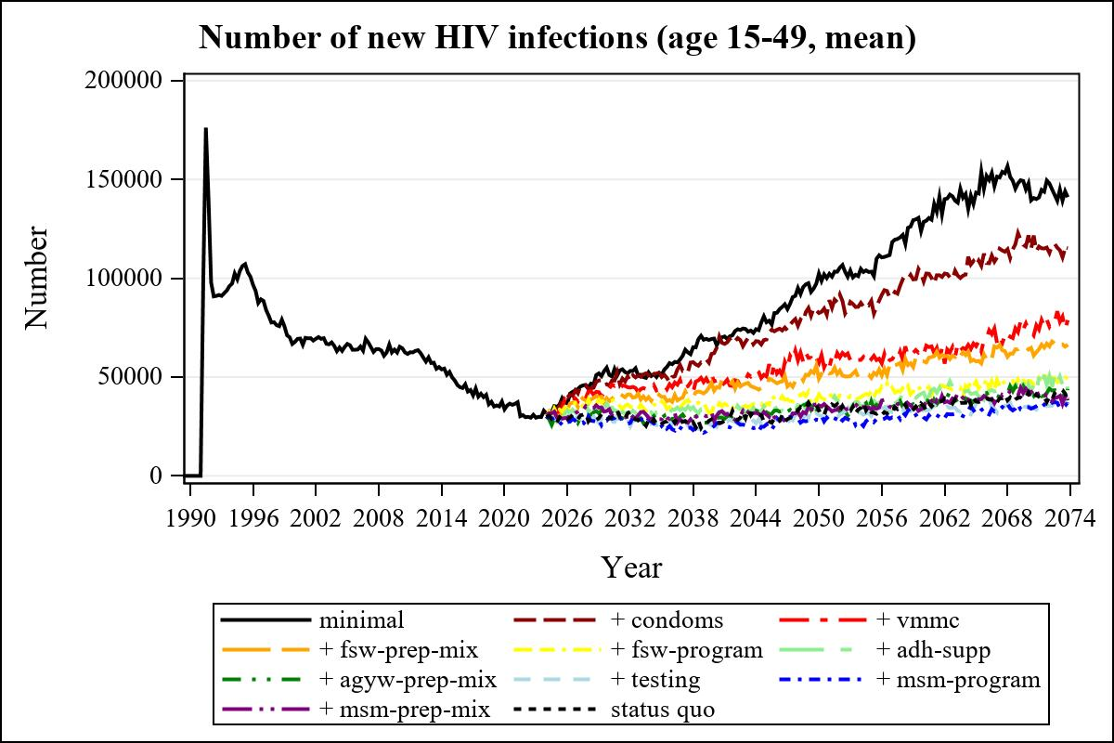

Obs | mean_n_new_inf1549__0 | mean_n_new_inf1549__1 | mean_n_new_inf1549__2 | mean_n_new_inf1549__3
226 | 69487.86 | 62110.24 | 47802.55 | 43091.03

Obs | mean_n_new_inf1549__4 | mean_n_new_inf1549__5 | mean_n_new_inf1549__6 | mean_n_new_inf1549__7
226 | 35545.23 | 33329.95 | 27132.52 | 27233.37

Obs | mean_n_new_inf1549__8 | mean_n_new_inf1549__9 | mean_n_new_inf1549__99
226 | 25169.23 | 27850.04 | 26323.34

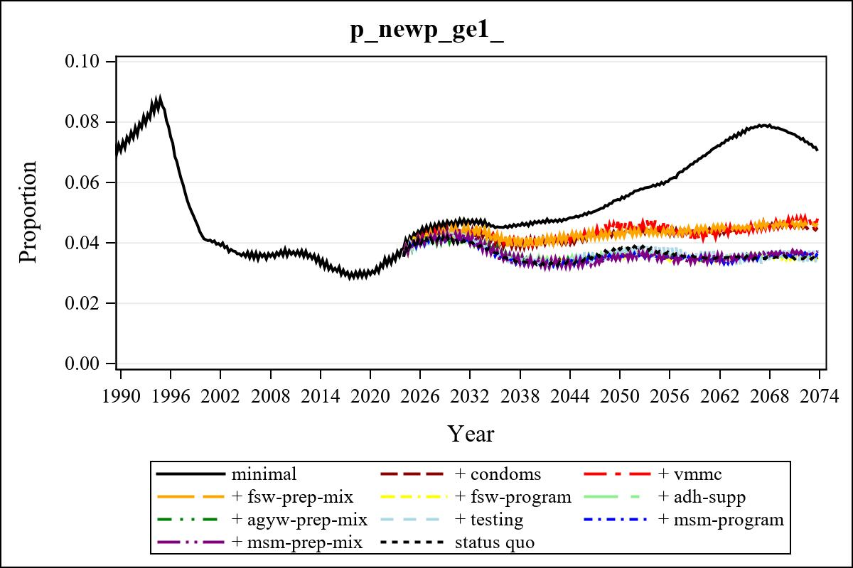

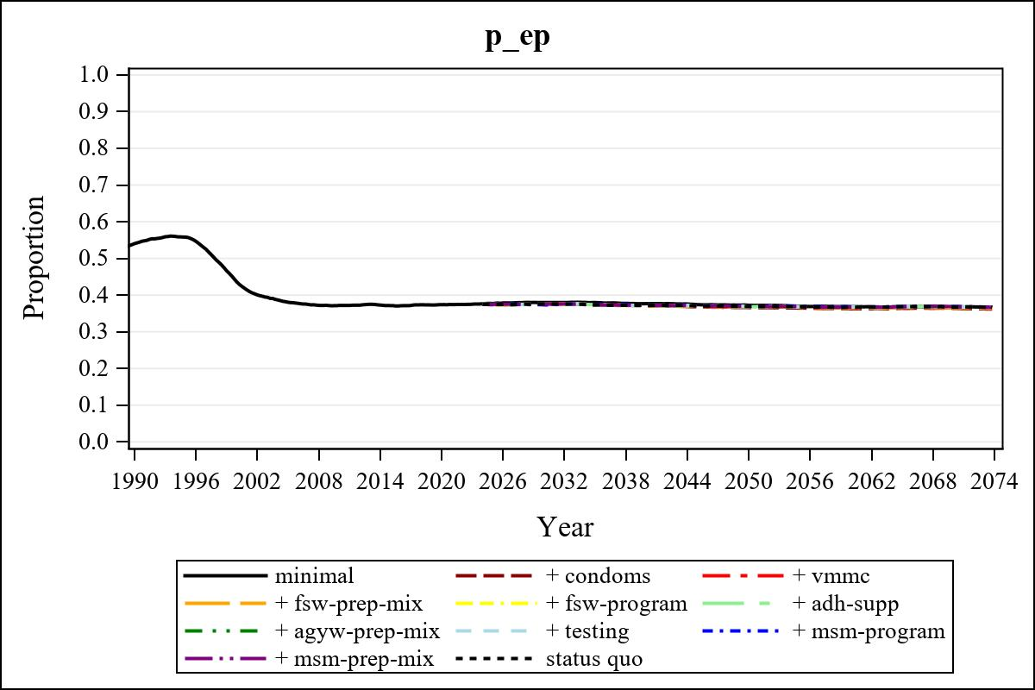

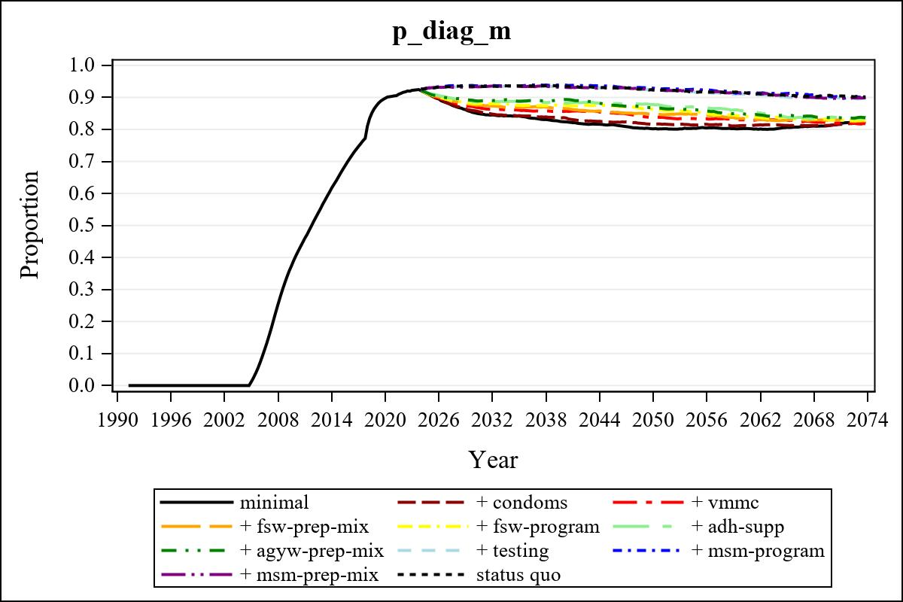

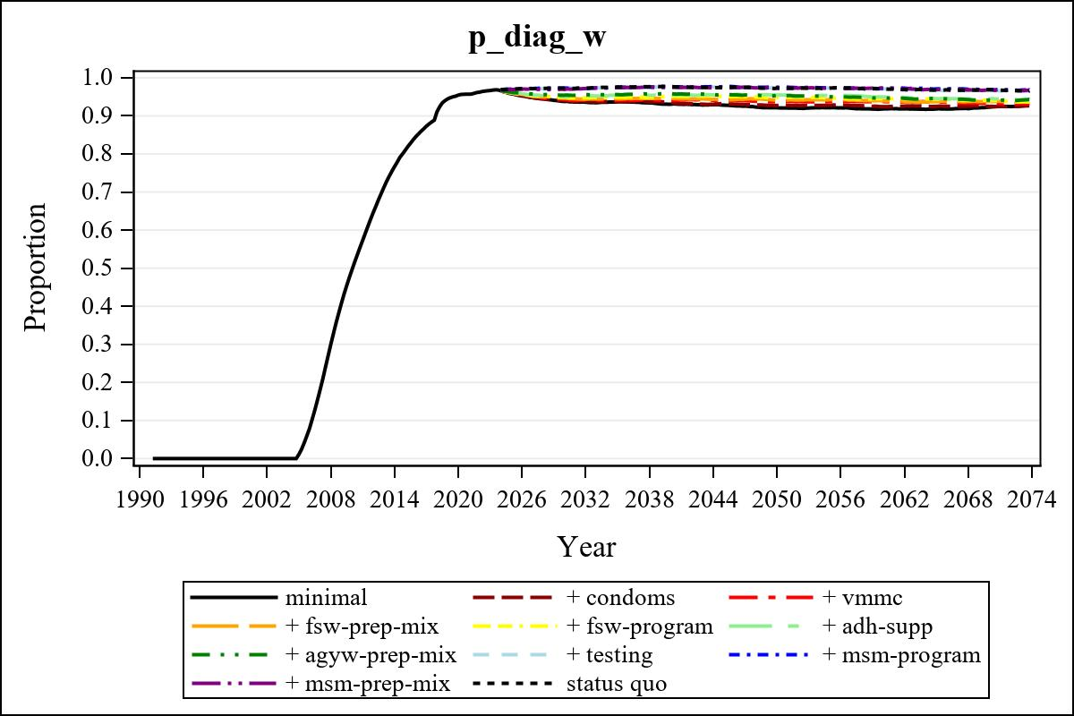

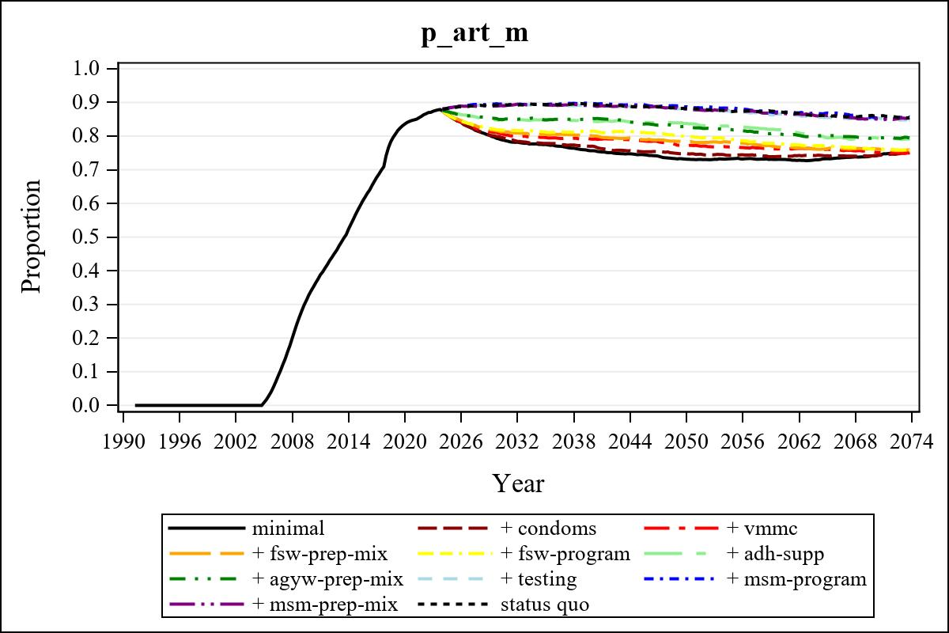

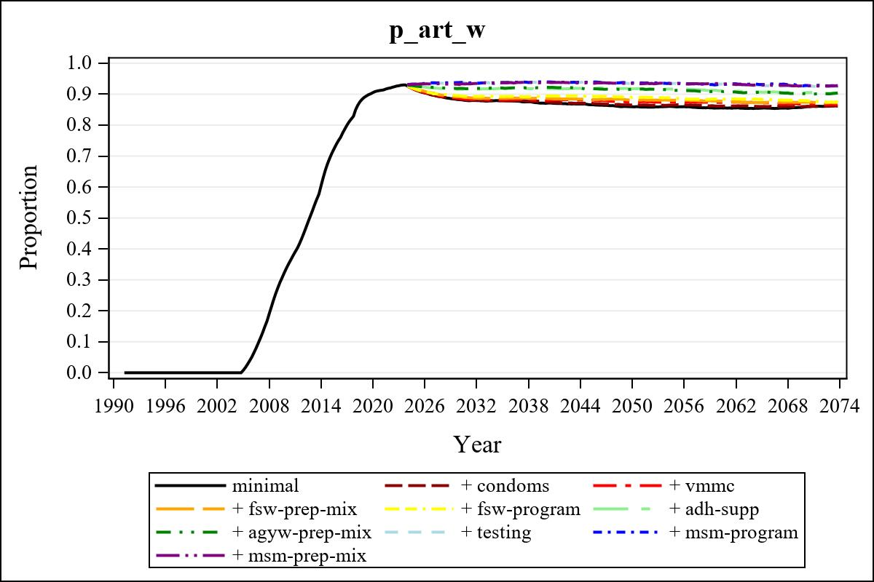

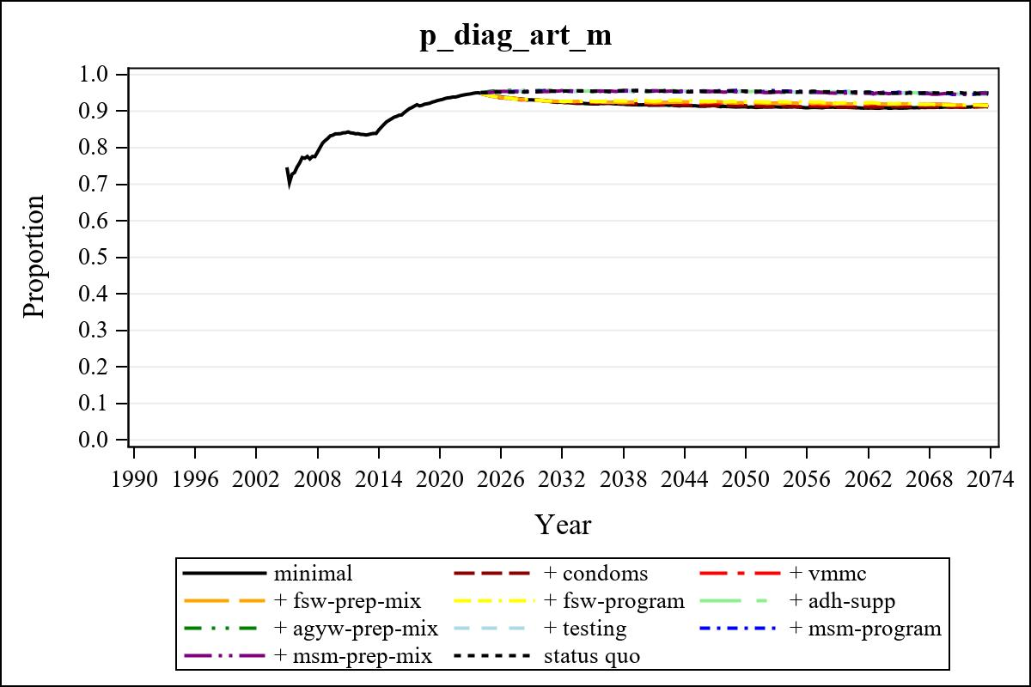

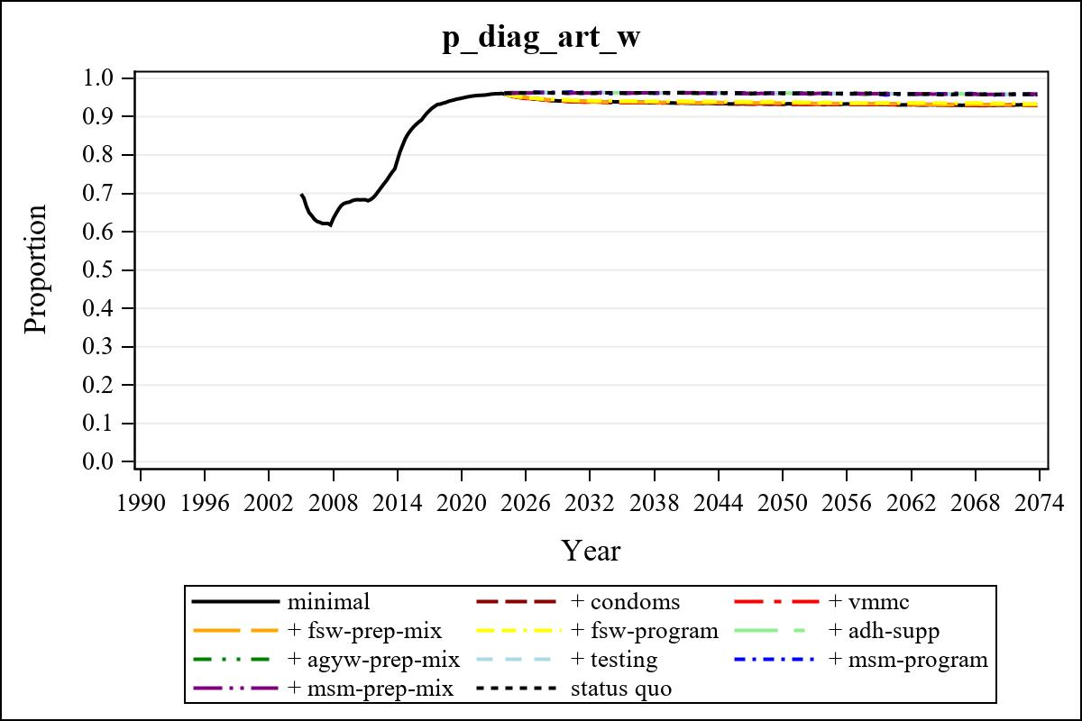

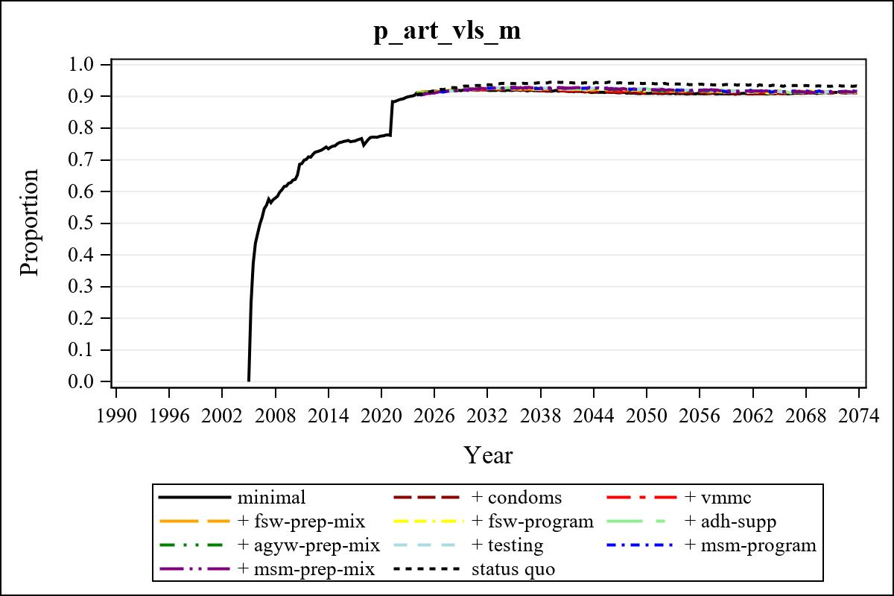

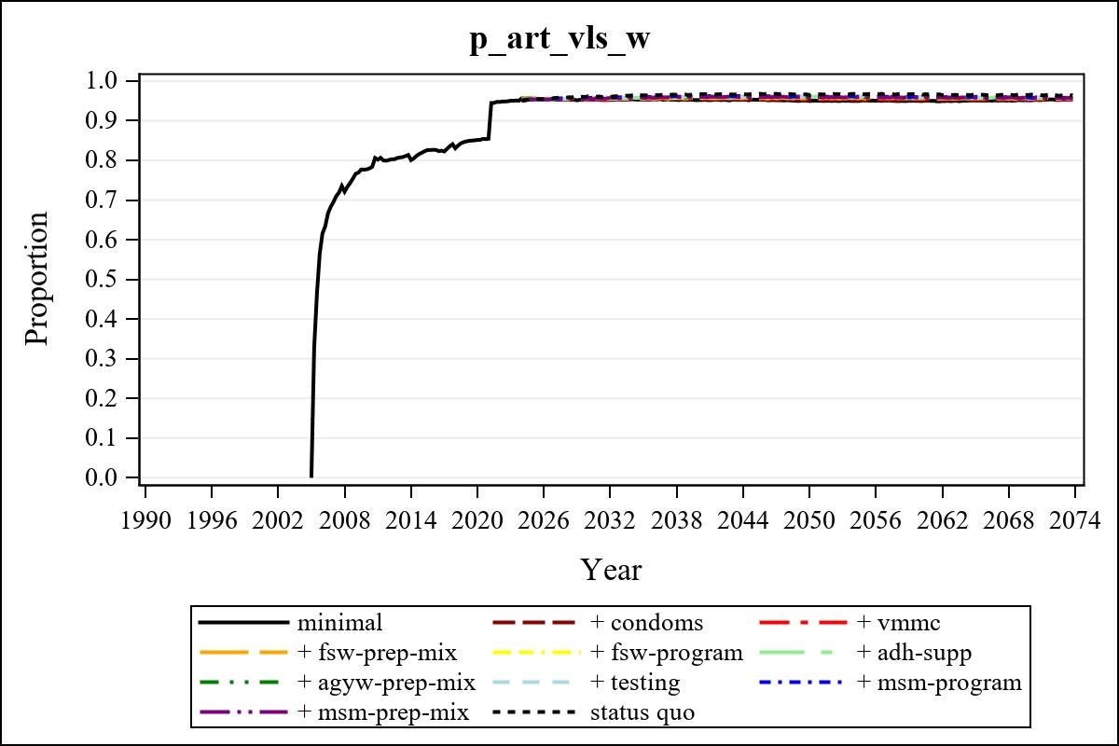

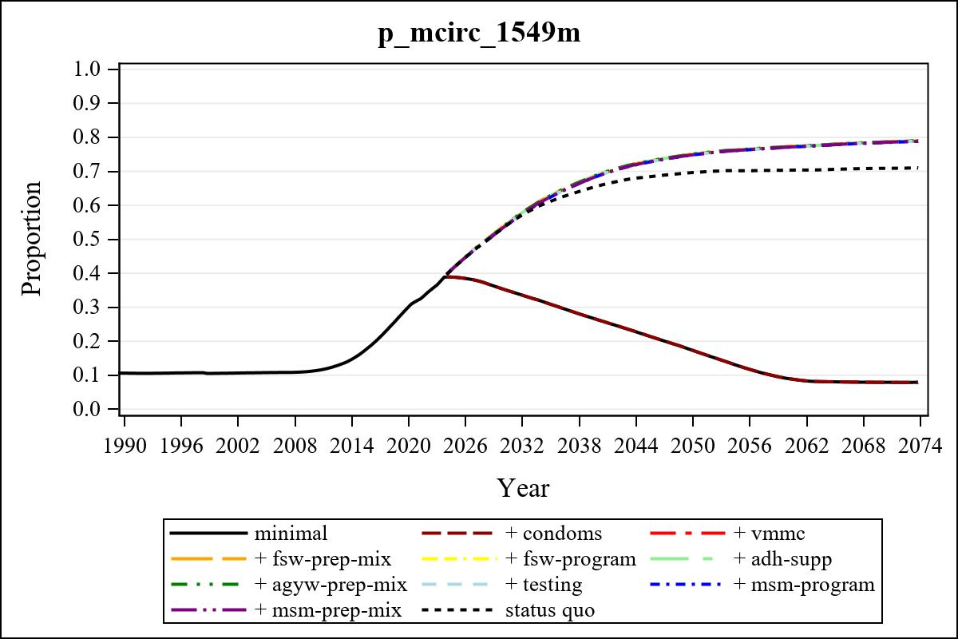

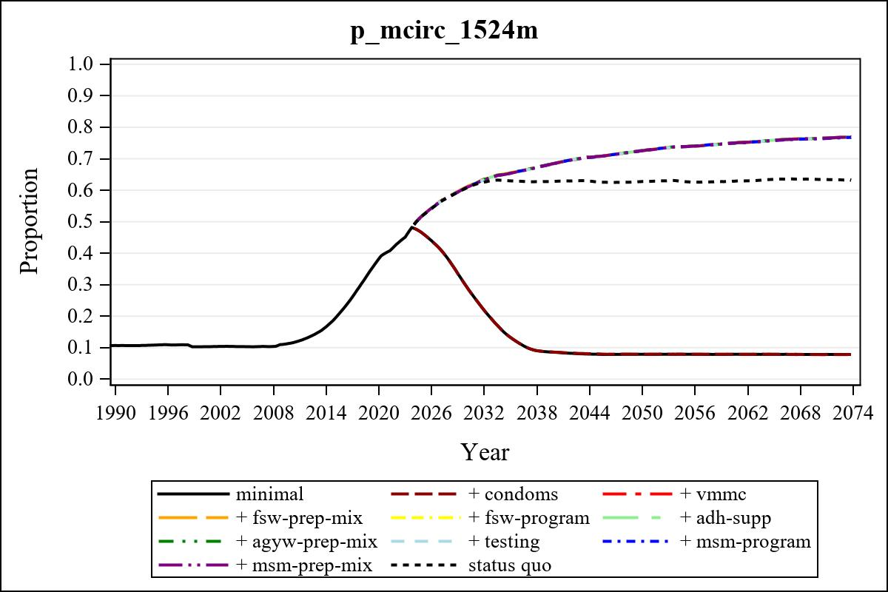

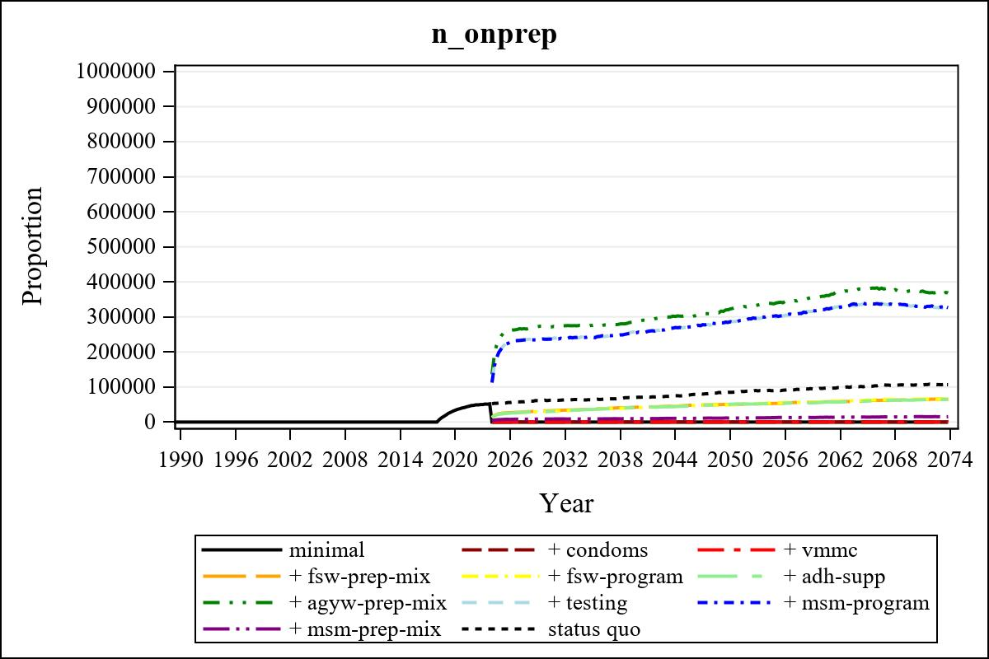

Obs | mean_n_onprep_0 | mean_n_onprep_1 | mean_n_onprep_2 | mean_n_onprep_3
346 | 0 | 0 | 0 | 64417.84

Obs | mean_n_onprep_4 | mean_n_onprep_5 | mean_n_onprep_6 | mean_n_onprep_99
346 | 65004.37 | 62449.62 | 376456.18 | 105349.02

Obs | mean_n_sw_1564__1 | mean_n_undiag_sw_1 | mean_n_elig_prep_1 | mean_n_elig_prep_any_sw_1
186 | 131630.52 | 74919.85 | 0 | 0

Obs | mean_n_onprep_sw_1 | mean_n_onprep_w_1 | mean_n_sw_1564__2 | mean_n_undiag_sw_2
186 | 0 | 0 | 131925.28 | 75874.56

Obs | mean_n_elig_prep_2 | mean_n_elig_prep_any_sw_2 | mean_n_onprep_sw_2 | mean_n_onprep_w_2
186 | 0 | 0 | 0 | 0

Obs | mean_n_onprep_oral_sw_2 | mean_n_onprep_len_sw_2 | mean_n_agyw_pg_3 | mean_n_elig_prep_3
186 | 0 | 0 | 953852.33 | 80913.15

Obs | mean_n_onprep_agyw_pg_3 | mean_n_onprep_w_3 | mean_n_agyw_pg_4 | mean_n_elig_prep_4
186 | 12440.45 | 32010.81 | 950581.52 | 82495.55

Obs | mean_n_onprep_agyw_pg_4 | mean_n_onprep_w_4 | mean_n_onprep_oral_agyw_pg_4
186 | 10511.88 | 30244.12 | 1998.31

Obs | mean_n_onprep_len_agyw_pg_4 | mean_n_alive_msm_5 | mean_n_elig_prep_5 | mean_n_onprep_msm_5
186 | 8513.57 | 64632.44 | 82781.03 | 0

Obs | mean_n_onprep_m_5 | mean_n_alive_msm_6 | mean_n_elig_prep_6 | mean_n_onprep_msm_6
186 | 0 | 64770.65 | 912135.24 | 0

Obs | mean_n_onprep_m_6 | mean_n_onprep_oral_msm_6 | mean_n_onprep_len_msm_6 | mean_pc_elig_onprep_1
186 | 0 | 0 | 0 | .

Obs | mean_pc_elig_onprep_2 | mean_pc_elig_onprep_3 | mean_pc_elig_onprep_4 | mean_pc_elig_onprep_5
186 | . | 0.40567 | 0.37938 | 0.37595

Obs | mean_pc_elig_onprep_6
186 | 0.29598

Obs | mean_n_sw_1564__1 | mean_n_undiag_sw_1 | mean_n_elig_prep_1
186 | 131630.52 | 74919.85 | 0

Obs | mean_n_elig_prep_any_sw_1 | mean_n_onprep_sw_1 | mean_n_onprep_w_1
186 | 0 | 0 | 0

Obs | ratio_oral_len_2 | ratio_oral_len_4 | ratio_oral_len_6
1 | . | 0.18825 | 0.23337

