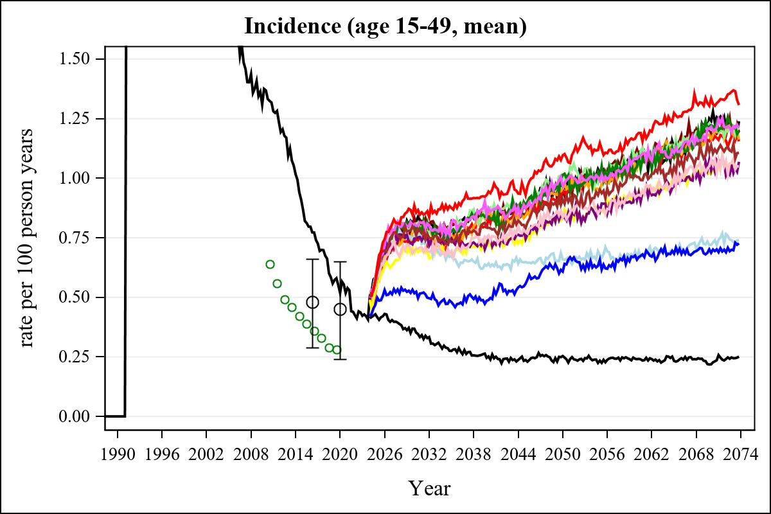

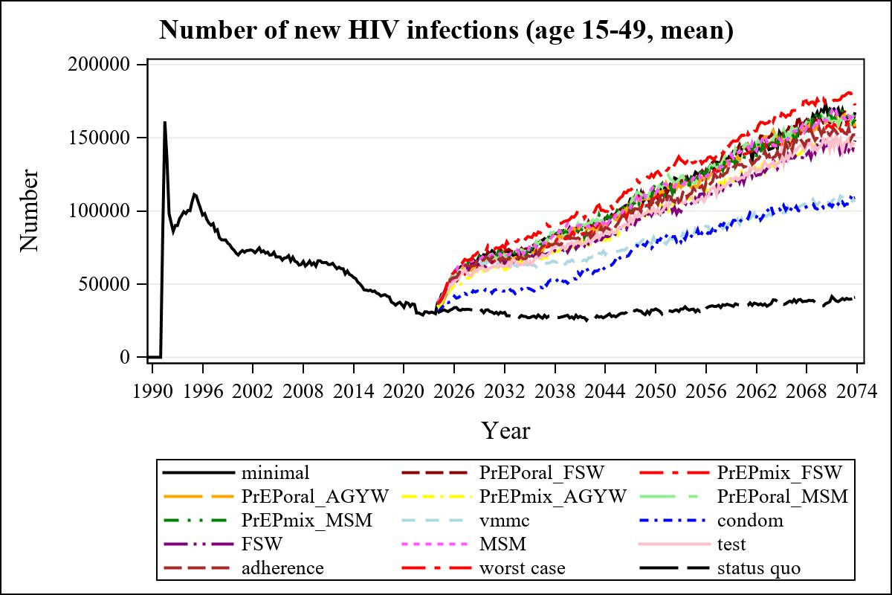

Obs | mean_n_new_inf1549__0 | mean_n_new_inf1549__1 | mean_n_new_inf1549__2 | mean_n_new_inf1549__3
345 | 167780.85 | 160035.83 | 158137.05 | 158008.10

Obs | mean_n_new_inf1549__4 | mean_n_new_inf1549__5 | mean_n_new_inf1549__6 | mean_n_new_inf1549__7
345 | 141857.61 | 162663.51 | 165314.96 | 104043.29

Obs | mean_n_new_inf1549__8 | mean_n_new_inf1549__9 | mean_n_new_inf1549__10 | mean_n_new_inf1549__11
345 | 102309.22 | 142384.29 | 163468.88 | 148950.83

Obs | mean_n_new_inf1549__12 | mean_n_new_inf1549__13 | mean_n_new_inf1549__99
345 | 155507.83 | 176227.84 | 35172.17

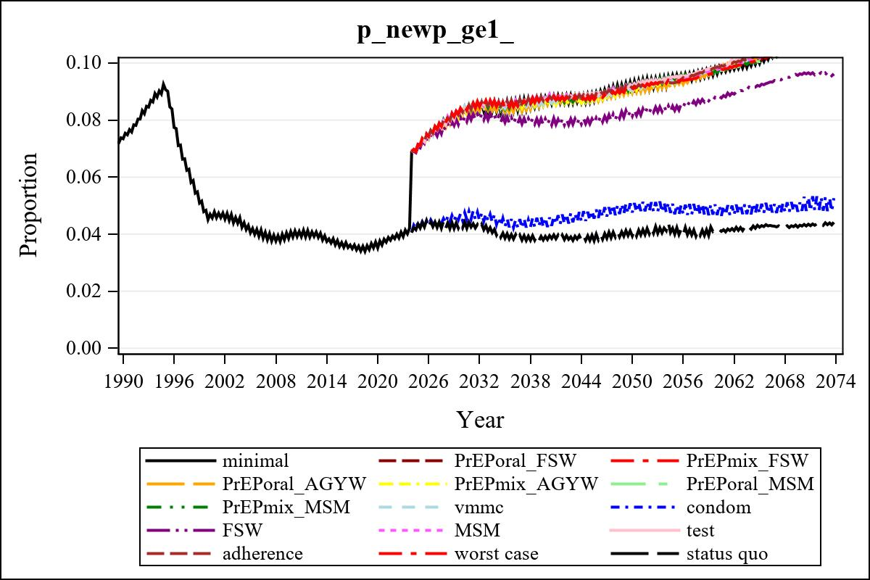

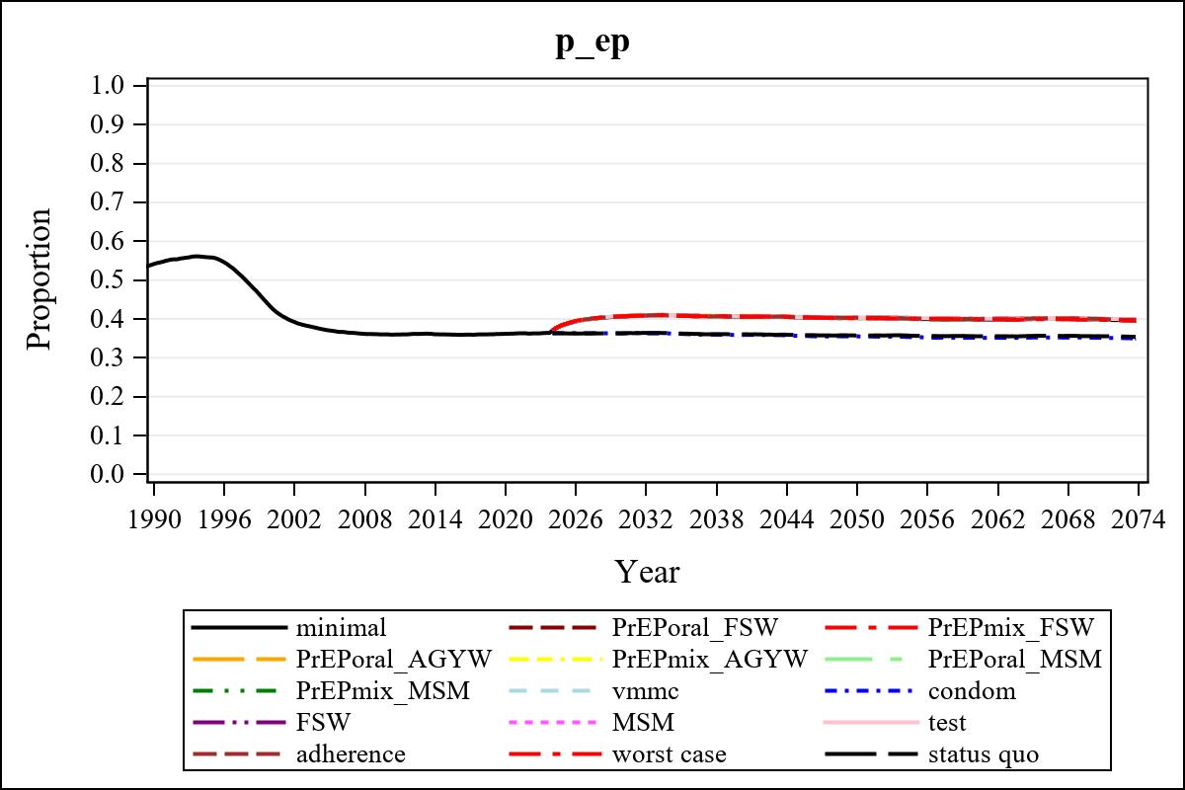

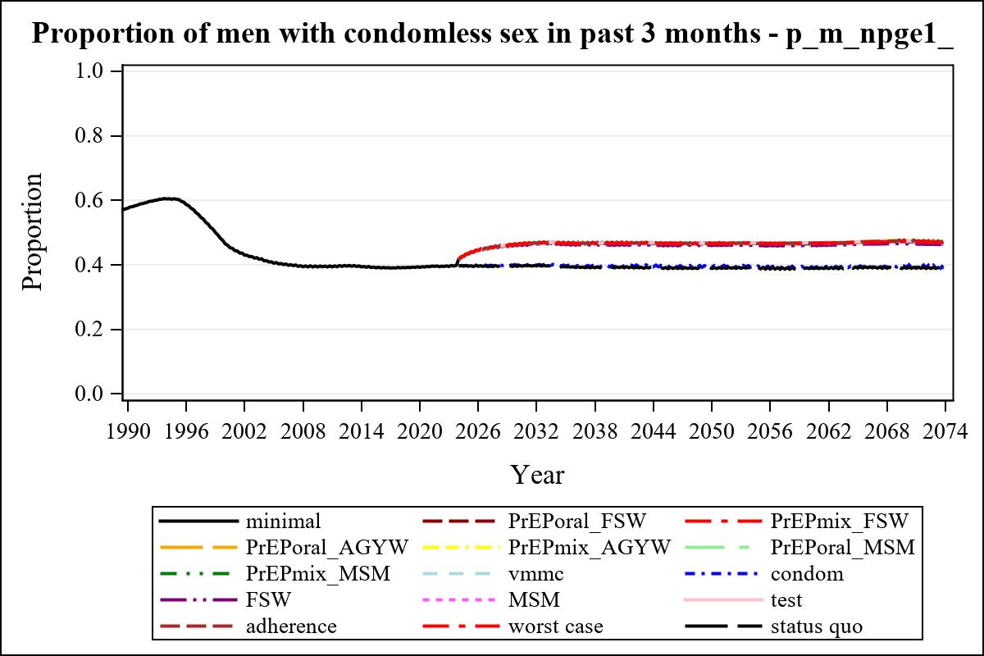

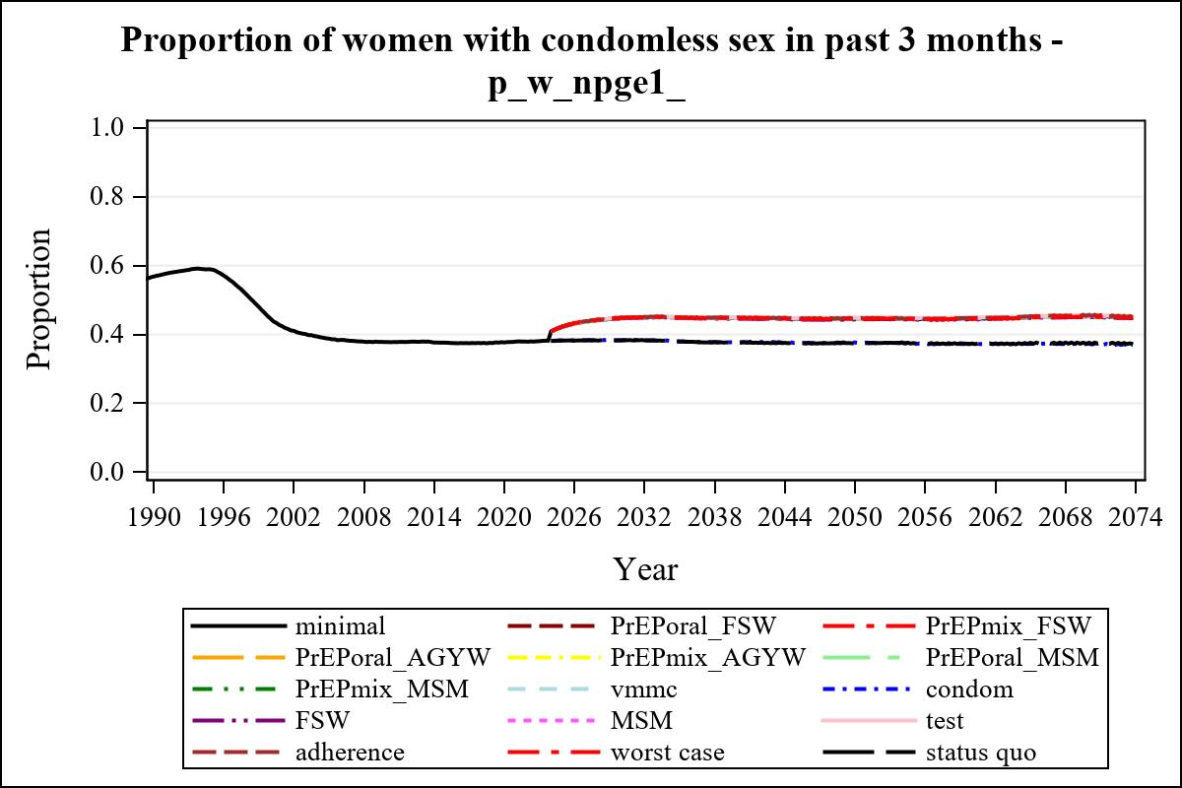

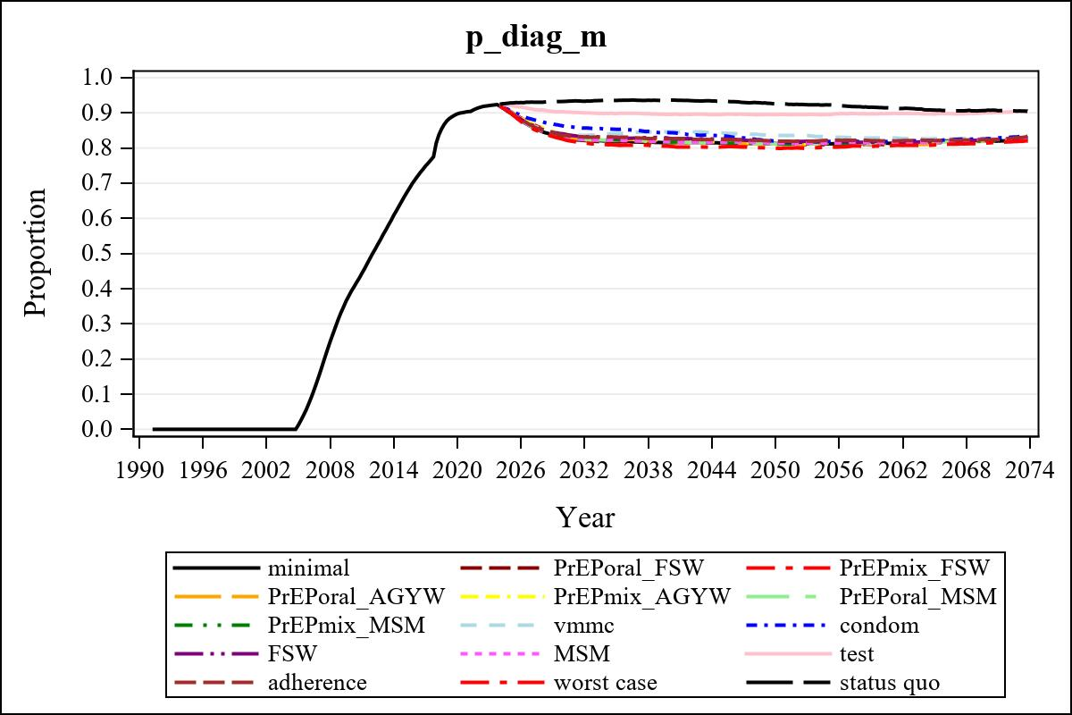

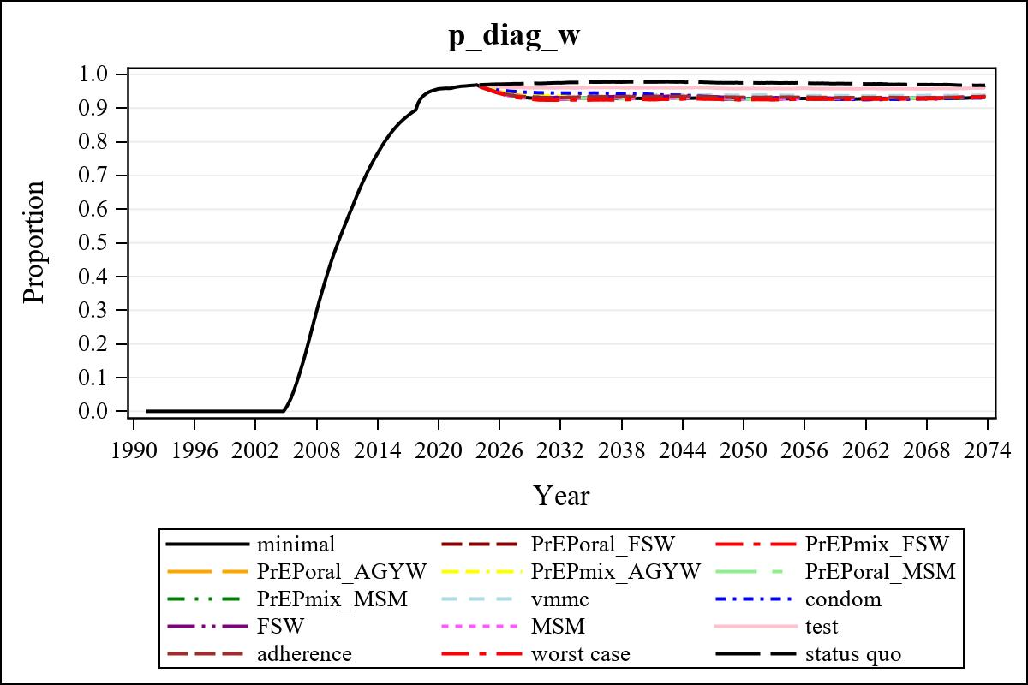

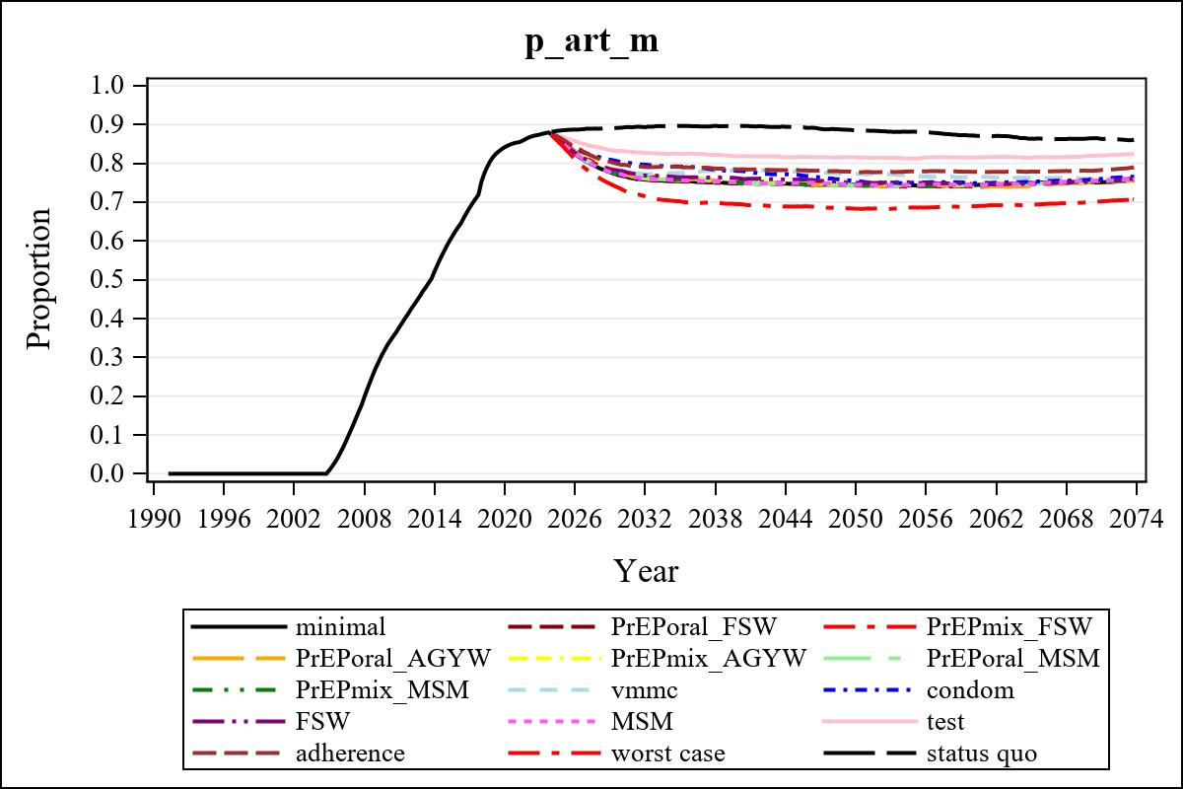

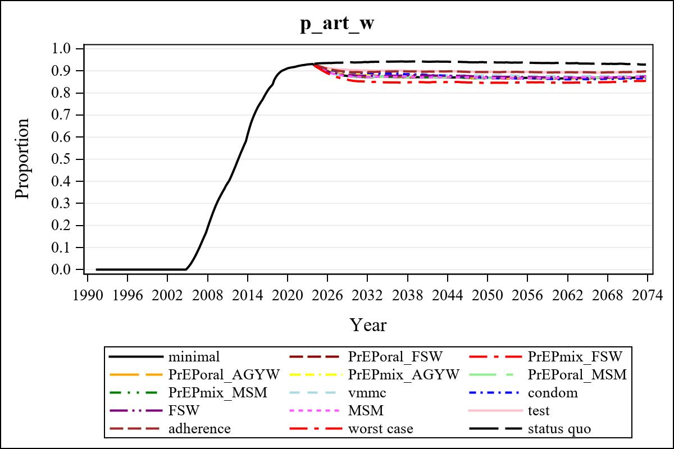

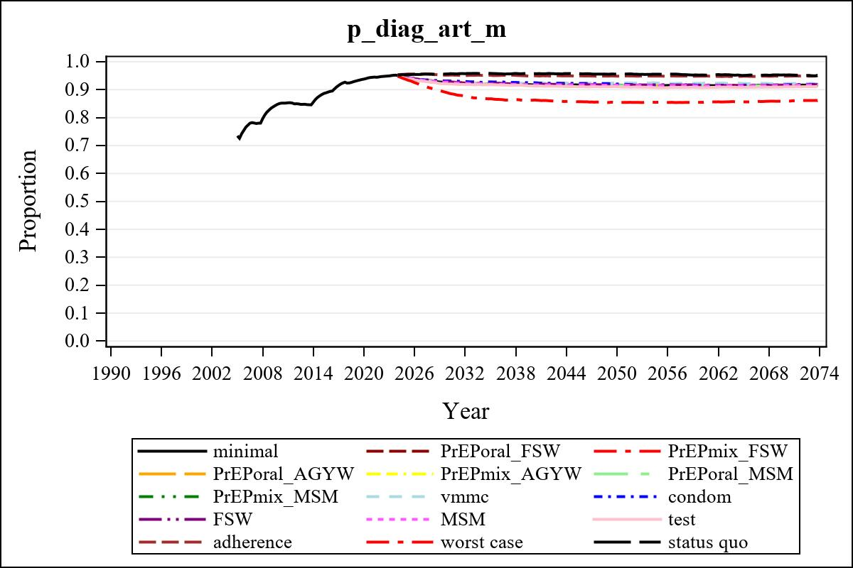

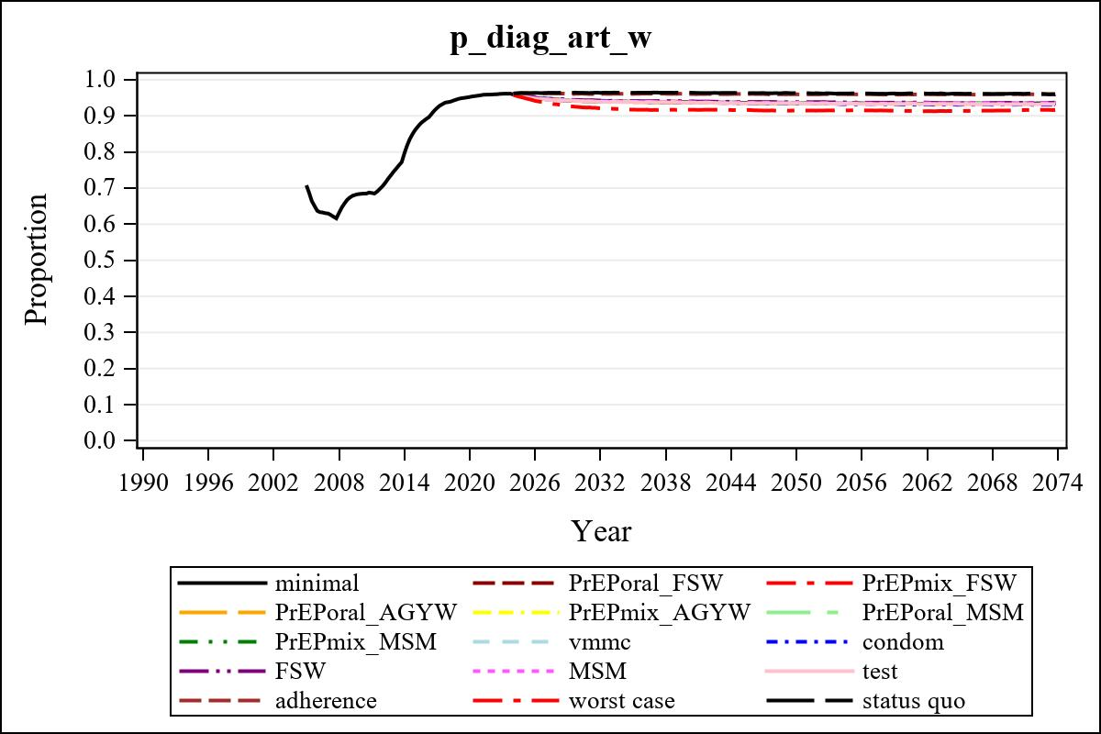

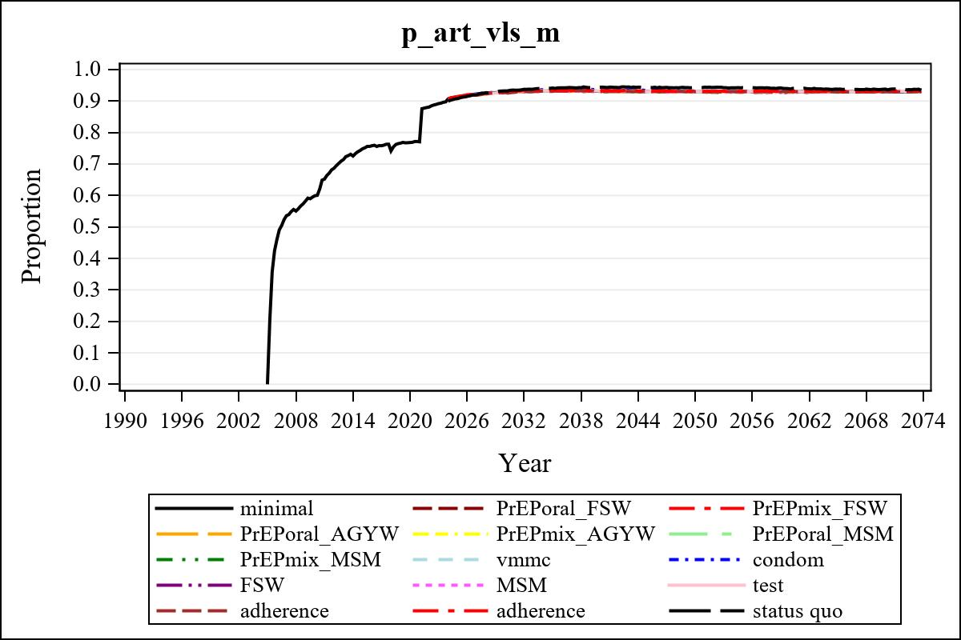

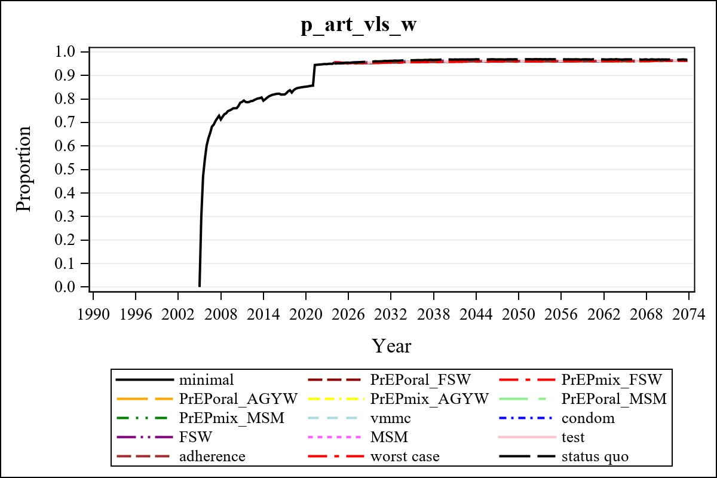

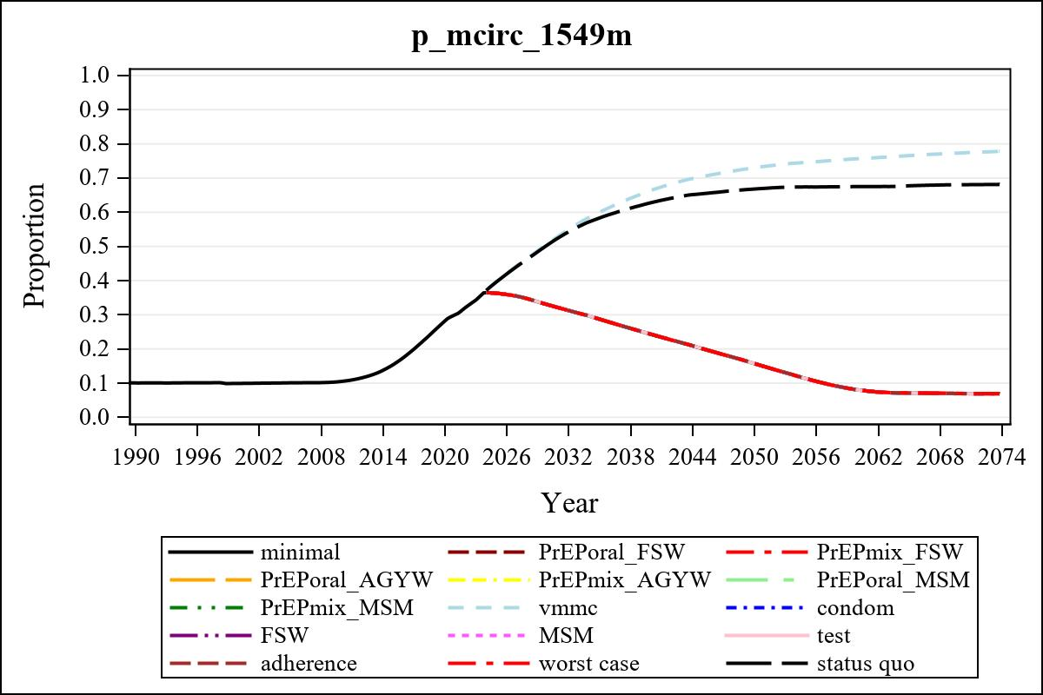

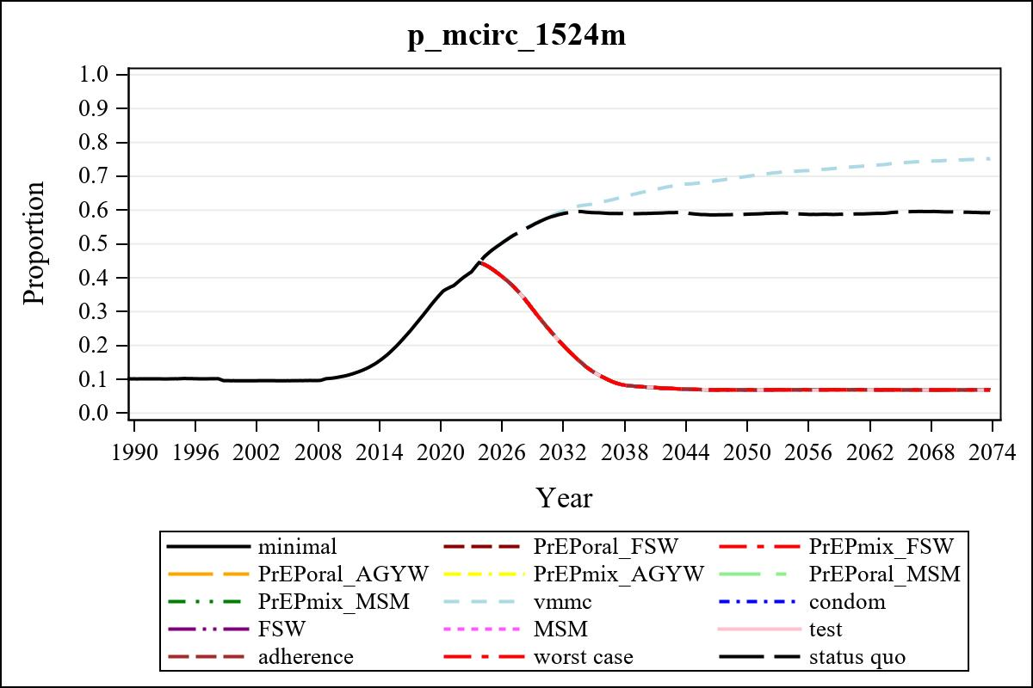

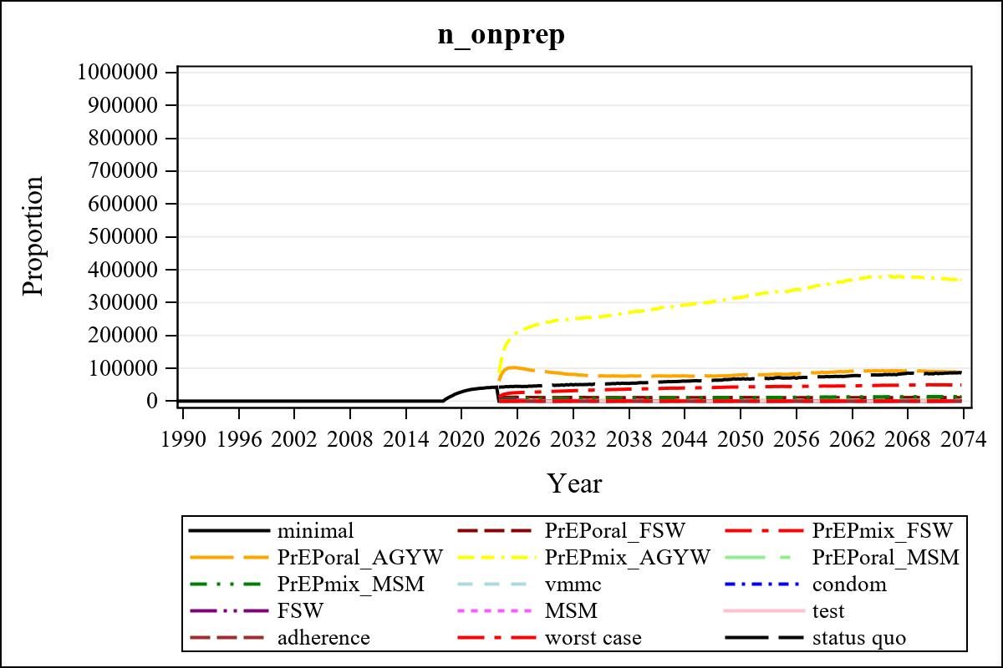

Obs | mean_n_onprep_0
345 | 0

Obs | mean_n_elig_prep_1 | mean_n_sw_1564__1 | mean_n_onprep_sw_1 | mean_n_onprep_w_1
185 | 69301.18 | 120982.63 | 10810.66 | 10810.66

Obs | mean_n_elig_prep_2 | mean_n_sw_1564__2 | mean_n_onprep_sw_2 | mean_n_onprep_w_2
185 | 73329.84 | 120649.36 | 29836.76 | 29836.76

Obs | mean_n_onprep_oral_sw_2 | mean_n_onprep_len_sw_2 | mean_n_elig_prep_3 | mean_n_agyw_pg_3
185 | 5494.63 | 24342.13 | 1000445.30 | 1071033.43

Obs | mean_n_onprep_agyw_pg_3 | mean_n_onprep_w_3 | mean_n_elig_prep_4 | mean_n_agyw_pg_4
185 | 86121.46 | 86121.46 | 1007018.78 | 1070883.64

Obs | mean_n_onprep_agyw_pg_4 | mean_n_onprep_w_4 | mean_n_onprep_oral_agyw_pg_4
185 | 244912.38 | 244912.38 | 47934.80

Obs | mean_n_onprep_len_agyw_pg_4 | mean_n_elig_prep_5 | mean_n_alive_msm_5 | mean_n_onprep_msm_5
185 | 196977.58 | 22069.93 | 63517.27 | 2700.50

Obs | mean_n_onprep_m_5 | mean_n_elig_prep_6 | mean_n_alive_msm_6 | mean_n_onprep_msm_6
185 | 2700.50 | 22678.79 | 63574.87 | 8422.66

Obs | mean_n_onprep_m_6 | mean_n_onprep_oral_msm_6 | mean_n_onprep_len_msm_6 | mean_pc_elig_onprep_1
185 | 8422.66 | 1449.70 | 6972.96 | 0.15274

Obs | mean_pc_elig_onprep_2 | mean_pc_elig_onprep_3 | mean_pc_elig_onprep_4 | mean_pc_elig_onprep_5
185 | 0.40695 | 0.090782 | 0.24657 | 0.12177

Obs | mean_pc_elig_onprep_6
185 | 0.37405

Obs | ratio_oral_len_2 | ratio_oral_len_4 | ratio_oral_len_6
1 | 0.19910 | 0.22069 | 0.18352

