PLOS Medicine Revisions - Model Diagnostics
Matt Hickey
13 November, 2024
Table of Contents

Net DALY probability distribution
## `summarise()` has grouped output by 'source'. You can override using the
## `.groups` argument.
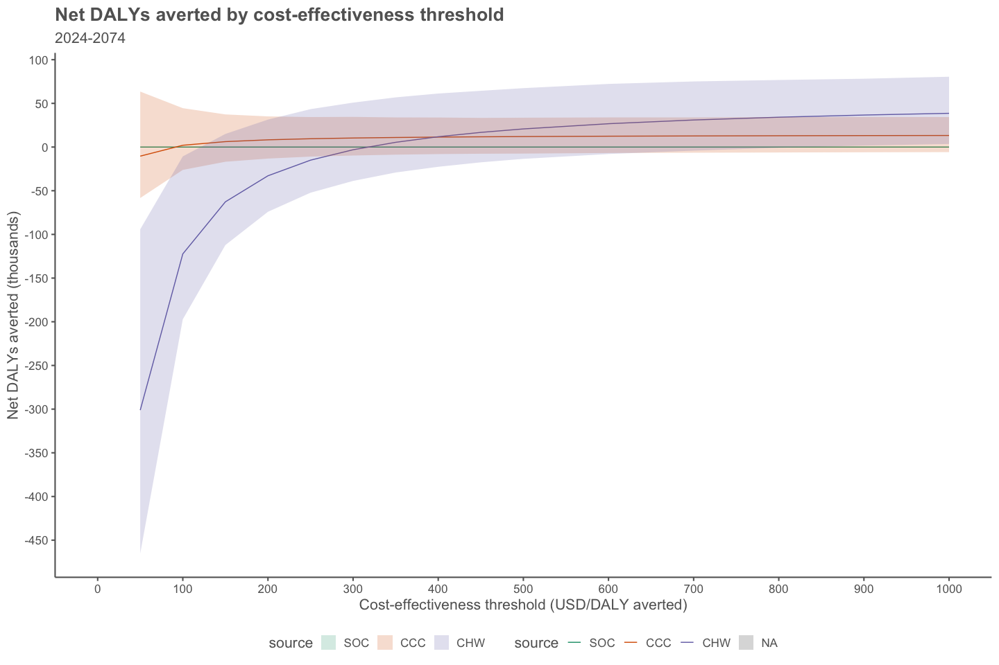

Cost-effectiveness frontiers with scatterplot
Including all data points to show distribution around ICER estimates
## Warning: Using `size` aesthetic for lines was deprecated in ggplot2 3.4.0.
## ℹ Please use `linewidth` instead.
## This warning is displayed once every 8 hours.
## Call `lifecycle::last_lifecycle_warnings()` to see where this warning was
## generated.
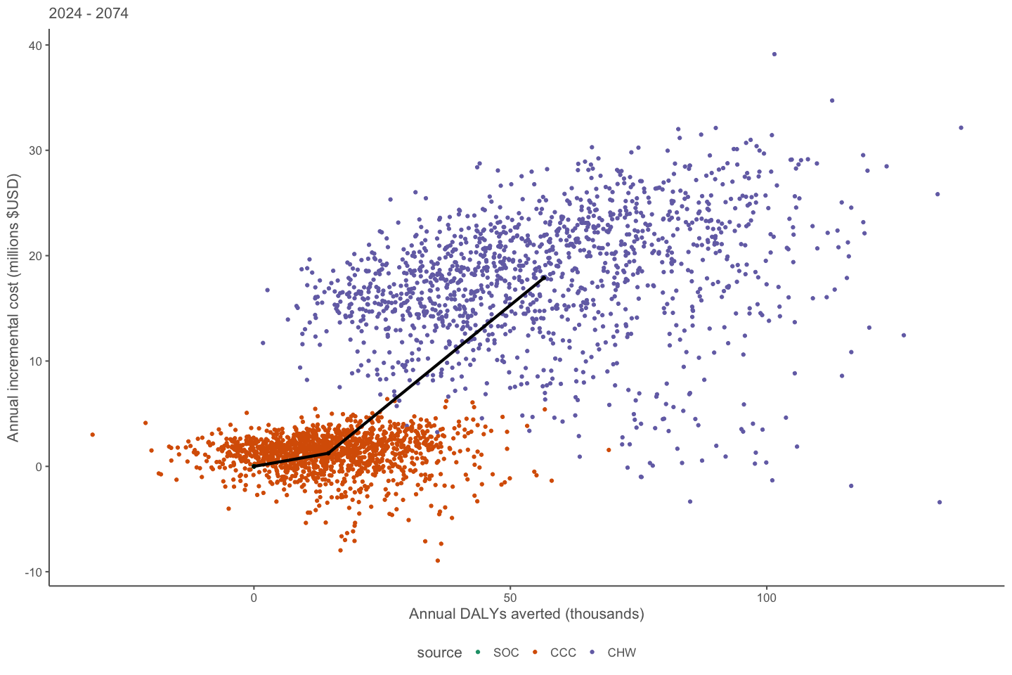
Including selected paired datapoints for illustration 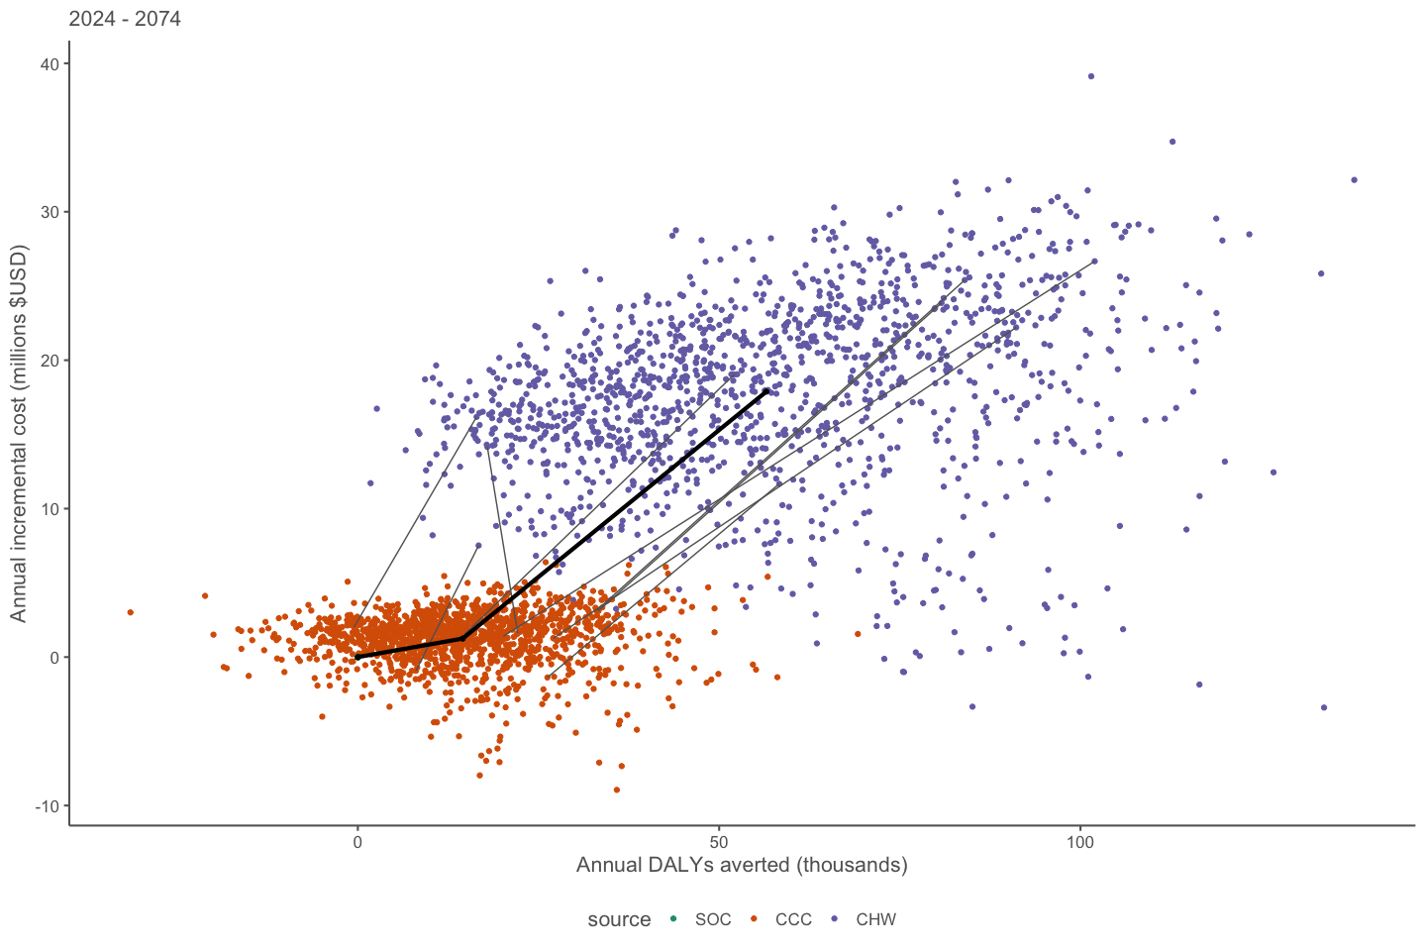

Hypertension diagnosis, treatment, control over time

Age 18+

0.25-Year Increments
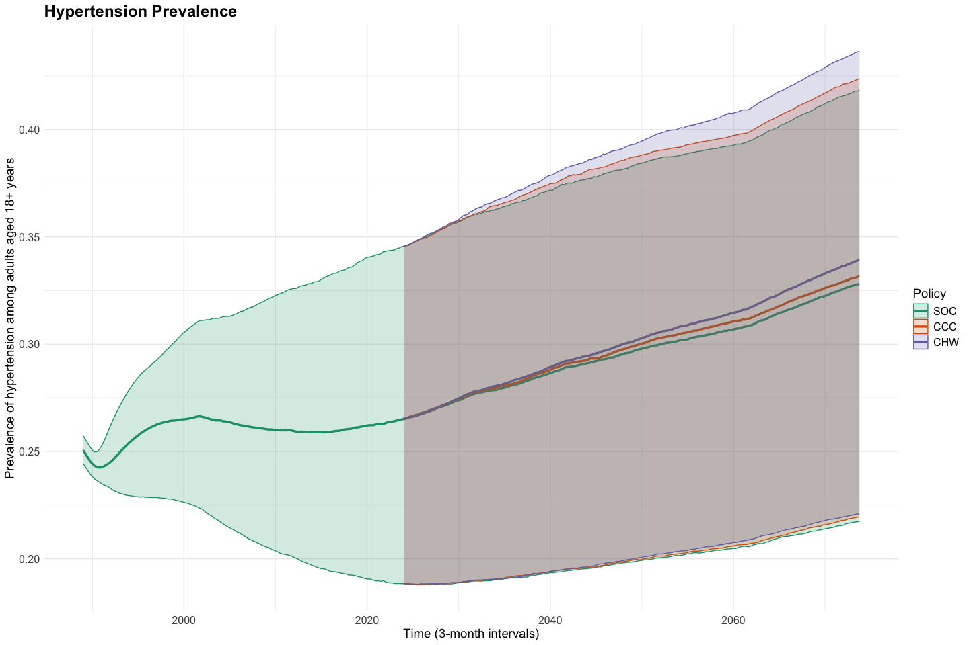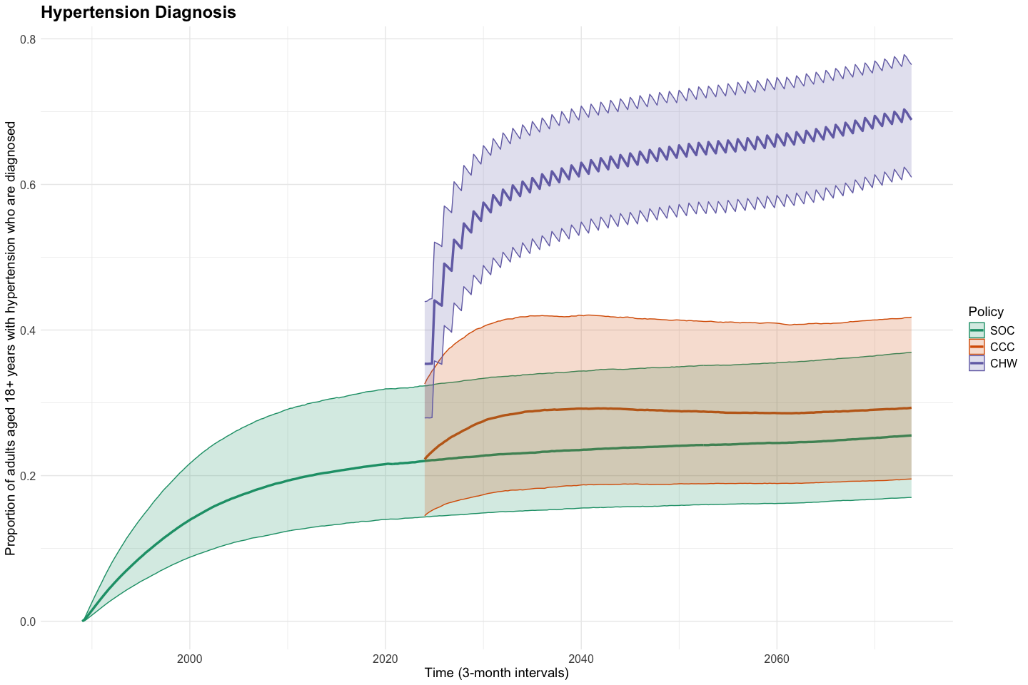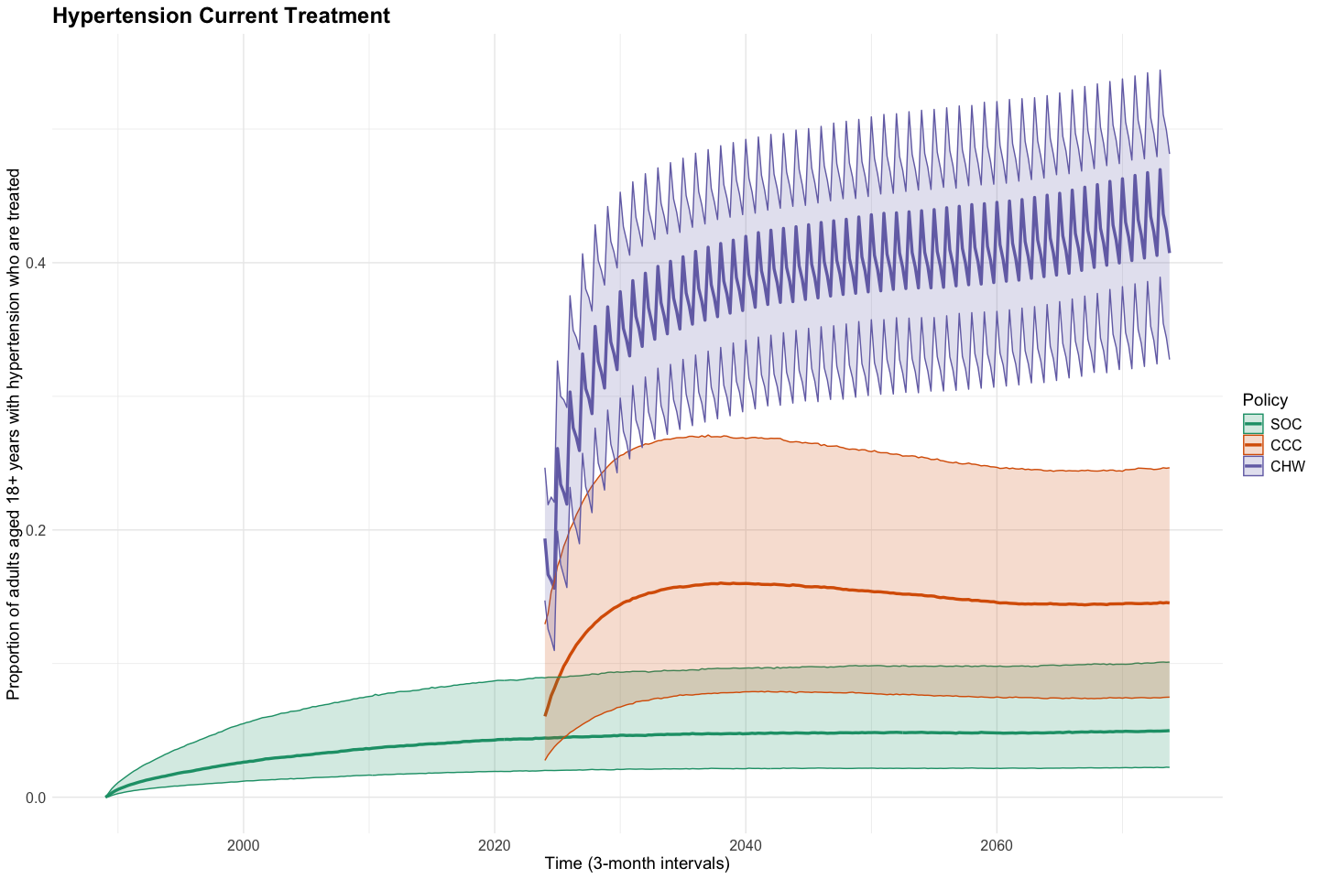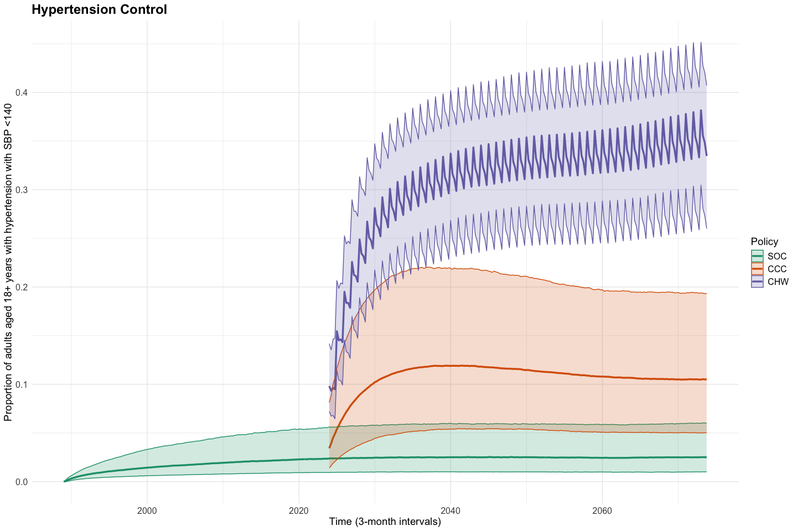

1 year increments
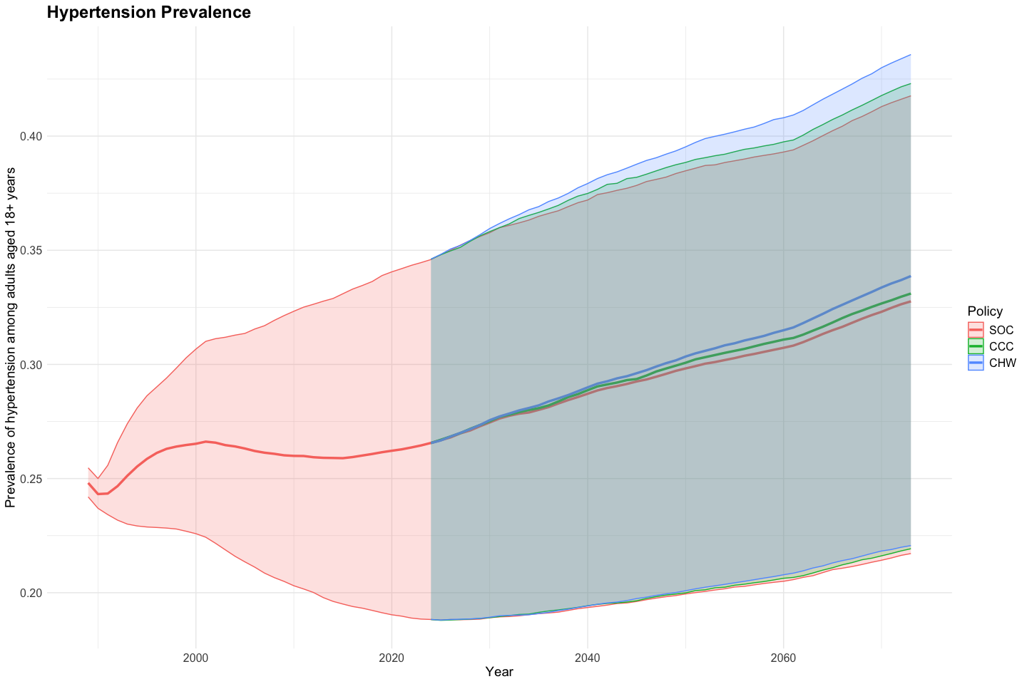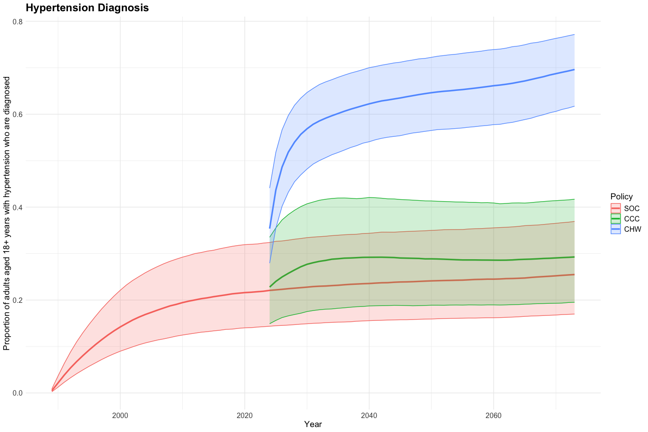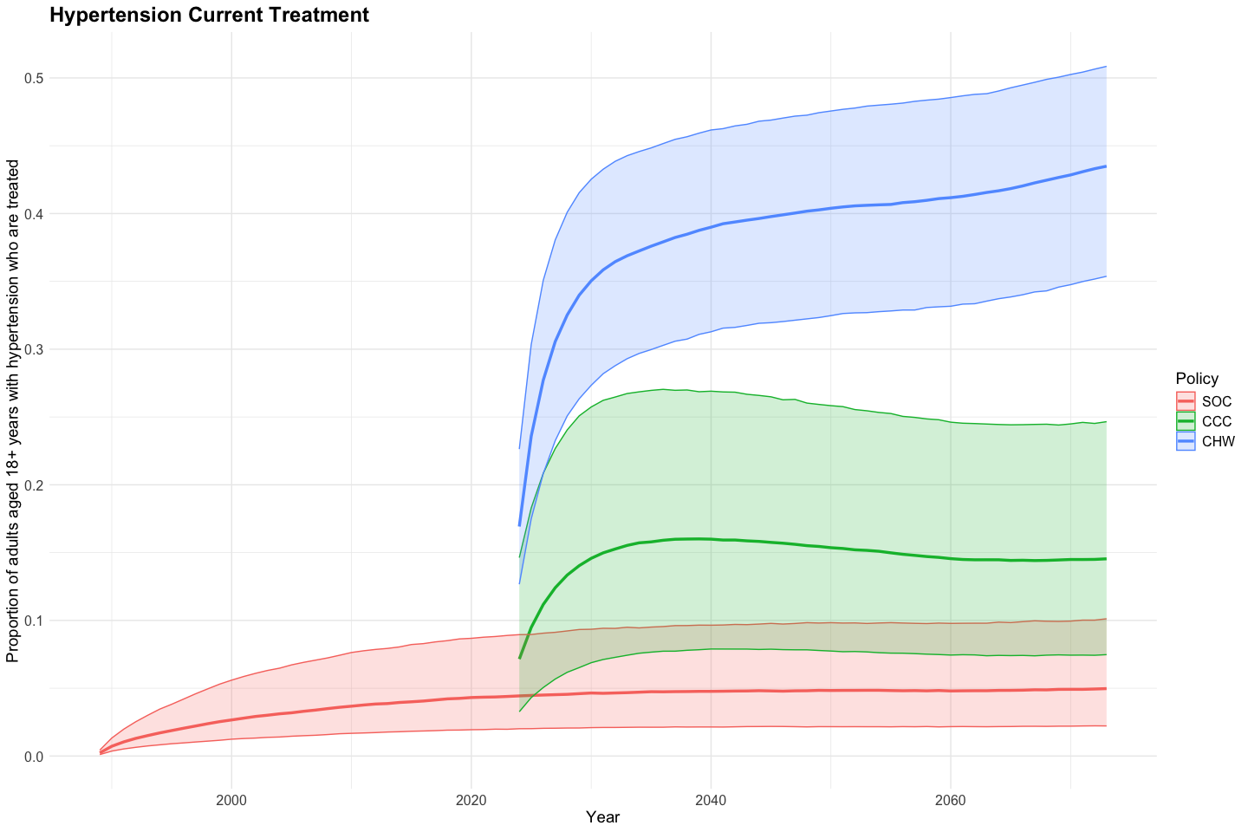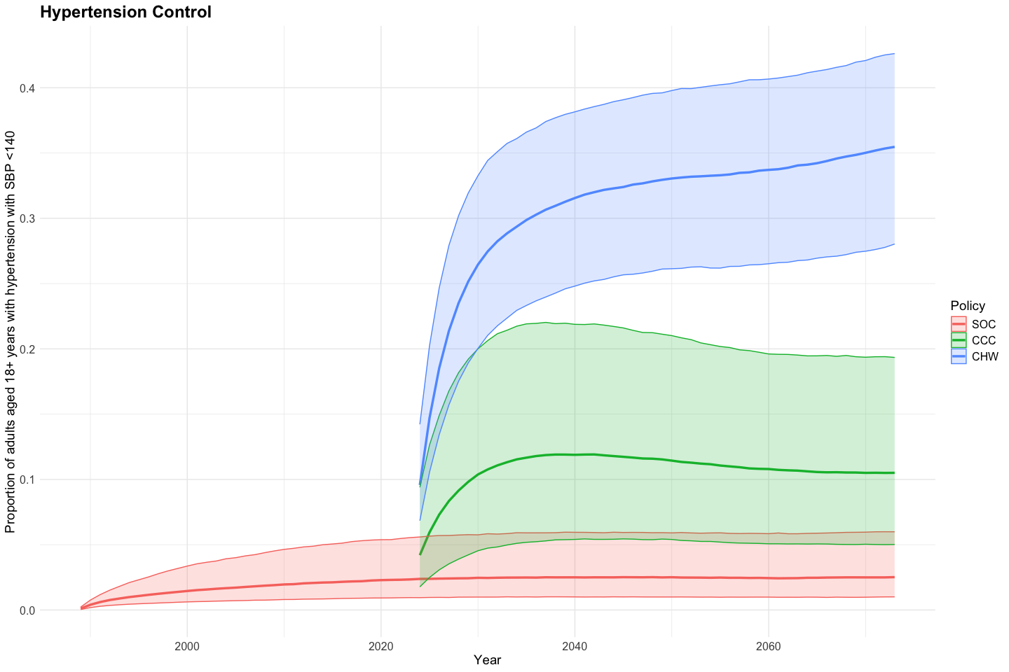

Age 45-64

0.25 year increments
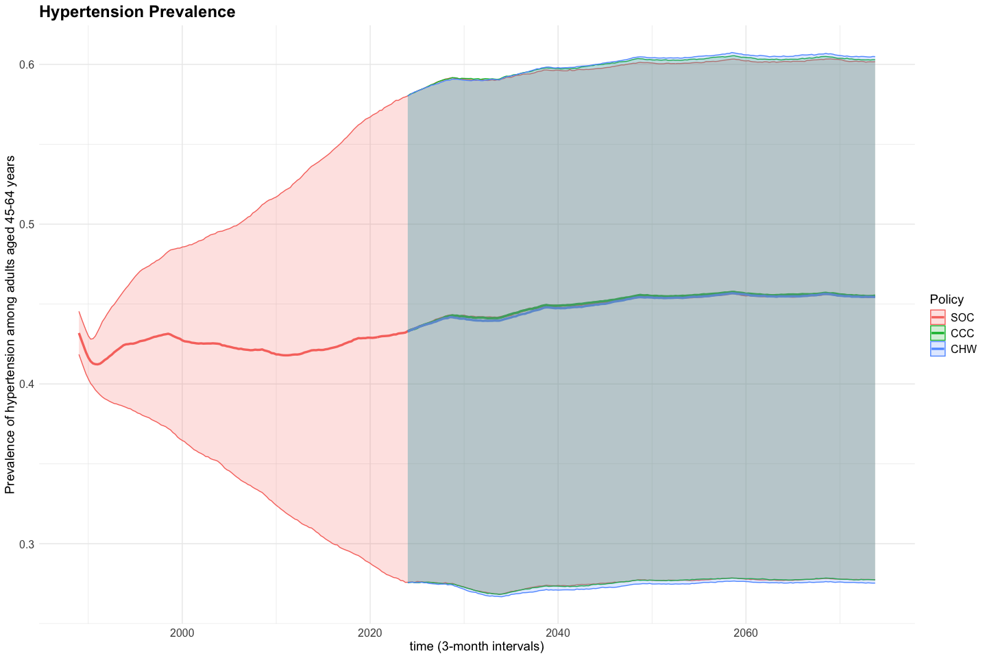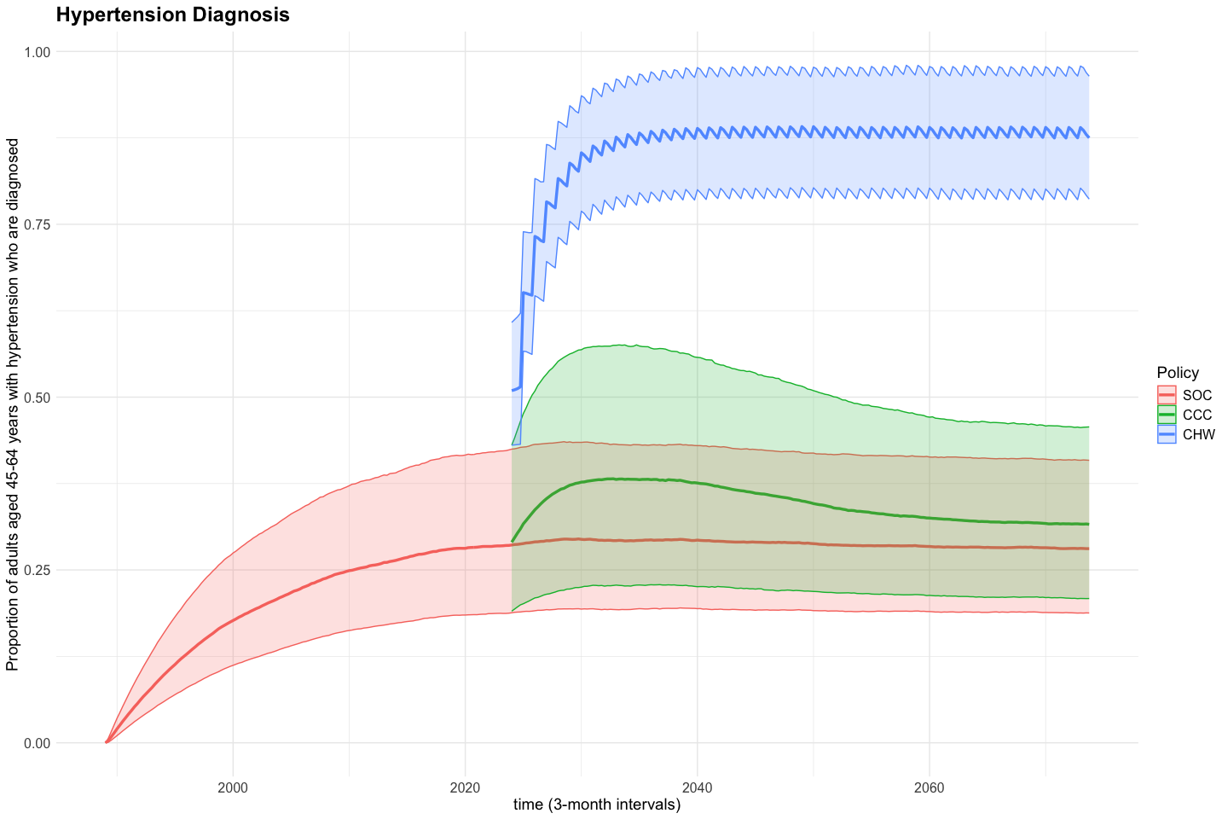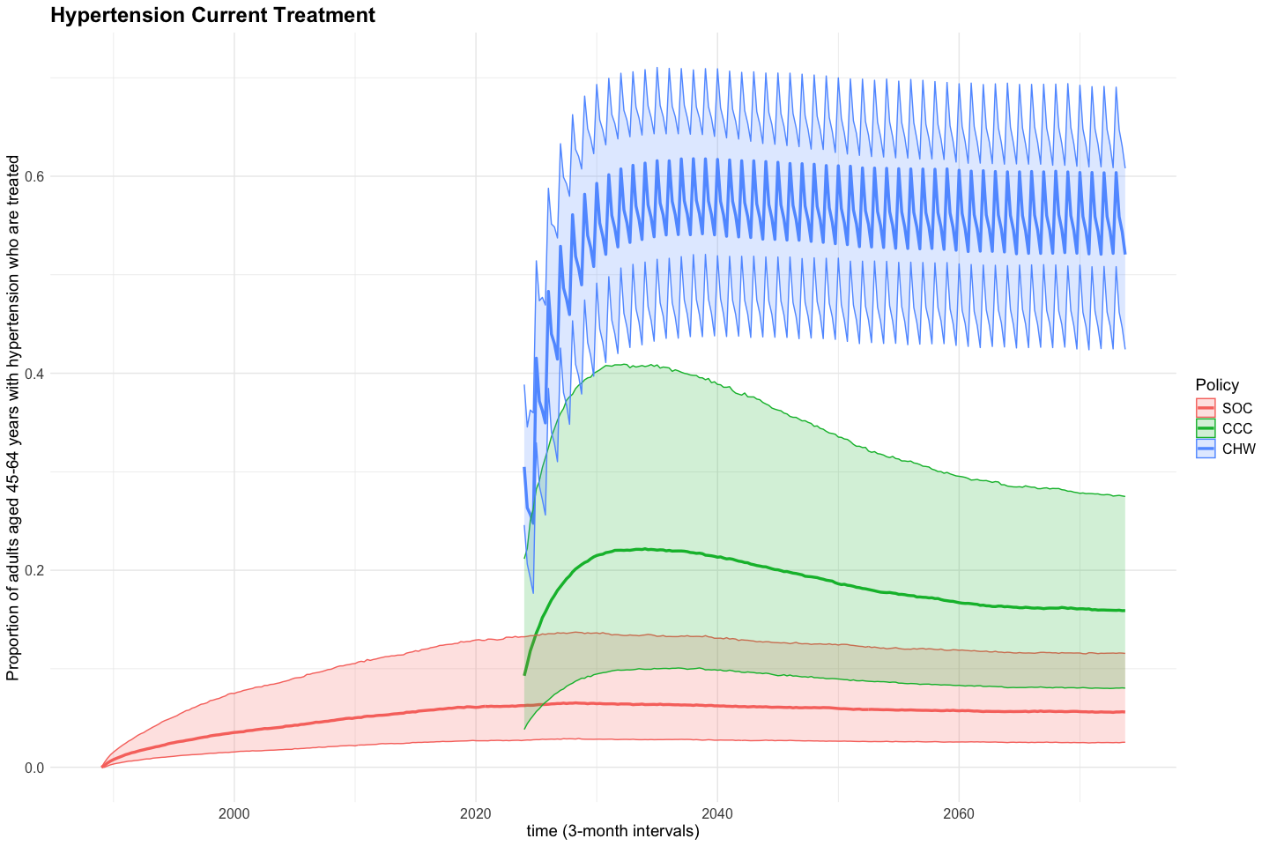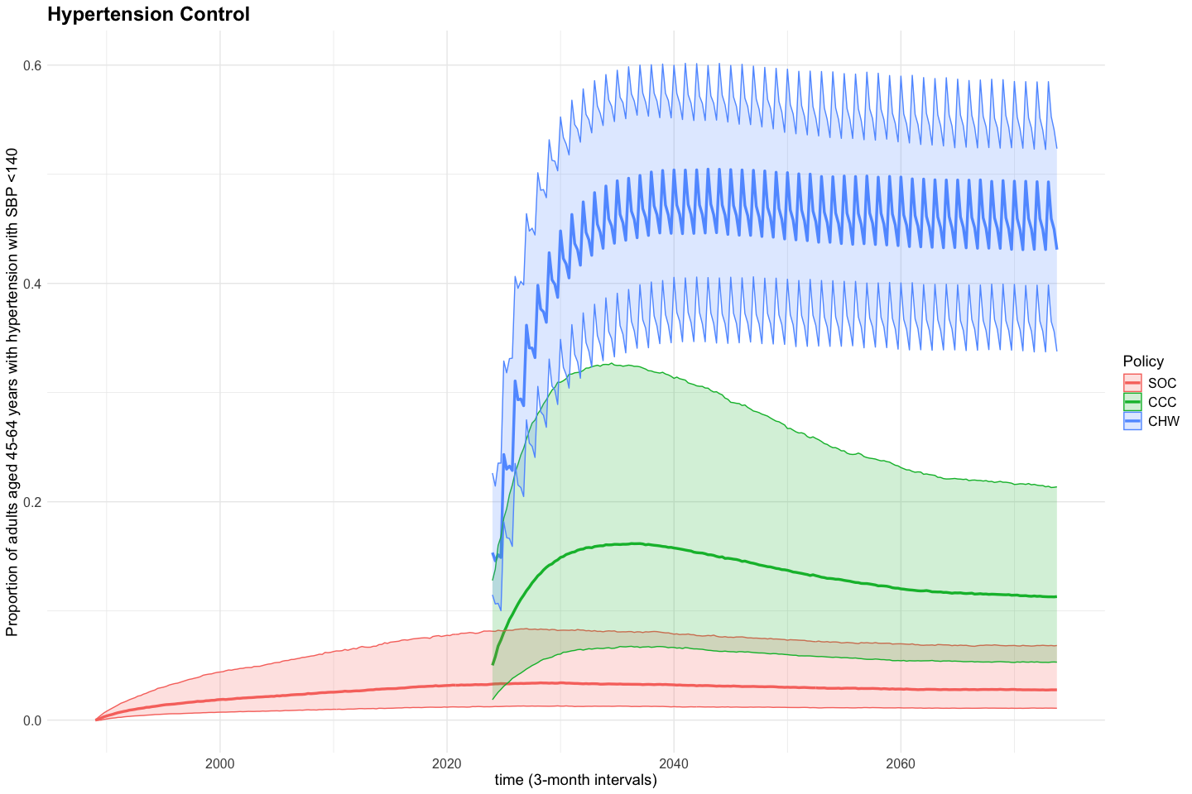

1 year increments
